***Level-1***

***Query-1: Display the name, IMDb rating and genre of all the movies with an IMDb rating greater than or equal to 8.0.***

***Query-2: Find how many movies are there in each genre with an IMDb rating greater than or equal to 8.0.***

***Query-3: Find the name and average IMDb rating of those genre whose average IMDB rating is greater than or equal to 7.5.***

***Query-4: Find the name ,number of films and number of awards of the director who directed the most number of movies.***

***Query-5: Find the name, current age, number of films and number of awards of the youngest actor.***

***Query-1: Display the name, IMDb rating and genre of all the movies with an IMDb rating greater than or equal to 8.0.***

***SQL:*** *SELECT Movie_Name,IMDB_Rating,Genre FROM movie WHERE IMDB_Rating>=8.0;*

***Output:***



***Query-2:*** *Find how many movies are there in each genre with an IMDb rating greater than or equal to 8.0.*

***SQL****: SELECT Genre, COUNT(Movie_ID) FROM movie WHERE IMDB_Rating>=8.0 GROUP BY Genre ;*

**Output:**



**Query-3:***Find the name and average IMDb rating of those genre whose average IMDB rating is greater than or equal to 7.5.*

***SQL:*** *SELECT Genre,AVG(IMDB_Rating) FROM movie GROUP BY Genre HAVING AVG(IMDB_Rating)>=7.5;*

***Output:***

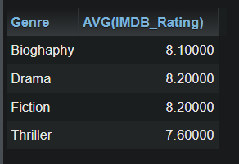

***Query-4:*** *Find the name ,number of films and number of awards of the director who directed the most number of movies.*

***SQL:***

*SELECT Director_Name,No_Of_Films,No_Of_Awards FROM director WHERE No_Of_Films=(SELECT MAX(No_Of_Films) FROM director);*

***Output:***



***Query-5:*** *Find the name, current age, number of films and number of awards of the youngest actor.*

***SQL:***[SELECT](http://localhost/phpmyadmin/url.php?url=https://dev.mysql.com/doc/refman/8.0/en/select.html) Actor_Name,(Year([CURRENT_DATE](http://localhost/phpmyadmin/url.php?url=https://dev.mysql.com/doc/refman/8.0/en/date-and-time-functions.html%23function_current_date))-Birth_Year) AS AGE,No_Of_Films,No_Of_Awards FROM actor WHERE Birth_Year=([SELECT](http://localhost/phpmyadmin/url.php?url=https://dev.mysql.com/doc/refman/8.0/en/select.html) [MAX](http://localhost/phpmyadmin/url.php?url=https://dev.mysql.com/doc/refman/8.0/en/aggregate-functions.html%23function_max)(Birth_Year) FROM actor); ***Level-2***

***Query-6:*** *Find the name ,number of films as a director, number of films as an actor , number of award as a director and number of awards as an actor of all the directors.( if a director never acted in any film then number of films and number of awards as an actor will be null)*

***Query-7:*** *Find the name, number of films as a director , number of films as an actor, number of awards as director and number of awards as an actor of all the actors and directors.*

***Query-8:*** *Find the name, number of films and the number of awards of those actors who never directed any film.*

***Query-9****: Find the name, IMDb rating and genre of those movies whose IMDb rating is above average.*

***Query-10:*** *Among all the movie genres, find the highest average IMDb rating.*

***Query-6:*** *Find the name ,number of films as a director, number of films as an actor , number of award as a director and number of awards as an actor of all the directors.( if a director never acted in any film then number of films and number of awards as an actor will be null)*

***SQL:*** *SELECT director.Director_Name,director.No_Of_Films AS Director_NO_of_film,actor.No_Of_Films AS Actor_No_Of_Film,director.No_Of_Awards AS Diretor_No_Of_Award,actor.No_Of_Awards AS Actor_No_Of_Award FROM director LEFT JOIN actor ON director.Person_ID=actor.Person_ID;*

***Output:***

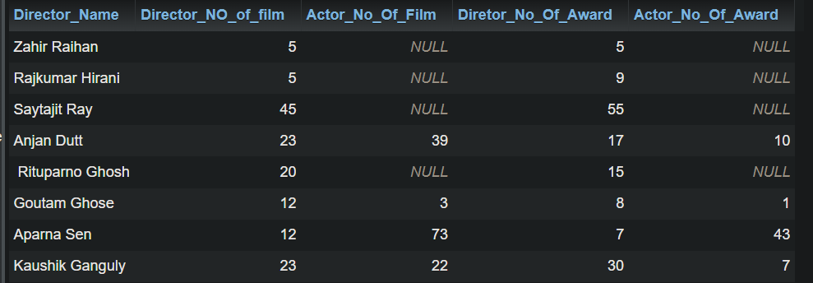

**Query-7:**Find the name, number of films as a director, number of films as an actor, number of awards as a director and number of awards as an actor of all the actor and directors.

**SQL:***(SELECT Director_Name,director.No_Of_Films AS Director_No_Of_Film,actor.No_Of_Films AS Actor_No_Of_Films,director.No_Of_Awards AS Director_No_Of_Award,actor.No_Of_Awards AS Actor_No_Of_Award FROM director LEFT JOIN actor ON director.Person_ID=actor.Person_ID)*

*UNION*

*(SELECT Director_Name,director.No_Of_Films AS Director_No_Of_Film,actor.No_Of_Films AS Actor_No_Of_Films,director.No_Of_Awards AS Director_No_Of_Award,actor.No_Of_Awards AS Actor_No_Of_Award FROM director RIGHT JOIN actor ON director.Person_ID=actor.Person_ID);*

**Ouput:**

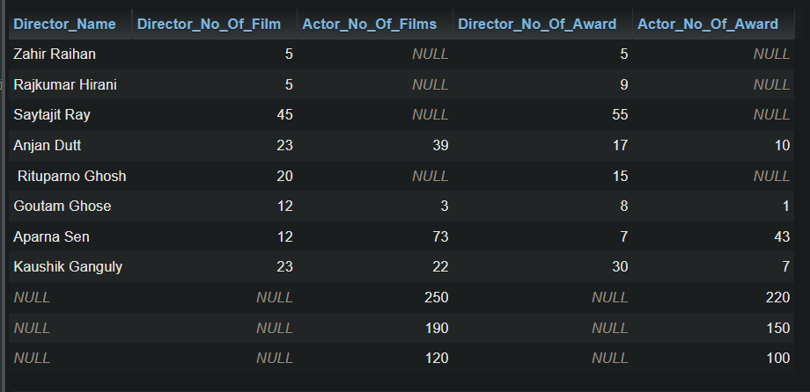

***Query-8:*** *Find the name, number of films and number of awards of those actors who never directed any film.*

***SQL:*** *SELECT Actor_Name,actor.No_Of_Films,actor.No_Of_Awards FROM actor WHERE actor.Person_ID NOT IN (SELECT Person_ID FROM director);*

***Output:***



***Query-9:*** *Find the name, IMDb rating and genre of those movies whose IMDb rating is above average.*

***SQL:*** *SELECT Movie_Name,IMDB_Rating,Genre FROM movie WHERE IMDB_Rating>(SELECT AVG(IMDB_Rating) FROM movie);*

*Output:*



***Query-10:*** *Among all the movie genres, find the highest average IMDb rating.*

***SQL:*** *SELECT Genre, MAX(avg_imdb) FROM (SELECT Genre, AVG(movie.IMDB_Rating) AS avg_imdb FROM movie GROUP BY movie.Genre) AS maxavimdb;*

*Or,*

*SELECT t.Genra,MAX(t.mi) FROM (SELECT Genra,AVG(IMDB_Rating) AS mi FROM movie GROUP BY Genra) AS t;*

***Ouput:***



