***Lab-5***

***Create movie_characters table :***

CREATE TABLE movie_characters (

Character_ID int(11) NOT NULL PRIMARY KEY,

Character_Name varchar(50) DEFAULT NULL,

Age int(11) DEFAULT NULL

);

***Data insert Query into movie_characters table:***

INSERT INTO movie_characters VALUES(1, 'Apu', 7),

INSERT INTO movie_characters VALUES(2, 'Durga', 10),

INSERT INTO movie_characters VALUES(3, 'Harihar', 42),

INSERT INTO movie_characters VALUES(4, 'Sarbajaya', 35),

INSERT INTO movie_characters VALUES(5, 'Ramesh', 28),

INSERT INTO movie_characters VALUES(6, 'Hemnalini', 25),

INSERT INTO movie_characters VALUES(7, 'Nalinaksha', 30),

INSERT INTO movie_characters VALUES(8, 'Kamala', 20),

INSERT INTO movie_characters VALUES(9, 'Shikha', 21),

INSERT INTO movie_characters VALUES(10, 'Apratim', 26),

INSERT INTO movie_characters VALUES (11, 'Feluda', 25),

INSERT INTO movie_characters VALUES (12, 'Maganlal Meghraj', 35),

INSERT INTO movie_characters VALUES (13, 'Jatayu', 45),

INSERT INTO movie_characters VALUES (14, 'Topshe', 18),

INSERT INTO movie_characters VALUES (15, 'Ruku', 6),

INSERT INTO movie_characters VALUES (16, 'Faruk', 22),

INSERT INTO movie_characters VALUES (17, 'Bithi', 19),

INSERT INTO movie_characters VALUES (18, 'Sathi', 24),

INSERT INTO movie_characters VALUES (19, 'Lalon', NULL),

INSERT INTO movie_characters VALUES (20, 'Kaluah', 25),

INSERT INTO movie_characters VALUES (21, 'Siraj Saain', 45),

INSERT INTO movie_characters VALUES (22, 'Komli', 25),

INSERT INTO movie_characters VALUES (23, 'Subir Banerjee', NULL),

INSERT INTO movie_characters VALUES (24, 'Ashima', 24),

INSERT INTO movie_characters VALUES (25, 'Rashmoni', NULL),

INSERT INTO movie_characters VALUES (26, 'Somalata', 24),

INSERT INTO movie_characters VALUES (27, 'Chaitali', 18),

INSERT INTO movie_characters VALUES (28, 'Byomkesh Bakshi', 26),

INSERT INTO movie_characters VALUES (29, 'Ait', 27),

INSERT INTO movie_characters VALUES (30, 'Malati', 16),

INSERT INTO movie_characters VALUES (31, 'Debkumar', 50),

INSERT INTO movie_characters VALUES (32, 'Doctor Anukul', 45),

INSERT INTO movie_characters VALUES (33, 'Prabhat', 27),

INSERT INTO movie_characters VALUES (34, 'Satyabati', 22),

INSERT INTO movie_characters VALUES (35, 'Anadi Babu', 55),

INSERT INTO movie_characters VALUES (36, 'PK', NULL),

INSERT INTO movie_characters VALUES (37, 'Jaggu', 26),

INSERT INTO movie_characters VALUES (38, 'Sarfaraz', 29),

INSERT INTO movie_characters VALUES (39, 'Tapasvi Maharaj', 50);

***Create movie_character_relationship Table:***

CREATE TABLE Movie_Character_Relationship (

Character_ID int NOT NULL,

Movie_ID int NOT NULL,

FOREIGN KEY (Character_ID) REFERENCES Movie_Characters(Character_ID),

FOREIGN KEY (Movie_ID) REFERENCES Movie(Movie_ID),

CONSTRAINT CombinePrimaryKey PRIMARY KEY (Character_ID, Movie_ID)

);

***Data insert Query into movie_character_relationship Table:***

INSERT INTO movie_character_relationship VALUES(1,1);

INSERT INTO movie_character_relationship VALUES(2 ,1);

INSERT INTO movie_character_relationship VALUES(3, 1);

INSERT INTO movie_character_relationship VALUES(4 ,1);

INSERT INTO movie_character_relationship VALUES(5 ,2);

INSERT INTO movie_character_relationship VALUES(6 ,2);

INSERT INTO movie_character_relationship VALUES(7, 2);

INSERT INTO movie_character_relationship VALUES(8 ,2);

INSERT INTO movie_character_relationship VALUES(9, 3);

INSERT INTO movie_character_relationship VALUES(10, 3);

INSERT INTO movie_character_relationship VALUES(11, 4);

INSERT INTO movie_character_relationship VALUES(12, 4);

INSERT INTO movie_character_relationship VALUES(13, 4);

INSERT INTO movie_character_relationship VALUES(14, 4);

INSERT INTO movie_character_relationship VALUES(15 ,4);

INSERT INTO movie_character_relationship VALUES(16 ,5);

INSERT INTO movie_character_relationship VALUES(17 ,5);

INSERT INTO movie_character_relationship VALUES(18 ,5);

INSERT INTO movie_character_relationship VALUES(19 ,6);

INSERT INTO movie_character_relationship VALUES(20 ,6);

INSERT INTO movie_character_relationship VALUES(21 ,6);

INSERT INTO movie_character_relationship VALUES(22 ,6);

INSERT INTO movie_character_relationship VALUES(23 ,7);

INSERT INTO movie_character_relationship VALUES(24 ,7);

INSERT INTO movie_character_relationship VALUES(25 ,8);

INSERT INTO movie_character_relationship VALUES(26 ,8);

INSERT INTO movie_character_relationship VALUES(27 ,8);

INSERT INTO movie_character_relationship VALUES(28 ,9);

INSERT INTO movie_character_relationship VALUES(28 ,10);

INSERT INTO movie_character_relationship VALUES(29 ,9);

INSERT INTO movie_character_relationship VALUES(29 ,10);

INSERT INTO movie_character_relationship VALUES(30 ,9);

INSERT INTO movie_character_relationship VALUES(31 ,9);

INSERT INTO movie_character_relationship VALUES(32 ,9);

INSERT INTO movie_character_relationship VALUES(33 ,10);

INSERT INTO movie_character_relationship VALUES(34 ,9);

INSERT INTO movie_character_relationship VALUES(34 ,10);

INSERT INTO movie_character_relationship VALUES(35 ,10);

INSERT INTO movie_character_relationship VALUES(36 ,11);

INSERT INTO movie_character_relationship VALUES(37 ,11);

INSERT INTO movie_character_relationship VALUES(38 ,11);

INSERT INTO movie_character_relationship VALUES(39 ,11);

***Level-1***

***Query-1:*** Find the name and age of all the movie-characters who are not teenagers.

***SQL:***

SELECT Character_Name,Age FROM movie_characters WHERE age>19 OR age<13;

***Output:***

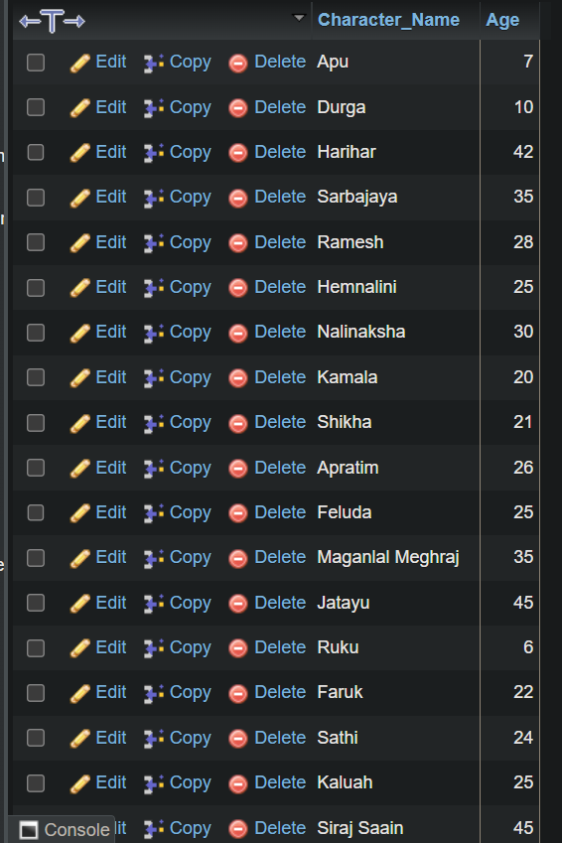

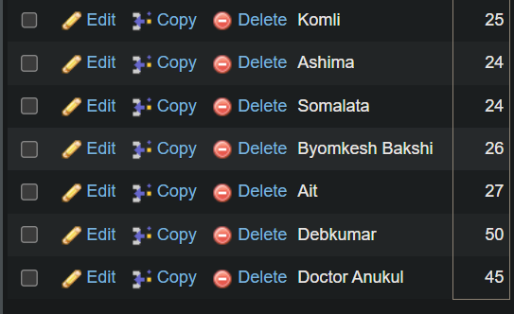

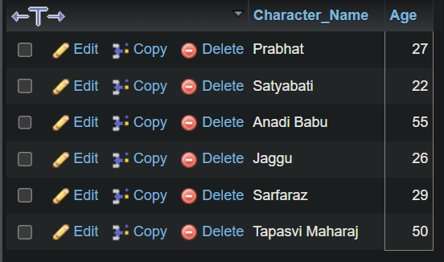

***Query-2:*** *Find the movie ID of all the movies and number of movie-characters in each movie.*

***SQL:***

**SELECT Movie_ID,COUNT(Movie_ID) AS No_Of_Character FROM movie_character_relationship GROUP BY Movie_ID;**

***Output:***

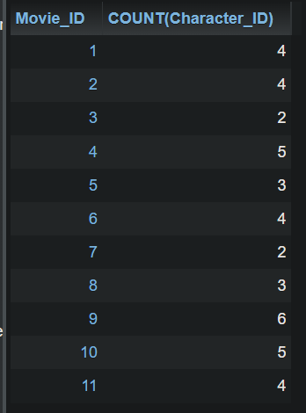

**Query-3*:*** *Find the movie name of all movies and the number of movie-characters in each movie.*

**SQL:**

*SELECT Movie_Name,COUNT(Character_ID) AS No_of_Characters FROM movie_character_relationship,movie WHERE movie.Movie_ID=movie_character_relationship.Movie_ID GROUP BY movie_character_relationship.Movie_ID;*

*OR,*

*SELECT Movie_Name, COUNT(Movie_ID) as No_Of_characters FROM movie_character_relationship JOIN movie USING (Movie_ID) GROUP BY Movie_ID;*

**Or,**

*SELECT Movie_Name,No_Of_character FROM (SELECT Movie_ID,COUNT(Movie_ID) AS No_Of_character FROM movie_character_relationship GROUP BY Movie_ID) AS character_relation, movie WHERE movie.Movie_ID=character_relation.Movie_ID;*

*Or,*

*SELECT Movie_Name, t.cn FROM (SELECT Movie_ID,COUNT(Character_ID) AS cn FROM movie_character_relationship GROUP by Movie_ID) AS t,movie WHERE t.Movie_ID=movie.Movie_Id;*

**Output:**

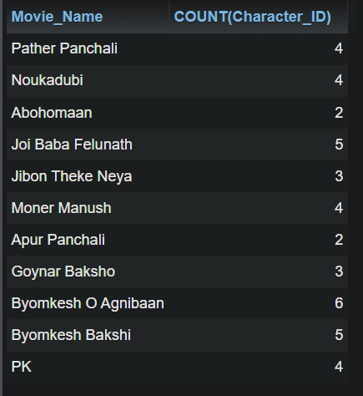

**Query-4:** *Find the name ,year of release, IMDB rating and the name of the director of all the movies that contain at least 12 characters ( including spaces) in their name.*

SELECT Movie_Name,Year,IMDB_Rating,Director_Name FROM movie,director WHERE movie.Director_ID=director.Person_ID AND Movie_Name LIKE '____________%';

Or,

SELECT Movie_Name,Year,IMDB_Rating,Director_Name FROM movie,director WHERE movie.Director_ID=director.Person_ID AND length(Movie_Name)>=12;

Or,

**SQL:** SELECT Movie_Name,Year,IMDB_Rating,Director_Name FROM movie join director WHERE movie.Director_ID=director.Person_ID AND length(Movie_Name)>=12;

**Output:**

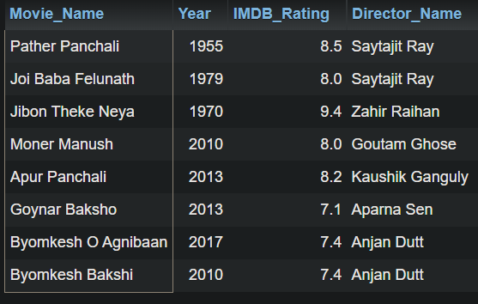

**Query-5:** *Find the name, year of release, IMDB rating and the name of the director of all the movies that contain at most 12 characters ( including spaces) in their name.*

**SQL:** SELECT Movie_Name,Year,IMDB_Rating,Director_Name FROM movie JOIN director WHERE movie.Director_ID=director.Person_ID AND length(Movie_Name)<=12;

**Output:**

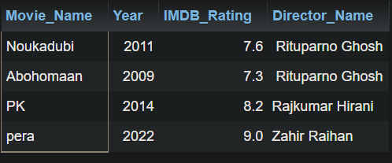

**Level-2**

**Q-1:** Find the name, year of release, IMDB rating of all the movies of Byomkesh (NB: A movie of Byomkesh may not contain the term Byomkesh in it’s name);

**Q-2: Find the name and age of all the characters from the movies of Feluda(N.B: A movie of Feluda may not contain the term ‘Feluda’ in its name).**

***Query 2.6:*** *Find the name, year of release, IMDB rating of all the movies of Byomkesh (NB: A movie of Byomkesh may not contain the term Byomkesh in it’s name);*

***SQL:*** *SELECT Movie_Name,Year,IMDB_Rating FROM movie_characters LEFT JOIN movie_character_relationship ON movie_characters.Character_ID=movie_character_relationship.Character_ID LEFT JOIN movie ON movie.Movie_ID=movie_character_relationship.Movie_ID WHERE Character_Name LIKE '%Byomkesh%';*

*OR,*

*SELECT Movie_Name,Year,IMDB_Rating FROM (SELECT Movie_ID FROM (SELECT Character_ID FROM movie_characters WHERE Character_Name LIKE '%Byomkesh%') AS char_id,movie_character_relationship WHERE char_id.Character_ID=movie_character_relationship.Character_ID)AS movie_char,movie WHERE movie.Movie_ID=movie_char.Movie_ID;*

*Or,*

*SELECT Movie_Name,Year,IMDB_Rating FROM (SELECT Movie_ID FROM (SELECT Character_ID FROM movie_characters WHERE Character_Name LIKE '%Byomkesh%') as t1,movie_character_relationship WHERE t1.Character_ID=movie_character_relationship.Character_ID) as t2,movie WHERE t2.Movie_ID=movie.Movie_Id;*

***Output:***

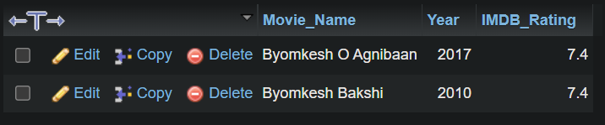

Query 2.7: Find the name and age of all the characters from the movies of Feluda.

SQL:

SELECT Character_Name,Age FROM (SELECT Character_ID FROM (SELECT Movie_ID FROM (SELECT Character_ID FROM movie_characters WHERE Character_Name ='Feluda') AS CHARACTERS,movie_character_relationship WHERE CHARACTERS.Character_ID=movie_character_relationship.Character_ID) AS MCR,movie_character_relationship WHERE MCR.Movie_ID=movie_character_relationship.Movie_ID) AS MC,movie_characters WHERE MC.Character_ID=movie_characters.Character_ID;

OR,

*SQL:* SELECT Character_Name, Age from (SELECT Movie.Movie_ID FROM Movie_Characters JOIN Movie_Character_Relationship ON Movie_Characters.Character_ID = Movie_Character_Relationship.Character_ID JOIN Movie ON Movie.Movie_Id = Movie_Character_Relationship.Movie_ID

WHERE Character_Name LIKE '%Feluda%') as MovieForCharacter JOIN Movie_Character_Relationship ON MovieForCharacter.Movie_ID = Movie_Character_Relationship.Movie_ID JOIN Movie_Characters ON Movie_Characters.Character_ID = Movie_Character_Relationship.Character_ID;

OR,

SELECT movie_characters.Character_Name,movie_characters.Age FROM movie_characters AS MC LEFT JOIN movie_character_relationship AS MCR ON MC.Character_ID=MCR.Character_ID LEFT JOIN movie_character_relationship AS MCR1 ON MCR.Movie_ID=MCR1.Movie_ID LEFT JOIN movie_characters ON MCR1.Character_ID=movie_characters.Character_ID WHERE movie_characters.Character_Name='Feluda';

*Output:*

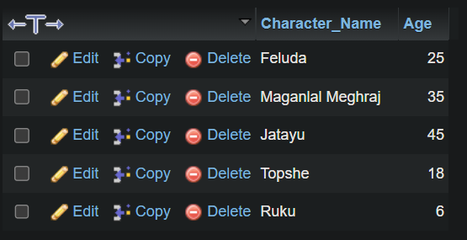

**Query 2.8:** Find the name and age of all the characters from the movies of Saytajit Ray.

**SQL:**

SELECT Character_Name,Age FROM director LEFT JOIN movie ON director.Person_ID=movie.Director_ID LEFT JOIN movie_character_relationship ON movie.Movie_ID=movie_character_relationship.Movie_ID LEFT JOIN movie_characters ON movie_character_relationship.Character_ID=movie_characters.Character_ID WHERE Director_Name LIKE '%Saytajit Ray%';

OR,

SELECT Character_Name,Age FROM (SELECT Character_ID FROM (SELECT Movie_ID FROM (SELECT Person_ID FROM director WHERE Director_Name LIKE '%Saytajit Ray%') AS DIRECTOR,movie WHERE director.Person_ID=movie.Director_ID) AS MOVIE,movie_character_relationship WHERE movie.Movie_ID=movie_character_relationship.Movie_ID) AS CHARACTERS,movie_characters WHERE CHARACTERS.Character_ID=movie_characters.Character_ID;

Or,

SELECT Character_Name,Age FROM (SELECT Character_ID FROM (SELECT Movie_ID FROM (SELECT Person_ID FROM director WHERE Director_Name LIKE '%Saytajit Ray%') as t1,movie WHERE movie.Person_ID=t1.Person_ID) as t2,movie_character_relationship WHERE t2.Movie_ID=movie_character_relationship.Movie_ID) as t3,movie_characters WHERE t3.Character_ID=movie_characters.Character_ID;

OUTPUT:

