1. Create view of movie natural join movie_character

SQL:

CREATE VIEW MovieCharacter AS (SELECT * FROM movie NATURAL JOIN Movie_Character);

Ouput:

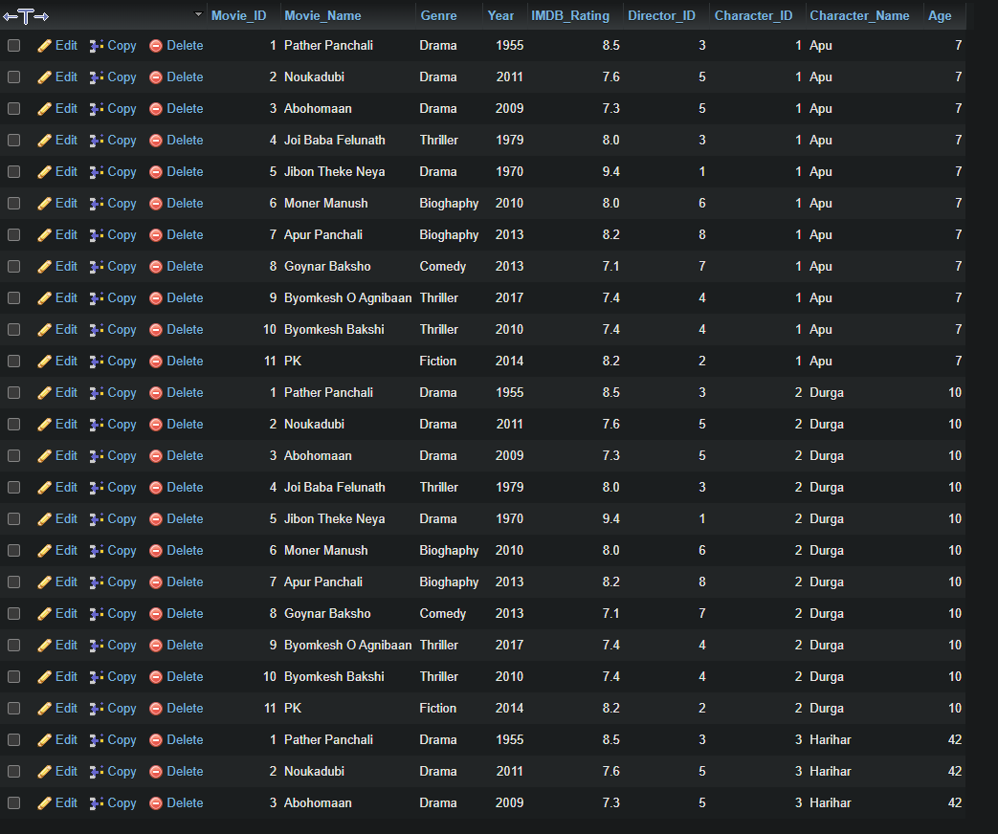

1. Create view of each genre and highest imdb rating in each genre

SQL:

CREATE VIEW MovieView AS (SELECT Genre,MAX(IMDB_Rating) FROM movie GROUP BY Genre);

Output:



Effect after insertion:

1. Create view From movie relation

SQL: CREATE VIEW Movies AS (SELECT * FROM movie);

Ouput:

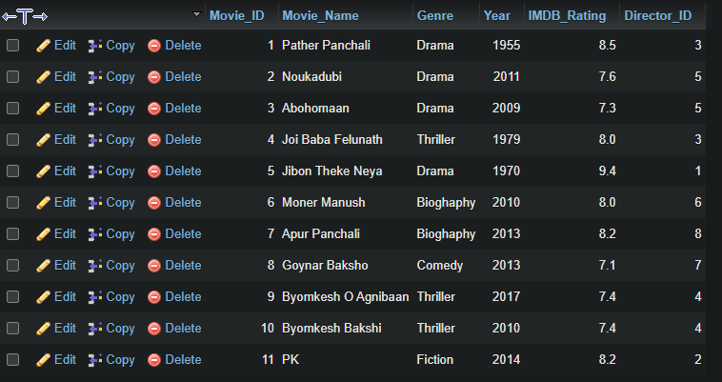

*** INSERT EFFECTS:

SQL: INSERT INTO movie VALUES(12,'pera','Thriller',2022,9.0,1);

Output:

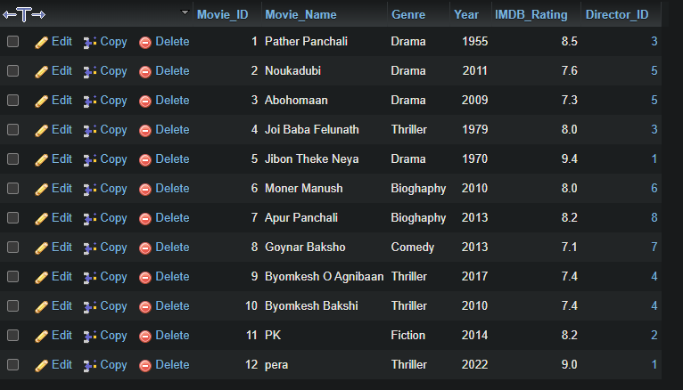

Effect of movie_character view after insert into movie relation:

**Effect on movies view:**

SQL: INSERT INTO movies (Movie_ID,Movie_Name) VALUES (13,'shantiiiiiii');

Output:

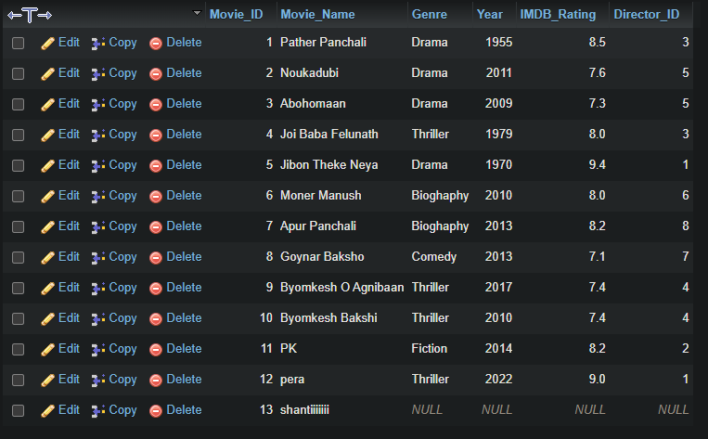

**Effects on movie:**

