1.1 Create Movie info database
SQL:

CREATE DATABASE Movie_Info;

1.2 Create director table
SQL:

CREATE TABLE Director (
Person_Id int PRIMARY KEY,
Director_Name varchar(200) NOT NULL,
Birth_Year int NOT NULL,
No_Of_Films int NOT NULL,
No_Of_Awards int NOT NULL
);

1.3 Data Entry
SQL:

INSERT INTO Director (
Person_ID,
Director_Name,
Birth_Year,
No_Of_Films,
No_Of_Awards
) VALUES (
1,
'Zahir Raihan',
1935,
5,
5
);

INSERT INTO Director (Person_Id, Director_Name, Birth_Year, No_Of_Films, No_Of_Awards)
VALUES
(6, 'Goutam Ghose', 1950, 12, 8),
(7, 'Aparna Sen', 1945, 12, 7),
(8, 'Kaushik Ganguly', 1968, 23, 30);

1.4 Create Movie table
SQL:

CREATE TABLE Movie (
Movie_Id int PRIMARY KEY,
Movie_Name varchar(200) NOT NULL,
Genra varchar(100) NOT NULL,
Year int NOT NULL,
IMDB_Rating float,
FOREIGN KEY (Director_Id) REFERENCES Director (Person_Id)
);

1.5 Insert movie data
SQL:

2.1 Create Actor Table
SQL:

CREATE TABLE Actor(
Person_ID int PRIMARY KEY,
Actor_Name varchar(200),
Birth_Year int NOT NULL,
No_Of_Films int NOT NULL,
No_Of_Awards int
);
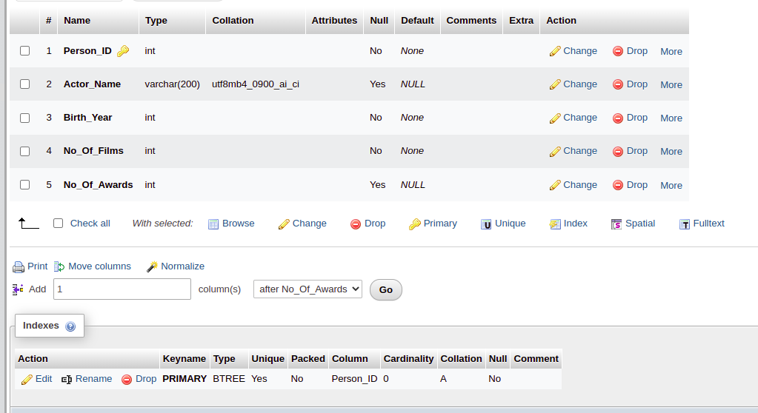

2.1 Insert Data to Actor Table
SQL:

INSERT INTO Actor (
Person_ID,
Actor_Name,
Birth_Year,
No_Of_Films,
No_Of_Awards
)
VALUES
(11, 'Uttam Kumar', 1926, 190, 150),
(12, 'Razzak', 1942, 120, 100),
(7, 'Aparna Sen', 1945, 73, 43),
(6, 'Goutam Ghose', 1950, 3, 1),
(8, 'Kaushik Ganguly', 1968, 22, 7),
(10, 'Soumitra Chatterjee', 1935, 250, 220),
(4, 'Anjan Dutt', 1953, 39, 10);

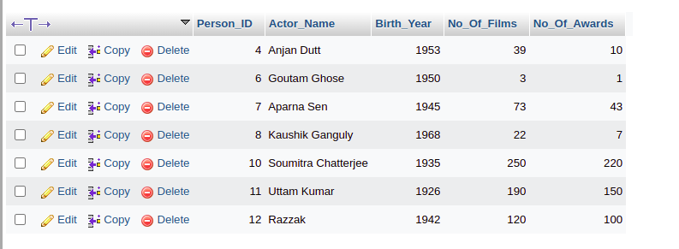

Question 2.1.1 : Find the name, genre, IMDb Rating and release year of all the movies.

SQL:

SELECT Movie_Name, Genre, IMDB_Rating, Year FROM Movie;

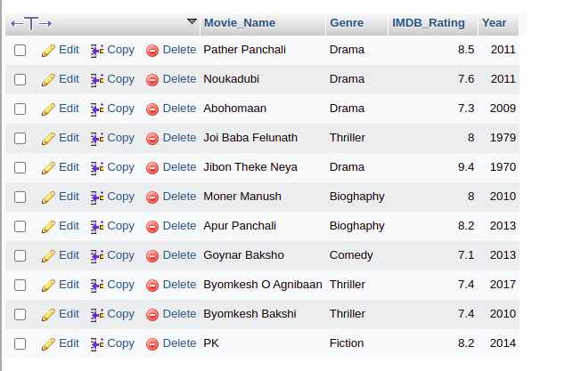

Question 2.1.2: Display all the distinct movie-genres
SQL:

SELECT DISTINCT Genre FROM Movie;



Question 2.1.3: Find the name and the current age of all the actors
SQL:

SELECT Actor_Name, 2022 - Birth_Year as Age from Actor;

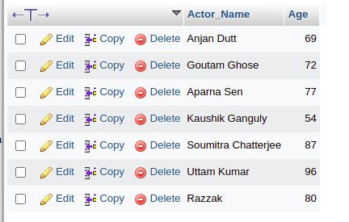

Question 2.1.4: Find the name, IMDb rating and the name of director of all the movies.

SQL:
SELECT Movie_Name, IMDB_Rating, Director_Name from Movie LEFT JOIN Director ON Movie.Director_Id = Director.Person_Id;

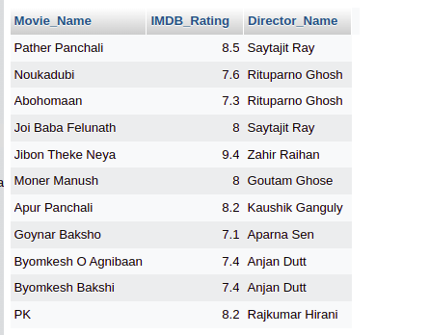

Question 2.1.5: Find the name, IMDb rating, release year and the director name of all the movies of drama genre whose IMDb rating is greater than or equal to 8.0.

SQL:

SELECT Movie_Name, IMDB_Rating, Year, Director_Name FROM Movie, Director WHERE Movie.Director_Id = Director.Person_Id AND Movie.Genre = 'Drama' AND Movie.IMDB_Rating >= 8.0;

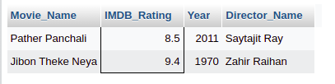

Question 2.1.6: Find the name and genre of all the movies that contain an ‘A’ or a ‘J’ as the 1st character of its name.

SQL:

SELECT Movie_Name, Genre FROM Movie WHERE Movie_Name LIKE 'A%' OR Movie_Name LIKE 'J%';

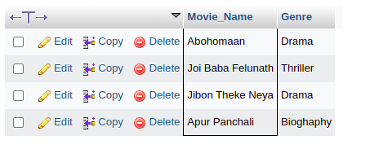

Question 2.1.7: Find the name and the number of awards of those directors whose name contains an ‘a’ as its 2nd character.

SQL:
SELECT Director_Name, No_Of_Awards FROM Director WHERE Director_Name LIKE '_a%';

Question 2.1.8: Find the name, genre and release year of all the movies that contain the term ‘Byomkesh’ in anywhere of its name.

SQL:
SELECT Movie_Name, Genre, Year FROM Movie WHERE Movie_Name LIKE '%Byomkesh%';

Question 2.1.9: Find the name and IMDb rating of those movies whose name consists of only 2 characters.
SQL:
SELECT Movie_Name, IMDB_Rating FROM Movie WHERE Movie_Name LIKE '__';

Question 2.1.10: Find the name, genre and IMDb rating of all the movies that contain at least 3 characters in its name.
SQL:
SELECT Movie_Name, Genre, IMDB_Rating FROM Movie WHERE Movie_Name LIKE '___%';

Question 2.1.final: Find the name, IMDb rating and the name of the directors of all the moves that contain at most 10 characters in its name.

SQL:
SELECT Movie_Name, Genre, IMDB_Rating FROM Movie WHERE Movie_Name NOT LIKE '___________%';

Lab 3:

Problem 1.1: Display all the movies according to the IMDb rating (in descending order); if multiple movies have same IMDb rating then rearrange those movies alphabetically according to the movie-name.

SQL:
SELECT Movie_Name, IMDB_Rating FROM Movie ORDER BY IMDB_Rating DESC, Movie_Name ASC

Output:

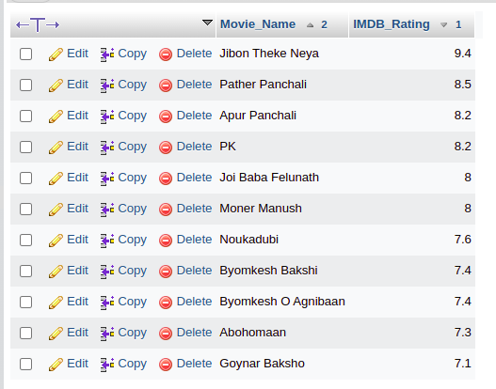

Question 1.2: Find the total number of movies in the DB.

SQL:
SELECT COUNT(Movie_Id) AS Total_Movie FROM Movie

Question 1.3: Find how many movie-genres are there in the DB.

SQL:
SELECT COUNT( DISTINCT Genre) AS TotalGenre FROM Movie;

Question 1.4: Find the average IMDb rating of all the movies of drama genre.

SQL:
SELECT AVG(IMDB_Rating) FROM Movie WHERE Genre = 'Drama'

Question 1.5: Find total number of movies in each genre.

SQL:
SELECT Genre, COUNT(Movie_Id) AS NumberOfMovies FROM Movie GROUP BY Genre;

Question 2.1: Find the name and the current age of all the actors and directors.

SQL:
(SELECT Actor_Name as Name, 2022 - Birth_Year AS Age FROM Actor) UNION (SELECT Director_Name as Name, 2022 - Birth_Year AS Age FROM Director);

Question 2.2: Find the name, birth year , number of awards as an actor and the number of awards as a director of those actors who directed at least one movie of those directors who acted in at least one movie.

SQL:
SELECT Director.Director_Name AS Name, Director.Birth_Year, Director.No_Of_Awards from Director, Actor WHERE Director.Person_ID = Actor.Person_ID;

Question 2.3: Find the name, genre, IMDb rating and the name of the director of all the movies directed by Satyajit Ray, Zahir Raihan, Riporno Ghosh and Kaushik Ganguly.

SQL:
SELECT Movie.Movie_Name, Movie.Genre, Movie.IMDB_Rating, Director.Director_Name from Movie NATURAL JOIN Director WHERE Director.Person_ID = Movie.Director_Id AND Director_Name in ('Saytajit Ray', 'Zahir Raihan', 'Rituparno Ghosh', 'Kaushik Ganguly');

Question 2.4: Find the number of movies directed by a director in average.

SQL:
SELECT AVG(No_Of_Films) AS AverageFilms from Director;

Question 2.5: Find the name of all the directors and the number of movies directed by each director considering there exists no No of Films column in the director table.

SQL:
SELECT Director.Director_Name, COUNT( Movie.Director_Id) AS No_Of_Films from Director NATURAL JOIN Movie WHERE Director.Person_ID = Movie.Director_Id GROUP BY Director.Person_ID;

Lab 4:

Query 1.1: Display the name, IMDb rating and genre of all the movies with an IMDB rating greater than than or equal to 8.0

SQL:

Query 1.2:

SQL:
SELECT Genre, COUNT(Movie_ID) Number_Of_Movies from Movie WHERE IMDB_Rating >= 8.0 GROUP BY Genre;

Query 1.3:

SQL:
SELECT Genre, COUNT(IMDB_Rating) from Movie GROUP BY Genre HAVING AVG(IMDB_Rating) >= 7.5;

Query 1.4:

SQL:
SELECT Director_Name, No_Of_Films, No_Of_Awards from Director WHERE No_Of_Films = (SELECT MAX(No_Of_Films) from Director);

Query 1.5:

SQL:
SELECT Actor_Name, (Year(CURRENT_DATE) - Birth_Year) as Age, No_Of_Films, No_Of_Awards from Actor where Birth_Year = (SELECT MAX(Birth_Year) from Actor);

Label 2:

Query 2.1: Find the name, number of films as a director, number of films as an actor, number of awards as a director and number of awards as an actor of all the directors(If a director never acted in any film then number of films and number of awards as an actor will be null).

SQL:
SELECT D.Director_Name AS Name, D.No_Of_Films AS Director_No_Of_Films, A.No_Of_Films AS Actor_No_Of_Films, D.No_Of_Awards AS Director_No_Of_Awards, A.No_Of_Awards AS Actor_No_Of_Awards FROM Director AS D LEFT OUTER JOIN Actor AS A USING (Person_ID);

Query 2.2: Find the name, number of films as a director, number of films as an actor, number of awards as a director and number of awards as an actor of all the actor and directors.

SQL:
(SELECT D.Director_Name AS Name, D.No_Of_Films AS Director_No_Of_Films, A.No_Of_Films AS Actor_No_Of_Films, D.No_Of_Awards AS Director_No_Of_Awards, A.No_Of_Awards AS Actor_No_Of_Awards FROM Director AS D LEFT OUTER JOIN Actor AS A USING (Person_ID)) UNION (SELECT A.Actor_Name AS Name, D.No_Of_Films AS Director_No_Of_Films, A.No_Of_Films AS Actor_No_Of_Films, D.No_Of_Awards AS Director_No_Of_Awards, A.No_Of_Awards AS Actor_No_Of_Awards FROM Director AS D RIGHT OUTER JOIN Actor AS A USING (Person_ID));

Query 2.3: Find the name, number of films and number of awards of those actors who never directed any film.

SQL:
SELECT Actor_Name, No_Of_Films, No_Of_Awards FROM Actor WHERE Person_ID NOT IN (SELECT Person_ID FROM Director);

Query 2.4: Find the name, IMDb rating and genre of those movies whose IMDb Rating is above average.

SQL:
SELECT Movie_Name, Genre, IMDB_Rating FROM Movie WHERE IMDB_Rating > (SELECT AVG(IMDB_Rating) FROM Movie);

Query 2.5: Among all the movie genres, find the highest average IMDb rating.

SQL:
SELECT MAX(Avg_IMDB_Rating) FROM (SELECT Genre, AVG(IMDB_Rating) AS Avg_IMDB_Rating FROM Movie GROUP BY Genre) AS Avg_Genre ;

Lab: 5

Query 4.1: Find the name and age of all the movie characters who are not teenagers.

SQL:
SELECT Character_Name, Age FROM `Movie_Characters` WHERE Age > 19 OR Age < 13

Query 4.2: Find the movie ID of all the movies and the number of movie characters in each movie.

SQL:
SELECT Movie_ID, count(Movie_ID) AS CharacterCount FROM `Movie_Character_Relationship` GROUP BY Movie_ID;

Query 4.3: Find the movie name of all movies and the number of movie-characters in each movie.

SQL:
SELECT Movie.Movie_Name, CharacterCount FROM (SELECT Movie_ID, count(Movie_ID) AS CharacterCount FROM `Movie_Character_Relationship` GROUP BY Movie_ID) AS RelationTable, Movie WHERE Movie.Movie_Id = RelationTable.Movie_ID ;

Query 4.4: Find the name year of release IMDB rating and the name of the director of all the movies that contain at least 12 characters ( including spaces) in their name.

SQL:
SELECT Movie_Name, Year, IMDB_Rating FROM Movie JOIN Director WHERE Movie.Director_Id = Director.Person_ID AND length(Movie_Name) >=12;

Query 4.5: Find the name year of release IMDB rating and the name of the director of all the movies that contain at most 12 characters ( including spaces) in their name.

SQL:
SELECT Movie_Name, Year, IMDB_Rating FROM Movie JOIN Director WHERE Movie.Director_Id = Director.Person_ID AND length(Movie_Name) <=12;

Query 2.6: Find the name, year of release, IMDB rating of all the movies of Byomkesh (NB: A movie of Byomkesh may not contain the term Byomkesh in it’s name);

SQL:
SELECT Movie_Name, Year, IMDB_Rating FROM Movie_Characters LEFT OUTER JOIN Movie_Character_Relationship ON Movie_Characters.Character_ID = Movie_Character_Relationship.Character_ID LEFT OUTER JOIN Movie ON Movie.Movie_Id = Movie_Character_Relationship.Movie_ID
WHERE Character_Name LIKE '%Byomkesh%';

Query 2.7: Find the name and age of all the characters from the movies of Feluda

SQL:
SELECT Character_Name, Age from (SELECT Movie.Movie_ID FROM Movie_Characters JOIN Movie_Character_Relationship ON Movie_Characters.Character_ID = Movie_Character_Relationship.Character_ID JOIN Movie ON Movie.Movie_Id = Movie_Character_Relationship.Movie_ID
WHERE Character_Name LIKE '%Feluda%') as MovieForCharacter JOIN Movie_Character_Relationship ON MovieForCharacter.Movie_ID = Movie_Character_Relationship.Movie_ID JOIN Movie_Characters ON Movie_Characters.Character_ID = Movie_Character_Relationship.Character_ID;

