**Heaven’s Light is Our Guide**



**Computer Science And Engineering**

**Rajshahi University of Engineering and Technology**

**Course No: CSE3202**

**Course Title: Operating system**

**Date of Submission: 12-12-22**

|  |  |
| --- | --- |
| **Submitted To** | **Submitted By** |
| **Mohiuddin Ahmed**  **Lecturer,**  **Department Of Computer Science And Engineering**  **Rajshahi University Of Engineering And Technology** | **Nazmul Haque**  **Roll: 1803109**  **Section: B**  **Department Of Computer Science And Engineering**  **Rajshahi University Of Engineering And Technology** |

**Problem-1:** Basic fork() operation and verify using child and parent id.

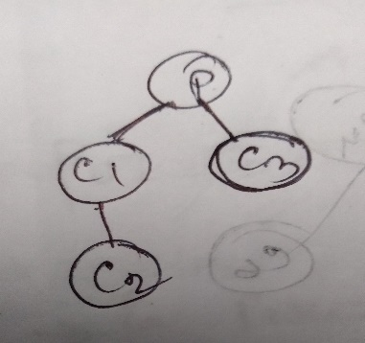

**Theory:**

fork() function create a duplicate under the portion of this function. if we print ‘hello world’ under a fork() function then first ‘hello world’ will be print for it’s main program and another ‘hello world’ will be print for duplicate portion of main code.

**1. Code:**

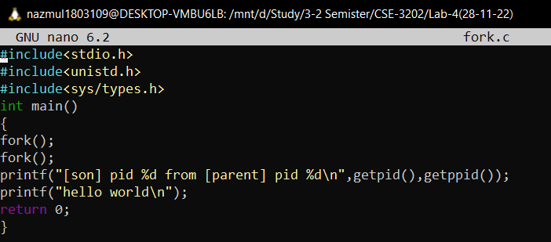

**Input and output:**

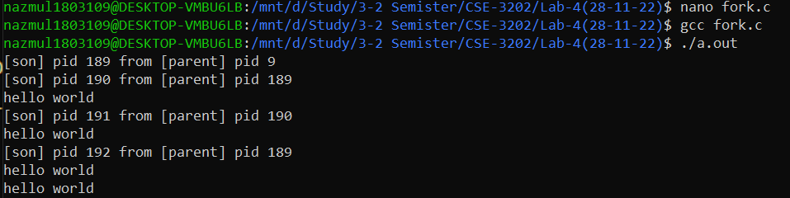

**Problem-2:**

**implement this problem using fork() function and verify using child and parent id.**

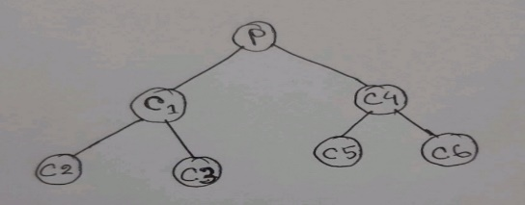

**Theory:**

Using getpid() function we can find out the id of child process and id of the parent process can be find out using getppid() function. To run program in backend I use ./a.out & command. Using pstree -p -s $BASHPID command we can show the tree representation of child parent process id . to show this tree representation we need to use sleep() function.

**2. Code:**

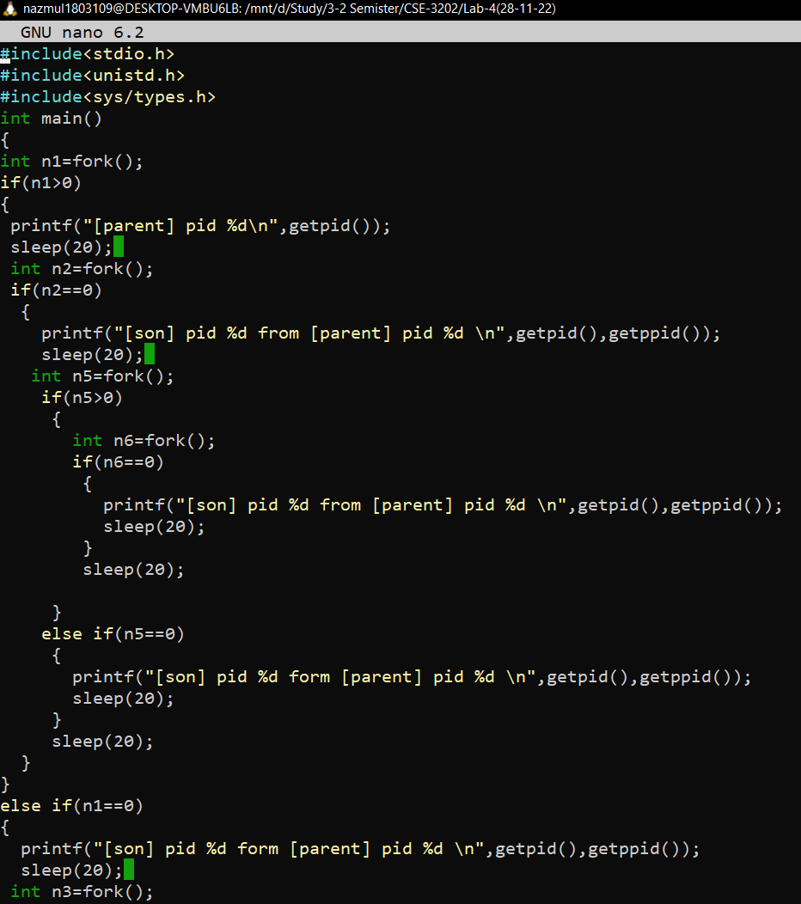

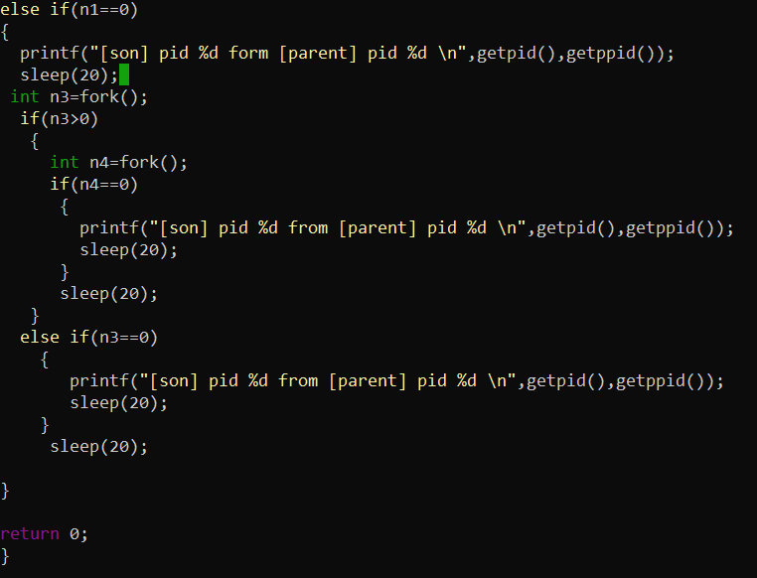

**Input And Output:**

Input output when taking sleep with 10 s.

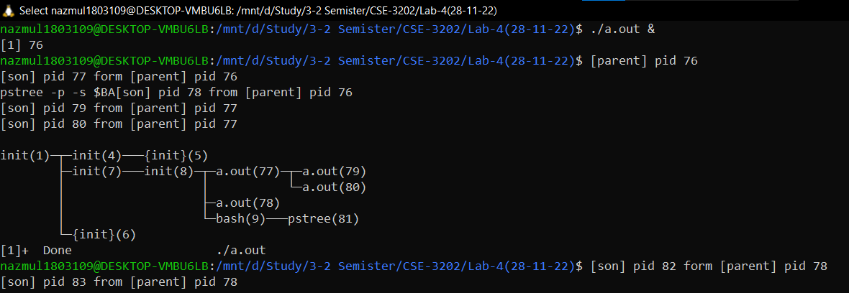

Input output when taking sleep with 20 s.

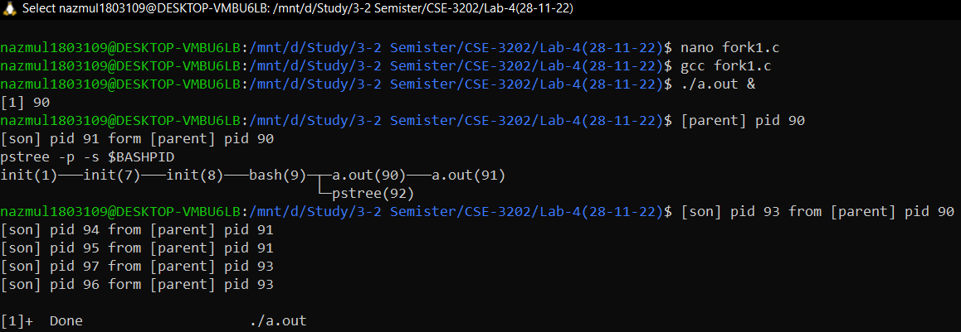

**Discussion:**

The above two codes run successfully except tree representation. Though, I use sleep function with 10s at first attempt then at second attempt take sleep function with 20s.But don’t show proper tree representation of child ,parent process id. Although show correct child, parent process id.