**Heaven’s Light is Our Guide**



**Computer Science And Engineering**

**Rajshahi University of Engineering and Technology**

**Course No: CSE3102**

**Course Title: Operating system**

**Date of Submission: 17-10-22**

|  |  |
| --- | --- |
| **Submitted To** | **Submitted By** |
| **Mohiuddin Ahmed**  **Lecturer,**  **Department Of Computer Science And Engineering**  **Rajshahi University Of Engineering And Technology** | **Nazmul Haque**  **Roll: 1803109**  **Section: B**  **Department Of Computer Science And Engineering**  **Rajshahi University Of Engineering And Technology** |

**1.1 Experiment No :** 01

**1.2 Experiment Name:** History of linux and shell coding with important commands.

**1.3 Theory:**

Fisrt and foremost , linux is an operating system. An operating system is simply a collection of software that manages hardware resources and provides an environment where applications can run. The operating system allows applications to store information,send documents to printers,interact with users and other things.

Linux was created by linus Torvalds when he was a student at the university of Helsinki,studying computer science. In early 1991 he purchased an IBM-compatible personal computer that came with the MS-DOS operating system. Linus wasn’t satisfied with MS-DOS and wanted to use UNIX operating system like he was accustomed to at the university. When he set out to obtain a copy of UNIX for his personal use, he found that the least expensive UNIX he could buy was about $5,000 USD. Driven by the desire to run a UNIX-like operating system on his personal computer,he set out to create Linux. Linus and over 100 developers worked on Linux over the next couple of years and in March 1994, version 1.0 of the Linux kernel was released.

Linux is open source software. This means that anyone can use,copy, study and change the software in any way they chose so long as the source code is openly shared with others. To date, thousands of people have made improvements to Linux. With Linux being free and open source software,it has led to the rise of Linux distributions. In every case, the source code is free, but in some cases,the distribution is not free- the binaries ,the compiled code is not free. For example, you have to pay a license in order to run Red Hat Enterprise Linux. However, Red Hat release their source code for anyone to download.

**Linux shell coding:**

A shell is pecial user program which provide an interface to user to use operating system services. Shell accept human readable commands from user and convert them into something which kernel can understand. It is a command language interpreter that execute commands read from input devices such as keyboards or from files. The shell gets started when the user logs in or start the terminal. Such as shell command are ls -al, cd, touch, mkdir etc.

**\*Commands:**

**1.Clear:** this command use for clearing screen.



**2. cd:** i) This command use for change directory. Here directory means folder.



Here d means D-drive. Now present directory is D-drive

Ii) we can access a folder( such as: study) in d-drive using cd.



iii) if the folder name contains space then need to write that folder name in double quotation or write back-slash(\) and each word separated by space.



Or,

Note : cd .. : using this command we can go back to previous folder/directory.



**3. pwd:** This command used for showing the present/current working directory/folder.



**4. touch :** This command use for creating new file in present working directory/folder.



**5. ls -al :** using this command we can show all folder and file under the present working directory/folder.

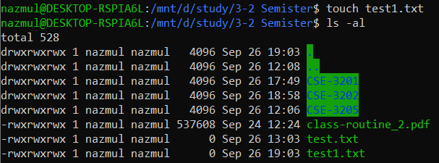

**6. write in file :** To write something in file we need to use two editor (such as: nano,vim). At first we need to write nano file_name . after press enter open a new window and write something in that window.

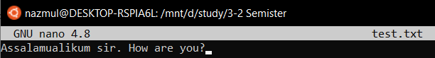

If we want to return back to terminal we must press ctrl+x and need to choose yes or no option. In this case we choose yes option.



**7. cat :** If we want to show the text which is remain in the file we must use ‘cat file_name’ command.



**8. rm :** This command is used to remove a file under particular directory/folder.

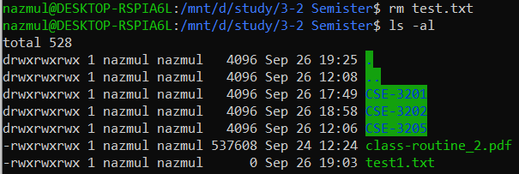

After pressing enter that file will be removed. For confermation we use ls -al command. We can see that that file is missing .

**9. mkdir :** To create a directory under a particular directory we can use this command.

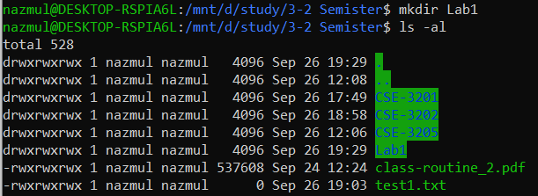

Press enter and to see the change we use ‘ls -al’ command. We see that Lab1 directory is created.

**10. Remove Folder :** To removing a particular folder we need to go to it’s parent folder/directory. Then use ‘rm -R folder_name’ this command for removing that particular folder.

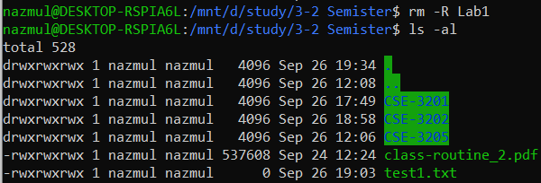

Using ‘ls -al’ command we can see that changes.

**11. Permission :**



d = directory , r = read , w = write , x = execute

after d first rwx represents user permission. Second rwx represents the permission of rest of group members and third rwx represents the permission of outside of the group members. Here syntax of a new line is : nazmul is root then 4096 , current date and time then folder/directory, file namesu.

If user permission is : rwx , then other group members and outside of the group members get a permission for only read. There is a short form for user, group and others.

user=u, group = g, others = o

**12. chmod :** We can change the user permission using this command. In wsl we can not change permission for user directly. So we need follow some instruction. That instruction are given bellow.







After exit wsl we need to restart the system. Then we can change the permission for user.

**1.4 Discussion:**

In previous lab, some simple commands were run . such as change directory (cd), return previous directory(cd ..), make file under a directory(using touch), make directory/folder(using mkdir), remove directory(using rm ) and change permission of a directory. All of the above commands run successfully in wsl. But permission changing command is not work successfully, though follow the commands which is given in shell coding documents.