**Heaven’s Light is Our Guide**



**Computer Science And Engineering**

**Rajshahi University of Engineering and Technology**

**Course No: CSE3206**

**Course Title: Computer Network**

**Date of Submission: 17-12-22**

|  |  |
| --- | --- |
| **Submitted To** | **Submitted By** |
| **Tasmia Jannat**  **Lecturer,**  **Department Of Computer Science And Engineering**  **Rajshahi University Of Engineering And Technology** | **Nazmul Haque**  **Roll: 1803109**  **Section: B**  **Department Of Computer Science And Engineering**  **Rajshahi University Of Engineering And Technology** |

1. **last octate of the IP address of “Name PC” is the last 3 digits of my roll number (Static Host)**

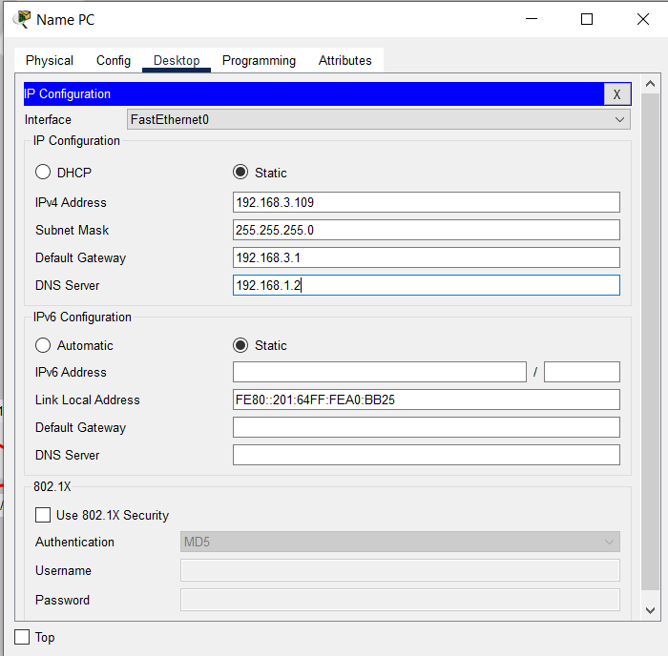

1. **Use Dynamic Routing for the connection:**

**Router0:**

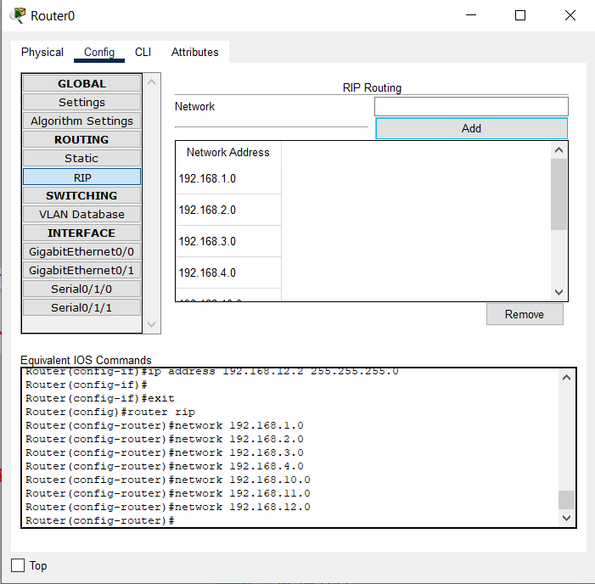

**Router1:**

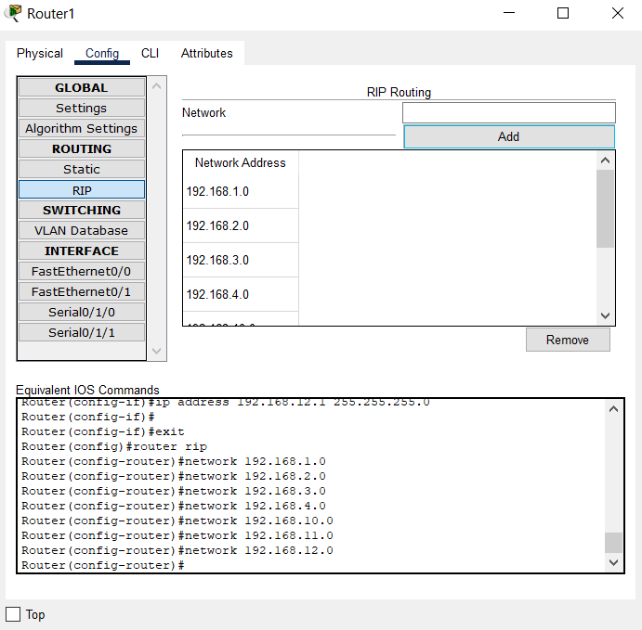

**Router2:**

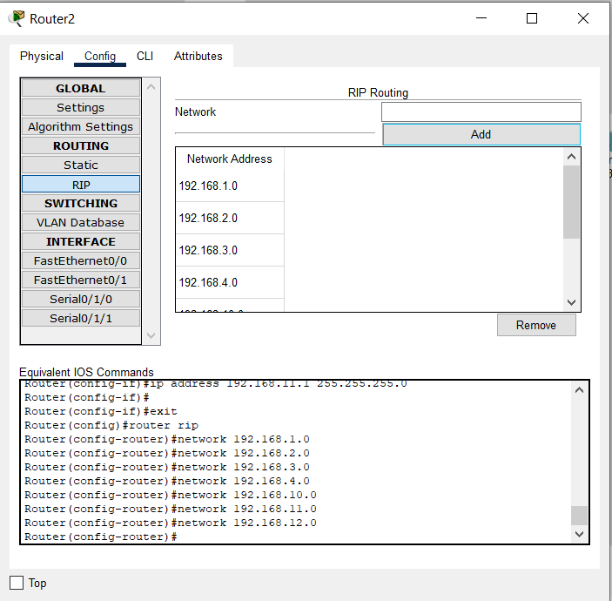

**3.Assign the DNS name to “Name PC” as my Name.**

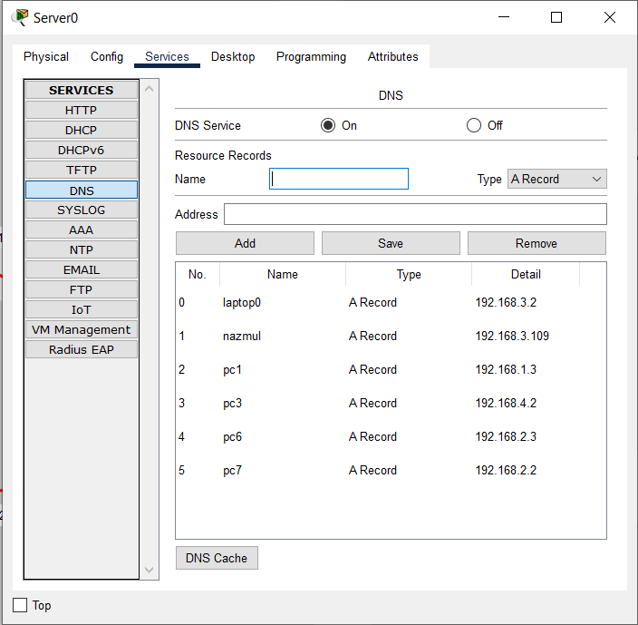

**i)Finding Nazmul pc from laptop0(DNS) :**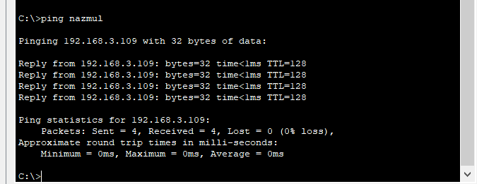

**ii) Finding nazmul pc from pc3(DNS) :**

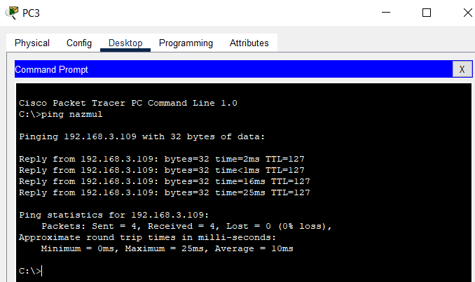

1. **Assign IP addresses to all the host by DHCP except “Name PC”.**

**Router0:**

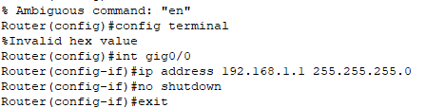

Router0(gig0/0):

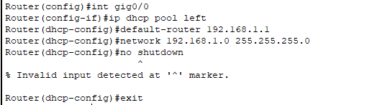

**Router1(Fa0/0):**

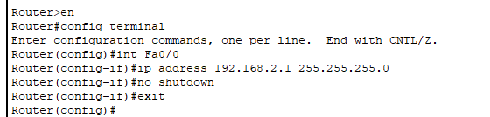

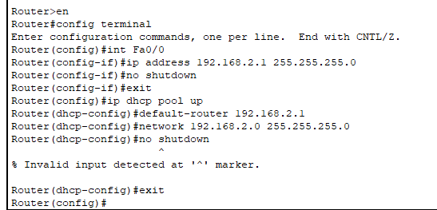

**For generating ip for different network from server:**

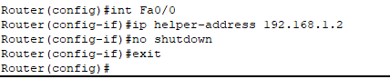

**Router2(Fa0/1):**

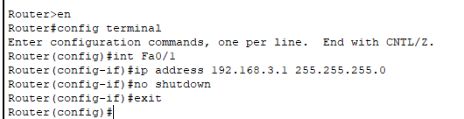

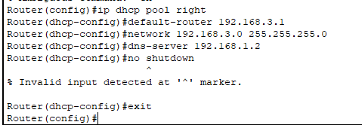

**Router2(Fa0/0):**

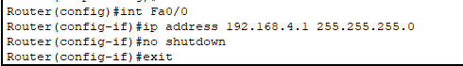

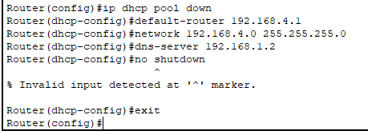

**Discussion:** All connections work successfully. I attached that screenshot below:

