

**Project Report**

**Project Name: Password based door lock system using 8051**

**Course Name: Microprocessor Interfacing & Embedded System**

**Course Code: CSE 331**

**Submitted To**

**Mohammad Sakib Mahmud**

**Section: 9**

**Group Members**

**1. Samiha Samsi – 1610652042**

**2. Anusha Mehrin- 1621451042**

**3. Taufiq Ahmed Noor- 1712141642**

**4. Nazmul Haque- 1712766642**

## 

## **Objective**

**Our goal is to provide a password based door lock system by using the 8051 MCU. This will replace the traditional and mechanical lock and key system. Password based door lock system is a more advanced technique, but at the same time it’s simple. It’s highly efficient and is revolutionary in the field of security system. Password based door lock system is way more secure than the traditional one as the chances of getting invaded is lowered due to high efficiency. Only the people who are given access to will be able to pass the security system, which decreases the risk of burglary and other crimes.**

# **Applications**

**The applications are as follows:**

* **This security system can be used at houses, offices and shops to restrict entry.**
* **This can also be used at bank vaults to strengthen the security.**
* **The password based door lock system can be used at museum and art galleries to prevent burglary.**

# **Block Diagram**

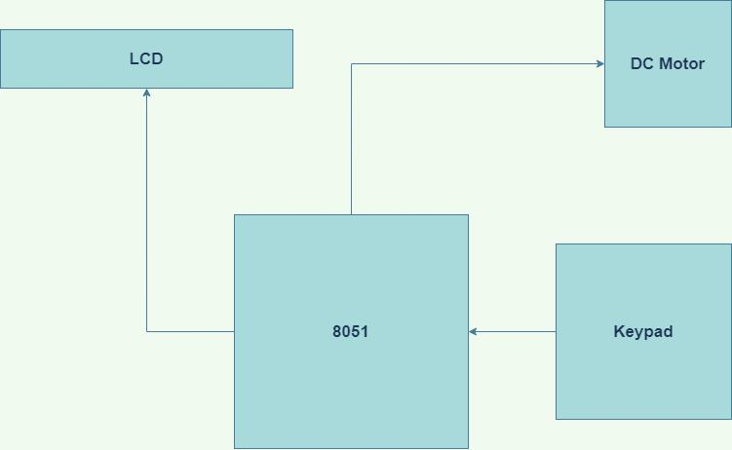

# **Required Components**

* **AT89C51 Microcontroller**
* **DC Motor**
* **3x4Numeric Keypad**
* **20x2 LCD Display**

# **Working Procedure**

* **AT89C51 microcontroller’s pin configuration were studied**
* **AT89C51 Microcontroller was prepared for component connection**
* **P1.0 to P1.6 ports are assigned for keypad I/O**
* **P1.0 to P1.3 ports are assigned to the row connections of the keypad (A,B,C,D)**
* **P1.4 to P1.6 ports are assigned to the columns connections of the keypad (1,2,3)**
* **P2.0 to P2.7 ports are assigned to the data bits of LCD display (D0 to D7)**
* **P3.0 to P3.2 ports are assigned to the control bits of LCD display (RS, RW, EN)**
* **P3.3 & P3.4 ports are assigned to the DC Motor (In & Out)**
* **A C program is built which maps the corresponding bits to variables for I/O, sets up an algorithm to match preset and user-entered passwords and configure the display to prompt user for the password and give out appropriate user feedback**
* **The code file is converted into a HEX file for Proteus simulation deployment**
* **HEX is injected to the simulation and executed**

# Image of Schematic Circuit :

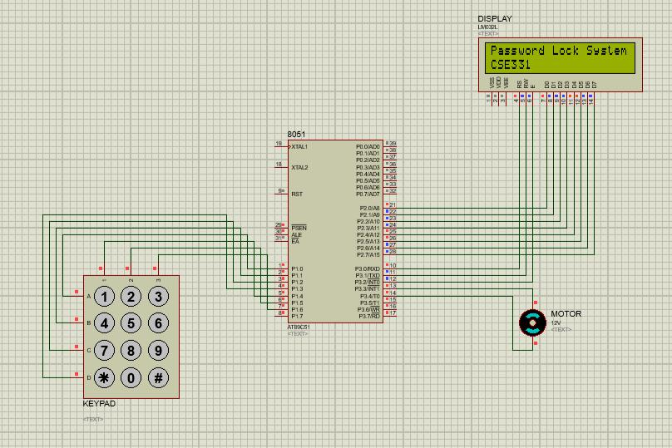

# Code

**#include<reg51.h>**

**sbit r1=P1^0;**

**sbit r2=P1^1;**

**sbit r3=P1^2;**

**sbit r4=P1^3;**

**sbit c1=P1^4;**

**sbit c2=P1^5;**

**sbit c3=P1^6;**

**sbit rs=P3^0;**

**sbit rw=P3^1;**

**sbit en=P3^2;**

**sbit motp=P3^3;**

**sbit motn=P3^4;**

**void lcdcmd(unsigned char);**

**void lcddat(unsigned char);**

**void lcddis(unsigned char *, unsigned char);**

**void delay();**

**void check();**

**unsigned char pwd[10];**

**void main()**

**{**

**unsigned int x;**

**unsigned int d;**

**lcdcmd(0x38);**

**lcdcmd(0x01);**

**lcdcmd(0x10);**

**lcdcmd(0x0c);**

**lcdcmd(0x80);**

**lcddis("Password Lock System", 20);**

**lcdcmd(0xc0);**

**lcddis("CSE331", 6);**

**lcdcmd(0x01);**

**lcddis("Enter the password", 18);**

**lcdcmd(0xc0);**

**while(1)**

**{**

**r1=0;**

**if(c1==0)**

**{**

**pwd[x]='1';**

**for(d=1;d<8;d++)**

**{**

**delay();**

**}**

**lcddat('*');**

**x=x+1;**

**}**

**if(c2==0)**

**{**

**pwd[x]='2';**

**for(d=1;d<8;d++)**

**{**

**delay();**

**}**

**lcddat('*');**

**x=x+1;**

**}**

**if(c3==0)**

**{**

**pwd[x]='3';**

**for(d=1;d<8;d++)**

**{**

**delay();**

**}**

**lcddat('*');**

**x=x+1;**

**}**

**r2=0;**

**r1=1;**

**if(c1==0)**

**{**

**pwd[x]='4';**

**for(d=1;d<8;d++)**

**{**

**delay();**

**}**

**lcddat('*');**

**x=x+1;**

**}**

**if(c2==0)**

**{**

**pwd[x]='5';**

**for(d=1;d<8;d++)**

**{**

**delay();**

**}**

**lcddat('*');**

**x=x+1;**

**}**

**if(c3==0)**

**{**

**pwd[x]='6';**

**for(d=1;d<8;d++)**

**{**

**delay();**

**} lcddat('*');**

**x=x+1;**

**}**

**r3=0;**

**r2=1;**

**if(c1==0)**

**{**

**pwd[x]='7';**

**for(d=1;d<8;d++)**

**{**

**delay();**

**}**

**lcddat('*');**

**x=x+1;**

**}**

**if(c2==0)**

**{**

**pwd[x]='8';**

**for(d=1;d<8;d++)**

**{**

**delay();**

**}**

**lcddat('*');**

**x=x+1;**

**}**

**if(c3==0)**

**{**

**pwd[x]='9';**

**for(d=1;d<8;d++)**

**{**

**delay();**

**}**

**lcddat('*');**

**x=x+1;**

**}**

**r4=0;**

**r3=1;**

**if(c1==0)**

**{**

**pwd[x]='*';**

**for(d=1;d<8;d++)**

**{delay();**

**lcddat('*');**

**x=x+1;**

**}**

**if(c2==0)**

**{**

**pwd[x]='0';**

**for(d=1;d<8;d++)**

**{**

**delay();**

**}**

**lcddat('*');**

**x=x+1;**

**}**

**if(c3==0)**

**{**

**check();**

**for(d=1;d<8;d++)**

**{**

**delay();**

**}**

**}**

**r4=1;**

**}**

**}**

**void check()**

**{**

**if(pwd[0]=='5'&&pwd[1]=='5'&&pwd[2]=='5')**

**{**

**unsigned int d;**

**motp=1;**

**motn=0;**

**lcdcmd(0x01);**

**lcddis("Password Correct!", 17);**

**for(d=1;d<8;d++)**

**{**

**delay();**

**}**

**}**

**else**

**{**

**lcdcmd(0x01);**

**lcddis("Password Incorrect!", 19);**

**}**

**}**

**}**

**void lcdcmd(unsigned char val)**

**{**

**unsigned int d;**

**P2=val;**

**rs=0;**

**rw=0;**

**en=1;**

**for(d=1;d<8;d++)**

**{**

**delay();**

**}**

**en=0;**

**}**

**void lcddat(unsigned char dat)**

**{**

**unsigned int d;**

**P2=dat;**

**rs=1;**

**rw=0;**

**en=1;**

**for(d=1;d<8;d++)**

**{**

**delay();**

**}**

**en=0;**

**}**

**void lcddis(unsigned char *s, unsigned char r)**

**{**

**unsigned int d;**

**unsigned char i;**

**for(i=0;i<r;i++)**

**{**

**lcddat(s[i]);**

**for(d=1;d<8;d++)**

**{**

**delay();**

**}**

**}**

**}**

**void delay()**

**{**

**unsigned int i,j;**

**for(i=0;i<4000;i++);**

**for(j=0;j<100;j++);**

**}**

# **Discussion**

**In the password based door lock system project, we used a microcontroller 8051 and LM032L LCD display along with a keypad.**

**At first, we encountered an issue with LCD that displays the messages. We were unsure about the code used in clearing the screen or in moving the cursor to the next line. Later the issue was solved by using lcdcmd (0x01) for clearing the screen after a message is shown and lcdcmd (0xc0) for displaying the message the second time.**

**We also encountered an issue with setting the delay function. We tried to decrease the delay but once a single input was given it was repeated a few times. Later the issue was solved by using delay functions in every display or input function, it stopped double input or output values from showing up.**

**We also encountered an issue with Proteus, it kept crashing every time we ran the program. We had to reopen the program every time we tried to run it. But using Proteus for simulation made the working process easier than it would’ve been using hardware components.**

**The significance of the project is to make eliminate the traditional lock system and launch the modern password based lock system. If it can be implemented properly, the security system everywhere will get more efficient and less problematic. The system is simple and easy to implement, which makes it user friendly.**

# **Contribution :**

**1. Samiha Samsi : Schematic Diagram and Code**

**2. Anusha Mehrin : Schematic Diagram and Code**

**3. Taufiq Ahmed Noor : Schematic Diagram and Code.**

**4. Nazmul Haque : Schematic Diagram and Code**