TASK 3

Real-World Dataset
Analysis Project
South Asia • Economic and health indicators • 2000–2024
Prepared by Nazmus Sakib

1. Question and dataset
In this project, I examined how real GDP per capita and life expectancy changed in Bangladesh, India, Nepal, Pakistan, and Sri Lanka between 2000 and 2024. I downloaded the two annual country-level series from the World Bank Indicators API and joined them by country and year. The panel contains 125 country-year observations: five countries across 25 years. GDP per capita is reported in constant 2015 US dollars; life expectancy is measured in years [1] [2]. The World Bank identifies the indicators' sources and provides the data under CC BY 4.0 [1] [2].

2. Data preparation and exploratory checks
I retained the original indicator values, created a tidy country-year table, sorted records chronologically within each country, and checked key integrity, missingness, and valid ranges. The merged table has 125 rows and 5 columns. It contains 0 missing GDP values, 0 missing life-expectancy values, 0 duplicate country-year keys, and 0 invalid values under the checks used. I did not impute or remove observations. The API response metadata reports last updates of 2026-10-08 for GDP and 2026-10-08 for life expectancy. I used the World Bank's version 2 API, which supports programmatic access and requires no API key [3].

3. Country trends
From 2000 to 2024, real GDP per capita increased in all five economies. Bangladesh had the largest cumulative increase at 212.8% (about 4.87% annualized), while Pakistan had the smallest increase at 55.8%. Life expectancy also rose in every country in the observed series; the largest endpoint gain was Bangladesh at 12.9 years. These are comparisons between the first and last years, not a claim that change was smooth each year.

4. Findings by country
Country | GDP pc  2000 | GDP pc  2024 | GDP pc  change | Life exp.  2000 | Life exp.  2024 | Life exp.  change
Bangladesh | $621 | $1,941 | 212.8% | 62.0 | 74.9 | +12.9
India | $757 | $2,367 | 212.8% | 62.7 | 72.2 | +9.5
Nepal | $547 | $1,180 | 115.6% | 62.6 | 70.6 | +8.0
Pakistan | $1,050 | $1,635 | 55.8% | 61.9 | 67.8 | +5.9
Sri Lanka | $1,957 | $4,199 | 114.6% | 71.2 | 77.7 | +6.5

In 2024, Sri Lanka had the highest GDP per capita in this five-country subset ($4,199), while Nepal had the lowest ($1,180). Sri Lanka had the highest life expectancy in 2024 at 77.7 years. The two rankings do not match exactly, showing why economic output per person should not be treated as a complete measure of health or well-being.

5. Visual exploration
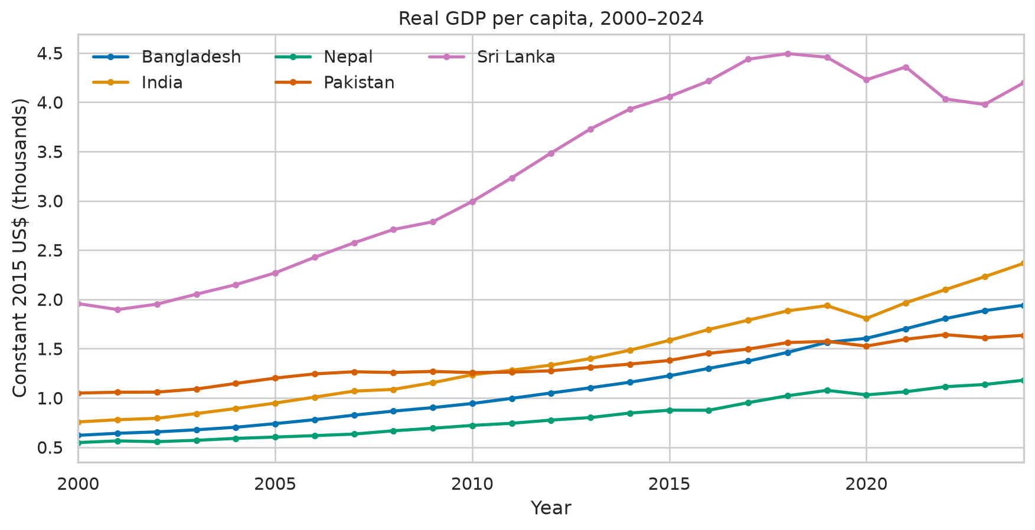
Figure 1. Real GDP per capita by country, constant 2015 US$.
The lines show upward long-run paths with differing levels and rates of change. The vertical axis uses thousands of constant 2015 US dollars for readability.
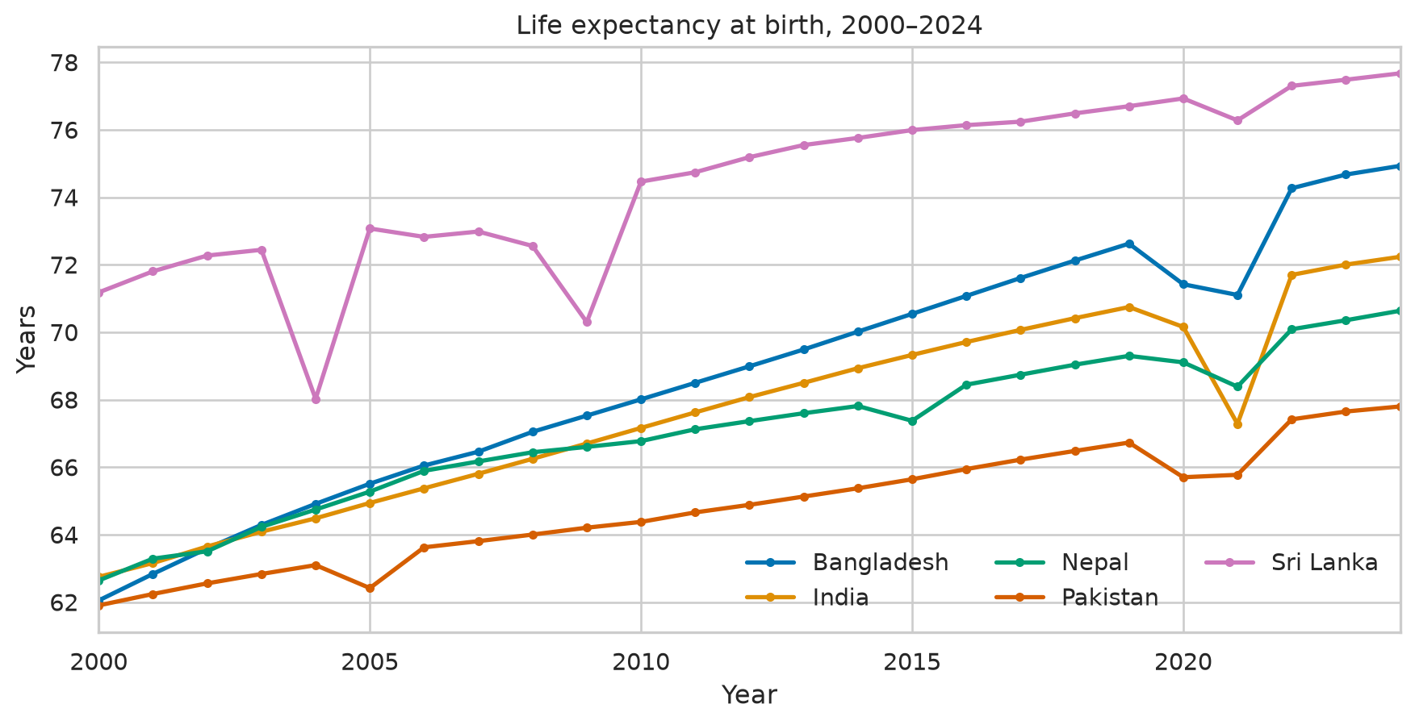
Figure 2. Life expectancy at birth by country, years.
The series rise over the period, with differences in levels between countries. The chart shows annual estimates rather than individual-level life histories.
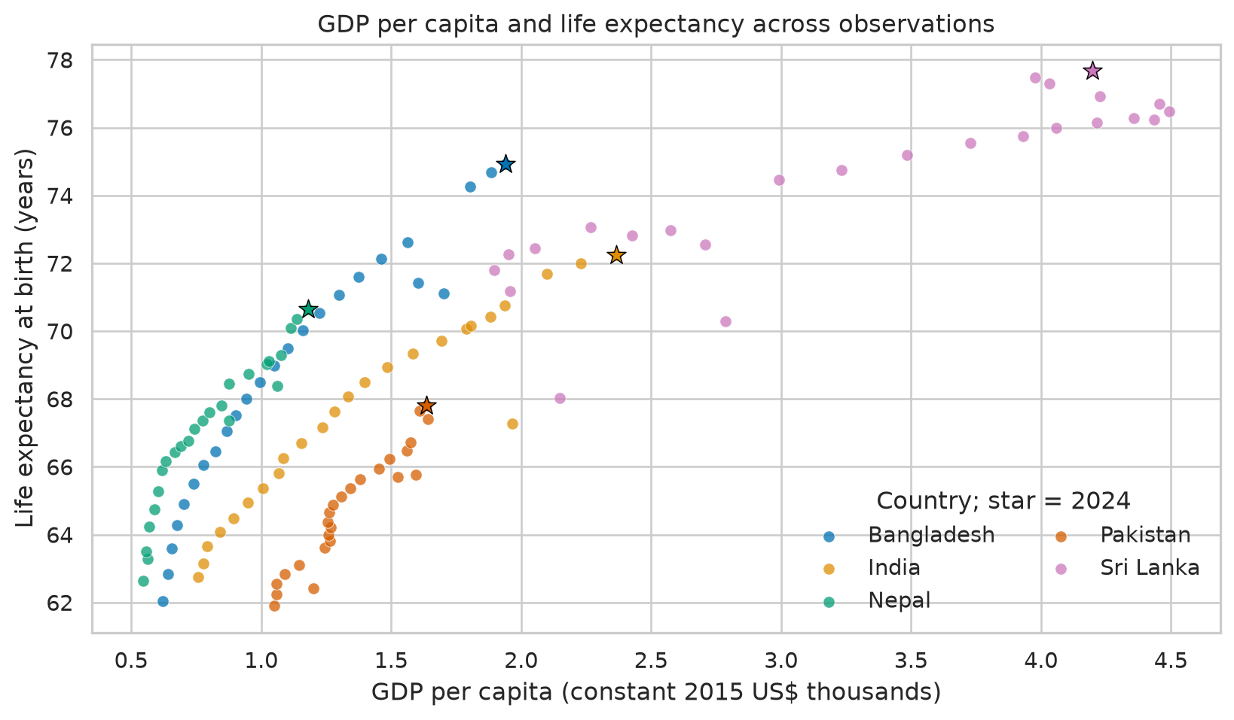
Figure 3. GDP per capita and life expectancy for each country-year; stars mark 2024.
The scatter indicates a positive descriptive relationship across the pooled observations. Country and time trends overlap, so pooled association should not be read as a causal effect.
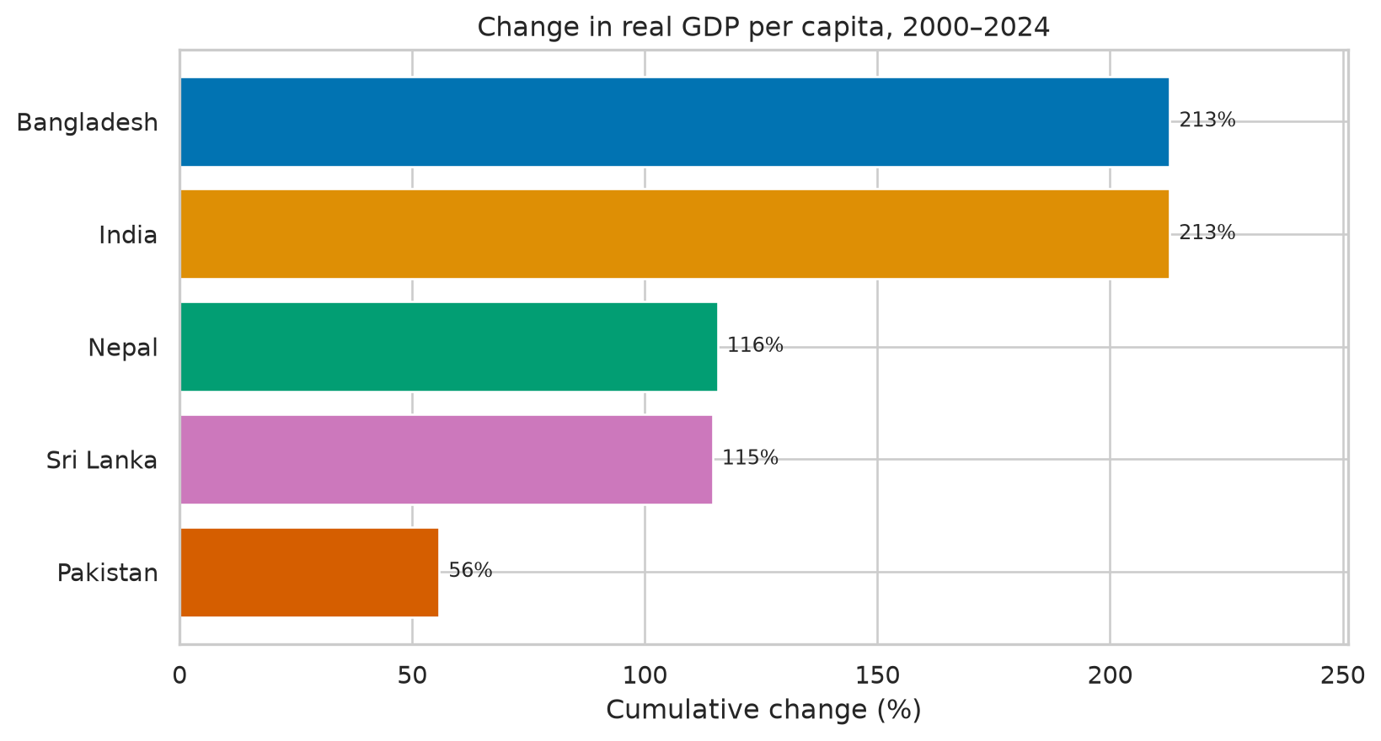
Figure 4. Cumulative percentage change in GDP per capita from 2000 to 2024.
The endpoint comparison makes cross-country differences in cumulative growth visible; percentage changes are relative to each country's 2000 baseline.

6. Association and limitations
Across all 125 country-year observations, the Pearson correlation between GDP per capita and life expectancy is 0.84. This pooled coefficient summarizes co-movement in the assembled panel. It does not establish that higher GDP per capita causes longer life expectancy. Countries differ in institutions, demography, health systems, education, and other factors; observations from the same country over adjacent years are also not independent. The data cover only five South Asian economies and end in 2024. World Bank estimates may be revised, and life-expectancy series draw on demographic sources including the UN Population Division and national statistical offices [2]. The analysis is descriptive, uses no causal design, and should not be generalized to all countries or interpreted as an individual-level relationship.

7. Reproducibility
I included the API responses, merged data, analysis script, executed notebook, summary table, figures, dependency list, and this report in the project repository. From the project folder, install packages with `pip install -r requirements.txt`, then run `python analyze_world_bank.py`. To inspect the steps interactively, open `Task3_WorldBank_Analysis.ipynb` in Jupyter. The script records the retrieval date and source indicator codes and rebuilds the tables and charts from the saved API data.

References
[1]: https://data.worldbank.org/indicator/NY.GDP.PCAP.KD "World Bank GDP per capita indicator"
[2]: https://data.worldbank.org/indicator/SP.DYN.LE00.IN "World Bank life expectancy indicator"
[3]: https://datahelpdesk.worldbank.org/knowledgebase/articles/889392 "World Bank Indicators API documentation"

