TASK 6 / FINAL DATA SCIENCE CAPSTONE

Measuring Growth,
Longevity & Model Fit
A reproducible country-panel analysis and time-block holdout study across five South Asian economies, 2000–2024
125  validated country-year rows | 100 / 25  train / held-out records | 0.90 years  Ridge holdout MAE
Prepared by Nazmus Sakib | Machine Learning Engineer Internship | 6 November 2026

Executive summary
This capstone builds a reproducible data-science workflow around World Bank World Development Indicators for Bangladesh, India, Nepal, Pakistan, and Sri Lanka. It combines 25 annual observations per country (2000–2024) for real GDP per capita in constant 2015 US dollars and life expectancy at birth. The work includes data validation, exploratory analysis, country comparisons, stakeholder-oriented charts and recommendations, then a modest supervised-learning experiment to estimate life expectancy in a chronological holdout period.
The analytical panel contains 125 records with no missing selected indicators, duplicate country-year keys, non-positive GDP values, or life-expectancy values outside the broad 0–120 plausibility range. Between 2000 and 2024, GDP per capita increased in every included economy; Bangladesh and India each recorded an approximately 213% endpoint increase, while Pakistan had the smallest increase at approximately 56%. Life expectancy also increased in all five countries; Bangladesh gained about 12.9 years, while Sri Lanka had the highest 2024 level (77.7 years). These observations are descriptive and do not isolate causes.
For model evaluation, the first 20 years (2000–2019; 100 rows) form the training set and the final five years (2020–2024; 25 rows) the held-out set. A Ridge model using country identity, year, and log GDP per capita achieved a mean absolute error (MAE) of 0.895 years, RMSE of 1.230 years, and R² of 0.889 on the holdout. Its MAE was modestly lower than the last-observed-2019 baseline (1.137 years) and substantially lower than a country-specific training-mean baseline (3.732 years). Because contemporaneous GDP values are included for 2020–2024, this is a retrospective holdout estimation exercise—not an advance forecast. The small panel, time dependence, common trends, and omitted health/social variables prevent causal interpretation or deployment claims.

Capstone at a glance
- Question: how did income and longevity change across the five economies, and how well does a simple interpretable model estimate held-out longevity values?
- Pipeline: source data → quality checks → exploratory analysis → engineered log-GDP feature → chronological split → baseline and Ridge comparison → stakeholder interpretation.
- Decision use: frame follow-up questions and balanced monitoring; do not use the model for patient, budget, or country-ranking decisions.

1. Problem framing and scope
The project integrates foundational data science skills—tabular data inspection, validation, descriptive statistics, feature engineering, model selection, evaluation, visualization, reproducible scripting, and communication. It is intentionally scoped to a balanced panel of five countries and two development indicators. The target variable for the modeling experiment is life expectancy at birth (years); the available predictors are country, calendar year, and GDP per capita. This narrow predictor set is useful for demonstrating workflow and model evaluation, but not sufficient to describe the many determinants of population health.

2. Data, provenance, and quality assurance
The dataset is the saved World Bank WDI country-year extract from the source project. GDP per capita uses indicator NY.GDP.PCAP.KD (constant 2015 US$). Life expectancy at birth, total years, uses SP.DYN.LE00.IN. The merged panel has 5 × 25 = 125 observations from 2000 through 2024. Automated assertions verify required columns, country set, date range, row count, unique country-year keys, completeness for both indicators, positive GDP, and a broad plausible life-expectancy range. Validation is a structural check of the supplied extract; it does not independently verify the source agencies’ underlying measurements or revisions.
No rows required imputation or deletion for the two selected variables. The model feature log_gdp is the natural logarithm of positive real GDP per capita. Country is one-hot encoded; year and log GDP are standardized inside a scikit-learn pipeline. The fitted estimator is Ridge regression (alpha = 1.0), chosen as a transparent regularized linear baseline rather than a tuned or complex model.

3. Exploratory findings

3.1 Economic progress differs by starting point and pace
Real GDP per capita rose in every country at the two endpoints. Bangladesh increased from about $621 to $1,941 and India from about $757 to $2,367 (constant 2015 US$), each approximately +213%. Nepal rose about 116%, Sri Lanka 115%, and Pakistan 56%. Sri Lanka had the highest 2024 level in this five-country set, at roughly $4,199. Endpoints summarize long-run change but conceal annual volatility and within-country distribution.
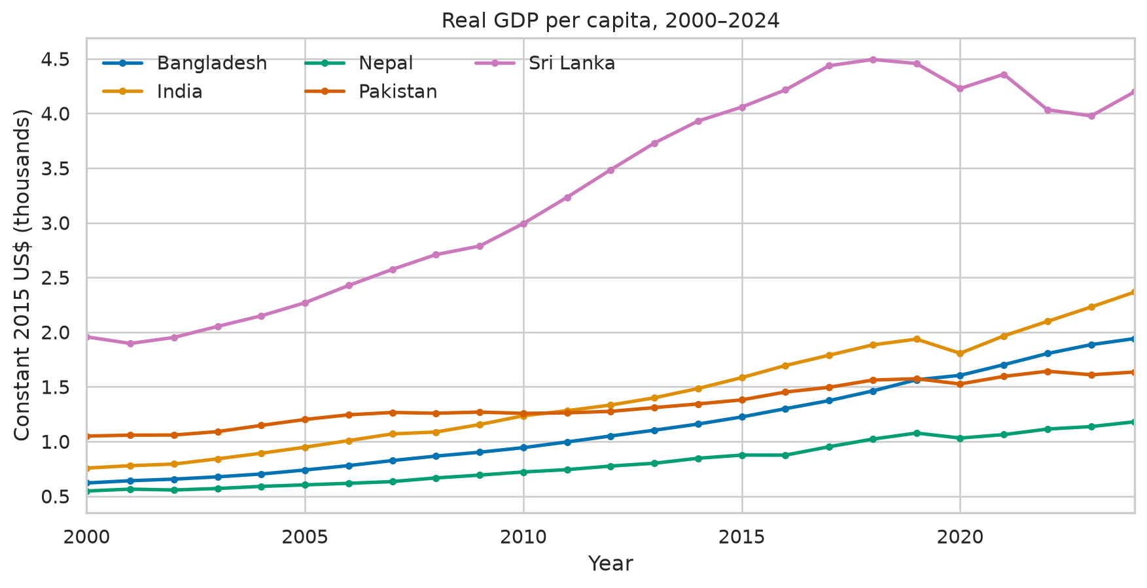
Figure 1. Real GDP per capita, constant 2015 US$ (thousands).

3.2 Longevity improved across the panel
Life expectancy increased from 2000 to 2024 for all five countries. Bangladesh had the largest endpoint gain (+12.9 years), followed by India (+9.5), Nepal (+8.0), Sri Lanka (+6.5), and Pakistan (+5.9). Sri Lanka remained highest in 2024 at 77.7 years. These aggregate trends do not establish which policies or social conditions produced the gains.
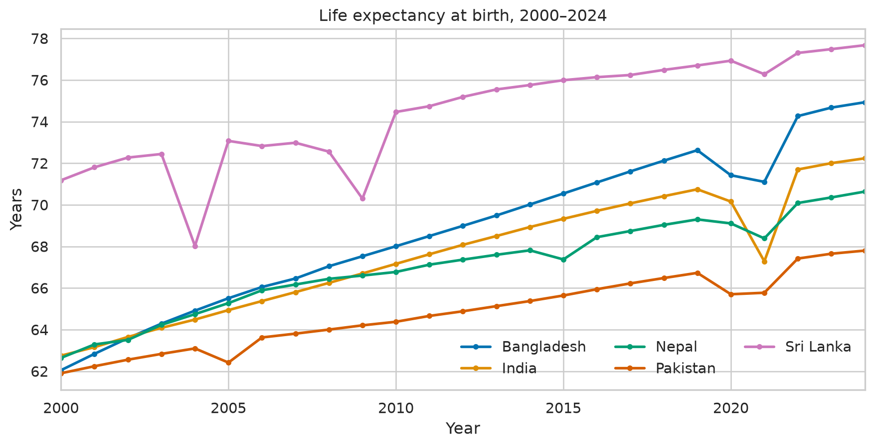
Figure 2. Life expectancy at birth, total years.
Country | GDP pc 2000 | GDP pc 2024 | GDP change | Life 2000 | Life 2024 | Life gain
Bangladesh | $621 | $1,941 | 212.8% | 62.0 | 74.9 | +12.9
India | $757 | $2,367 | 212.8% | 62.7 | 72.2 | +9.5
Nepal | $547 | $1,180 | 115.6% | 62.6 | 70.6 | +8.0
Pakistan | $1,050 | $1,635 | 55.8% | 61.9 | 67.8 | +5.9
Sri Lanka | $1,957 | $4,199 | 114.6% | 71.2 | 77.7 | +6.5
Table 1. Country endpoint comparison. GDP per capita is in constant 2015 US$.
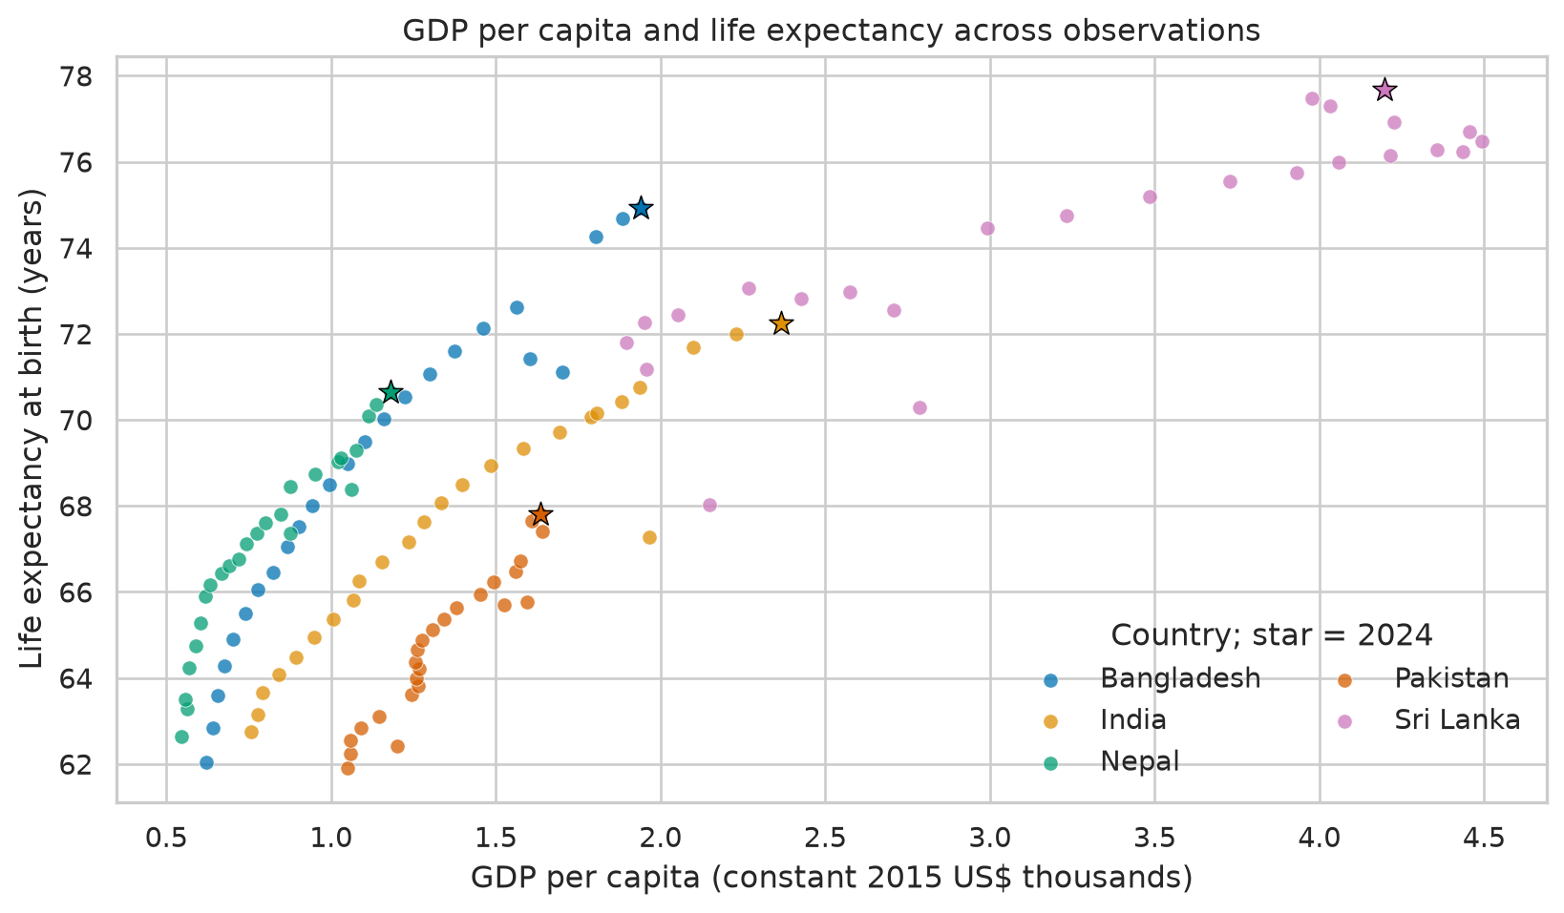
Figure 3. Pooled GDP–life-expectancy association; stars denote 2024.
The pooled Pearson correlation is approximately 0.835 (125 country-years), with median GDP per capita near $1,265 and median life expectancy near 67.8 years. This coefficient summarizes co-movement; country differences, time trends, and serial dependence mean it is not a causal estimate and the 125 rows are not independent observations.

4. Supervised-learning workflow and evaluation

4.1 Chronological holdout
To avoid randomly mixing earlier and later years, the model uses 2000–2019 for training and holds out 2020–2024 for evaluation. All five countries appear in both periods, with 20 training and five test rows per country. The feature set is country, year, and natural-log real GDP per capita. The model is a pipeline that one-hot encodes country, standardizes numeric features, then fits Ridge regression with alpha = 1.0. The alpha value is fixed in advance for a transparent demonstration; the project does not perform extensive hyperparameter search.

4.2 Baselines and metrics
The comparison includes (1) a country-specific mean life expectancy calculated on training years and (2) persistence at each country’s 2019 life-expectancy value. Performance is reported using mean absolute error (MAE), root mean squared error (RMSE), and R² on the same 25 held-out rows. MAE and RMSE are measured in years; R² is relative to the test-set mean and may be negative for weak models.
Method | MAE (years) | RMSE (years) | R²
Country training mean | 3.732 | 4.071 | -0.215
Last observed (2019) | 1.137 | 1.327 | 0.871
Ridge (country + year + log GDP) | 0.895 | 1.230 | 0.889
Table 2. Holdout comparison on the fixed 2020–2024 block (n=25). Lower MAE/RMSE and higher R² are preferable.
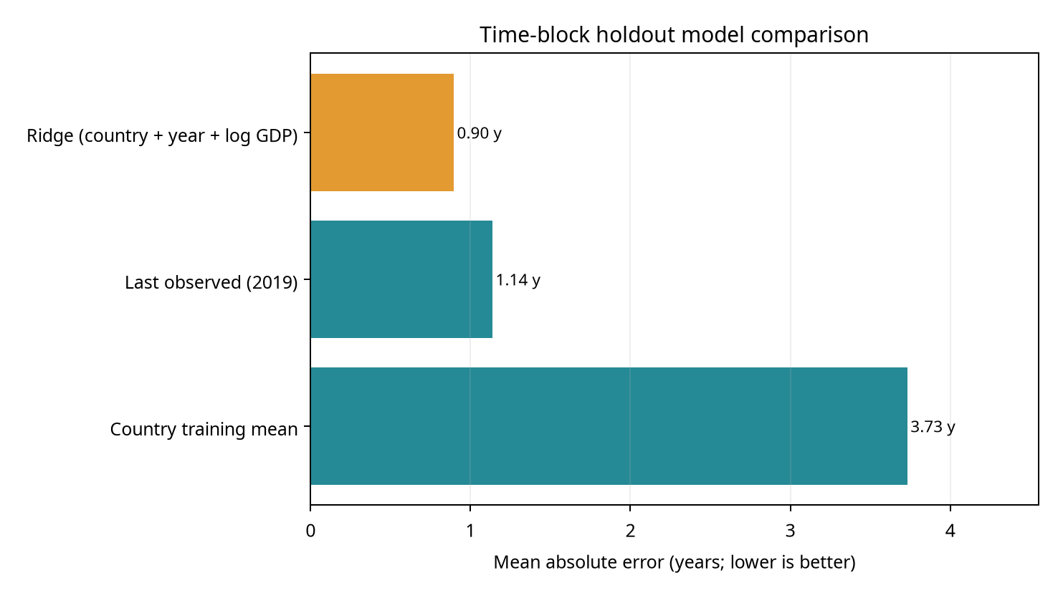
Figure 4. MAE comparison on the held-out block.
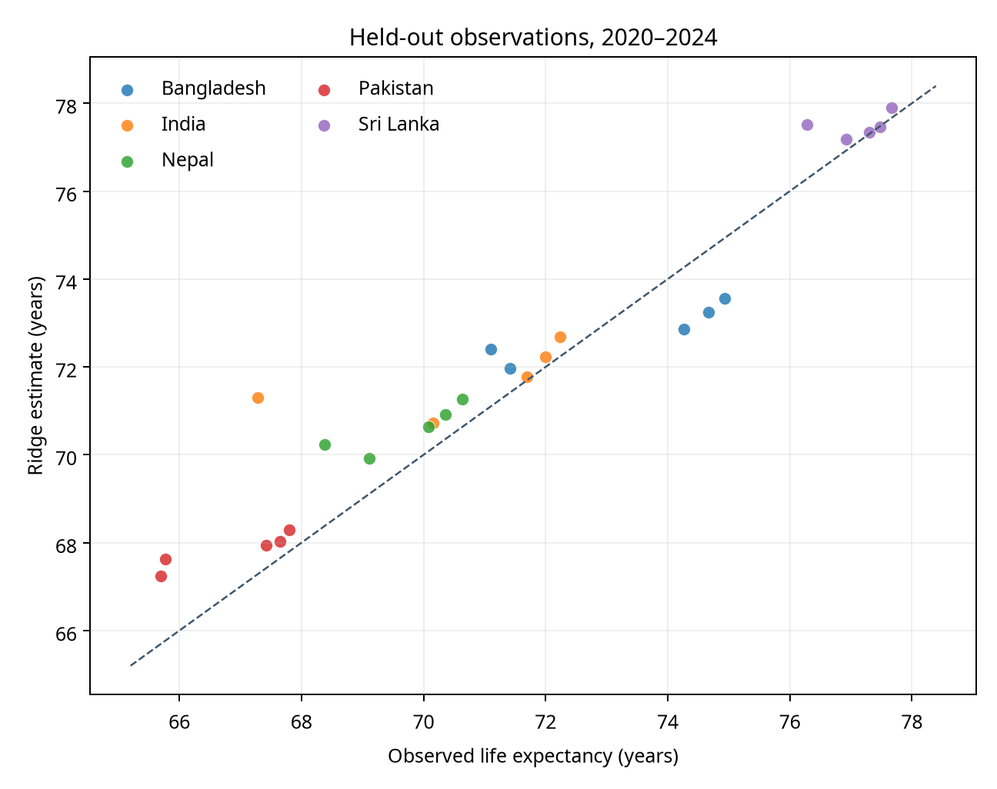
Figure 5. Ridge estimates versus observed held-out outcomes; the dashed line marks equality.
The Ridge model improves MAE from 1.137 to 0.895 years relative to the last-observed baseline—about a 21% reduction—while R² rises from 0.871 to 0.889. That is a modest gain against persistence, not evidence of broadly strong forecasting. Against the training-period country mean, the reduction is much larger because this baseline ignores the secular time trend. The distinction shows why a baseline should be relevant to the task and why a single metric cannot establish operational value.
Country | Test n | Ridge MAE (years) | Ridge RMSE (years)
Bangladesh | 5 | 1.210 | 1.257
India | 5 | 1.070 | 1.827
Nepal | 5 | 0.880 | 1.010
Pakistan | 5 | 0.959 | 1.138
Sri Lanka | 5 | 0.357 | 0.574
Table 3. Country-level holdout error; only five years per country.

5. Stakeholder insights and recommendations
Use balanced development scorecards.
Pair economic indicators with direct health, education, equity, and service-access measures. National GDP per capita and life expectancy alone do not show who benefits or which mechanism matters.
Treat country gaps as diagnostic questions.
Pakistan’s lower endpoint gains in this selected panel justify follow-up analysis with disaggregated health, education, fiscal, labor, and regional indicators; this capstone does not explain the gap or attribute it to policy.
Strengthen future data and evaluation.
Add indicators for health-system capacity, vaccination, maternal and child health, nutrition, sanitation, education, and inequality. Document definitions, missingness, revision dates, and subgroup coverage. For program decisions, use pre-specified outcomes and suitable quasi-experimental or longitudinal designs.
Keep the model in a learning role.
If the model is extended, obtain more countries and covariates, compare against country-specific trend baselines and regularized alternatives, use rolling-origin validation, and monitor subgroup error. Do not use this model to allocate healthcare resources or issue country performance grades.

6. Limitations, risks, and ethical guardrails
- Small scope: five countries and 125 rows; results cannot be generalized to all South Asia or local populations.
- Time structure: adjacent years are correlated; the fixed holdout is a single 2020–2024 block, and shocks or source revisions can affect errors. There are only five test years per country.
- Predictor availability: held-out GDP values are contemporaneous with life expectancy. Thus the task is retrospective estimation and cannot be used as an advance forecast without a separate GDP forecast and uncertainty propagation.
- Omitted variables and confounding: health systems, education, inequality, conflict, demographic structure, environment, and policy are absent. Neither the pooled correlation nor regression coefficients identify causal effects.
- Aggregation and fairness: national averages mask within-country disparities. A small country-level model can reproduce historical averages while being wrong for subgroups; no person-level inference is appropriate.
- Metric risk: R² is test-set dependent and can be inflated by common trends. The small MAE advantage over the 2019 persistence baseline is not proof of practical utility.

7. Reproducibility and project contents
The repository includes the original World Bank country-year data and metadata, the capstone report, analysis script, saved predictions and metrics, validation-scope JSON, and figures. Run from repository root with Python 3.10 or later, the existing project requirements, and scikit-learn installed: `python task6_capstone/capstone_analysis.py`. The script validates source structure, calculates endpoint summaries, fits the fixed pipeline, writes test predictions and metrics, and regenerates model charts. World Bank WDI values may be revised; results correspond to the saved extract in the repository.

Conclusion
This capstone demonstrates a complete, reproducible data-science workflow and a deliberately modest modeling exercise. It finds broad increases in both selected indicators, substantial country variation, and a Ridge model with 0.895-year MAE on a chronological holdout—only modestly better than persistence. The strongest practical conclusion is methodological: combine clear exploratory reporting with temporal evaluation, meaningful baselines, explicit limitations, and cautious decision use. Further policy analysis requires richer, disaggregated data and a stronger identification strategy.

References
World Bank WDI: GDP per capita (constant 2015 US$), NY.GDP.PCAP.KD, https://data.worldbank.org/indicator/NY.GDP.PCAP.KD; life expectancy at birth, total years, SP.DYN.LE00.IN, https://data.worldbank.org/indicator/SP.DYN.LE00.IN. Indicators API documentation: https://datahelpdesk.worldbank.org/knowledgebase/articles/889392-about-the-indicators-api-documentation. Reproducibility project: https://github.com/Nazmussakib247/task3-world-bank-south-asia-analysis.

