SOFTWARE REQUIREMENTS SPECIFICATION (SRS)
Project Title:

Ordinis

A Dynamic Multi-Tenant Organization Workflow & Chain-of-Command Management System

SL | Student ID | Student Name | Role
1 | 23201023 | Md. Nazmuz Saif | Software Developer (Programmer)
2 | 23201008 | Fawjiya Fahima Eifa | System Designer / Software Architect
3 | 23201055 | Montasim Kabir Mahin | Project Manager
4 | 23201029 | Sadia Jahan Disha | System Analyst / Business Analyst
5 | 23201050 | Md. Tahsin Rahman Khan | Tester / Quality Assurance (QA) Engineer

Document Version | Date of Submission
1.0 | September 2, 2026

Contents
Document History
1. Introduction
1.1 Purpose
1.2 Scope
1.3 Definitions, Acronyms, and Abbreviations
1.4 References
1.5 Overview
2. Overall Description
2.1 Product Perspective
2.2 Product Functions
2.3 User Classes and Characteristics
2.4 Operating Environment
2.5 Design and Implementation Constraints
2.6 Assumptions and Dependencies
3. Specific Requirements
3.1 Functional Requirements
3.2 Non-Functional Requirements
4. External Interface Requirements
4.1 User Interfaces
4.2 Hardware Interfaces
4.3 Software Interfaces
5. System Models
6. Other Requirements
7. SDG Traceability
8. Requirements Traceability
Appendix A: Requirement Elicitation/Discovery Process
Appendix B: Survey/Questionnaire Responses and Statistics

Document History
Version | Date | Authors | Change Log | Approved By
V1.0 | 2 September, 2026 | Montasim Kabir Mahin  Fawjiya Fahima Eifa  Md.Tahsin Rahman Khan  Md. Nazmuz Saif  Sadia Jahan dish | Initial SRS Version

1. Introduction

1.1 Purpose
The purpose of this Software Requirements Specification (SRS) document is to provide a complete, clear, and detailed description of the features, functional behavior, operational constraints, and non-functional specifications of Ordinis which is a Dynamic Multi-Tenant Organization Workflow & Chain-of-Command Management System.
This document serves as the foundational agreement and baseline reference for software developers, system architects, quality assurance (QA) engineers, system analysts, project managers, and organizational stakeholders throughout the Software Development Life Cycle (SDLC).
The SRS defines the complete requirements of the Ordinis platform, including system functionality, user interactions, security requirements, interface requirements, performance expectations, and architectural constraints. It establishes a common understanding among all stakeholders regarding what the system should accomplish and provides a structured guideline for design, development, testing, and future maintenance activities.

1.2 Scope
Ordinis is a dynamic, multi-tenant Software-as-a-Service (SaaS) web application designed to solve the operational management challenges of startups, small and medium enterprises (SMEs), and growing organizations.
The system enables client organizations to independently model, manage, and scale their internal organizational hierarchy, including structures such as CEO, General Manager, Department Head, Team Lead, and Employee, along with cross-functional roles such as HR Manager, Accountant, and Finance Manager.
Unlike traditional organization management software that follows fixed organizational structures, Ordinis provides a configurable organization operating system where companies can define their own departments, designations, reporting relationships, roles, permissions, and approval workflows dynamically without hardcoding organizational rules into the system.
The platform follows a multi-tenant SaaS architecture where multiple organizations can use the same application while maintaining complete data isolation and security. Each organization operates independently with its own employees, hierarchy, workflows, permissions, and operational data.
The major scope of Ordinis includes dynamic organization structure management, role-based access control (RBAC), workflow and approval management, task management, employee management, attendance management, leave management, payroll support, notification services, audit logging, and organizational analytics.
The system allows management personnel to gain real-time visibility into organizational activities, monitor workflow progress, track employee responsibilities, and improve decision-making through centralized and data-driven insights.
Ordinis aims to provide a flexible platform where the software adapts according to the organization's structure rather than forcing organizations to change their existing operational processes according to predefined software limitations.

1.3 Definitions, Acronyms, and Abbreviations
- Ordinis – Dynamic multi-tenant organization workflow and chain-of-command management system.
- SRS – Software Requirements Specification.
- FR / NFR – Functional Requirement / Non-Functional Requirement.
- RBAC – Role-Based Access Control.
- CEO – Chief Executive Officer / Company Owner.
- GM / AGM – General Manager / Assistant General Manager.
- HR – Human Resources.
- CTE – Common Table Expression for recursive hierarchy traversal.
- Tenant – An organization/company using an isolated environment of the multi-tenant platform.
- Audit Log – Timestamped record of significant system actions and changes.
- DFD – Data Flow Diagram.
- ERD – Entity Relationship Diagram.
- API – Application Programming Interface.

1.4 References
- IEEE Std 830-1998 Software Requirements Specification
- Ordinis Project Proposal, Version 1.0
- Ordinis stakeholder interviews/questionnaires
- Ordinis feasibility and system design documents

1.5 Overview
This SRS describes the overall system, functional and non-functional requirements, external interfaces, system models, other requirements, SDG traceability, requirements traceability, and requirement elicitation process.

2. Overall Description

2.1 Product Perspective
Ordinis is a standalone web-based multi-tenant SaaS application. Each tenant maintains isolated organizational data including hierarchy, users, roles, permissions, workflows, tasks, attendance, leave, payroll, notifications, and audit records. The application is accessed through web browsers and uses a centralized relational database.

2.2 Product Functions
- Dynamic organization structure creation and modification.
- Employee onboarding, profile, role, department, and lifecycle management.
- Hierarchy-based RBAC with functional roles such as HR and Accountant.
- Task/project assignment, progress tracking, and reporting.
- Configurable approval workflows and delegation.
- Attendance, leave, and holiday management.
- Basic payroll, salary-slip, and expense management.
- Policy and announcement publishing.
- Action Inbox and real-time notification management.
- Organization dashboards and performance summaries.
- Audit log and activity tracking.
- Basic multi-tenant subscription plan and billing simulation.

2.3 User Classes and Characteristics
User Class | Description
CEO / Company Owner | Configures organization structure, views company dashboard, publishes policies/announcements, and approves budgets.
GM / AGM/Manager | Assigns tasks/projects, monitors department progress, approves leave at first level, and delegates authority.
Department Head / Team Lead | Assigns team tasks, monitors team progress/attendance, reviews requests, and prepares team reports.
HR | Manages employee onboarding/exit, final leave approval, performance review, holiday calendar, and policies.
Accountant | Generates payroll/salary records and manages basic expenses/invoices.
Employee | Uses Action Inbox, attendance/leave, assigned tasks, notifications, and salary-slip viewing.
Super Admin | Manages platform-level tenant, subscription, and support functions.

2.4 Operating Environment
- Web browsers: Chrome, Firefox, and Edge.
- Backend: Python, Django, Django REST Framework.
- Database: PostgreSQL.
- Frontend: React with HTML5, CSS3, and JavaScript.
- Deployment: Docker.
- Real-time: WebSocket using Django Channels.

2.5 Design and Implementation Constraints
- Strict tenant isolation must be enforced.
- Access control must combine organizational hierarchy and functional roles.
- Hierarchy traversal must support multiple levels using recursive queries.
- Sensitive HR/payroll information must be restricted to authorized users.
- Initial release is web-based; native mobile apps are excluded.
- Payroll is basic and excludes full statutory tax/labor-law calculations.
- Advanced AI analytics and predictive workload balancing are excluded.
- External ERP/accounting integrations are excluded.

2.6 Assumptions and Dependencies
- Users are expected to have basic digital literacy and access to a stable internet connection to use the Ordinis platform.
- Tenant administrators will provide accurate company information, employee details, department structure, and organizational hierarchy during system configuration.
- Authorized administrators will correctly configure roles, permissions, reporting relationships, and workflow rules according to organizational requirements.
- Notification and email services will be available and properly configured for delivering system alerts, approval updates, and user notifications.
- The availability of PostgreSQL, Django, Django REST Framework, Django Channels, and Docker environments is required for successful system development and deployment.
- Cloud hosting infrastructure and network availability are required to ensure reliable access to the SaaS platform.
- Organizations are responsible for maintaining accurate employee, workflow, and operational data within their tenant environment..

3. Specific Requirements

3.1 Functional Requirements

3.1.1 Authentication, Tenant & Account Management
Req ID | Priority | Requirement
FR-01 | High | The system shall allow authorized users to register a tenant or accept invitations to join an existing tenant using valid credentials.
FR-02 | High | The system shall authenticate users before granting access to protected features.
FR-03 | High | The system shall enforce tenant isolation so users can access only their organization's data.
FR-04 | High | The system shall enforce role- and hierarchy-based access control.
FR-05 | Medium | The system shall allow authorized users to view and update permitted employee profile information.

3.1.2 Organization Structure & Employee Management
Req ID | Priority | Requirement
FR-06 | High | The system shall allow authorized administrators to create and modify multi-level organizational structures.
FR-07 | High | The system shall allow authorized users to create departments, positions, reporting relationships, and organizational units.
FR-08 | High | The system shall allow authorized HR and administrators to onboard, update, transfer, and deactivate employees.
FR-09 | Medium | The system shall allow authorized users to assign organizational designations and functional roles such as HR or Accountant.
FR-10 | Medium | The system shall maintain records of significant organizational and employee changes.

3.1.3 Roles & Permissions
Req ID | Priority | Requirement
FR-11 | High | The system shall allow authorized administrators to configure permissions for organizational roles.
FR-12 | High | The system shall apply permissions based on configured organizational hierarchy and functional roles.
FR-13 | High | The system shall restrict sensitive modules according to functional permissions.
FR-14 | Medium | The system shall allow authorized users to review effective permissions for a user.

3.1.4 Task & Project Management
Req ID | Priority | Requirement
FR-15 | High | The system shall allow authorized managers to create and assign tasks or projects to employees or teams.
FR-16 | High | The system shall allow assignees to update task status and progress.
FR-17 | Medium | The system shall allow managers to monitor task/project progress by department or team.
FR-18 | Medium | The system shall maintain task assignment and completion history.
FR-19 | Medium | The system shall support deadlines and notify relevant users of approaching or overdue tasks.

3.1.5 Approval Workflow & Delegation
Req ID | Priority | Requirement
FR-20 | High | The system shall support configurable approval chains based on organizational hierarchy.
FR-21 | High | The system shall route approval requests to the appropriate authority.
FR-22 | High | The system shall allow authorized managers to approve, reject, or return requests with status tracking.
FR-23 | Medium | The system shall allow authorized managers to delegate approval authority for permitted workflows.
FR-24 | Medium | The system shall escalate pending approvals according to configured workflow rules.

3.1.6 Attendance, Leave & Holiday
Req ID | Priority | Requirement
FR-25 | High | The system shall allow employees to record attendance according to the configured attendance process.
FR-26 | High | The system shall allow employees to submit leave requests with dates and reasons.
FR-27 | High | The system shall route leave requests through the configured approval chain.
FR-28 | High | The system shall allow HR to manage holiday calendars.
FR-29 | Medium | The system shall update leave/attendance status after approval or rejection.
FR-30 | Medium | The system shall provide attendance and leave summaries to authorized managers and HR.

3.1.7 Payroll, Salary & Expense
Req ID | Priority | Requirement
FR-31 | High | The system shall allow authorized Accountant users to generate basic payroll records.
FR-32 | High | The system shall allow employees to view their authorized salary slips.
FR-33 | Medium | The system shall allow authorized users to record and track basic expenses/invoices.
FR-34 | High | The system shall restrict payroll and financial records to authorized roles.
FR-35 | Medium | The system shall maintain payroll and expense history.

3.1.8 Policy, Announcement & Notification
Req ID | Priority | Requirement
FR-36 | Medium | The system shall allow authorized users to publish company policies and announcements.
FR-37 | High | The system shall provide an Action Inbox containing relevant tasks, approvals, and pending actions.
FR-38 | High | The system shall provide in-app notifications for assignments, approvals, leave updates, and announcements.
FR-39 | Medium | The system shall support real-time notification delivery for configured events.

3.1.9 Dashboard, Performance & Audit
Req ID | Priority | Requirement
FR-40 | Medium | The system shall provide role-specific dashboards showing authorized organizational information.
FR-41 | Medium | The system shall provide department/team performance and progress summaries.
FR-42 | High | The system shall record auditable logs for significant organizational, permission, approval, attendance, and financial actions.
FR-43 | Medium | The system shall allow authorized users to search or filter audit records.

3.1.10 Subscription & Platform Administration
Req ID | Priority | Requirement
FR-44 | Medium | The system shall support configurable subscription plans for different tenant requirements.
FR-45 | Medium | The system shall maintain tenant subscription status and applicable employee-count limits.
FR-46 | Medium | The system shall allow platform administrators to manage tenant support and subscription records.

3.2 Non-Functional Requirements
Req ID | Priority | Category | Requirement
NFR-01 | High | Performance | The system shall respond to standard user actions within 3 seconds under normal operating conditions.
NFR-02 | High | Security | The system shall securely hash passwords and protect sensitive data in transit and at rest.
NFR-03 | High | Tenant Isolation | The system shall prevent unauthorized cross-tenant access to all protected organizational data.
NFR-04 | High | Authorization | The system shall enforce role-, hierarchy-, and module-level authorization.
NFR-05 | Medium | Availability | The system shall target at least 99% operational availability excluding scheduled maintenance.
NFR-06 | Medium | Usability | The system shall provide an intuitive interface requiring minimal technical training.
NFR-07 | Medium | Scalability | The system shall support growth in tenants, users, tasks, and transactions without significant degradation.
NFR-08 | High | Reliability | The system shall maintain transactional consistency across approval, attendance, leave, payroll, and dependent operations.
NFR-09 | Medium | Compatibility | The system shall function correctly on current Chrome, Firefox, and Edge browsers.
NFR-10 | Medium | Maintainability | The system shall use a modular architecture allowing independent maintenance of major modules.
NFR-11 | High | Data Privacy | The system shall restrict personal, HR, attendance, and payroll data to authorized users.
NFR-12 | High | Auditability | The system shall record significant security, permission, approval, and financial changes with timestamp and actor identity.
NFR-13 | Medium | Accessibility | The interface shall remain usable on common desktop/mobile screen sizes and modest network conditions.
NFR-14 | Medium | Real-Time Responsiveness | Configured real-time notifications shall be delivered without requiring a full page refresh.
NFR-15 | Medium | Backup & Recovery | The system shall support regular database backup and recovery procedures to reduce permanent data-loss risk.

4. External Interface Requirements

4.1 User Interfaces
- Responsive web-based user interface for desktop, tablet, and mobile browsers.
- Role-specific dashboards for CEO/Owner, GM/AGM, Department Head/Team Lead, HR, Accountant, Employee, and Platform Admin.
- Organization structure builder interface for authorized administrators.
- Forms and interfaces for employee management, task assignment, leave requests, approvals, payroll, policies, and announcements.
- Action Inbox and notification interface for managing pending tasks, approvals, and system updates.
- Interfaces for attendance, leave management, payroll, salary slip, reporting, and audit log monitoring.

4.2 Hardware Interfaces
- Server-client architecture operating through the internet.
- Client devices include desktops, laptops, tablets, and smartphones.
- Cloud-based application server responsible for application processing, database access, authentication, authorization, and storage management.
- Client devices require a supported web browser and stable network connection.

4.3 Software Interfaces
- Database: PostgreSQL.
- Backend: Python / Django / Django REST Framework.
- Frontend: React, Tailwind CSS, HTML5, CSS3, and JavaScript.
- Real-time: WebSocket / Django Channels.
- Deployment: Docker.
- Authentication: JWT.
- Notification: In-app notification and supported email delivery service where configured.

5. System Models

Use Case Diagram

Use Case Diagram Description
The Use Case Diagram represents the interaction between different users and the Ordinis Organization Operating System.The diagram includes major actors such as Super Admin, Company Owner/CEO, Manager, HR, Accountant, and Employee.Each actor can access system functionalities according to their assigned roles and permissions.Super Admin manages tenants, subscriptions, support, and platform activities.CEO manages organization structure, employees, roles, permissions, and analytics.Managers handle tasks, projects, approvals, and team activities.HR manages employee records, attendance, and leave operations.Accountants manage payroll and financial activities.Employees perform daily operations including task updates, requests, and notifications.

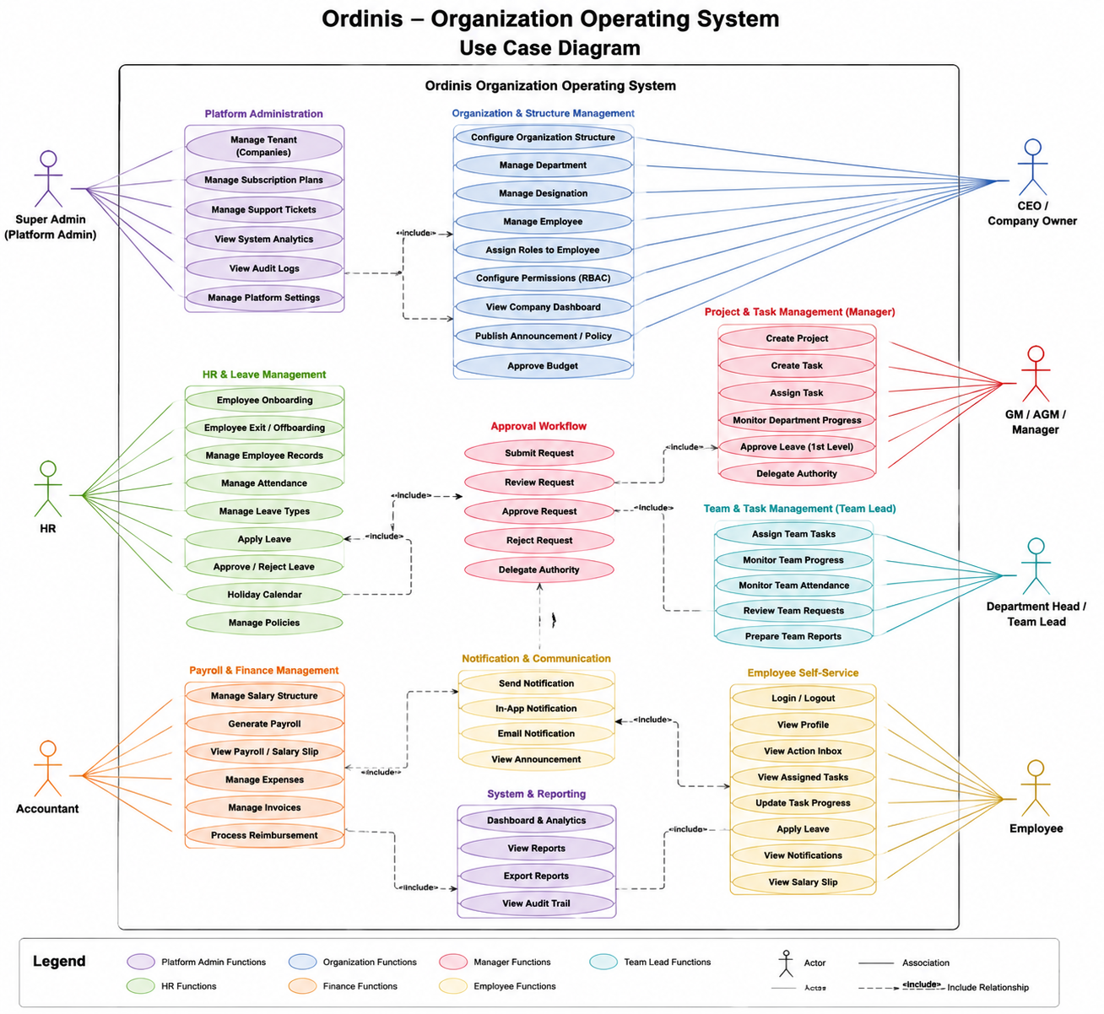

Data Flow Diagram (DFD Level - 0)
The context diagram represents Ordinis as a single system process and shows major information exchanges with organizational users and platform administration.
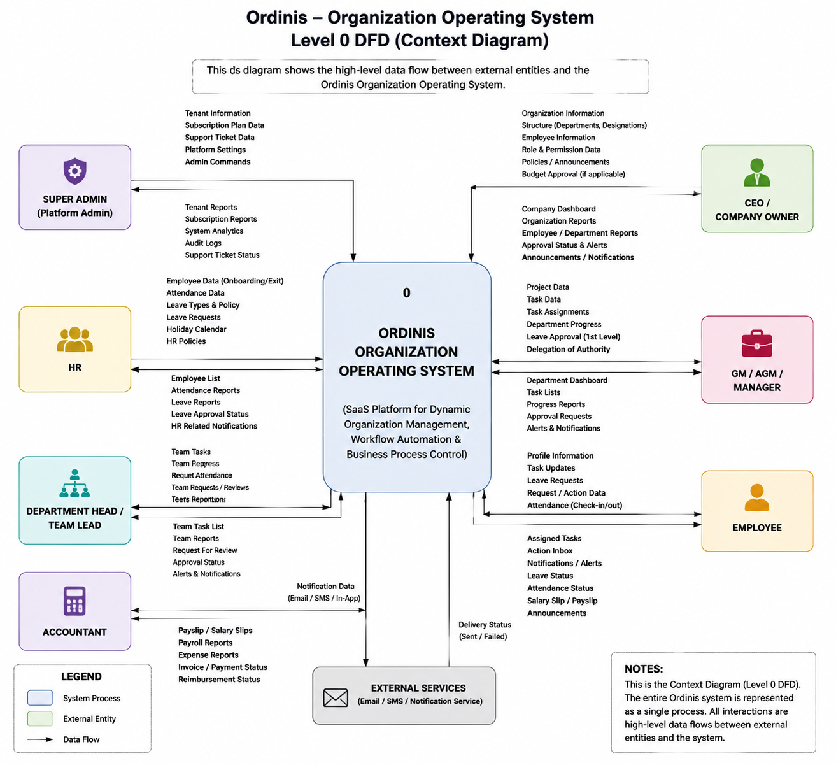

Data Flow Diagram (DFD Level - 1)
The Level 1 Data Flow Diagram represents the decomposition of the Ordinis system into major internal processes and data stores.It shows how different users interact with system modules such as authentication, organization management, task management, HR, payroll, and notification services.The diagram illustrates data flow between external entities, system processes, and database stores.Each process manages specific organizational operations and stores related information for future access.The diagram provides a detailed view of how data moves within the Ordinis system.
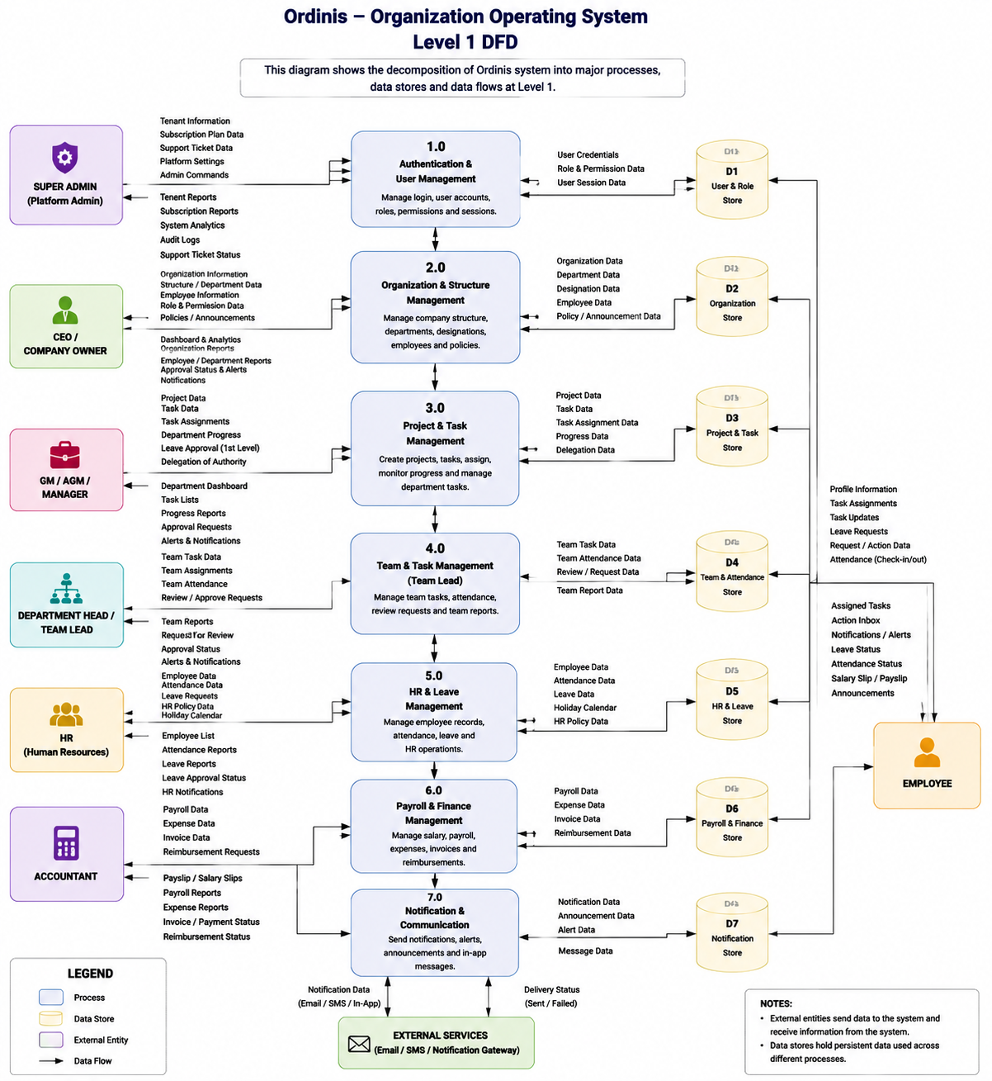

Database Requirement 6. Other Requirements
- Compliance with institutional academic submission and IT policies.
- Regular updates and version control using Git.
- Strict separation of tenant data and access permissions.
- Clear disclosure of system scope and limitations regarding payroll/accounting.
- Sensitive HR and payroll information shall not be exposed to unauthorized users.
- Audit records shall follow the configured retention policy.

7. SDG Traceability
SDG | Ordinis Capability | Contribution
SDG 8 – Decent Work and Economic Growth | Employee management, attendance/leave, payroll, task management, performance monitoring | Supports organized work processes and transparent workplace administration.
SDG 9 – Industry, Innovation and Infrastructure | Dynamic organization builder, workflow automation, multi-tenant SaaS, real-time notifications | Supports digital transformation and innovative organizational infrastructure for SMEs.
SDG 16 – Peace, Justice and Strong Institutions | RBAC, approval workflows, delegation, audit logs, tenant isolation | Supports accountable, transparent, and controlled organizational processes.
SDG 17 – Partnerships for the Goals | Centralized workflow and cross-role collaboration | Supports structured coordination across organizational roles and departments.

8. Requirements Traceability
Req ID | Requirement / Need | Source | Priority | Acceptance Criteria
FR-01 | User authentication and tenant account access | Md Siratul Islam (CEO, NextBox Network), Noor Muhammad (CEO/MD, Ayisha Soft) | High | Authorized users can securely login and access the system based on organization and assigned permissions.
FR-03 | Strict tenant data isolation | Noor Muhammad (CEO/MD, Ayisha Soft), Shah Md Mahahmudul Hasan (HR Executive, BluBird Interactive Ltd.) | High | Users cannot access information belonging to another organization.
FR-04 | Role and hierarchy-based access control | Md Siratul Islam (CEO, NextBox Network), Noor Muhammad (CEO/MD, Ayisha Soft), Fardin Maula (HR Executive, Slow Resorts Ltd.) | High | System provides access according to organizational hierarchy and assigned roles.
FR-06 | Dynamic multi-level organization structure | Md Siratul Islam (CEO, NextBox Network), Noor Muhammad (CEO/MD, Ayisha Soft) | High | Authorized administrators can create departments, designations, reporting relationships, and hierarchy levels.
FR-07 | Department and organizational unit management | Noor Muhammad (CEO/MD, Ayisha Soft), Sabrina Islam (GM/AGM, Eurotex Ltd.) | High | Authorized users can create, update, and manage departments.
FR-08 | Employee onboarding and lifecycle management | Fardin Maula (HR Executive, Slow Resorts Ltd.), Shah Md Mahahmudul Hasan (HR Executive, BluBird Interactive Ltd.) | High | HR can add, update, transfer, maintain documents, and deactivate employee records.
FR-09 | Assign hierarchy positions and functional roles | Md Siratul Islam (CEO, NextBox Network), HR Executive Sources | Medium | Authorized users can assign designations and functional roles.
FR-11 | Configurable roles and permissions | Md Siratul Islam (CEO, NextBox Network), Noor Muhammad (CEO/MD, Ayisha Soft) | High | Administrators can configure role permissions according to responsibilities.
FR-15 | Task and project assignment | Md Siratul Islam (CEO, NextBox Network), Redwan Rakib (Department Head/Team Lead, Synosis), Sabrina Islam (Department Head/Team Lead, Eurotex Ltd.) | High | Managers and team leads can create and assign tasks/projects.
FR-16 | Task progress update | Noor Muhammad (CEO/MD, Ayisha Soft), Taufiqur Rahman Anik (Employee, Neural Semiconductor) | High | Employees can update task progress and status.
FR-17 | Department and team progress monitoring | Zafarullah Momtaz (GM/AGM, eChithi), Sabrina Islam (GM/AGM, Eurotex Ltd.) | Medium | Managers can monitor department and team performance.
FR-20 | Configurable approval workflow | Md Siratul Islam (CEO, NextBox Network), Noor Muhammad (CEO/MD, Ayisha Soft), Fardin Maula (HR Executive, Slow Resorts Ltd.) | High | Requests follow configured approval chains.
FR-23 | Approval delegation | Zafarullah Momtaz (GM/AGM, eChithi), Sabrina Islam (GM/AGM, Eurotex Ltd.) | Medium | Managers can delegate approval authority for a specific period.
FR-25 | Attendance management | Taufiqur Rahman Anik (Employee, Neural Semiconductor), HR Executive Sources | High | Attendance records are stored and accessible to authorized users.
FR-26 | Leave request management | Taufiqur Rahman Anik (Employee, Neural Semiconductor), HR Executive Sources | High | Employees can submit leave requests and monitor status.

Appendix

Appendix A: Requirement Elicitation/Discovery Process

A.1 Introduction
Requirement elicitation for Ordinis focuses on identifying and analyzing the operational challenges, expectations, and functional needs of different organizational stakeholders. The elicitation process was conducted to understand how companies currently manage their internal operations and how a digital workflow management system can improve efficiency, transparency, and accountability.
The collected requirements focus on major organizational activities including dynamic organizational hierarchy, chain of command, task assignment and monitoring, approval workflows, attendance and leave management, employee administration, payroll management, notifications, reporting, and auditability.
Stakeholder inputs were gathered from different user groups, including CEO/Company Owner, GM/AGM/Manager, Department Head/Team Lead, HR Executive, Accountant/Finance Executive, and Employees. These requirements helped define the system functionalities, user roles, access permissions, workflow processes, and non-functional expectations of the Ordinis platform.
The elicited requirements serve as the foundation for designing a flexible, multi-tenant SaaS-based organization management system that can adapt to different company structures while maintaining security, transparency, and controlled access.

A.2 Elicitation Methods Used
The requirement elicitation process for Ordinis was conducted to identify organizational challenges, operational requirements, and expectations from different stakeholder groups. The elicitation process focused on understanding existing workflow management practices, organizational hierarchy, approval processes, employee management, and administrative operations.
The following methods were used for collecting and analyzing requirements:

1. Organizational Visits and Stakeholder Interviews
Stakeholder interviews were conducted through direct organizational visits and online Google Meet sessions with relevant users from different organizational roles.
The interviews focused on:
- Current task assignment and monitoring practices.
- Existing organizational hierarchy and reporting relationships.
- Approval and delegation processes.
- Employee management and HR operations.
- Attendance and leave management.
- Payroll and financial management.
- Reporting, dashboard, and accountability requirements.
- Security, privacy, and access control concerns.
The collected interview responses provided practical insights into existing organizational problems and helped identify system functionalities required for Ordinis.

2. Online Survey and Questionnaires
An online survey was conducted among employees to understand their daily operational experiences, challenges, and expectations from an organizational workflow management system.
The survey focused on:
- Current methods of attendance and task tracking.
- Difficulties in leave application and approval processes.
- Requirements for personal dashboards and daily activity visibility.
- Preferences regarding notifications and communication channels.
- Expectations regarding task progress updates and status tracking.
- Concerns related to data privacy, security, and system usability.
The survey findings were analyzed to identify common employee-level requirements and usability expectations. These findings supported the design of employee-focused features

3. Organizational Workflow and Domain Analysis
An organizational workflow and domain analysis was performed to understand how companies manage their internal processes.
The analysis focused on:
- Organizational hierarchy and chain of command.
- Department and employee relationships.
- Task assignment and progress monitoring flow.
- Approval workflows and delegation mechanisms.
- HR and financial management processes.
- Existing limitations of manual and scattered management approaches.
The findings were used to design Ordinis as a flexible multi-tenant SaaS platform capable of supporting different organizational structures.

A.3 Stakeholder Involvement
The following stakeholder groups contributed to the requirement discovery process:

CEO / Company Owner
CEO and Company Owner stakeholders provided insights regarding:
- Dynamic organizational hierarchy and reporting structure.
- Centralized dashboard and company-wide activity monitoring.
- Role-based access control and permission management.
- Task assignment and progress monitoring.
- Approval authority and workflow configuration.
- Payroll visibility and financial management expectations.
- Policy publishing and organizational decision-making.

GM / AGM / Manager
GM, AGM, and Manager stakeholders contributed insights related to:
- Department-wise monitoring and performance overview.
- Breaking down organizational targets into department tasks.
- Task priority management between departments.
- Approval handling and delegation of authority.
- Department progress reports and management dashboards.
- Notification and workflow requirements.

Department Head / Team Lead
Department Head and Team Lead stakeholders provided input regarding:
- Team task assignment and tracking.
- Real-time task progress monitoring.
- Delayed task identification.
- Team attendance and performance reports.
- Leave request review based on workload and deadlines.
- Reporting requirements for higher management.

HR Executive
HR stakeholders contributed requirements related to:
- Employee onboarding and exit processes.
- Employee information and document management.
- Attendance and leave management.
- Holiday calendar and HR policy management.
- Performance review access control.
- Employee data security and privacy.

Accountant / Finance Executive
Finance stakeholders provided insights regarding:
- Payroll generation and salary management.
- Attendance-linked salary calculation.
- Expense and reimbursement workflows.
- Financial report generation.
- Salary confidentiality and access restriction.
- Payroll approval and financial data security.

Employee
Employees contributed requirements through online surveys and interviews regarding:
- Daily task visibility and progress updates.
- Attendance status and leave tracking.
- Personal dashboard requirements.
- Salary slip access.
- Notification preferences.
- Correction request submission.
- System usability and simplicity expectations.
The collected stakeholder perspectives were considered during requirement identification, prioritization, validation, and the design of the Ordinis system functionalities.

A.4 Requirement Analysis and Prioritization
After collecting stakeholder interviews, employee survey responses, and organizational workflow analysis results, the gathered information was analyzed to identify common operational challenges, user expectations, and system requirements.
Similar findings were grouped into functional areas such as:
- Organization hierarchy and chain of command.
- User authentication and tenant management.
- Employee administration and lifecycle management.
- Role-based access control and permission management.
- Task and project management.
- Approval workflow and delegation.
- Attendance and leave management.
- Payroll and expense management.
- Notification and communication.
- Dashboard, reporting, and analytics.
- Audit logging and accountability.
- Subscription and tenant administration.
Non-functional concerns identified during the elicitation process were grouped into areas including:
- Performance.
- Security.
- Tenant isolation.
- Authorization.
- Availability.
- Usability.
- Scalability.
- Reliability.
- Compatibility.
- Maintainability.
- Data privacy.
- Auditability.
- Accessibility.
- Real-time responsiveness.
- Backup and recovery.
The identified requirements were assigned High, Medium, or Low priority based on stakeholder importance, business impact, technical feasibility, and project scope.

A.5 Outcomes of the Elicitation Process
The requirement elicitation process directly influenced the functional and non-functional requirements documented in Section 3:-Specific Requirements.
The major outcomes included the identification of the need for:
- A dynamic organization structure builder supporting different company hierarchies.
- A configurable chain-of-command and approval workflow system.
- Role-based and hierarchy-based access control.
- Centralized employee management and lifecycle tracking.
- Task and project assignment with progress monitoring.
- Attendance and leave management automation.
- Payroll and expense management with controlled access.
- Action Inbox for pending tasks and approvals.
- Role-specific dashboards and organizational reports.
- Real-time notifications and communication support.
- Audit logs for accountability and transparency.
- Multi-tenant SaaS architecture with strict data isolation.
- Secure management of HR and financial information.
- Future AI assistant integration through MCP with permission-controlled access.
These findings were transformed into the functional requirements FR-01 to FR-47 and non-functional requirements NFR-01 to NFR-15 presented in Section 3.
The relationship between stakeholder needs and system requirements is documented in the Requirements Traceability Matrix, which links selected requirements with their respective interview sources, survey findings, and acceptance criteria

Appendix B: Survey/Questionnaire Responses and Statistics
This section is reserved for the verified Ordinis questionnaire/interview responses and demographic information. No stakeholder response data has been invented. The final submission should insert the actual Google Form responses, interviewee/interviewer information, and response statistics.
Recommended stakeholder groups: CEO/Company Owner, GM/AGM, Department Head/Team Lead, HR, Accountant, and Employee. Include the required number of stakeholders from each group according to the course instruction.

B.1 Stakeholder Interview Responses
The stakeholder interview process was conducted with different organizational roles to identify existing operational challenges, workflow requirements, and expectations from a digital organization management platform. The collected responses helped define the functional requirements and system design of Ordinis.

B.1.1 CEO / Company Owner Interview Responses

Interviewee:
Md Siratul Islam
Designation: CEO
Organization: NextBox Network

Key Findings:
The CEO highlighted challenges related to organizational coordination, task monitoring, and centralized management visibility.
- The major requirements identified were:
- Dynamic organization structure where companies can define their own hierarchy.
- Centralized dashboard to monitor company activities and performance.
- Role-based access control to restrict information according to responsibilities.
- Task assignment and progress monitoring between management and employees.
- Approval workflow for organizational requests.
- Secure handling of employee and financial information.
- Payroll and employee management support.
The findings contributed to requirements related to organization management, RBAC, task management, dashboards, payroll, and security.

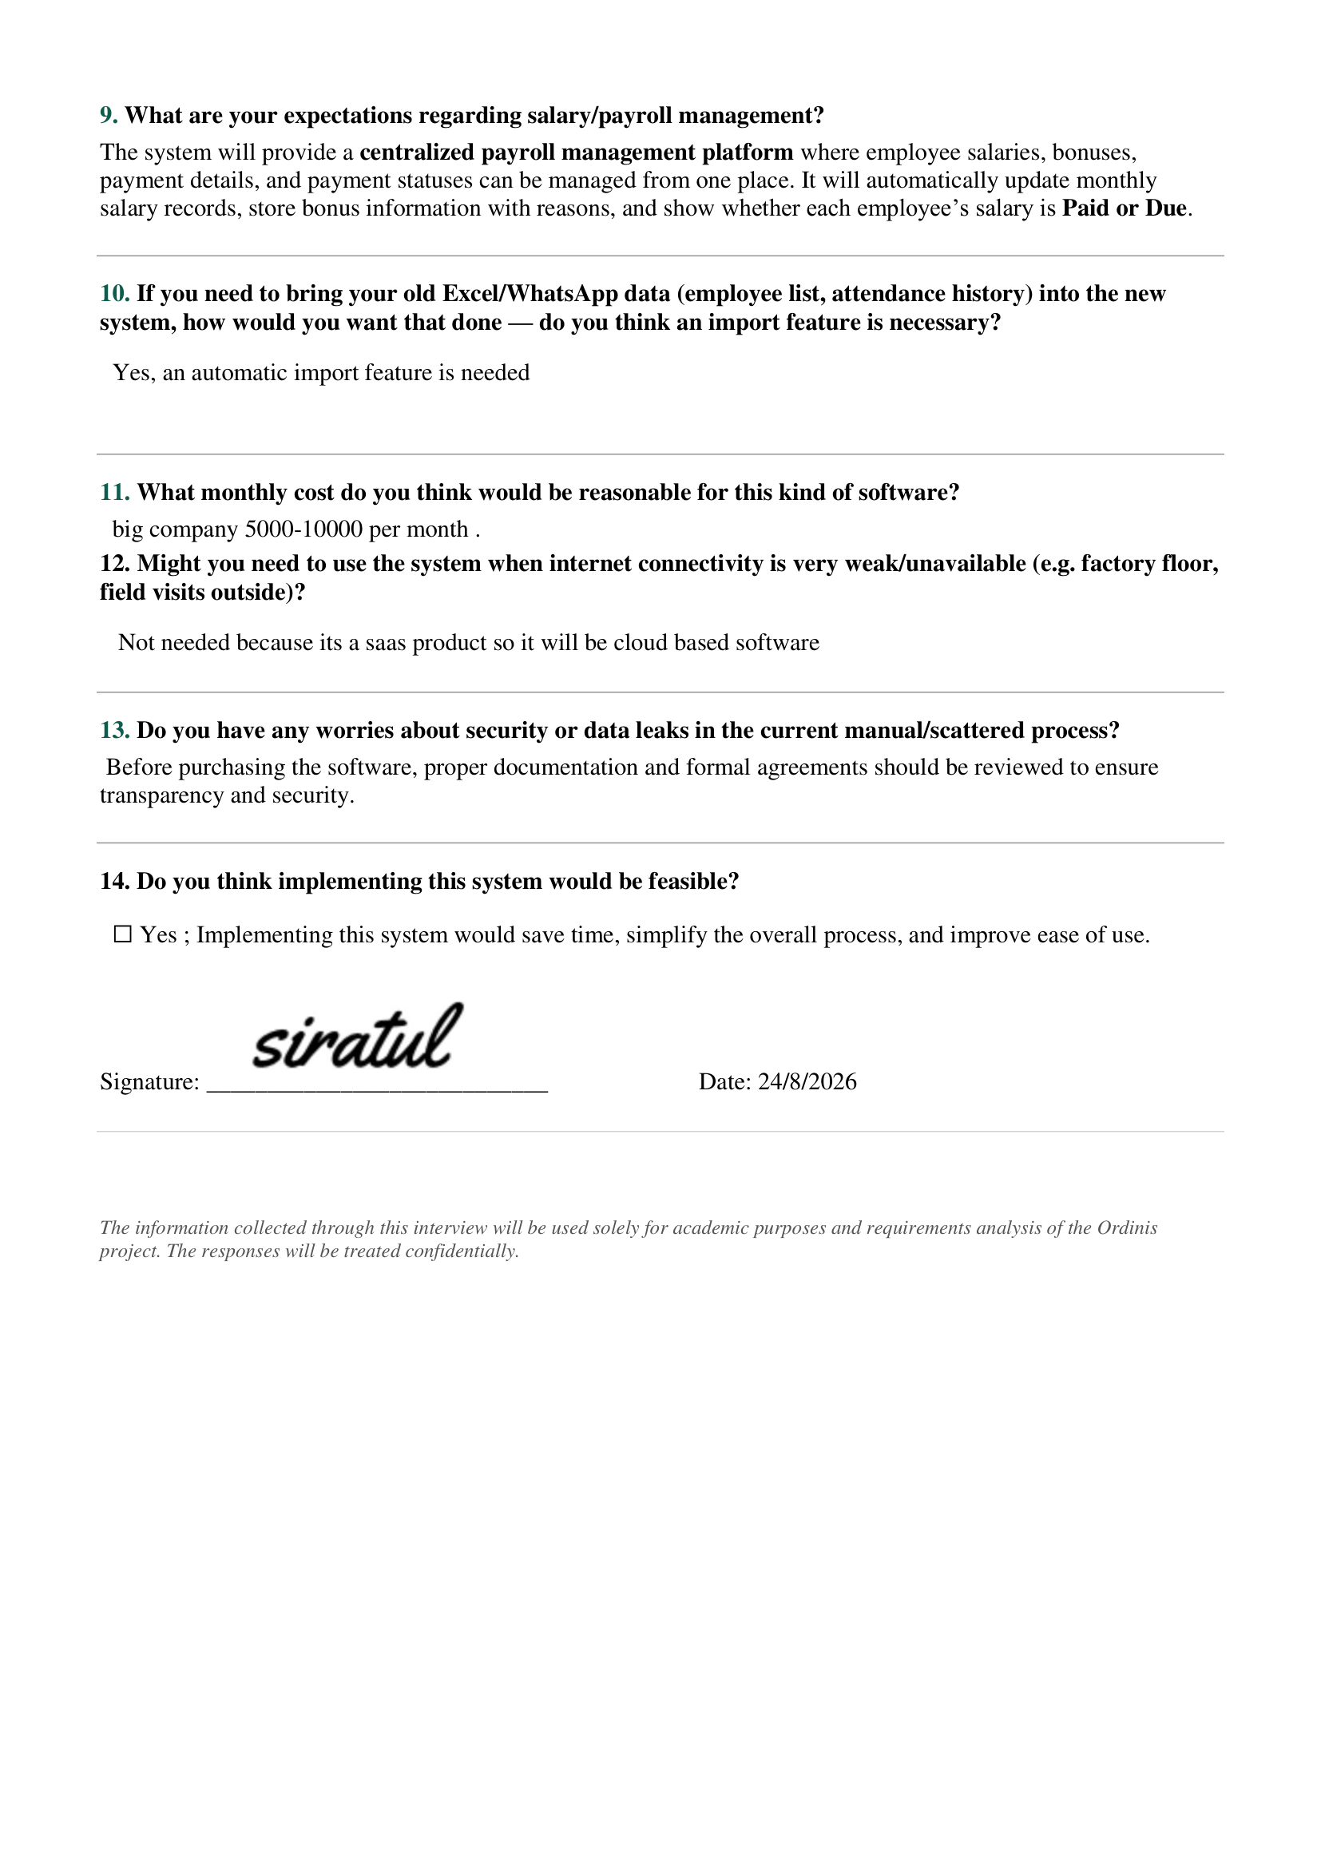
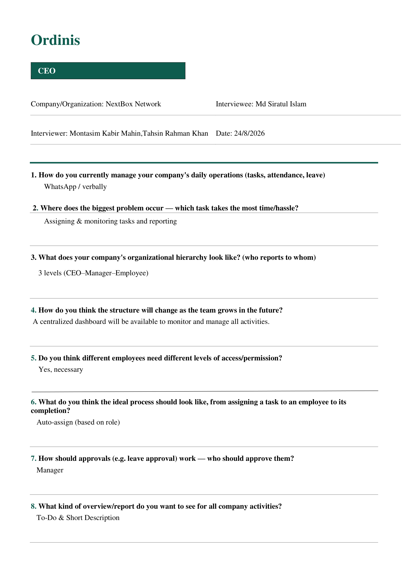

B.1.2 CEO / Managing Director Interview

Interviewee:
Noor Muhammad
Designation: Managing director
Organization: Ayisha Soft

Key Findings:
The CEO/MD emphasized the need for a flexible workflow system that can adapt to different organizational structures.
The major requirements identified were:
- Multi-level organizational hierarchy configuration.
- Department-wise monitoring and reporting.
- Configurable approval workflow based on chain of command.
- Task management similar to project management platforms.
- Action Inbox for pending activities.
- Real-time notifications.
- Audit history for important organizational actions.
- Strong permission management and data security.
The findings contributed to requirements related to dynamic hierarchy, workflow engine, task management, notifications, and auditability
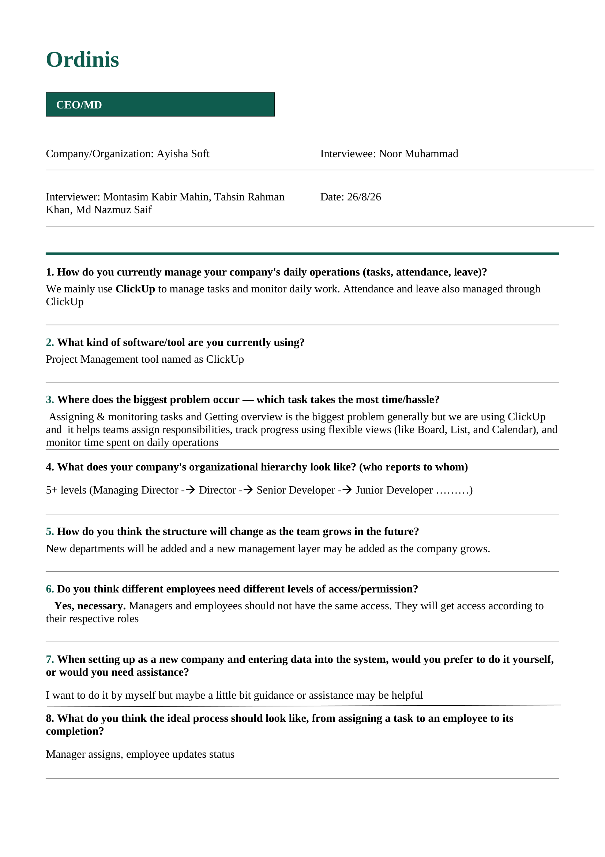

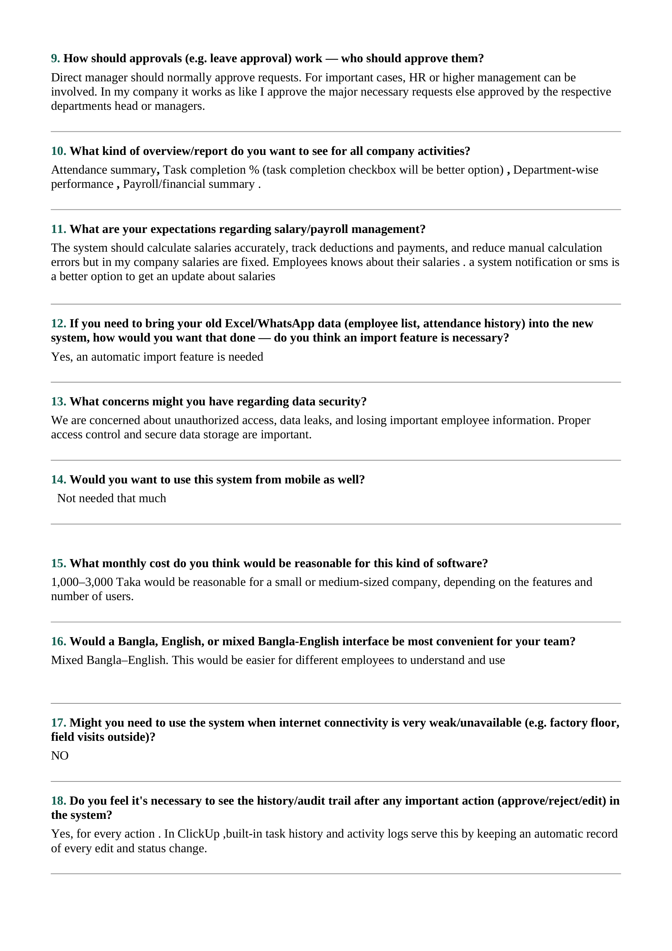
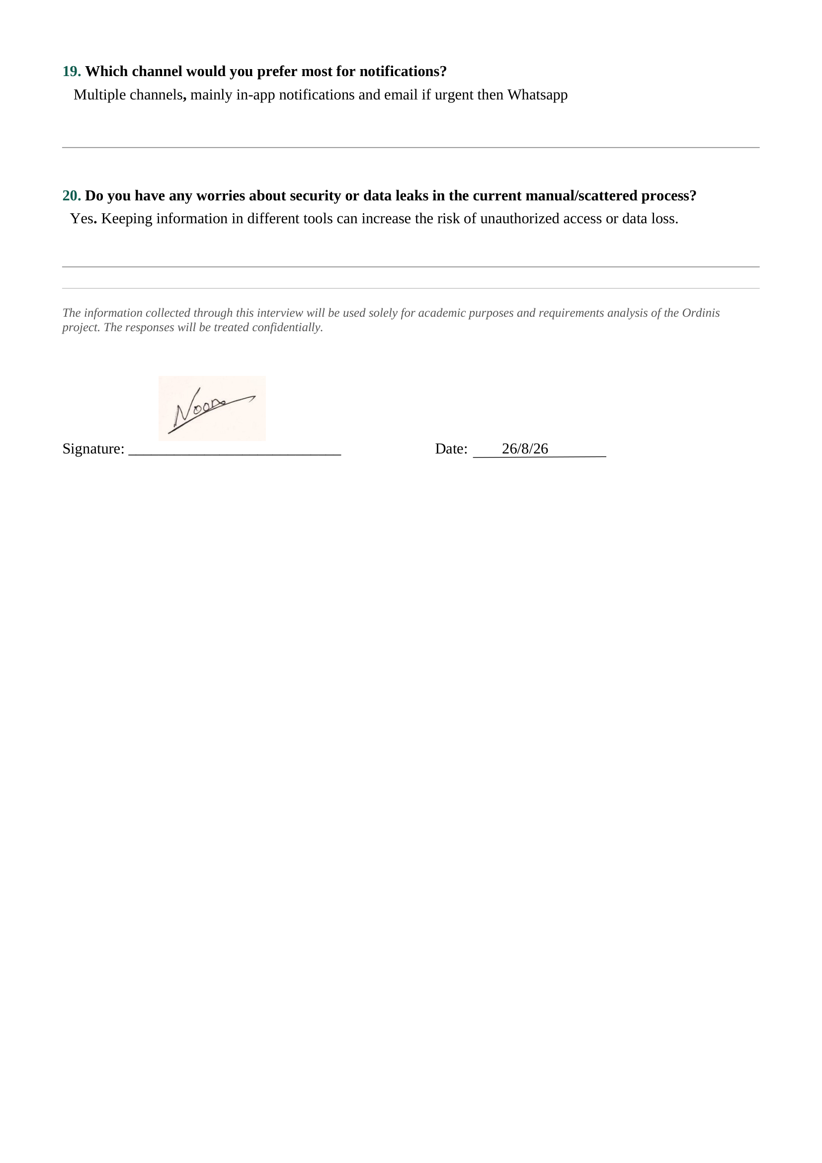

B.1.3 GM / AGM / Manager Interview Responses

Interviewee:
Zafarullah Momtaz
Designation: GM / AGM
Organization: eChithi

Key Findings:
The GM/AGM highlighted the importance of department monitoring and operational visibility.
The major requirements identified were:
- Department progress monitoring.
- Task assignment and tracking.
- Identification of delayed tasks.
- Real-time progress dashboard.
- Leave approval considering workload, leave history, and deadlines.
- Weekly reports for upper management.
The findings contributed to requirements related to task management, dashboards, approval workflow, and reporting.
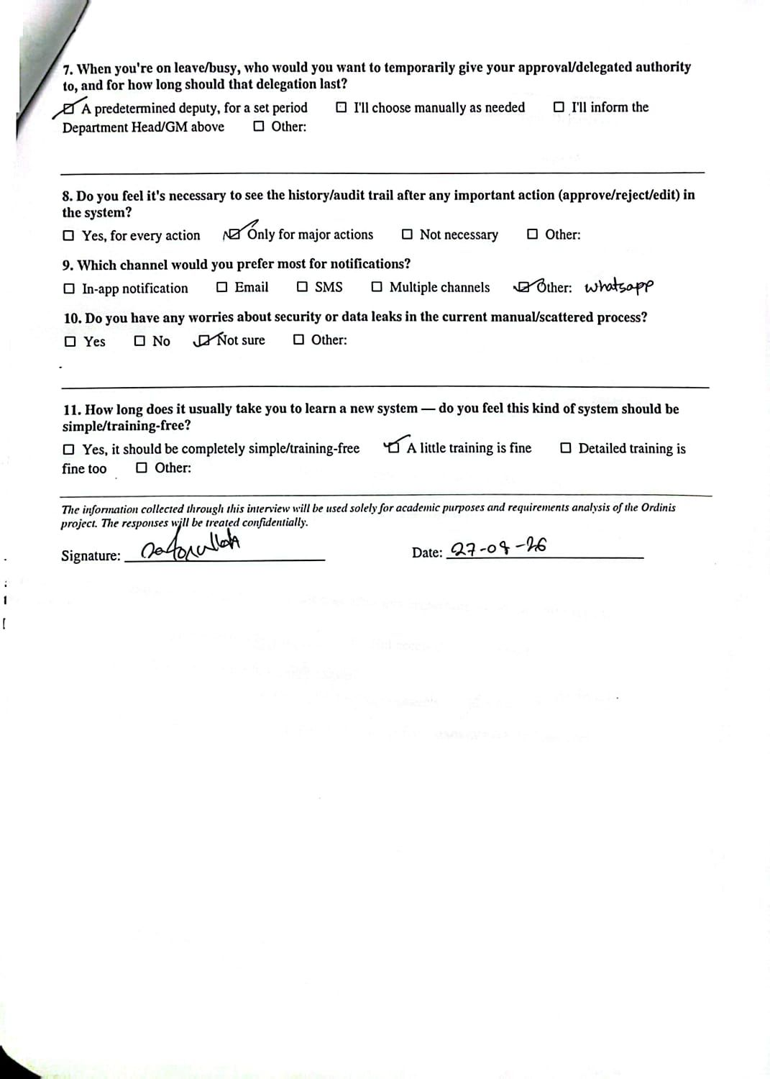
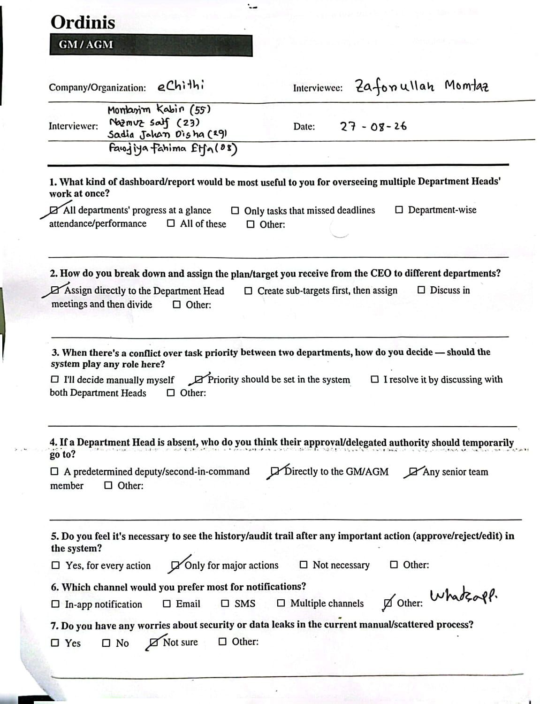

B.1.4 GM / AGM Interview Response
Company/Organization: Eurotex Ltd.
Interviewee: Sabrina Islam
Designation: GM / AGM

Key Findings:
The GM/AGM emphasized department visibility and management control.
The major requirements identified were:
- Dashboard showing all departments' progress.
- Visibility of missed deadlines and department attendance/performance.
- Direct target assignment to Department Heads.
- System-based task priority setting.
- Delegation directly to GM/AGM during Department Head absence.
- Audit history for every action.
- Multiple notification channels.
- Security awareness for preventing information leakage.
- Training support for system adoption.
The findings contributed to requirements related to dashboards, task management, delegation, notifications, and auditability.
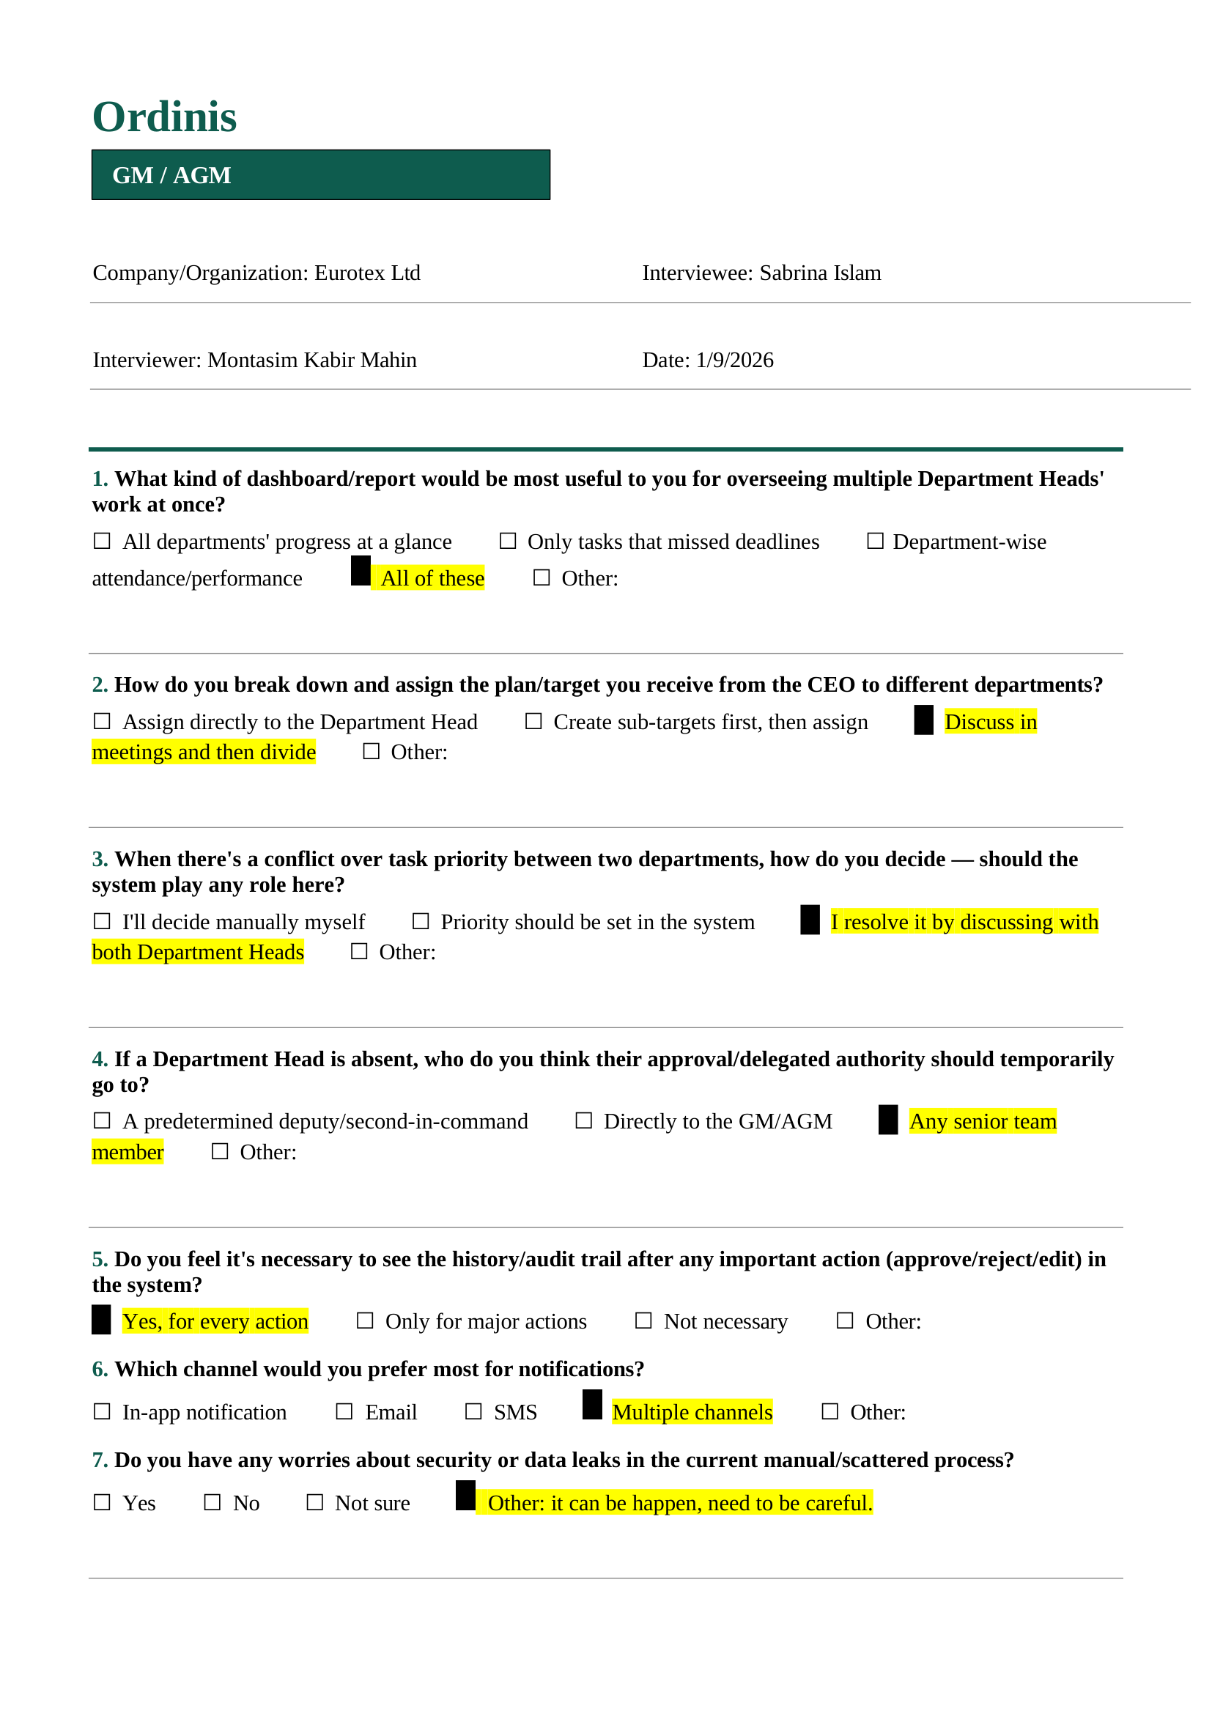
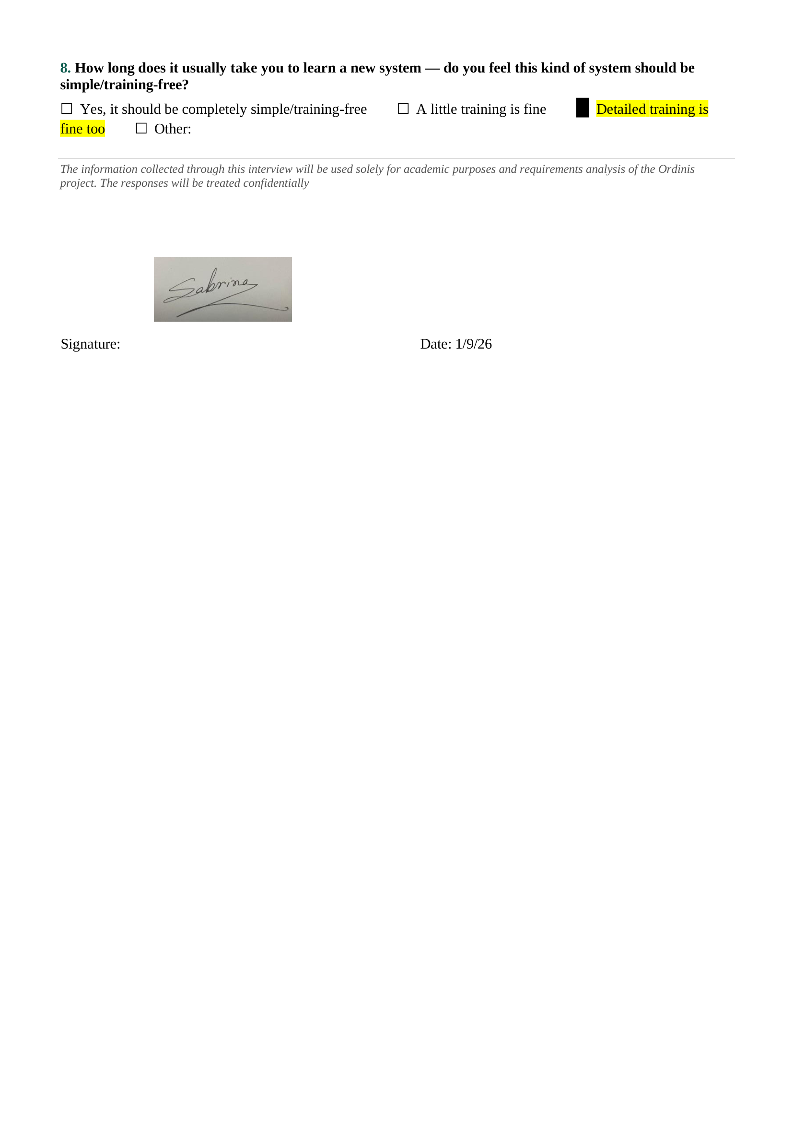

B.1.5 Department Head / Team Lead Interview Response
Company/Organization: eChithi
Interviewee: Zafarullah Momtaz
Designation: Department Head / Team Lead

Key Findings:
The stakeholder highlighted the importance of monitoring team progress and performance.
The major requirements identified were:
- Use of software-based task tracking.
- Monitoring delayed work through timeline tracking.
- Real-time dashboard for multi-day tasks.
- Leave approval considering workload, employee history, and deadlines.
- Task completion rate reports.
- Weekly reporting to upper management.
- Basic training support for new system adoption.
The findings contributed to requirements related to team monitoring, task progress, reporting, and usability.
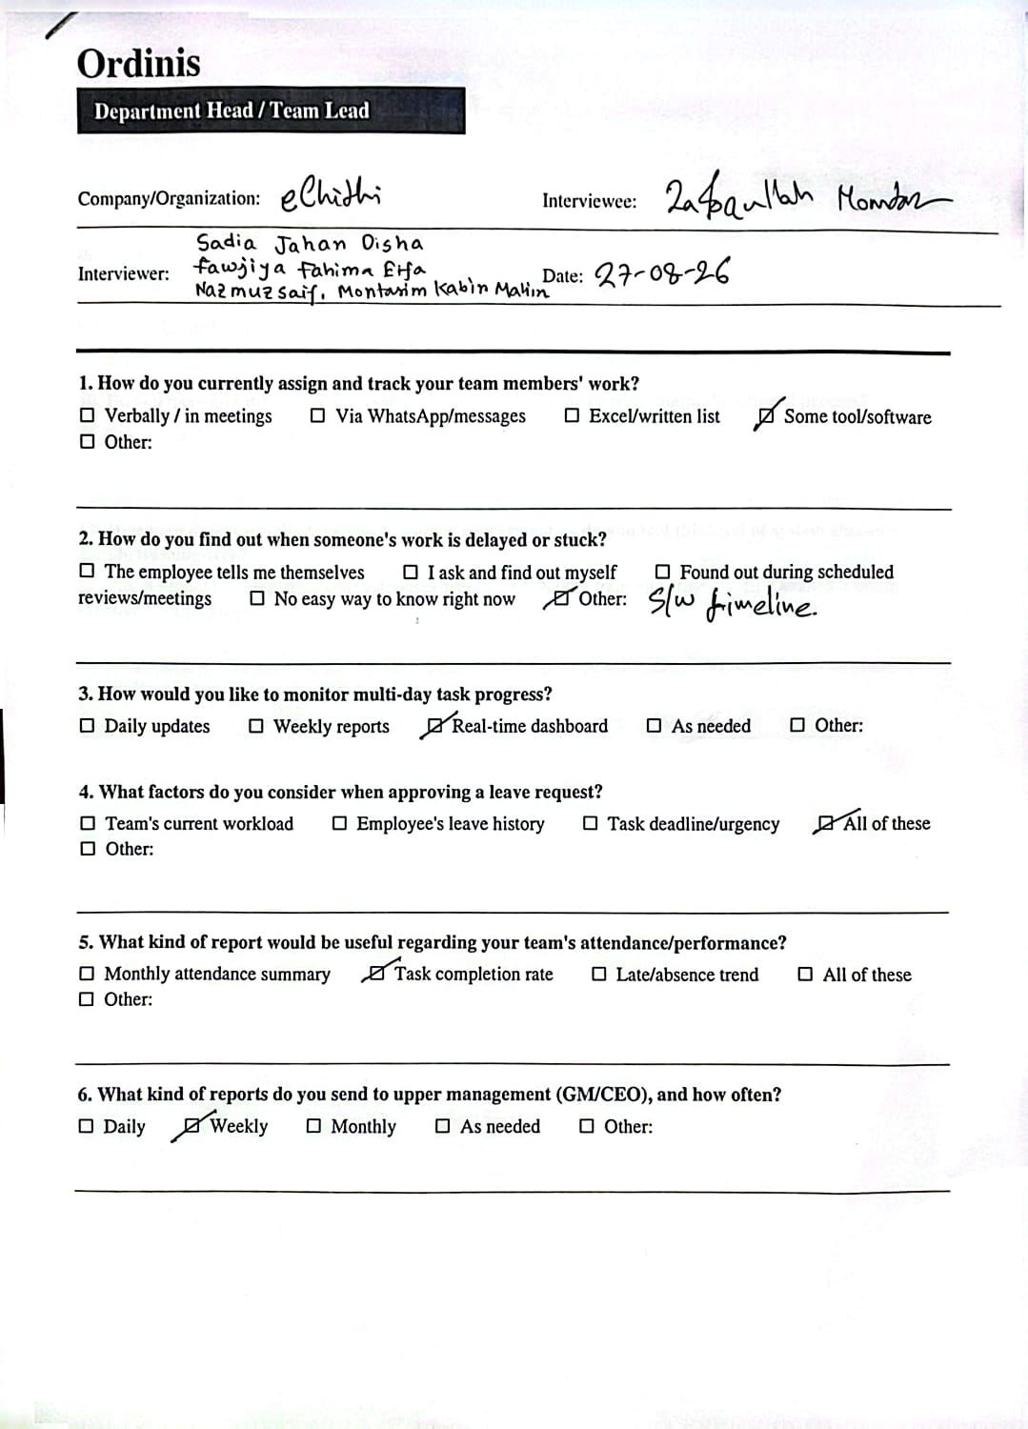

B.1.6 HR Executive Interview Response
Company/Organization: Slow Resorts Ltd.
Interviewee: Fardin Maula
Designation: HR Executive

Key Findings:
The HR executive highlighted employee lifecycle and HR process automation requirements.
The major requirements identified were:
- Digital onboarding process.
- Employee information and document management.
- Leave balance tracking.
- HR involvement in first-level leave approval.
- Notice period tracking during employee exit.
- Company announcements through email.
- Restricted access to performance review information.
- Separate HR roles and responsibilities.
- HR reports including attendance, leave utilization, and employee turnover.
- Employee self-update with HR approval.
- Audit trail for all important actions.
- Multiple notification channels.
The findings contributed to requirements related to HR management, employee lifecycle, leave management, RBAC, reporting, and auditability.

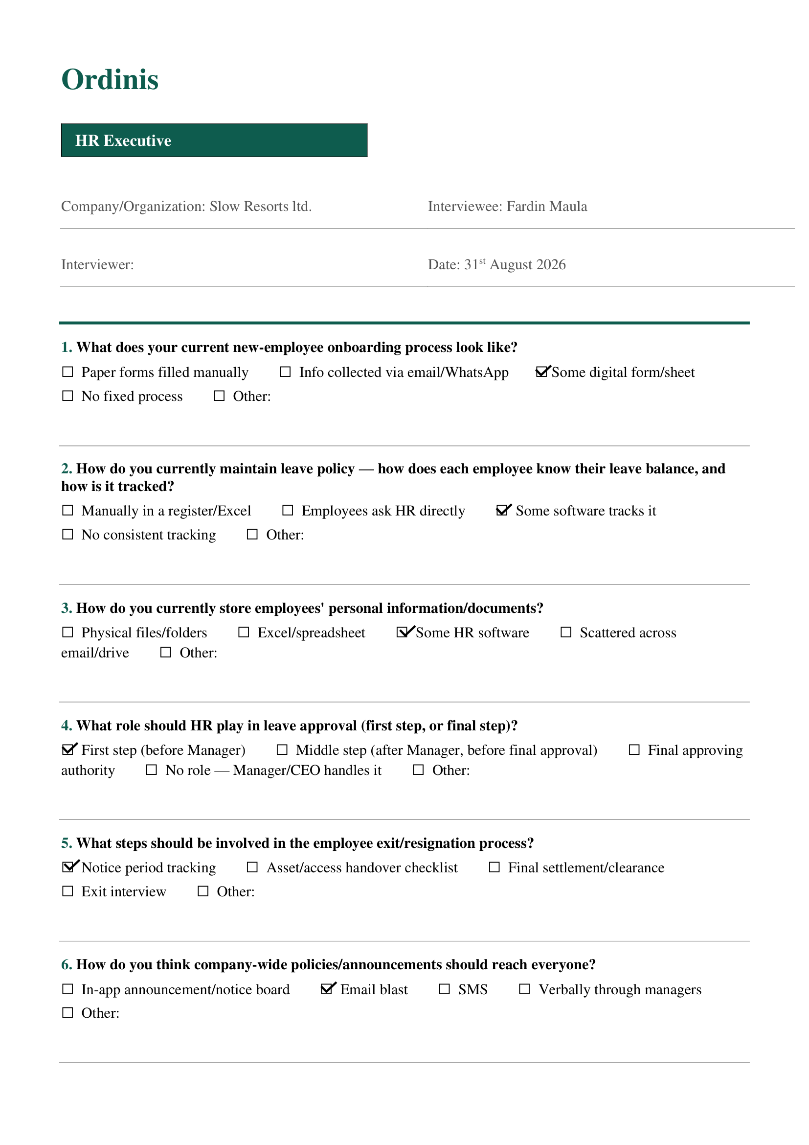
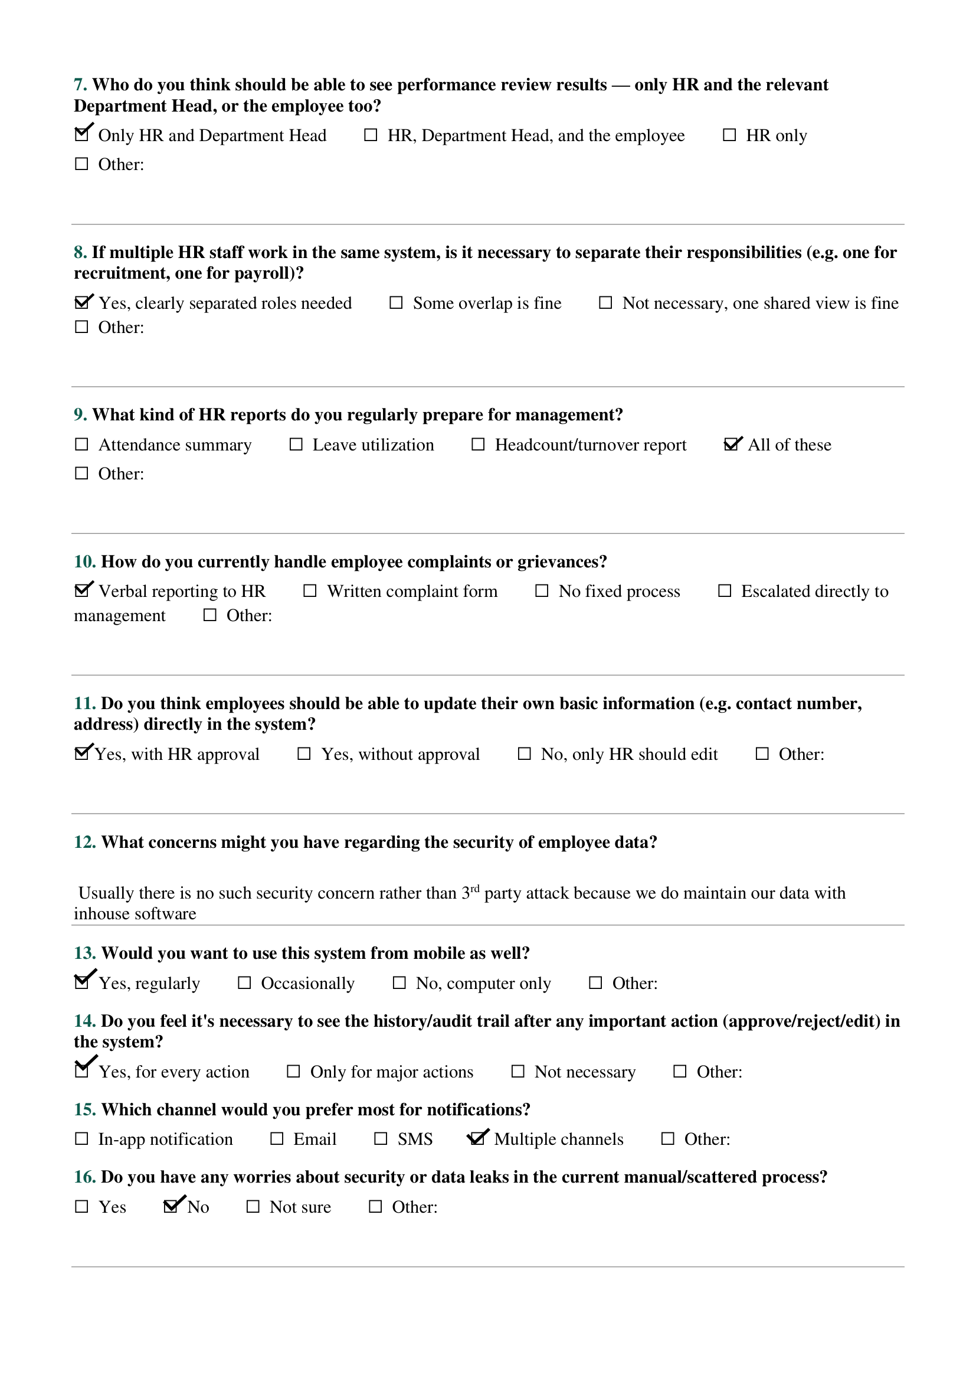
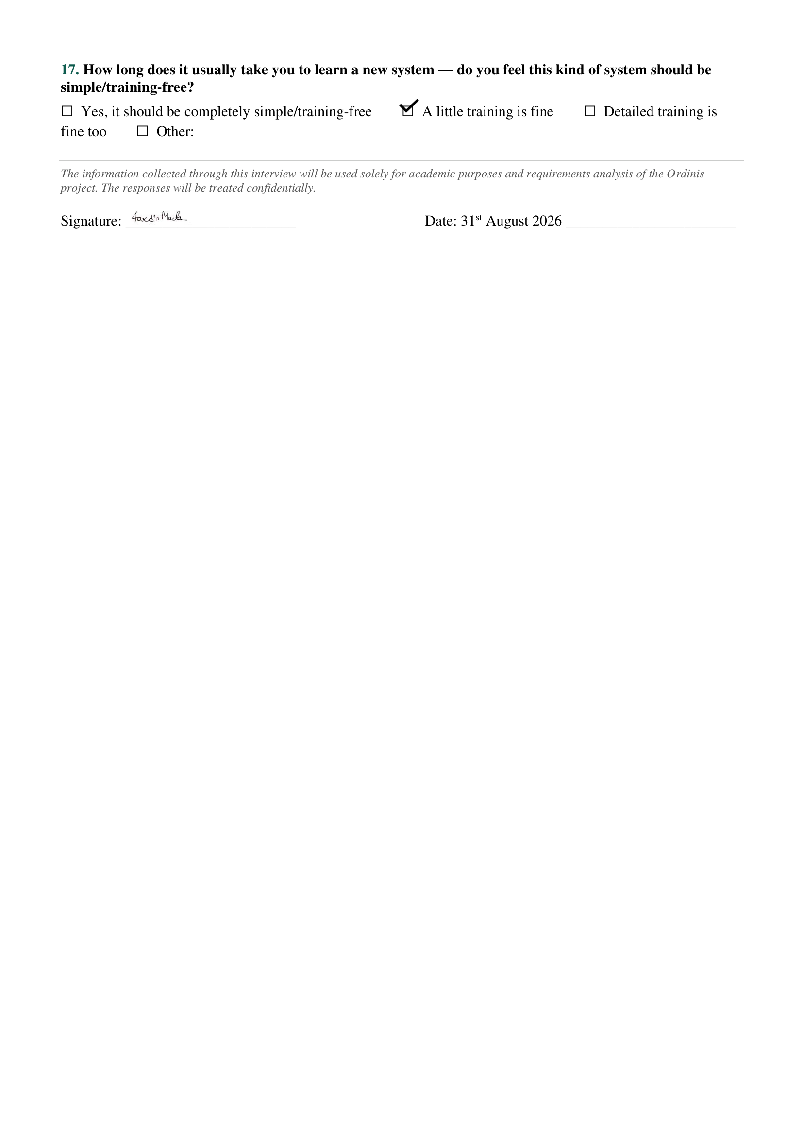

B.1.7 Accountant / Finance Executive Interview Response
Company/Organization: Onnorokom Group
Interviewee: Sadnan Saeeb
Designation: Accountant / Finance Executive

Key Findings:
The finance executive highlighted payroll accuracy and financial control requirements.
The major requirements identified were:
- Attendance and leave linked payroll processing.
- Salary deduction and allowance management.
- Payroll reports in Excel/PDF format.
- Controlled access to financial information.
- Voucher-based expense approval.
- API connection with existing accounting software.
- CEO/HR review before payroll finalization.
- Financial reports including payroll summary, expense summary, and budget versus actual reports.
- Payment status tracking.
- Financial data security.
- Mobile access support.
- Audit history for major financial actions.
- In-app and WhatsApp notifications.
The findings contributed to requirements related to payroll, expense management, financial security, integration, reporting, and auditability.
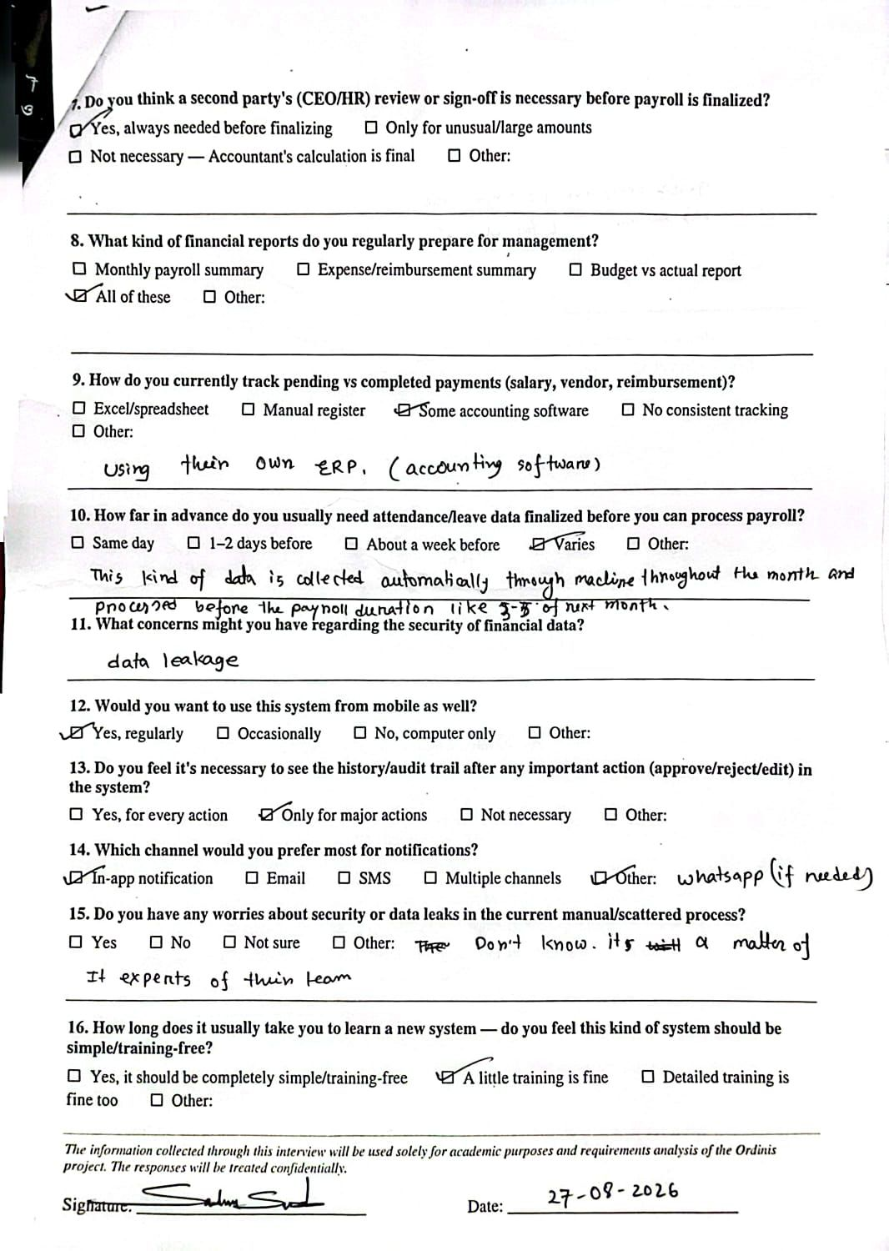
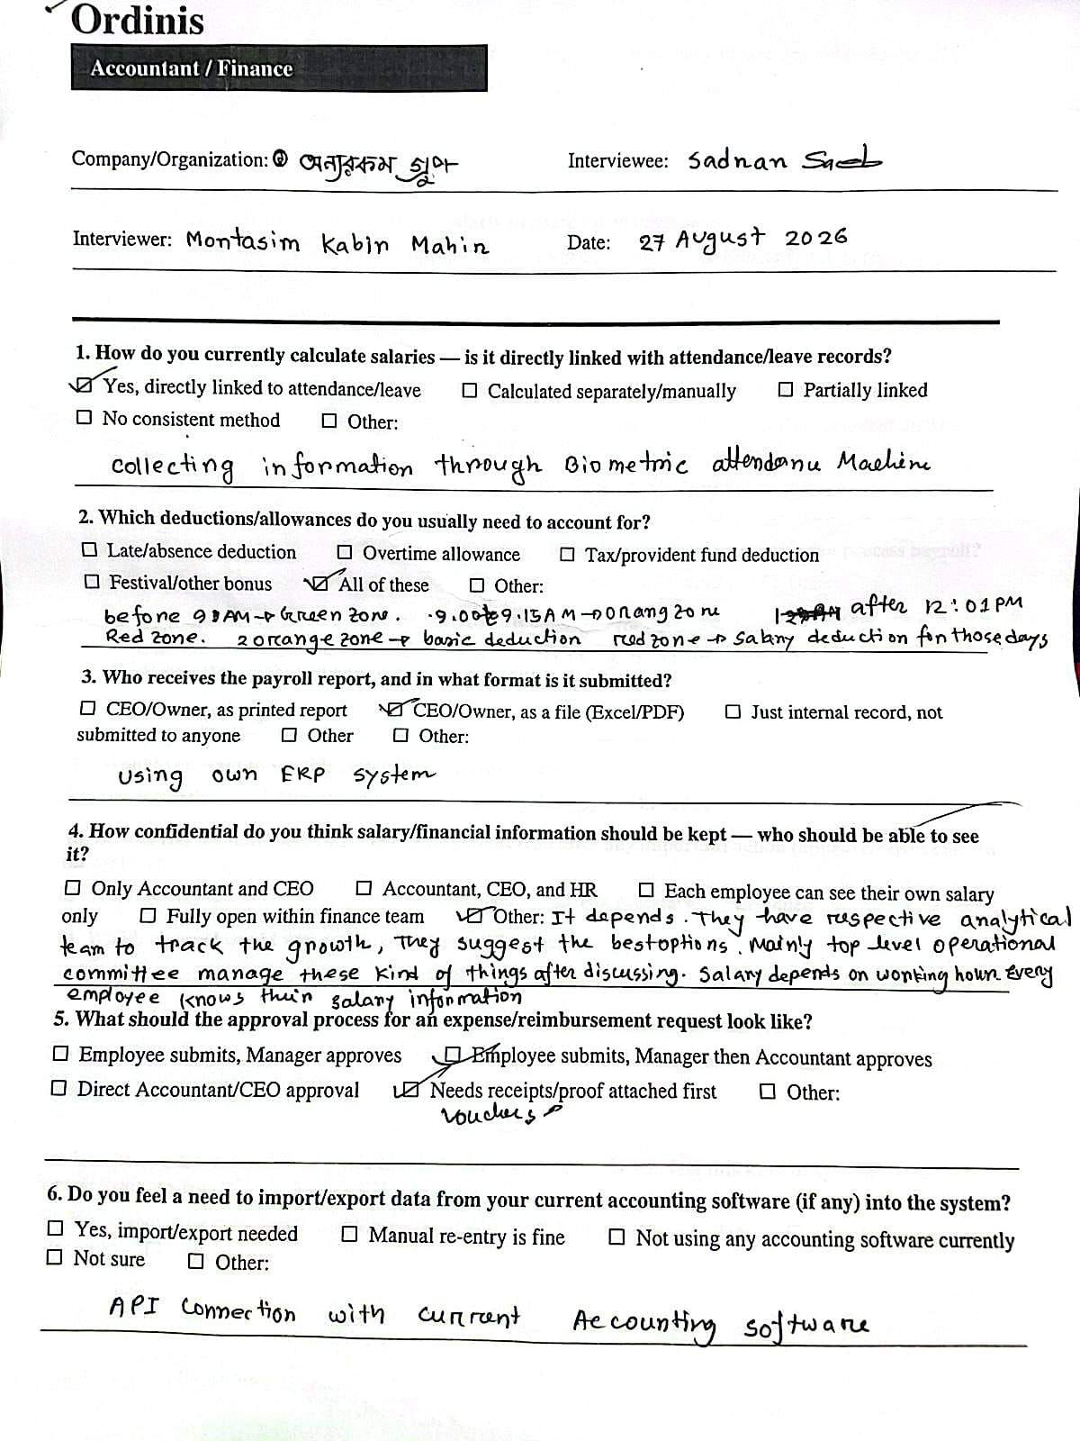

B.1.8 Accountant / Finance Executive Interview Response
Company/Organization: A&I Group
Interviewee: Sabbir Islam
Designation: Accountant / Finance Executive

Key Findings:
The accountant focused on payroll automation and financial confidentiality.
The major requirements identified were:
- Attendance and leave based salary calculation.
- Salary deductions and allowance handling.
- CEO/Owner payroll reports.
- Restricted salary visibility for Accountant, CEO, HR, and individual employees.
- Expense approval workflow:
- Employee-- Manager --Accountant --CEO
- Import/export support with accounting software.
- CEO/HR review before payroll finalization.
- Budget versus actual financial reporting.
- Payment tracking through accounting software.
- Mobile accessibility.
- Complete audit history.
- In-app notifications.
- Simple user-friendly system.
The findings contributed to requirements related to payroll, expense workflow, approval process, security, audit logging, and usability

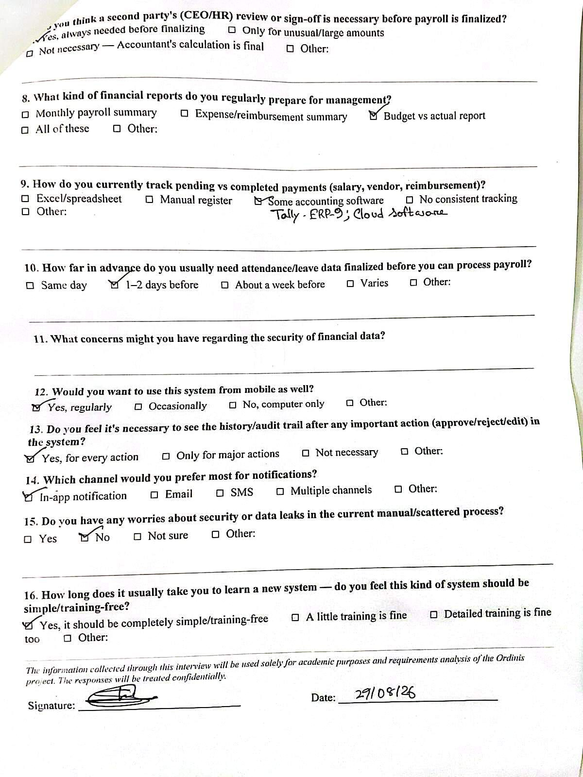
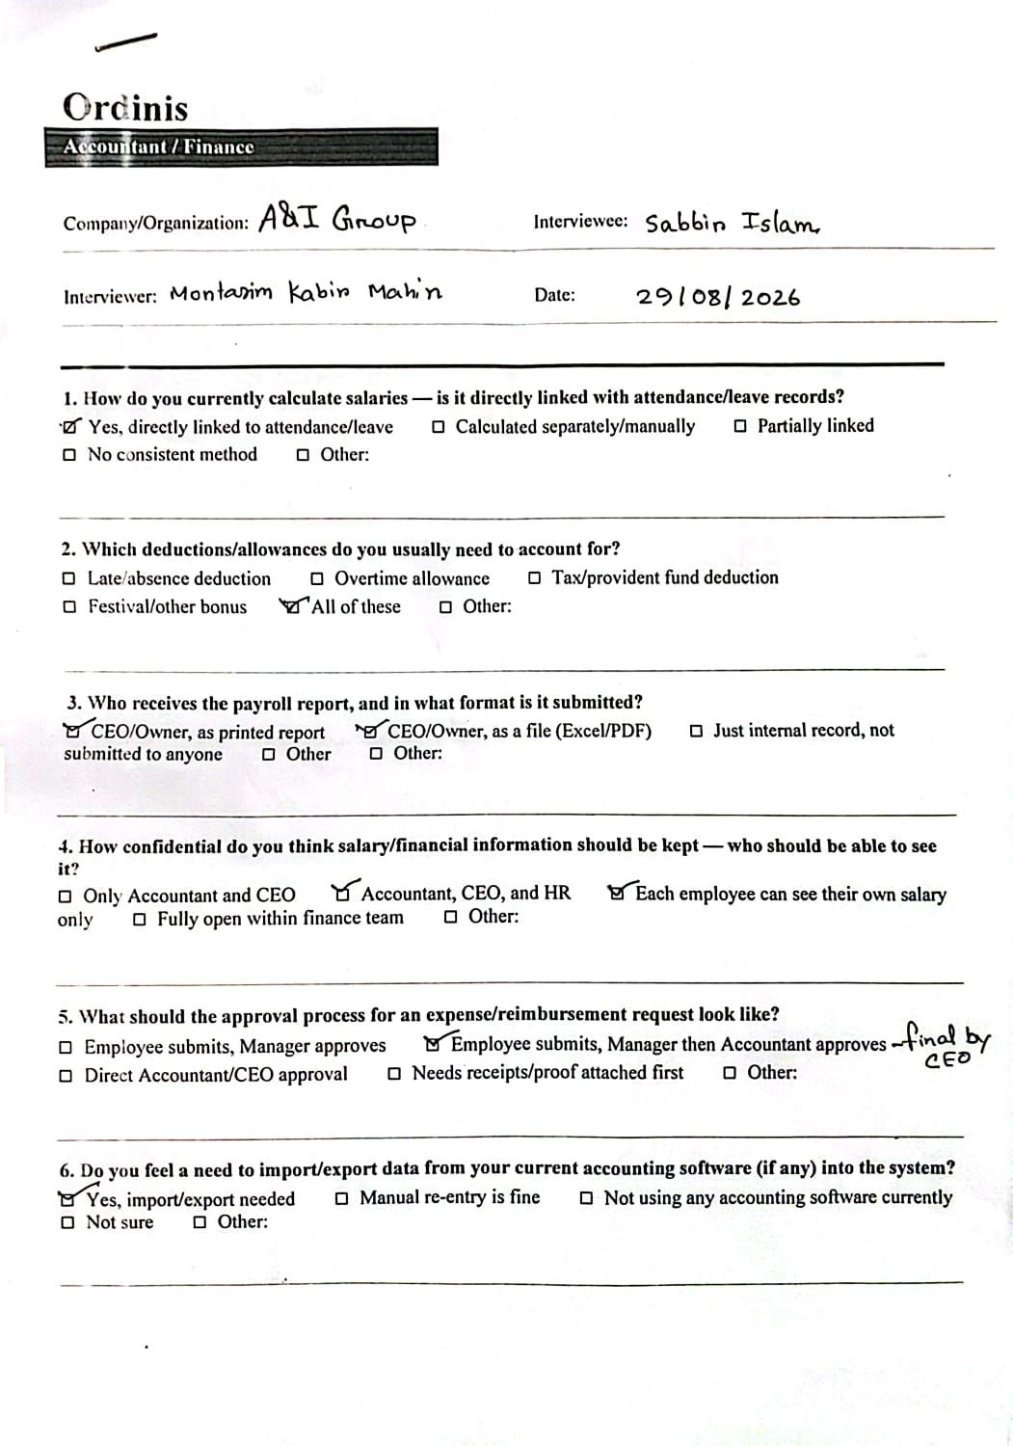

B.1.9 Employee Interview Response
Company/Organization: Neural Semiconductor
Interviewee: Taufiqur Rahman Anik
Designation: Employee

Key Findings:
The employee focused on simple daily workflow access.
The major requirements identified were:
- Attendance tracking through application.
- Task progress reporting through system.
- Leave application with status visibility.
- Salary slip and attendance record access.
- Dashboard showing attendance status.
- App and email notifications.
- Leave approval status visibility.
- Correction request submission for incorrect attendance/task history.
- Audit history for important actions.
- Simple and training-free user experience.
The findings contributed to requirements related to employee dashboard, attendance, leave management, notifications, usability, and auditability

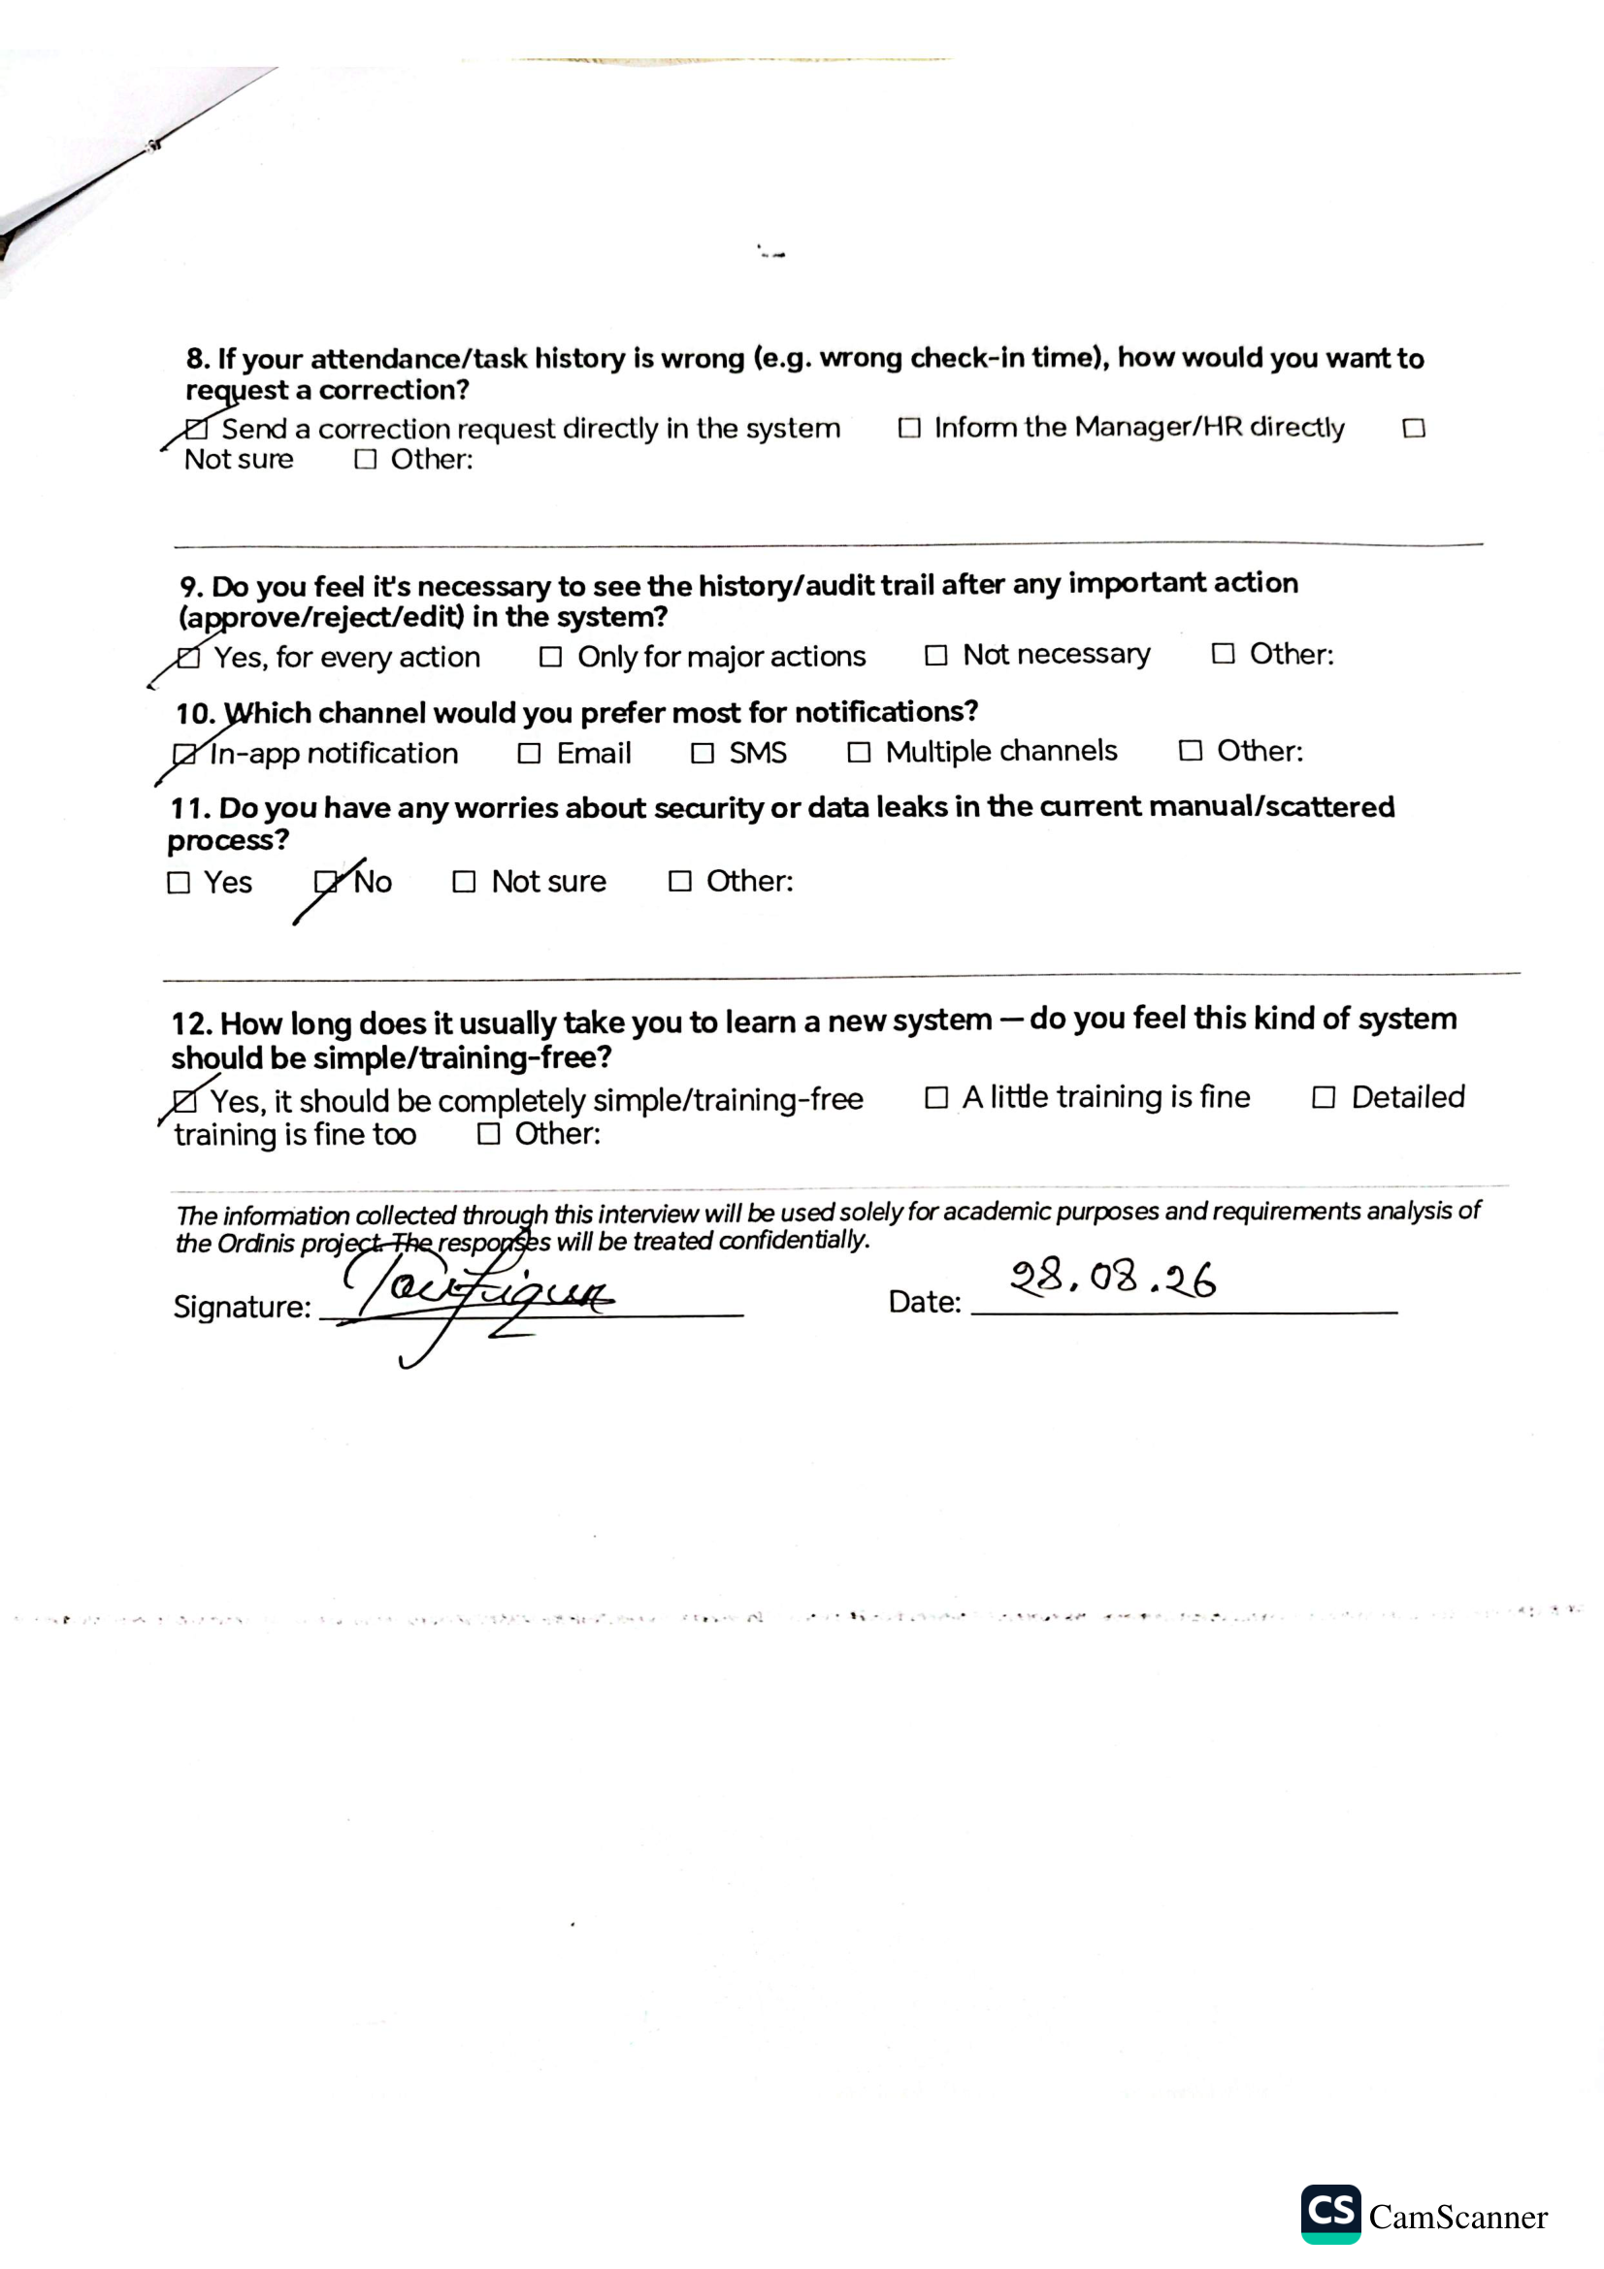
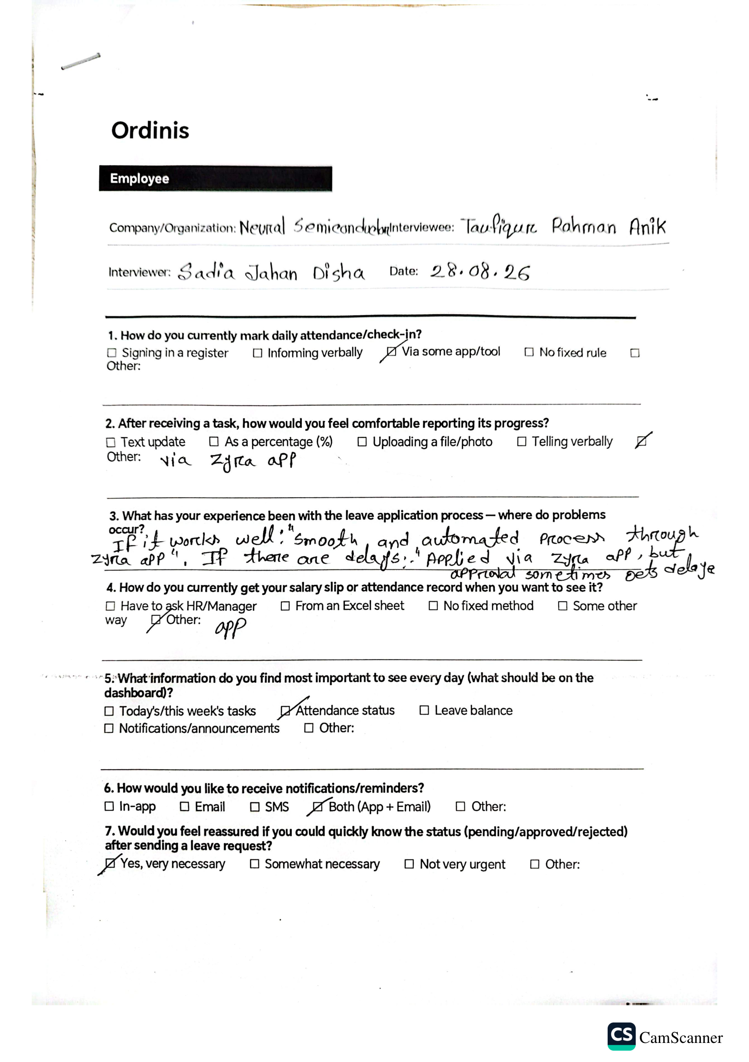

B.1.10 HR Executive Interview Response
Company/Organization: BluBird Interactive Ltd.
Interviewee: Shah Md Mahahmudul Hasan
Designation: HR Executive

Key Findings:
The HR executive identified challenges with manual HR operations.
The major requirements identified were:
- Digital onboarding instead of paper forms and email-based processes.
- Centralized employee documents instead of physical files and spreadsheets.
- Employee leave balance visibility.
- Asset and access handover checklist during exit.
- In-app announcements and notice board.
- Separated HR responsibilities through role-based access.
- Attendance summary reports.
- Employee request and complaint management.
- Employee profile updates with HR approval.
- Strong employee data security and access control.
- Audit history for HR actions.
- Email-based notifications.
The findings contributed to requirements related to HR automation, employee management, RBAC, notifications, audit logging, and data privacy.

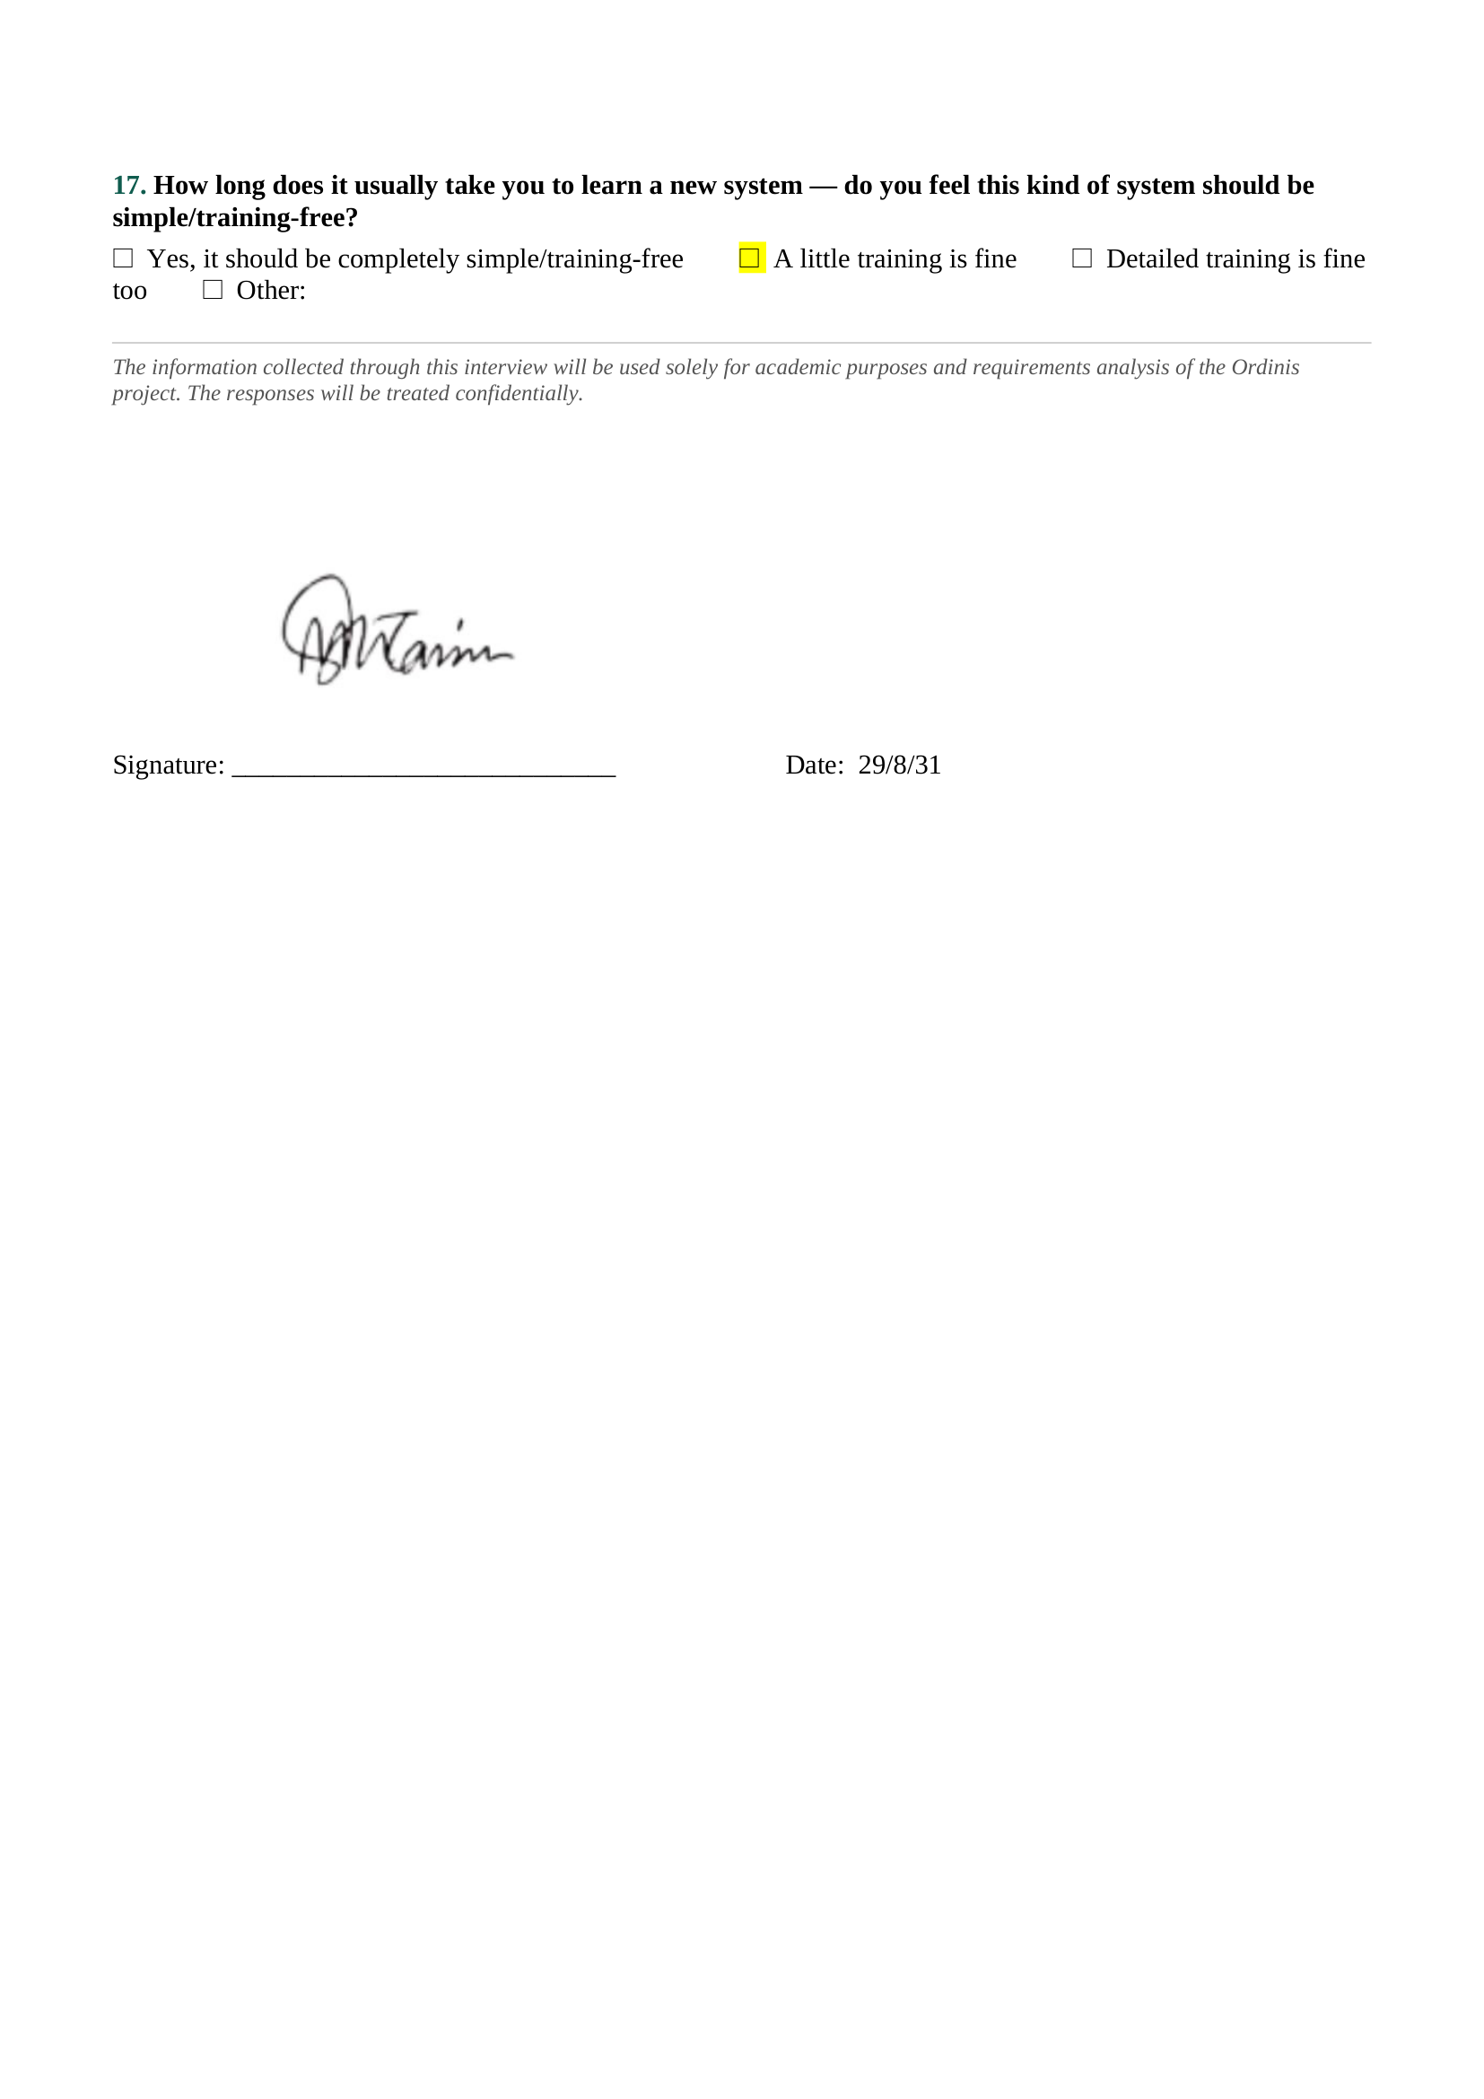
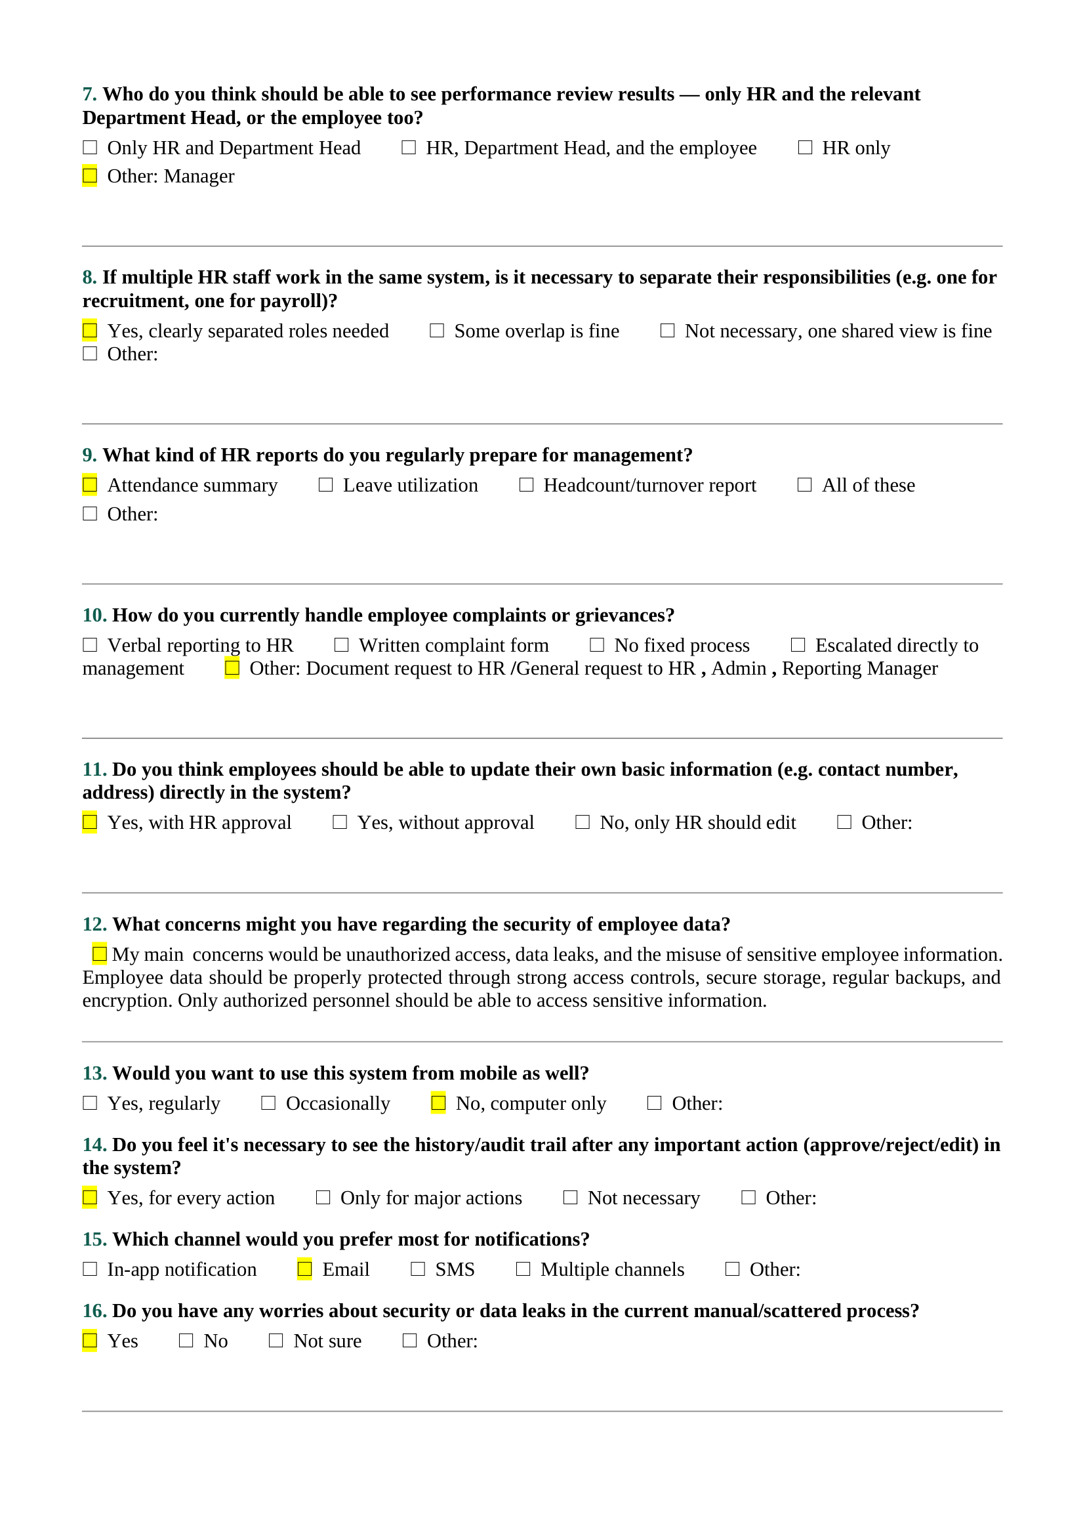
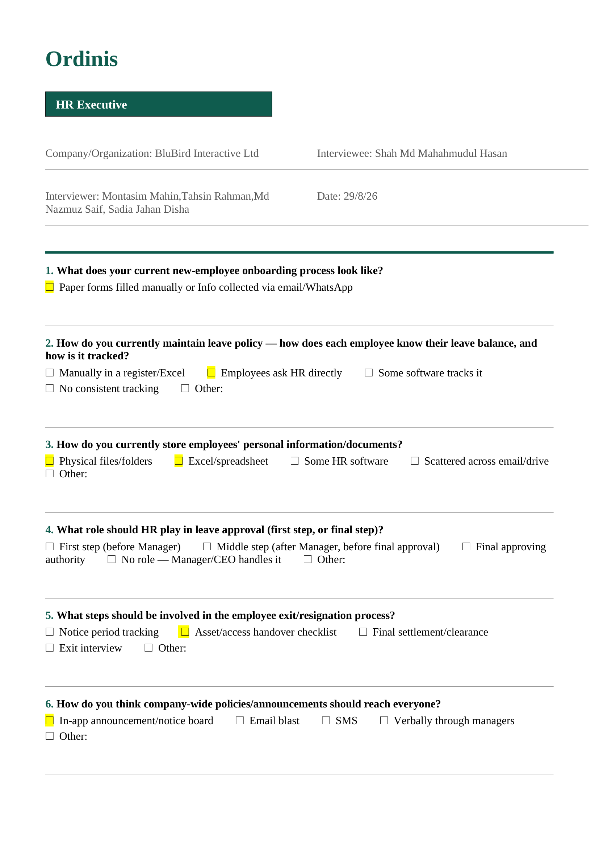

B.1.11 Department Head / Team Lead Interview Response
Company/Organization: Eurotex Ltd.
Interviewee: Sabrina Islam
Designation: Department Head / Team Lead

Key Findings:
The Department Head highlighted team monitoring and workflow visibility requirements.
The major requirements identified were:
- Software-based team task tracking.
- Monitoring delayed work through review process.
- Real-time dashboard for task progress.
- Leave approval based on workload, leave history, and deadlines.
- Task completion rate reporting.
- Monthly reports for upper management.
- Predetermined deputy delegation during absence.
- Audit history for every action.
- Multiple notification channels.
- Training support for system usage.
The findings contributed to requirements related to team management, task tracking, reporting, approval workflow, delegation, and auditability.
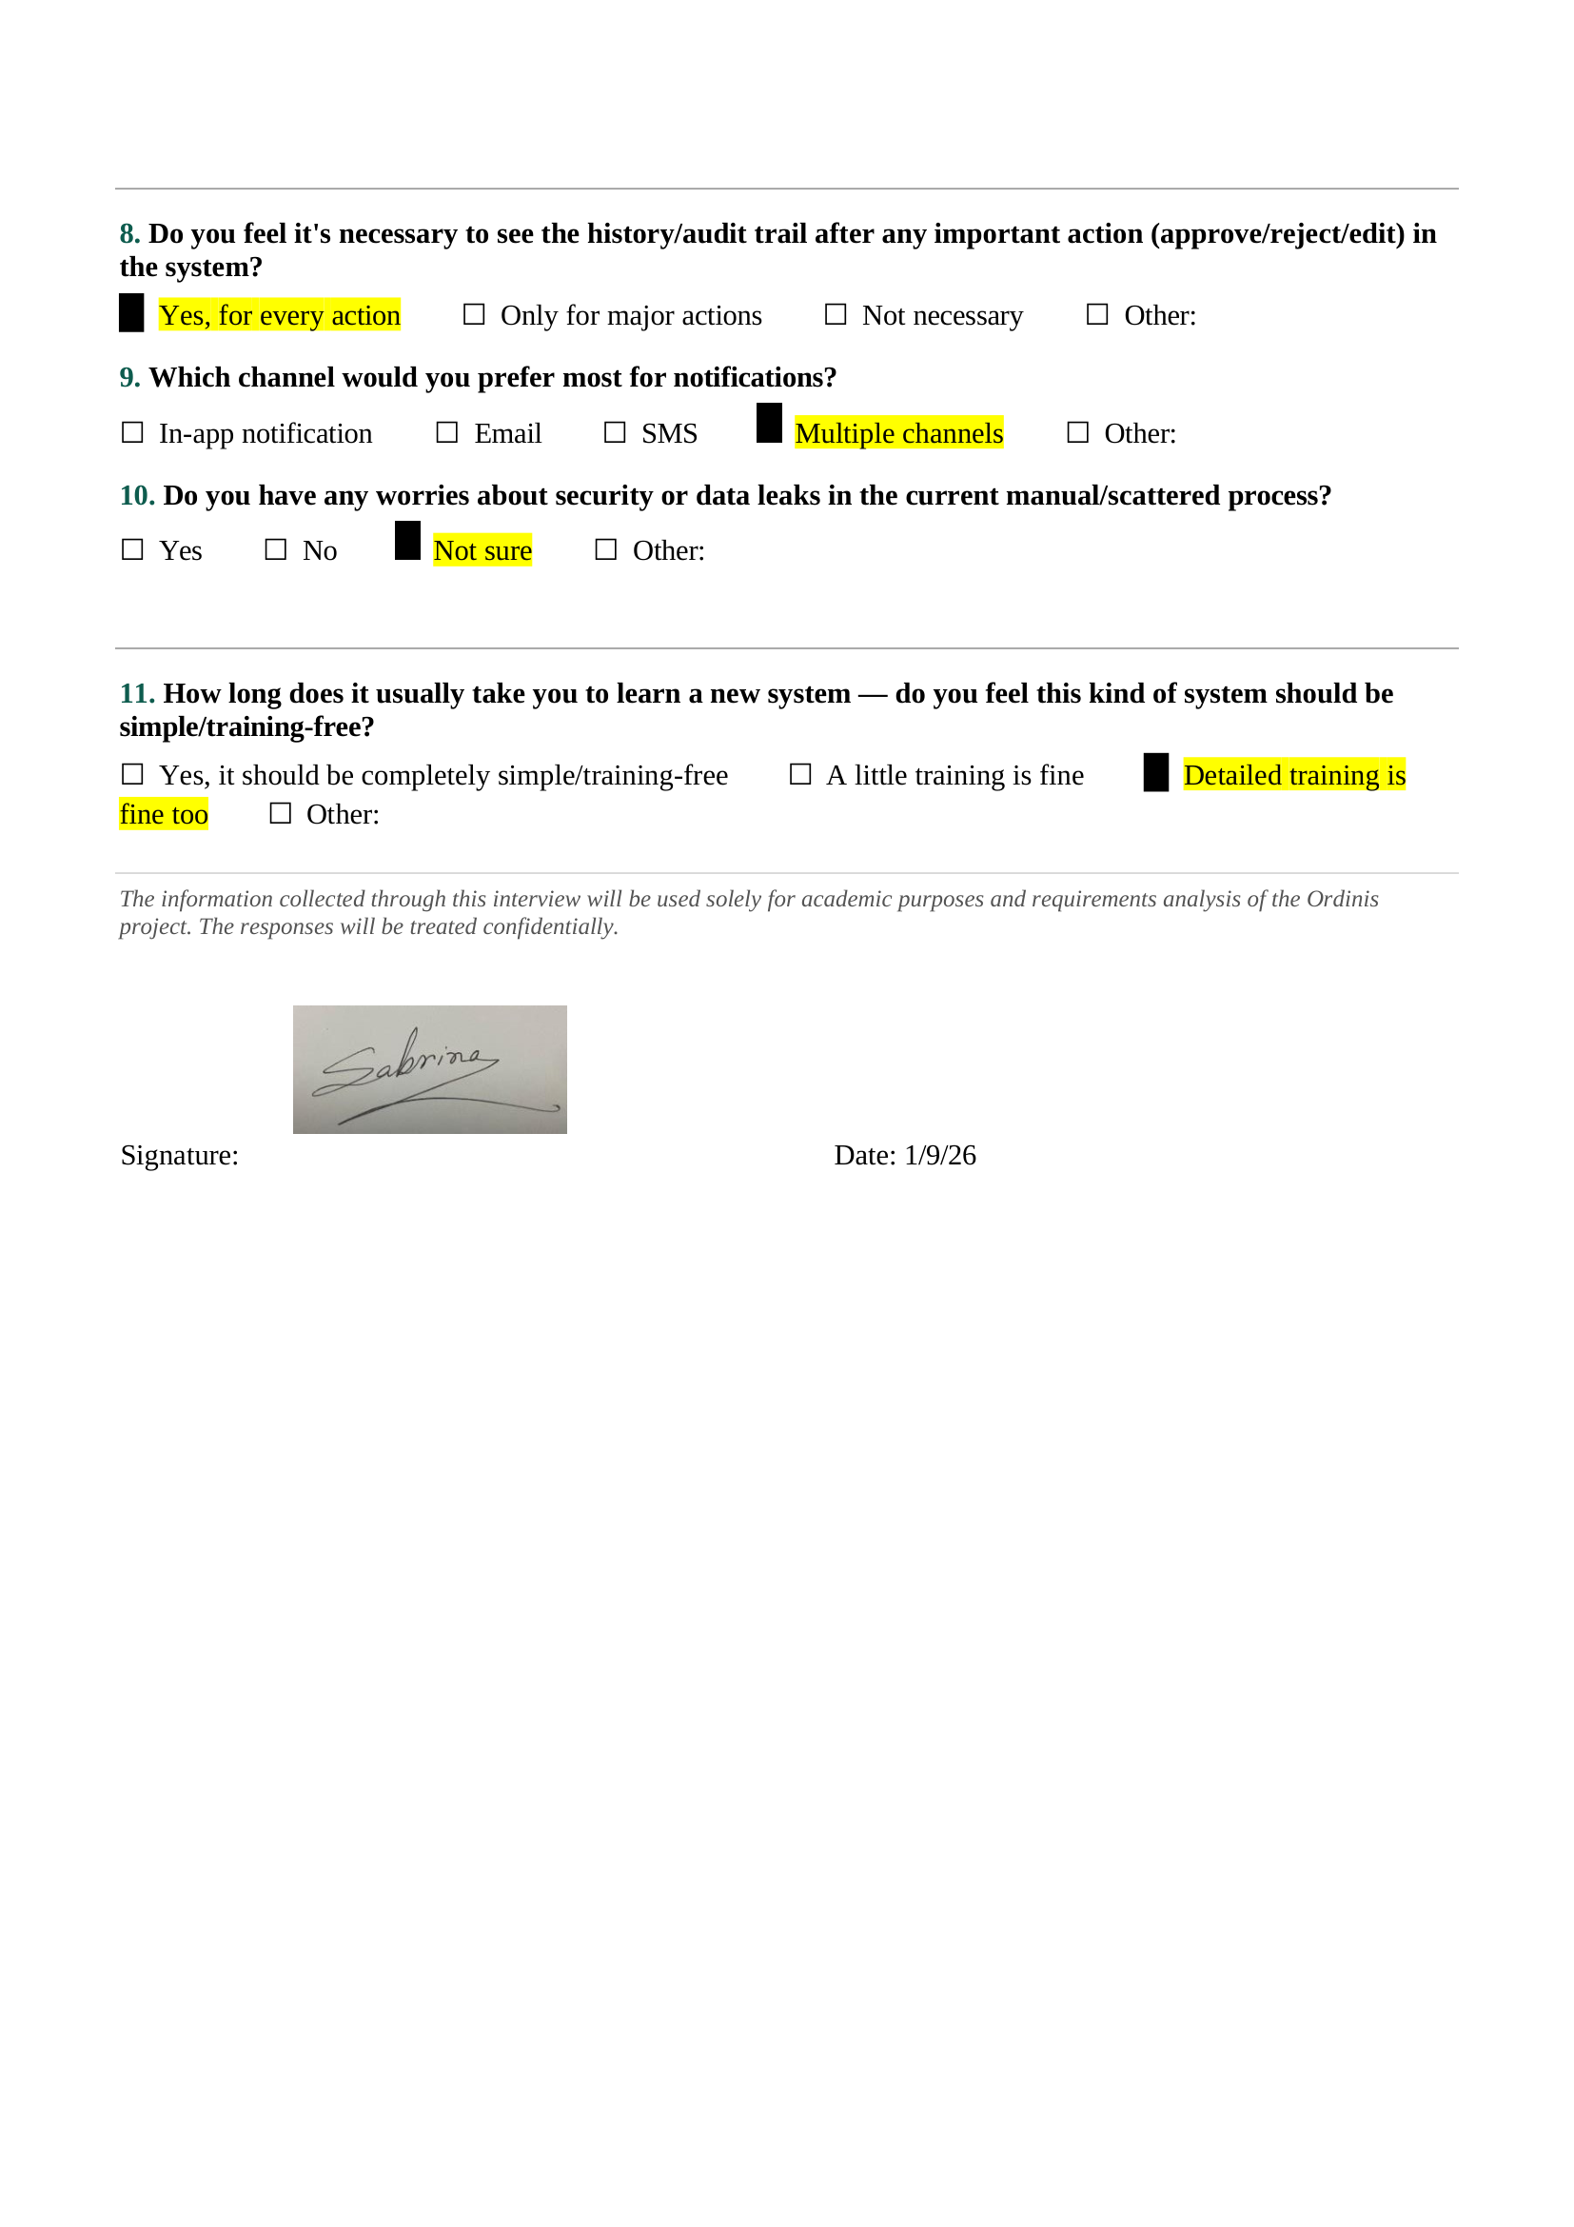
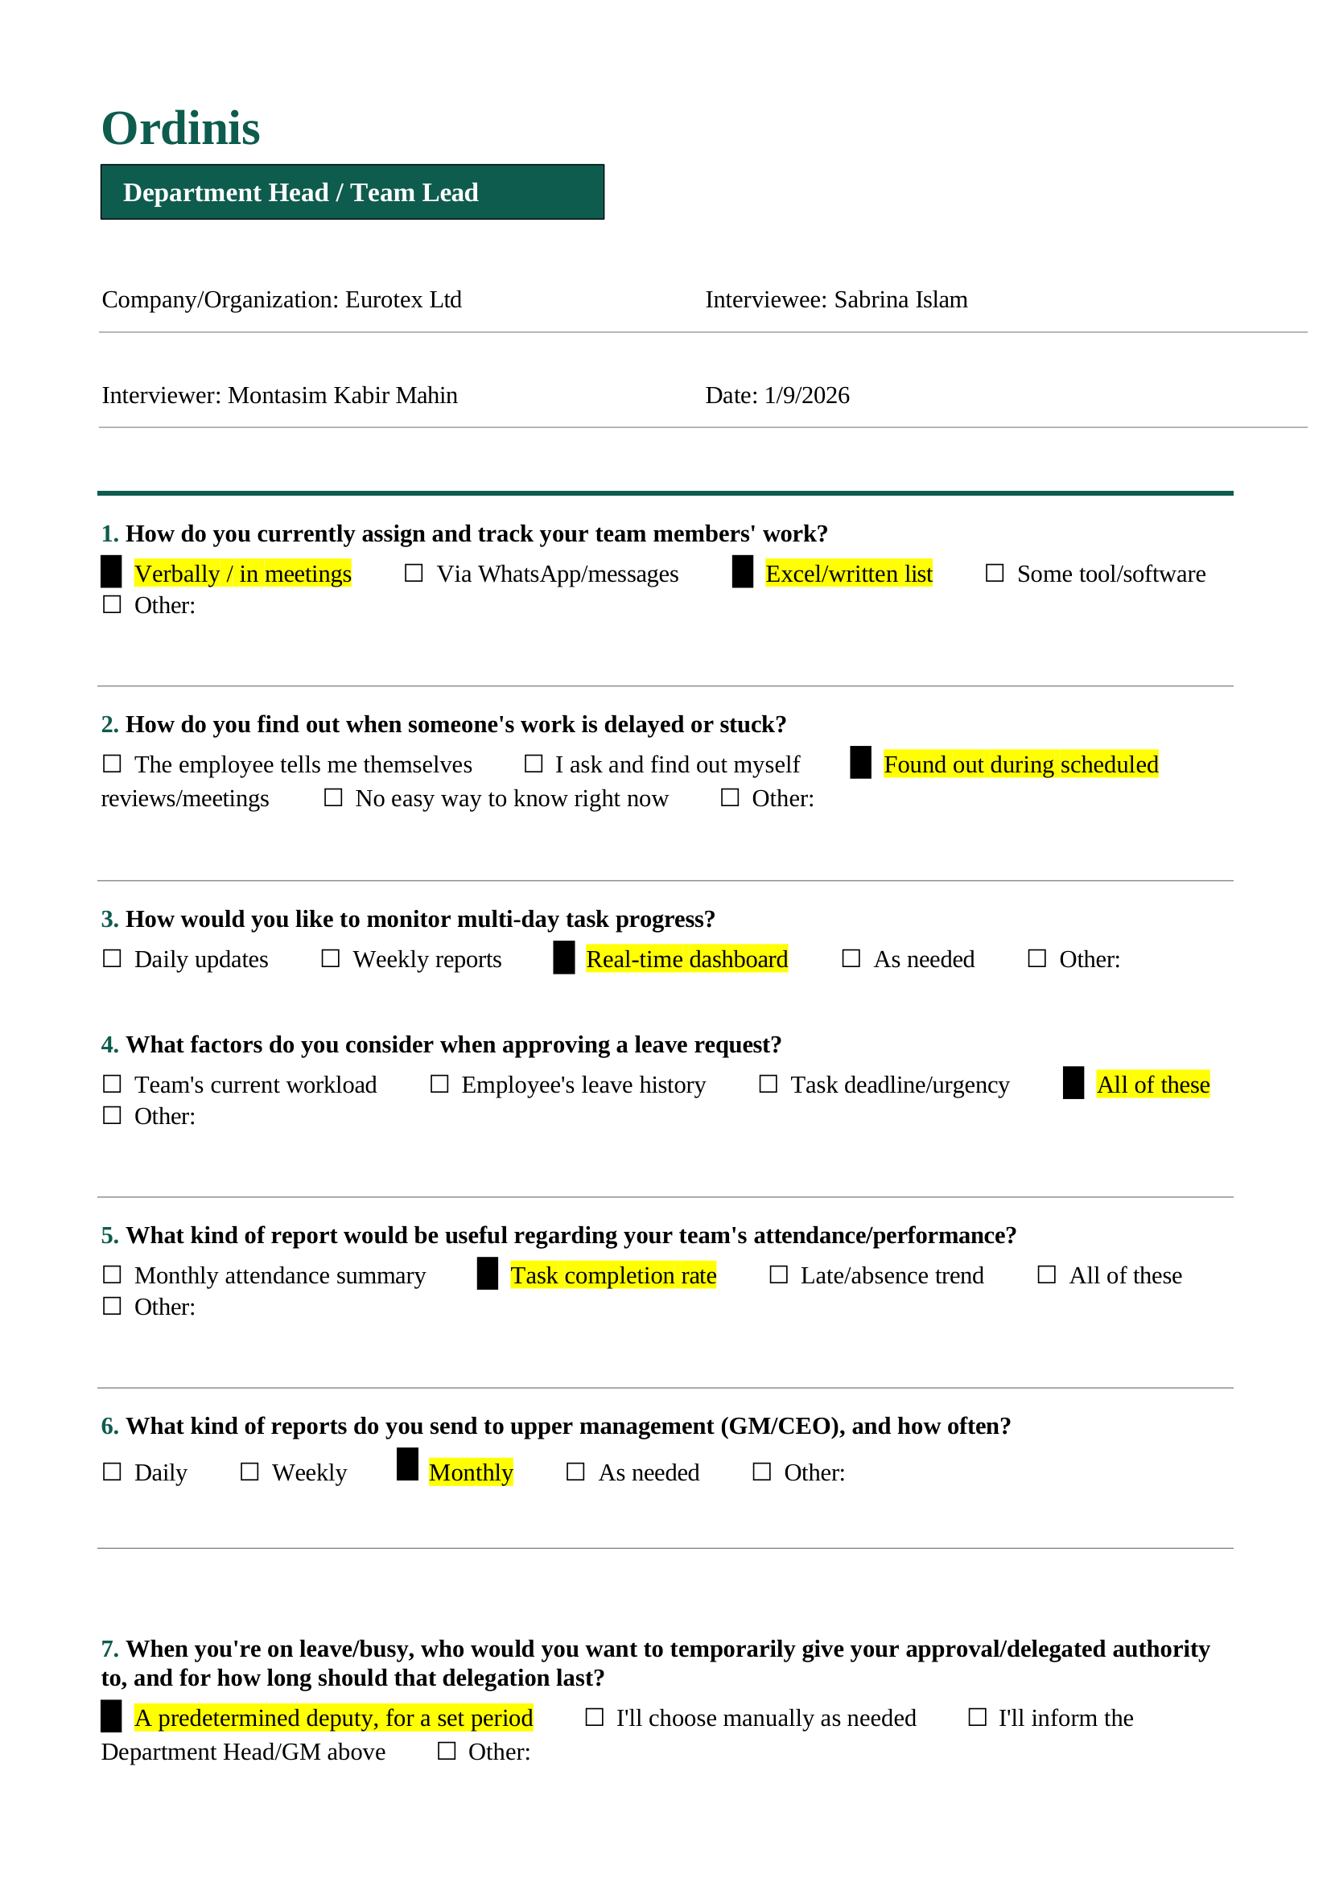

B.1.12 Department Head / Team Lead Interview Response
Company/Organization: Synosis
Interviewee: Redwan Rakib
Designation: Department Head / Team Lead

Key Findings:
The Department Head focused on team-level monitoring and task execution.
The major requirements identified were:
- Team task assignment and tracking.
- Identification of delayed or stuck tasks.
- Real-time dashboard with sub-task tracking.
- Leave approval based on workload, employee history, and deadlines.
- Monthly attendance summary and task completion reports.
- Performance reports for upper management.
- Temporary approval delegation through approved backup persons.
- Complete audit history for important actions.
- Secure access control to prevent unauthorized information access.
- Simple and understandable system design.
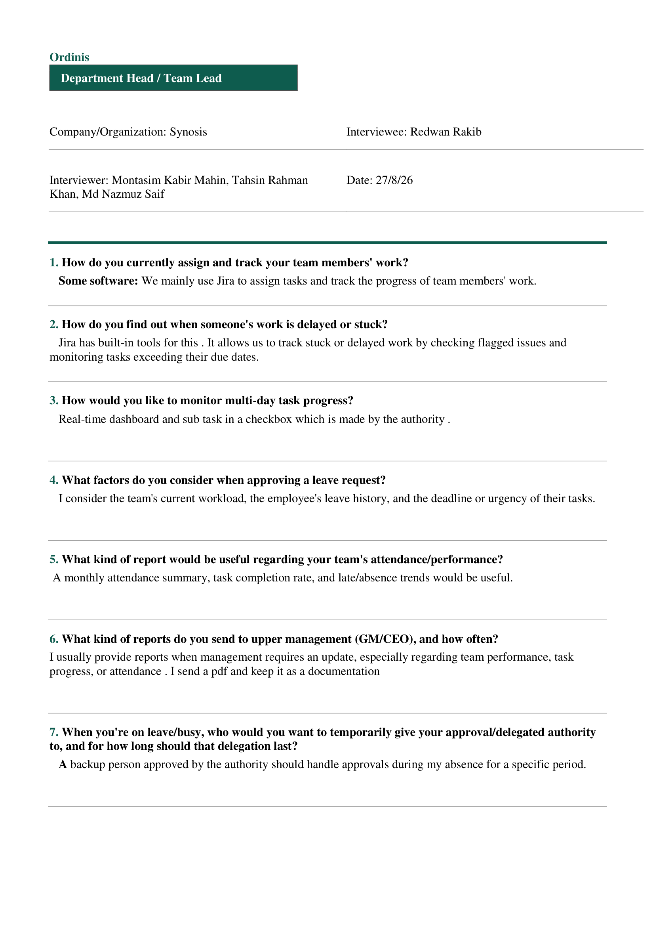
The findings contributed to requirements related to task management, attendance, leave, reporting, delegation, and security.
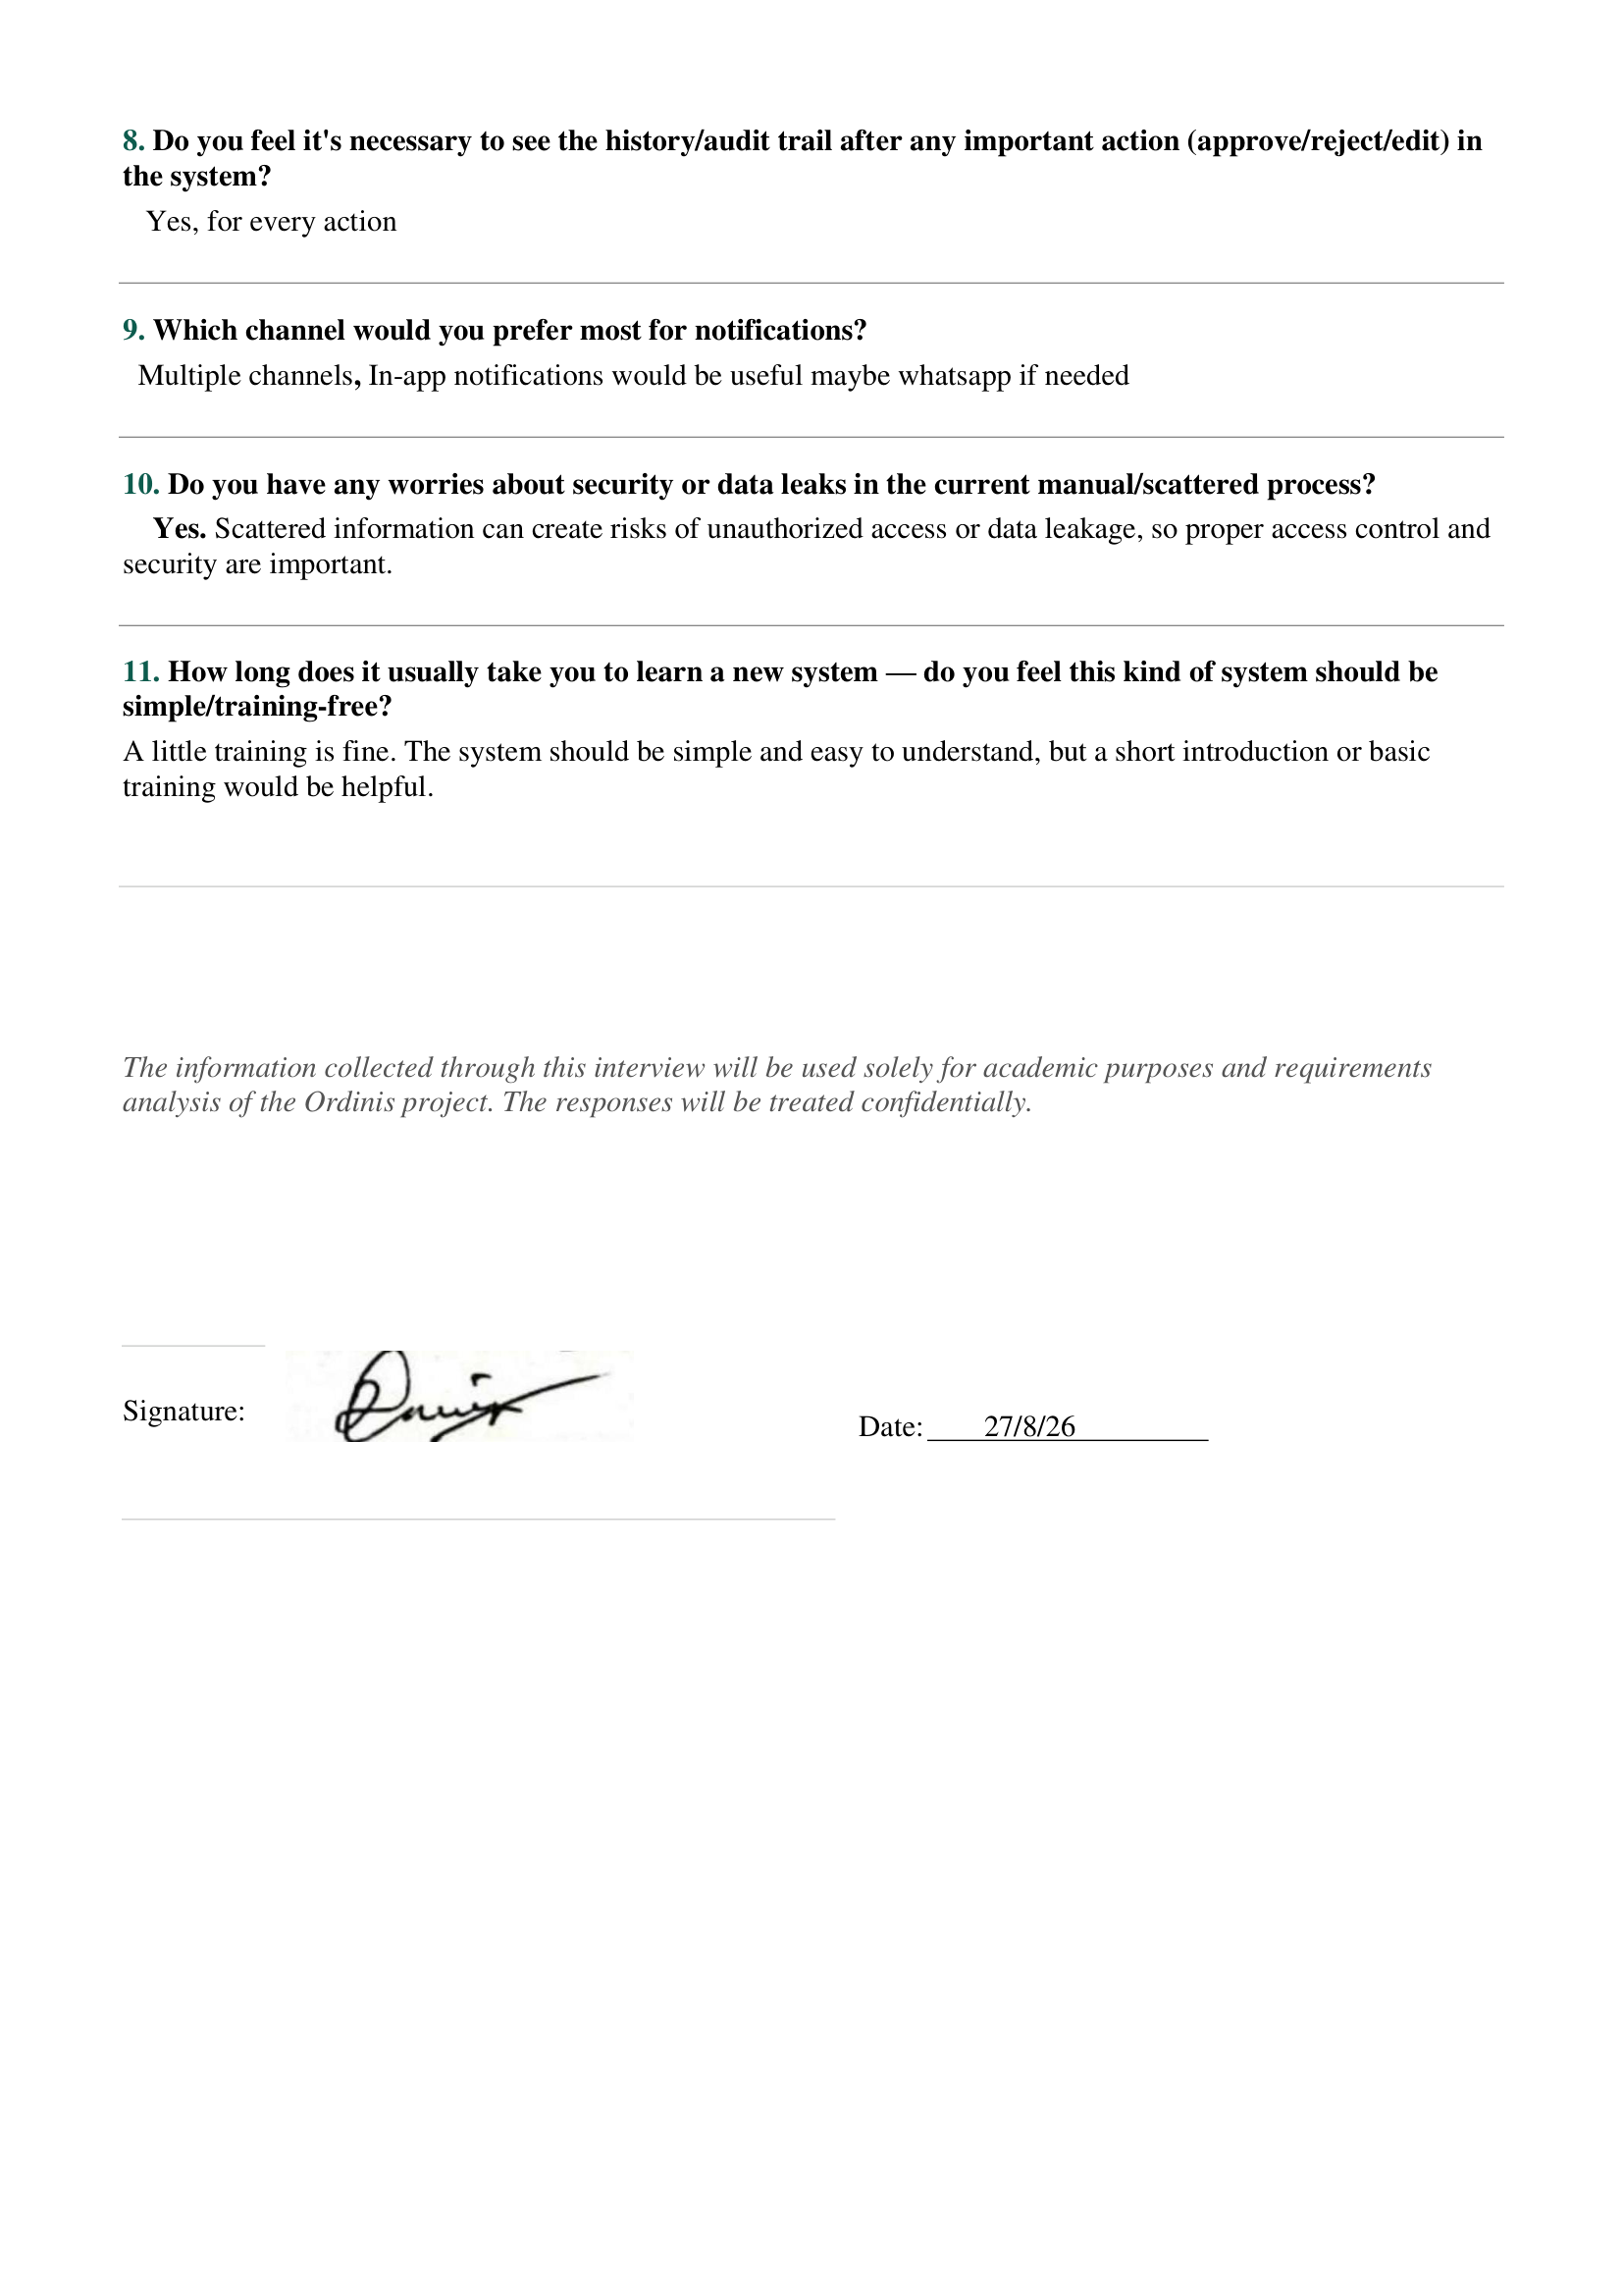

B.2 Employee Survey Responses and Statistics
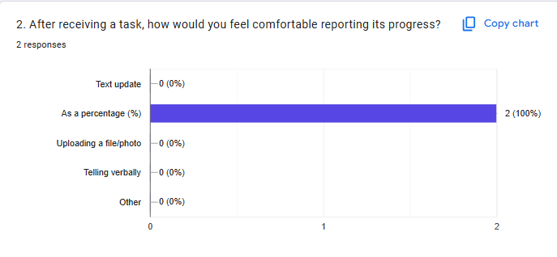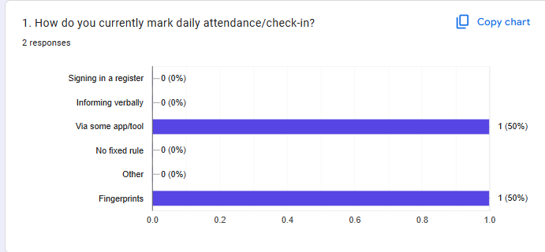

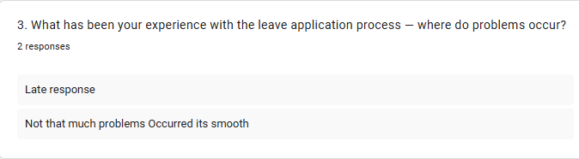
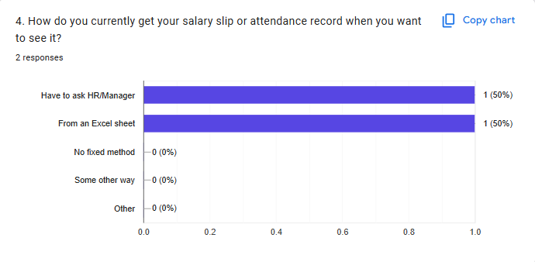

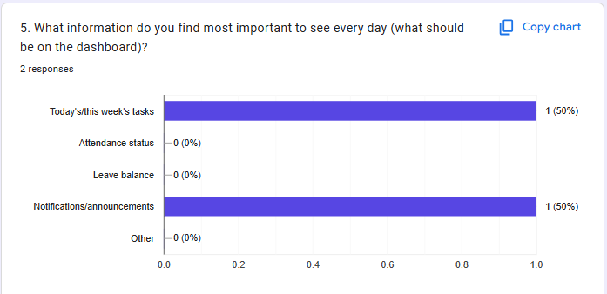

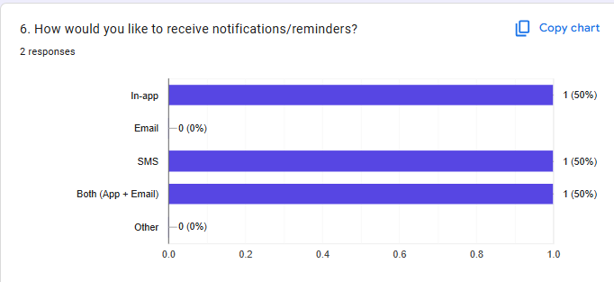
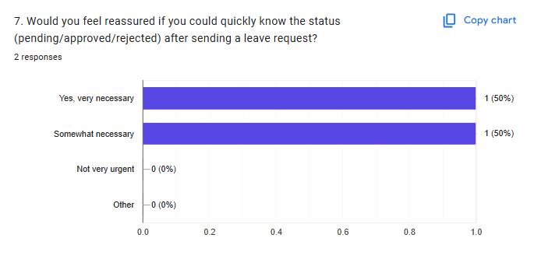
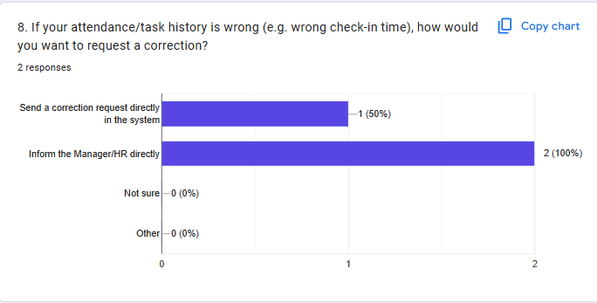

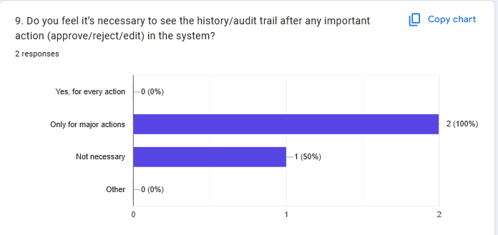

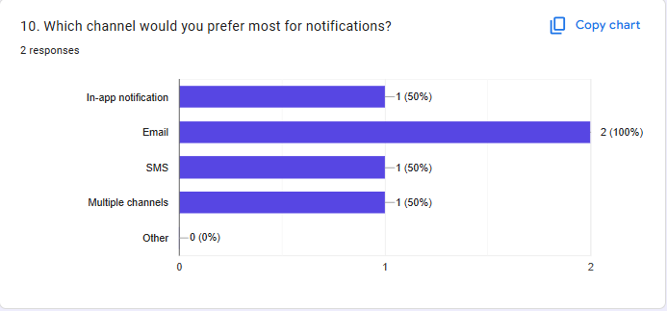
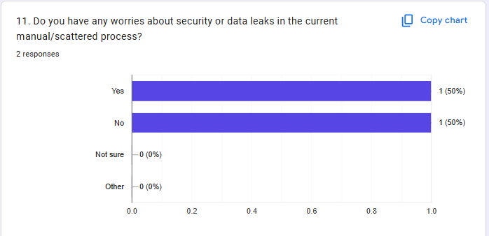

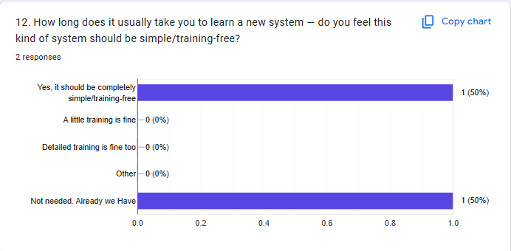

ALL Images, Interview Pdfs, Google Meet recording are here In this Drive Link as a proof:
https://drive.google.com/drive/folders/16KnTUsI9reSDEuSzyiEfnifE2O5_PlY7?usp=drive_link

google form responder link:
https://docs.google.com/forms/d/e/1FAIpQLSdu7d2_apg_Wm84NYJZLuTu3pdlVCXkEGsTj19jTblZsHiQRg/viewform?usp=dialog

