Login successful-username&password

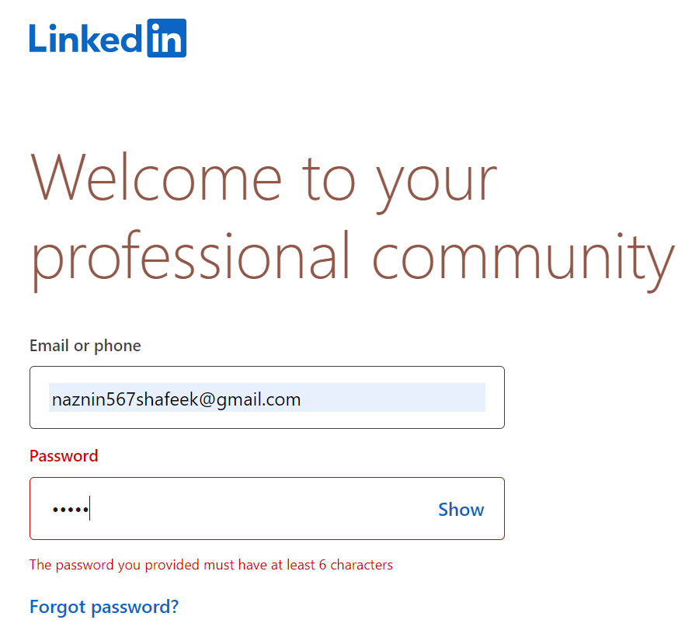

Login unsuccessful

Incorrect password

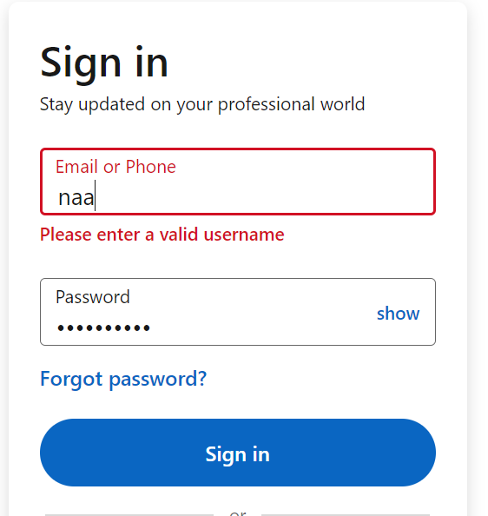

Login unsuccessful

Invalid username

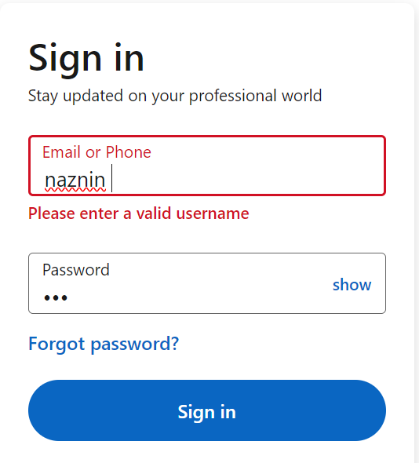

Login unsuccessful

Invalid username and Invalid password