
Department of Computer Science and Engineering
Final Project Report
BONDHU
A Bengali-Speaking Multimodal Assistive Companion Robot for Elderly Care
Course: Microprocessors and Microcontrollers Laboratory (CSE 4326)
Group No: 03, Section E
Submitted To:
Md.Abid Hossain, Lecturer, Department of CSE

Submitted by:
Naznin Sultana Tonni (0112330125)
Md. Rokan Uddin (0112330735)
Fatema Tuz Zohura Rifa (0112330722)
Raunak Binte Islam Faiza (0112330953)
Talha Jubayer (0112410062)
Atiqur Rahman Atiq (0112330317)

1. Abstract
BONDHU is a Bengali-speaking, multimodal assistive companion robot designed to support elderly individuals living alone or with limited supervision. Built with a Raspberry Pi 5 and a suite of sensors, the system combines a Bangla voice interaction pipeline, mmWave radar and camera-based human tracking, health and vitals monitoring, and a live caregiver dashboard to deliver both safety and companionship at home. This report documents the motivation, system design, implementation, results achieved, challenges faced, and future direction of the project, carried out as the final project for the Microprocessors and Microcontrollers Laboratory course.

2. Introduction and Motivation
A large share of elderly individuals live with chronic health conditions, often alone or without close supervision. Safety issues such as falls, prolonged inactivity, or fever frequently go undetected until it is too late, and no affordable monitoring solution exists for most households. Medication adherence is a further concern, as elderly patients often forget doses or have no one present to remind or confirm intake.
Existing smart home eldercare assistants are almost entirely English-based and cloud-dependent, which excludes Bangla-speaking elderly users and fails during internet outages. Family members and caregivers are also often not physically present or immediately reachable, so by the time an emergency is noticed, critical response time has already been lost.
BONDHU was conceived to directly address this gap.A low-cost, Bangla-speaking companion robot that stays present with the elderly individual, communicates naturally in Bangla, and improves elderly safety, independent living, and the affordability and accessibility of local eldercare technology.

3. Objectives
- To design and build a Bangla-speaking voice assistant pipeline for natural, app-free interaction.
- To implement sensor-based human tracking and fall/inactivity detection using mmWave radar and camera input.
- To build a caregiver dashboard that provides live monitoring, health trends, and instant alerts.
- To integrate basic health and vitals monitoring through a connected smartband.
- To demonstrate practical application of microprocessor/microcontroller concepts (GPIO, sensor interfacing, motor control) in a real, assistive embedded system.

4. System Analysis and Methodology
The project follows a five-stage pipeline, moving from the everyday risks faced by an elderly person living alone to a timely response from family or caregivers:
- Elderly person living alone faces everyday risks such as falls, missed medicine, and loneliness, with no one nearby to help.
- BONDHU keeps them company. The robot stays close, watches over them, and talks with them naturally in Bangla.
- BONDHU notices a problem, it recognizes signs such as a fall, unusually long inactivity, or a direct SOS call for help.
- Family is alerted instantly. A notification is sent to family members or caregivers, repeating until someone responds.
- Help arrives in time. Because the alert reached someone quickly, the elderly person gets help when it matters most and can continue living safely and independently.

5. System Architecture
The system is implemented as a five-stage data and control pipeline: Input, Processing, Core Software, and a final branch into Output/Action and Alert/Caregiver.
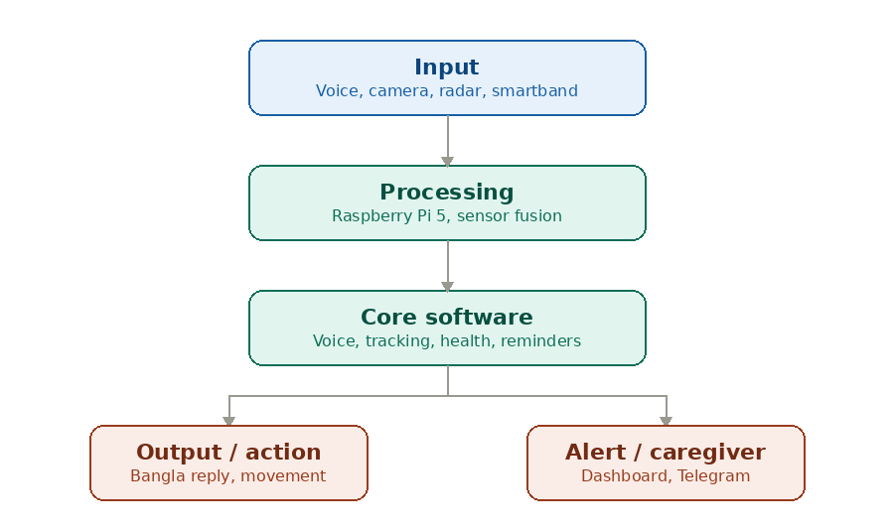
Figure 1: BONDHU system architecture

5.1 Input Layer
Voice (microphone), camera, LD2450 mmWave radar, and a connected smartband continuously feed data into the system.

5.2 Processing Layer
The Raspberry Pi 5 and esp32 S3 performs sensor fusion, combining radar and camera data to track the user's position and distance in real time.

5.3 Core Software Layer
The Bangla STT-LLM-TTS pipeline handles conversation, a Follow-Me algorithm converts radar distance/angle readings into motor commands, and health/reminder logic monitors vitals and schedules.

5.4 Output and Alert Layer
The robot replies in Bangla, moves to follow or assist the user, and delivers reminders. In parallel, if a fall, inactivity, or SOS event is detected, the system sends an alert through Telegram and updates the caregiver dashboard, which also shows a live video feed and health status.

6. Key Features

6.1 Natural Bangla Companionship
- Listens and responds in Bangla using an STT → LLM → TTS pipeline with voice activity detection.
- Answers everyday questions and offers simple companionship without requiring an app or typing.
- Daily Bangla voice check-ins with the user.

6.2 Elderly Safety Features & Alerts
- Possible fall detection (not a medical-grade diagnosis).
- Inactivity and night-time safety monitoring.
- Voice SOS command and physical panic button for emergencies.

6.3 Health Monitoring & Vitals
- Medication tracking with reminders.
- Vitals (heart rate, SpO₂) synced from a connected smartband.
- Hydration and meal reminders.

6.4 Mobility & Companion Features
- Follow-Me mode to stay near the user, driven by LD2450 radar tracking.
- Obstacle avoidance while moving around the home .
- Auto-docking for charging (planned).

6.5 Caregiver & Alert Dashboard
- Live video feed and instant fall/inactivity notifications sent via Telegram.
- Health and routine monitoring: heart rate, SpO₂, medication status, and daily activity.
- Robot and safety status: battery level and sensor connectivity.
- Google Home integration for additional voice/smart-home control.

7. Hardware Components and Budget
The following components were used to build BONDHU. Costs are approximate, in Bangladeshi Taka (৳).
No. | Component | Qty | Cost (৳)
1 | ESP32-S3 | 1 | 750
2 | HC-SR04 Ultrasonic Sensor | 3 | 330
3 | LD2450 mmWave Radar (24 GHz) | 1 | 650
4 | MQ2 Gas Sensor | 1 | 150
5 | Raspberry Pi 5 | 1 | 35,000
6 | DHT11 Temp/Humidity Sensor | 1 | 95
7 | 5V 5A Buck Converter | 1 | 350
8 | SpO2/Heart Rate Sensor | 1 | 250
9 | L298N Motor Driver | 1 | 220
10 | DC Gear Motor | 4 | 600
11 | Wheels | 4 | 280
12 | OLED Display Module | 2 | 500
13 | Logitech C270 Webcam | 1 | 800
14 | Touch Sensor Module | 1 | 40
 | Total |  | ৳40,015

Major cost drivers were the Raspberry Pi 5, the mmWave radar, the battery, and the health-monitoring devices.In future we will try our best to reduce the cost to an affordable range, so that all the people can afford it to provide more care for their loved ones.

8. Implementation

8.1 Software Implementation
The Bangla voice pipeline was built around a speech-to-text → LLM → text-to-speech chain, with wake-word detection used to trigger listening. The Follow-Me tracking module reads distance and angle data from the LD2450 radar and converts it into left/right motor commands sent to the L298N driver, allowing the robot to maintain a set following distance from the user. The caregiver dashboard was built as a web-based interface showing a live camera feed, vitals synced from the smartband, and an alert log, with notifications pushed to caregivers through Telegram along with controlling the robot from a distance.

8.2 Hardware Implementation
The robot body, Raspberry Pi 5, camera, radar, and audio components were assembled first, followed by wiring of the motor driver, gear motors, and wheels for mobility. Sensors (gas, temperature/humidity, SpO2/heart rate) were connected and tested individually before being integrated into the main sensor-fusion loop running on the Raspberry Pi 5.

9. Project Timeline
The project was carried out over an eight-week development plan, divided into three phases.
Week | Phase | Key Tasks
1-2 | Foundation | Requirements analysis and project planning; hardware setup (body, Pi 5, camera, radar, audio)
3-5 | AI + Sensors | Bangla voice interface and command module; LD2450 radar and camera integration; fall detection prototype
6-8 | Integration + Testing | Medication and vitals logging; caregiver dashboard and alert system; mobility integration; full system integration and evaluation

10. Results and Outcome

10.1 What We Achieved
- Hardware fully assembled : Raspberry Pi 5, LD2450 mmWave radar, and camera integrated on the robot body.
- Bangla voice pipeline (STT → LLM → TTS) built and working.
- Fall detection prototype functional.
- Caregiver dashboard with live video feed.
- Follow-Me human tracking implemented and under tuning.
- Smartband integration : vitals synced from the wearable to the system.
- Google Home integration for voice/smart-home control.

10.2 What We Did Not Achieve
- No GSM/SMS fallback for alerts when Wi-Fi is unavailable.
- No automated pill dispensing : only reminders and logging.
- No SLAM-based indoor mapping or automatic docking/charging yet.
- Physical panic button not yet built.
- Inactivity and night-time safety monitoring not explicitly completed.

11. Challenges Faced
The main technical challenge was bridging smartwatch health data into the system's SQLite database, since there was no free, direct API path from the wearable to the Pi. This required exploring a phone-based bridge through Health Connect and automation tools as a workaround. Tuning the Follow-Me algorithm to track a moving person smoothly, without overshooting or losing the target, also required repeated calibration of the radar's distance and angle thresholds. Integrating multiple independently-developed modules like voice, tracking, dashboard, and alerts into a single reliable pipeline on limited hardware (Raspberry Pi 5) was the most time-consuming part of the final integration phase.

12. SDG Impact
- SDG 3 (Good Health and Well-Being): Supports elderly safety, medication support, and emergency assistance.
- SDG 9 (Industry, Innovation and Infrastructure) and SDG 11 (Sustainable Cities and Communities): Demonstrates affordable assistive innovation, Bangla-language accessibility, and safer independent living at home.

13. Future Scope
- Smarter Navigation: SLAM-based indoor mapping, multi-room navigation, and automatic docking/charging.
- Telemedicine: Two-way live video/audio calls for remote family check-ins and doctor consultations.
- Clinical Integration: Connecting BP, glucometer, and SpO₂ devices for more complete, real-time vital-sign tracking.
- GSM Connectivity: Onboard SIM module for SMS/call-based alerts independent of Wi-Fi availability.
- Multilingual Support: Extending the voice pipeline beyond Bangla to other regional languages.
- Predictive Health Alerts: Trend analysis on logged vitals to flag early warning signs before an emergency occurs.
- Medication Dispensing: Automated pill dispensing with reminders and confirmation tracking.
- Cloud-based Multi-device Sync: Allowing one family to monitor multiple BONDHU units from a single dashboard.

14. Team Contributions
Name | Area | Contribution
Talha Jubayer | Hardware | Sensors and hardware interfacing
Naznin Sultana Tonni | Software | Caregiver dashboard design and UI refinement
Raunak Binte Islam Faiza | Monitoring | Live camera feed and monitoring system
Atiqur Rahman Atiq | Interaction | Voice agent and human-tracking logic
Md. Rokan Uddin | Connectivity | Smartband and Google Home integration
Fatema Tuz Zohura Rifa | Architecture | System structure and integration

15. Conclusion
BONDHU brings sensing, AI, and a warm Bangla-speaking voice together to give elderly people both safety and companionship at home. With mmWave radar, camera monitoring, fall detection, and a live caregiver dashboard, it moves beyond passive monitoring to active, present care. With the hardware complete and the software stack coming together, BONDHU shows that affordable, locally-built robotics can meaningfully support aging populations with room to grow into telemedicine, clinical integration, and smarter navigation ahead. Through this project, the team gained hands-on experience in sensor interfacing, GPIO control, motor control, and real-time embedded system integration using the Raspberry Pi 5, fulfilling the practical learning objectives of the Microprocessors and Microcontrollers Laboratory course.

