
United International University
Department of CSE
Course Code: CSE 4326
Course Name: Microprocessors & Microcontrollers Laboratory
Experiment no: 4
Experiment Name: Image and Video Processing with Raspberry Pi by interfacing pi camera
Submitted by:
Name: Naznin Sultana Tonni(On Behalf of My Team)
Student ID’s:
- Naznin Sultana Tonni(0112330125)
- Raunak Binte Islam Faiza(0112330953)
- Talha Jubayer(0112410062)
- Rokan Uddin(0112330735)
- Atiqur Rahman Atiq(0112330317)
- Fatema Tuz Zohura Rifa(0112330722)
Section: E
Date of Submission:03/10/2026
Objective:

The objective of this experiment is to design a multi-function camera control system for the Raspberry Pi that relies on a single push button to trigger three distinct actions. A single press is used to capture a still image, a long press starts continuous video recording with a single press used to stop and save the recording and a double press toggles a digital zoom in and out on the live camera feed.

Apparatus
- Raspberry Pi (with Camera Module)
- Push button
- LED
- Resistor (for LED)
- 10 kohm pull-down resistor (for push button)
- Breadboard and jumper wires
- Python 3 with gpiozero and picamera2 libraries
Theory:
1. Multi-Function Button Input
Three common press patterns are used here:
- Single press: the button is pressed and released quickly, with no second press following shortly after.
- Long press (hold): the button is held down continuously for a defined duration before being released.
- Double press: the button is pressed and released twice in quick succession, within a short time window .
Distinguishing a single press from the first half of a double press requires a short waiting period after release.But if a second press arrives within that window, it is treated as a double press; if not, it is confirmed as a single press. This is a standard debouncing/disambiguation technique used in embedded button interfaces.
2. Raspberry Pi Camera Control (picamera2)
The picamera2 library provides functions to configure, start, and stop the Raspberry Pi Camera Module for both still image capture (capture_file()) and video recording (start_recording() / stop_recording()), as well as controls such as
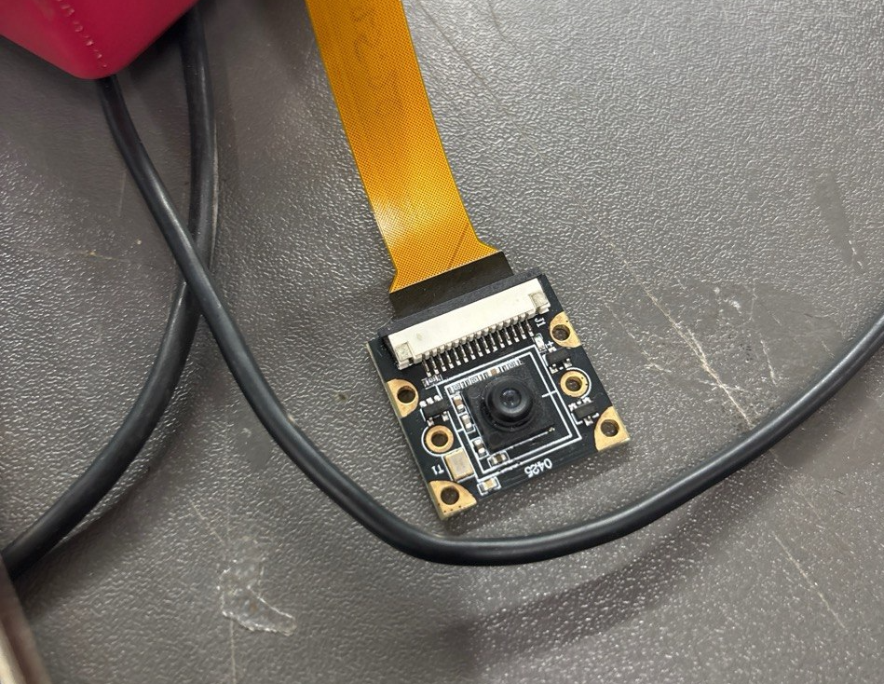
3. LED as a Status Indicator
The LED is used here purely as visual feedback like a brief flash confirms a photo was taken, a continuous blink indicates active video recording, and it turns off once the system returns to idle which gives the user clear confirmation of the system's current state without needing to check a screen.
Solution of the mentioned problems:
System Behavior (as designed):
Press Type | Action | LED Behavior
Single Press | Capture image | LED turns ON once, briefly
Long Press (3s) | Start video recording (a following single press ends & saves the video) | LED blinks continuously while recording
Double Press | Toggle digital zoom

Circuit Connection:
Component / Pin | Connected To | Notes
Push Button | GPIO 17 | 10 kohm pull-down resistor to GND
LED Anode | GPIO 27, via 10kΩ resistor | Current-limiting resistor
LED Cathode | GND
Camera Module | CSI camera port

Program codes:
#!/usr/bin/env python3
from picamera2 import Picamera2
from picamera2.encoders import H264Encoder
from picamera2.outputs import FfmpegOutput
from gpiozero import Button, LED
from signal import pause
from datetime import datetime
import time
import threading
# GPIO SETTINGS
BUTTON_PIN = 17
LED_PIN = 27
button = Button(
BUTTON_PIN,
pull_up=True,
bounce_time=0.1
)
led = LED(LED_PIN)
# CAMERA SETUP
picam2 = Picamera2()
video_config = picam2.create_video_configuration(
main={
"size": (1920,1080)
}
)
picam2.configure(video_config)
picam2.start()
# VARIABLES
recording = False
zoomed = False
hold_time = 1.0
# FLASH
def flash():
led.on()
time.sleep(0.15)
led.off()
# TAKE PHOTO
def take_photo():
filename = (
"photo_" +
datetime.now().strftime("%Y%m%d_%H%M%S")
+
".jpg"
)
print("Taking photo:", filename)
flash()
picam2.capture_file(filename)
# VIDEO RECORD
encoder = H264Encoder()
video_file = None
def start_video():
global recording
global video_file
video_file = (
"video_" +
datetime.now().strftime("%Y%m%d_%H%M%S")
+
".mp4"
)
print("Recording started")
output = FfmpegOutput(video_file)
picam2.start_recording(
encoder,
output
)
recording = True
threading.Thread(
target=blink_led,
daemon=True
).start()
def stop_video():
global recording
print("Recording stopped")
picam2.stop_recording()
recording=False
led.off()
# LED BLINK
def blink_led():
while recording:
led.toggle()
time.sleep(0.5)
# ZOOM CONTROL
def toggle_zoom():
global zoomed
if zoomed:
print("Zoom OFF")
picam2.set_controls(
{
"ScalerCrop":
(0,0,4056,3040)
}
)
zoomed=False
else:
print("Zoom ON")
picam2.set_controls(
{
"ScalerCrop":
(1000,750,2000,1500)
}
)
zoomed=True
# BUTTON EVENTS
press_start = 0
def button_pressed():
global press_start
press_start=time.time()
def button_released():
global recording
duration=time.time()-press_start
# HOLD
if duration >= hold_time:
if not recording:
start_video()
return
# SHORT PRESS
if recording:
stop_video()
else:
# check double click
if button.is_active:
return
time.sleep(0.25)
if button.is_active:
toggle_zoom()
else:
take_photo()
# Assign events
button.when_pressed = button_pressed
button.when_released = button_released
print("Camera ready")
pause()

Discussion:
This experiment showed how a single push button can be turned into a multi-function control input by carefully distinguishing between a quick single press, a sustained long press, and a rapid double press. Implementing this required understanding the press-pattern detection like correctly identifying a single press means deliberately introducing a short delay to rule out a following double press, which adds a small response lag to the system. Working with picamera5 for both still capture and video recording under the same button logic also required careful state management, particularly around switching between still and video configurations and ensuring the recording could be cleanly stopped and saved on a follow-up press rather than another hold. Overall, this task gave practical experience in combining GPIO input-pattern recognition with real camera hardware control on the Raspberry Pi, along with using an LED as simple, intuitive status feedback for the end user.

