**EXPERIMENT NO: 1**

**AIM:**

Introduction to Computer hardware: Physical identification of major components of a computer system such as mother board, RAM modules, daughter cards, bus slots, SMPS, internal storage devices, interfacing ports. Specifications of desktop and server class computers. Installation of common operating systems for desktop and server use. (Students may be asked to formulate specification for computer to be used as Desktop, Web server).

Study of a terminal-based text editor such as Vim or Emacs. (By the end of the course, students are expected to acquire following skills in using the editor: cursor operations, manipulate text, search for patterns, global search and replace) Basic Linux commands, familiarity with following commands/operations expected.

**OUTPUT:**

**EXPERIMENT NO: 1**

**AIM:**

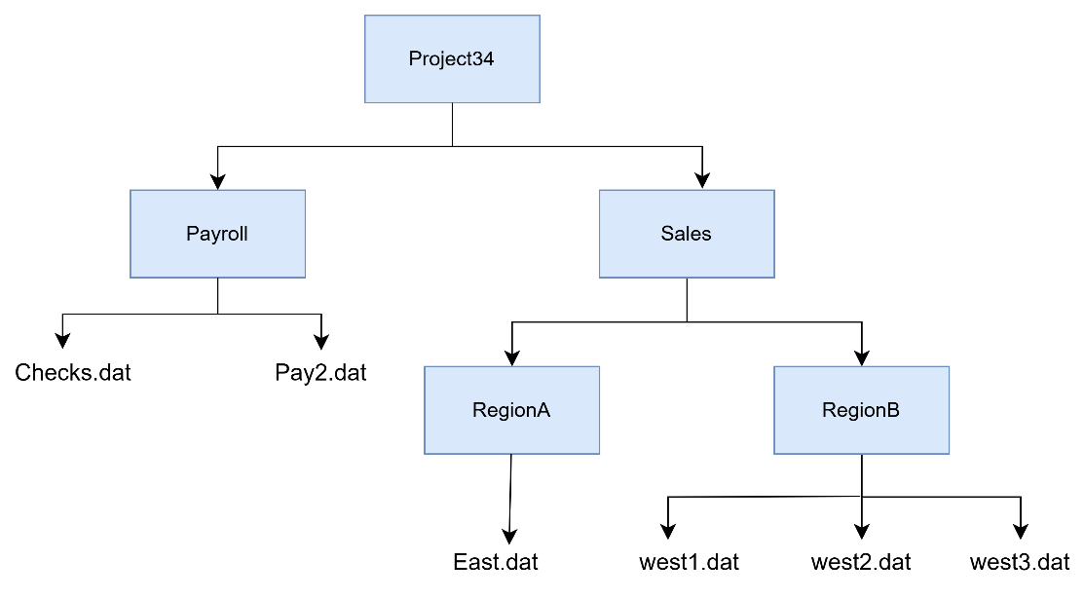

**1. Create the above directory tree and enter necessary data into the files. Then perform the following operations using linux utilities.**

a) Copy pay2.dat to directories RegionA and RegionB.

**developer@ccfl6-pc24:~/MCA_B22/nsa** $mkdir -p Project34/Payroll Project34/Sales

**developer@ccfl6-pc24:~/MCA_B22/nsa$** cd Project34/Payroll

**developer@ccfl6-pc24:~/MCA_B22/nsa/Project34/Payroll$** touch Checks.dat Pay2.dat

**developer@ccfl6-pc24:~/MCA_B22/nsa/Project34/Payroll$** cd ..

**developer@ccfl6-pc24:~/MCA_B22/nsa/Project34$** cd Sales

**developer@ccfl6-pc24:~/MCA_B22/nsa/Project34/Sales$** mkdir RegionA RegionB

**developer@ccfl6-pc24:~/MCA_B22/nsa/Project34/Sales$** cd RegionA

**developer@ccfl6-pc24:~/MCA_B22/nsa/Project34/Sales/RegionA$** touch East.dat

**developer@ccfl6-pc24:~/MCA_B22/nsa/Project34/Sales/RegionA$** cd ..

**developer@ccfl6-pc24:~/MCA_B22/nsa/Project34/Sales$** cd RegionB

**developer@ccfl6-pc24:~/MCA_B22/nsa/Project34/Sales/RegionB$** touch west1.datwest2.dat west3.dat

b) Save the file west3.dat to RegionA under the name East1.dat

**developer@ccfl6-pc24:~/MCA_B22/nsa/Project34/Sales/RegionB**$ cd ../../Payroll

**developer@ccfl6-pc24:~/MCA_B22/nsa/Project34/Payroll**$ cp Pay2.dat ../Sales/RegionA

**developer@ccfl6-pc24:~/MCA_B22/nsa/Project34/Payroll**$ cp Pay2.dat ../Sales/RegionB

c) Combine the contents of Checks.dat and pay2.dat into a new file payment.dat under payroll.

**developer@ccfl6-pc24:~/MCA_B22/nsa/Project34/Sales/RegionB**$ cd ../../Payroll

**developer@ccfl6-pc24:~/MCA_B22/nsa/Project34/Payroll**$ touch payment.dat

**developer@ccfl6-pc24:~/MCA_B22/nsa/Project34/Payroll**$ cat > Checks.dat

Hello

How are you

Welcome to Linux

^Z

[1]+ Stopped cat > Checks.dat

**developer@ccfl6-pc24:~/MCA_B22/nsa/Project34/Payroll**$ cat > Pay2.dat

Linux can perform the following:

Display

Copy

Create

View

^Z

[2]+ Stopped cat > Pay2.dat

**developer@ccfl6-pc24:~/MCA_B22/nsa/Project34/Payroll**$ cat Checks.dat Pay2.dat > payment.dat

d) Get the count of the number of ordinary files in Sales directory.

**developer@ccfl6-pc24:~/MCA_B22/nsa/Project34/Sales**$ find -type f |wc -l

7

e) Find the list all *.dat files in Project34 directory.

**developer@ccfl6-pc24:~/MCA_B22/nsa/Project34**$ find -name *.dat

./Payroll/payment.dat

./Payroll/Checks.dat

./Payroll/Pay2.dat

./Sales/RegionB/west3.dat

./Sales/RegionB/west1.dat

./Sales/RegionB/west2.dat

./Sales/RegionB/Pay2.dat

./Sales/RegionA/East1.dat

./Sales/RegionA/East.dat

./Sales/RegionA/Pay2.dat

f) Sort pay2.dat in the descending order of payment amount.

**developer@ccfl6-pc24:~/MCA_B22/nsa/Project34/Sales/RegionA**$ cat >Pay2.dat

60000

45000

50000

35000

^Z

[3]+ Stopped cat > Pay2.dat

**developer@ccfl6-pc24:~/MCA_B22/nsa/Project34/Sales/RegionA**$ sort -n -r Pay2.dat -o Pay2.dat

g) Display the list of all files in the Sales directory in uppercase.

**developer@ccfl6-pc24:~/MCA_B22/nsa/Project34**$ cd Sales

**developer@ccfl6-pc24:~/MCA_B22/nsa/Project34/Sales**$ find -type f | tr '[:lower:]' '[:upper:]'

./REGIONB/WEST3.DAT

./REGIONB/WEST1.DAT

./REGIONB/WEST2.DAT

./REGIONB/PAY2.DAT

./REGIONA/EAST1.DAT

./REGIONA/EAST.DAT

./REGIONA/PAY2.DAT

h) Remove RegionB directory and its contents in one shot.

**developer@ccfl6-pc24:~/MCA_B22/nsa/Project34**$ cd Sales

**developer@ccfl6-pc24:~/MCA_B22/nsa/Project34/Sales** $ rm -r RegionB

**EXPERIMENT NO: 2**

**AIM:**

**1. Sort an employee file containing employee name, salary, designation in the descending order of salary.**

**developer@ccfl6-pc24:~/MCA_B22/nsa/Project34**$ cat> employee

Name Salary Designation

John 60000 Manager

Jane 45000 Developer

Doe 50000 Analyst

^Z

[4]+ Stopped cat > employee

**developer@ccfl6-pc24:~/MCA_B22/nsa/Project34**$ sort -r -k2 employee

Name Salary Designation

John 60000 Manager

Doe 50000 Analyst

Jane 45000 Developer

**developer@ccfl6-pc24:~/MCA_B22/nsa/Project34**$ sort -nr -k2 employee

John 60000 Manager

Doe 50000 Analyst

Jane 45000 Developer

Name Salary Designation

**2. Find the largest file in the current directory. The final output should contain only the filenames and the respective file sizes**

**3. From the output of a long directory listing display only the file permissions. Then pipe this output to filter out any double lines & count the different permission types in this directory.**

**4. Use Find with –exec option to rename all .htm files to .html**

**5. Use tr filter to encrypt using ROT13.(Every character should be replaced with the 13th chr in the alphabetical order)**

**6. Use Find command to print the list of all files in the current directory containing the word linux inside them.**

**7. Use grep filter and wc filter to get the count of ordinary files in the current directory.**