Functional Specification
SAP User Creation Request Portal
Development based on OData Services · version 1.2 · 17.07.2026

1. Overview
The application is intended for creating and executing requests for new user accounts in SAP systems (ECC, HCM, BW, GRC). The portal user creates a request and specifies the User ID (format NK11022217), the organizational assignment and the required roles; no other user data is requested. No approval workflow is involved: once submitted, the request is passed directly to execution — the user account with the specified ID is created in the target system automatically.
After submission the requester sees the request in the “My Requests” list with its current status; the request page contains a visual status tracker (Draft → In Execution → Completed) and an execution log with the individual processing steps.

2. Process Description

2.1 Detail Flow Description
- User Login. The user logs into the portal using Active Directory (AD) / Single Sign-On (SSO).
- Request Entry. The user clicks “Create” and enters the User ID in the format NK11022217 (NK + 8 digits) and the account type. No other user data is requested; the account will be created with the specified ID.
- Select Directorate. The system retrieves the list of directorates (OData: DirectorateSet); the user selects the applicable directorate.
- Select Department. Based on the selected directorate, the system displays the corresponding departments (DepartmentSet, filtered by DirectorateId).
- Select Position. The positions of the selected department are displayed (PositionSet); roles are derived from the position.
- Select Roles. The portal retrieves the roles mapped to the position (RoleSet); only active and authorized roles are displayed. Multiple roles can be selected within a single request.
- Request Details. The user specifies the access validity dates (“Valid From”, “Valid To”) and the business justification. The system validates mandatory fields before submission.
- Submission (Deep Create). The portal creates the request together with its role items in a single POST call (see section 2.3). The request receives a number (prefix USR) and the status “In Execution”.
- Execution. Background processing creates the user account with the name UserId in the target system (BAPI_USER_CREATE1) and assigns the roles (BAPI_USER_ACTGROUPS_ASSIGN). Every step is recorded in the execution log.
- Monitoring. The requester sees the active request in the list with status “In Execution”; the request page shows the status tracker and the execution log. Once processing is finished, the request receives the status “Completed” and the requester is notified.

2.2 Status Model
Code | Status | Color (criticality) | Description
D | Draft | 0 — neutral | Request saved but not submitted; can be edited and deleted
P | In Execution | 2 — yellow | Request submitted; account creation and role assignment are being processed
E | Completed | 3 — green | User account created; the requester has been notified
If an execution error occurs, the request remains in status “In Execution”; the affected log step receives the result “Error” with the system message, and the administrator is notified.

2.3 Request Creation via Deep Create
The request is created with a single POST call on the root entity with the inline collection of roles (navigation property ToRoles). On the SAP side the call is handled by the CREATE_DEEP_ENTITY method of the DPC_EXT class: the request header and the role items are created in one LUW, the request number is generated, the status is set to “P” and background execution is started.
POST /sap/opu/odata/sap/ZUI_USER_REQUEST_SRV/UserRequestSet
{
"RequestType": "C",
"UserId": "NK11022217",
"UserType": "A",
"DirectorateId": "50000100",
"DepartmentId": "50000250",
"PositionId": "60000310",
"ValidFrom": "/Date(1785542400000)/",
"Justification": "New employee, order No. 145-K",
"ToRoles": [
{ "RoleName": "Z_ECC_FI_DISPLAY" },
{ "RoleName": "Z_ECC_MM_BUYER" }
]
}

The service response returns the created request with its RequestId and the inline role items. Drafts (status D) are created with the same call using the “Draft” flag: execution is not started.

3. Data Model (OData Entities)
Service: ZUI_USER_REQUEST_SRV (OData V2). The root entity is UserRequest; the request items (roles) and the execution log are dependent entities linked via navigation properties.

3.1 UserRequest — Request (Root Entity)
Field | Type (EDM) | Length | Req. | Description
RequestId | Edm.String | 12 | Key | Request number, generated automatically (number range, prefix USR)
RequestType | Edm.String | 1 | Yes | Request type: C — user creation
Status | Edm.String | 1 | Yes | Status code (see section 2.2)
StatusText | Edm.String | 30 | — | Status text for display
StatusCriticality | Edm.Byte | — | — | Status color code: 2 yellow, 3 green, 0 neutral
UserId | Edm.String | 10 | Yes | User ID — the name of the account to be created. Format NK + 8 digits (regex ^NK\d{8}$). Availability check against USR02. No other user data is requested or derived
UserType | Edm.String | 1 | Yes | Account type: A — dialog, B — system, C — communication
DirectorateId | Edm.String | 8 | Yes | Directorate ID (org. structure object O)
DepartmentId | Edm.String | 8 | Yes | Department ID (object O, subordinate to the directorate)
PositionId | Edm.String | 8 | Yes | Position ID (object S, assigned to the department)
ValidFrom | Edm.DateTime | — | Yes | Access validity start
ValidTo | Edm.DateTime | — | No | Access validity end (default 31.12.9999)
Justification | Edm.String | 255 | Yes | Business justification
CreatedBy | Edm.String | 12 | — | Requester
CreatedAt | Edm.DateTime | — | — | Creation date/time
ChangedBy | Edm.String | 12 | — | Last changed by
ChangedAt | Edm.DateTime | — | — | Last change date/time

Navigation properties: ToRoles (1..n RequestRole), ToExecutionSteps (1..n ExecutionStep).

3.2 RequestRole — Roles of the Request
Field | Type (EDM) | Length | Req. | Description
RequestId | Edm.String | 12 | Key | Request number
RoleName | Edm.String | 30 | Key | Technical role name (AGR_NAME)
RoleText | Edm.String | 80 | — | Role description
ValidFrom | Edm.DateTime | — | — | Role validity start (inherited from the request)
ValidTo | Edm.DateTime | — | — | Role validity end

3.3 ExecutionStep — Execution Log
Field | Type (EDM) | Length | Req. | Description
RequestId | Edm.String | 12 | Key | Request number
StepNo | Edm.String | 2 | Key | Step number (01–03)
StepText | Edm.String | 60 | — | Step name: data validation / account creation / role assignment
Result | Edm.String | 1 | — | Result: S — success, E — error, P — in progress, W — pending
ResultText | Edm.String | 30 | — | Result text
Message | Edm.String | 255 | — | System message (error text when Result = E)
ExecutedAt | Edm.DateTime | — | — | Step execution date/time

3.4 Value Help Entities
Entity | Key | Fields | Source
Directorate | DirectorateId | DirectorateId, DirectorateText | OM org. structure (HRP1000, object O, top level)
Department | DepartmentId | DepartmentId, DirectorateId, DepartmentText | HRP1000/HRP1001 — departments of the selected directorate (relationship B002)
Position | PositionId | PositionId, DepartmentId, PositionText | HRP1000/HRP1001 — positions of the department (object S, relationship B003)
Role | RoleName | RoleName, RoleText, PositionId | Role catalog (AGR_DEFINE/AGR_TEXTS) + position-to-role mapping table
Status | Status | Status, StatusText | Request status domain

3.5 Service Operations
Operation | Implementation | Description
Request creation (Deep Create) | CREATE_DEEP_ENTITY | Creates the header and roles in a single call; generates the number; sets status P; starts background execution
Draft saving | CREATE_DEEP_ENTITY (Draft = X) | The request is created in status D without starting execution; it can be changed and deleted
Reading a request with items | GET_EXPANDED_ENTITY ($expand=ToRoles,ToExecutionSteps) | Request page: header data, roles, execution log

4. Screen Design

4.1 “My Requests” List
The start screen. The user sees all own requests; active ones are shown first. The “Status” column is displayed with a colored indicator; the “User ID” column shows the name of the account to be created. The “Create” button opens the new request form.
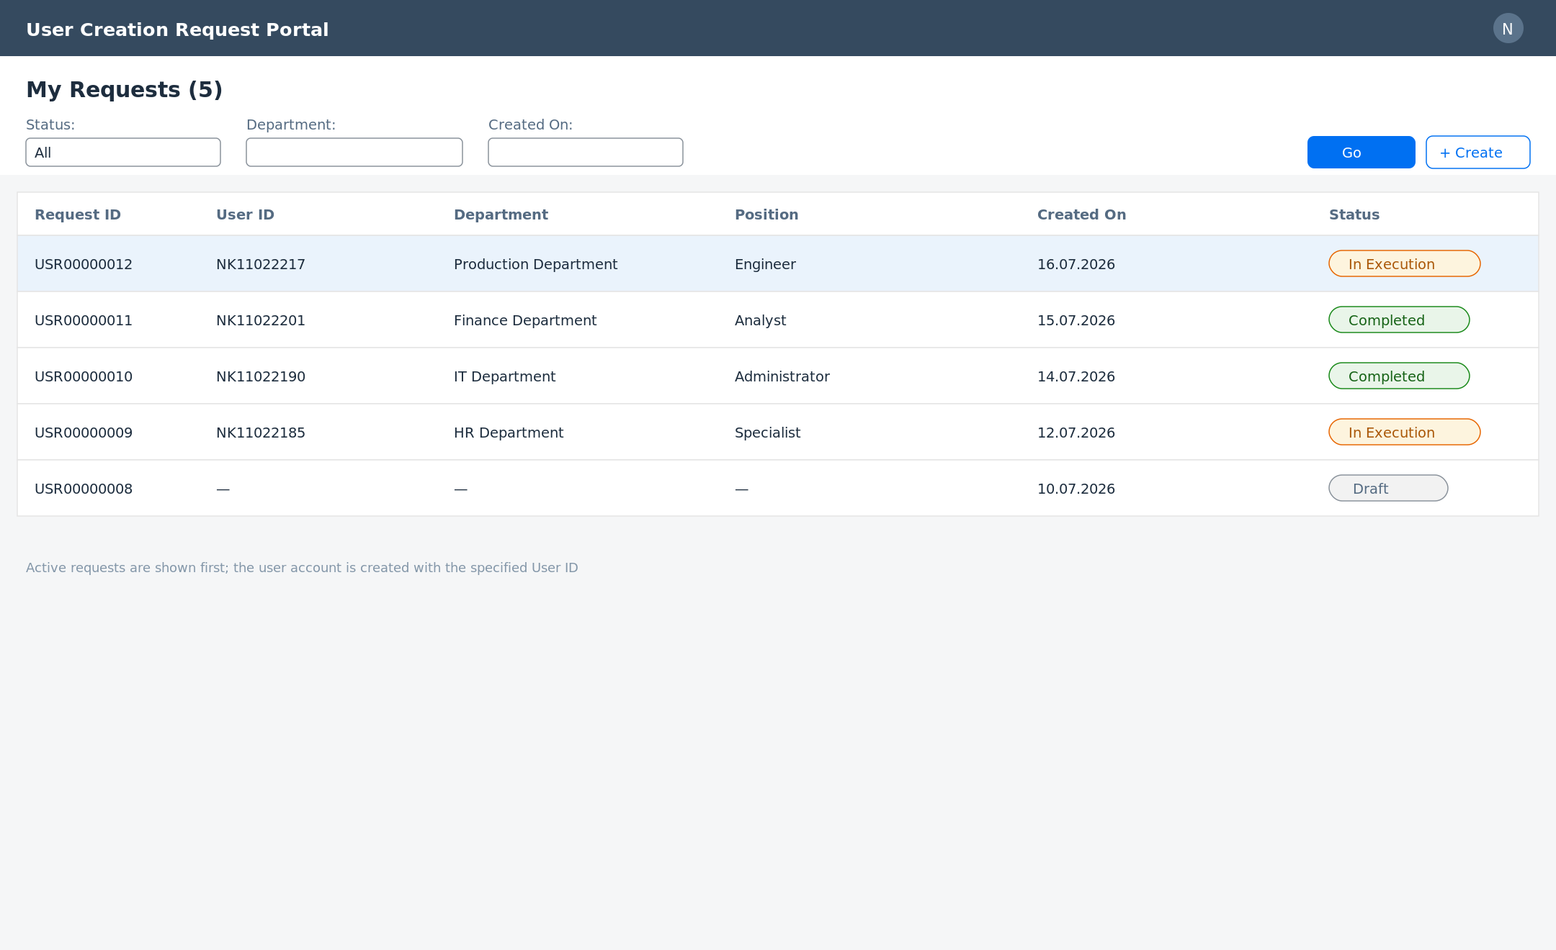
Fig. 1. Request list with statuses

4.2 Request Creation Form
The form consists of four sections: User ID (format NK + 8 digits, format and availability check), organizational data (cascading selection directorate → department → position), access (validity dates, roles by position) and justification. The “Submit” button performs the deep create and starts execution; “Save Draft” stores the request without submission.
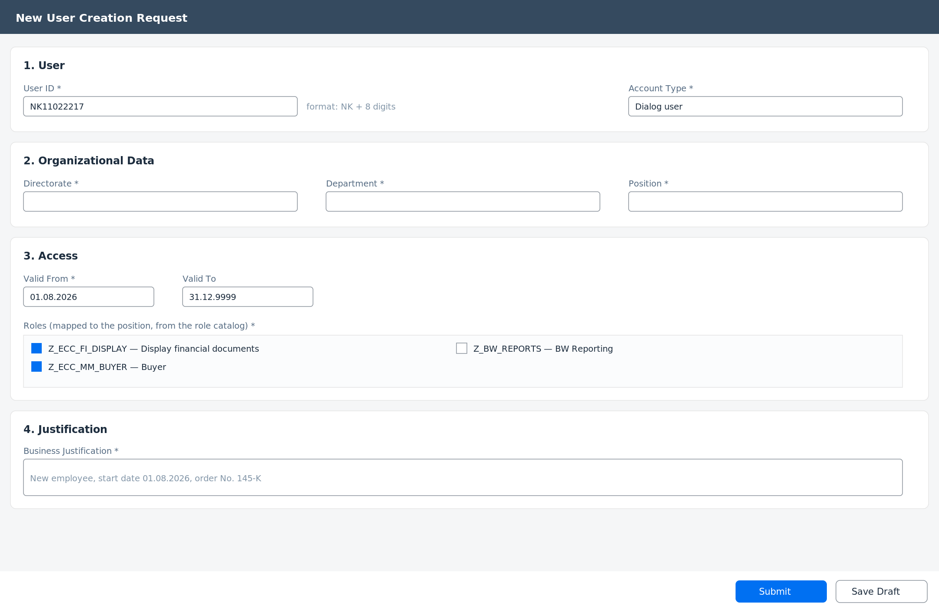
Fig. 2. Request creation form

4.3 Request Page (Status Monitoring)
After submission the requester opens the request page: at the top — the colored status badge and the status tracker (Draft → In Execution → Completed); below — the request details and the execution log with step results. The “Copy” action creates a new request based on the current one.
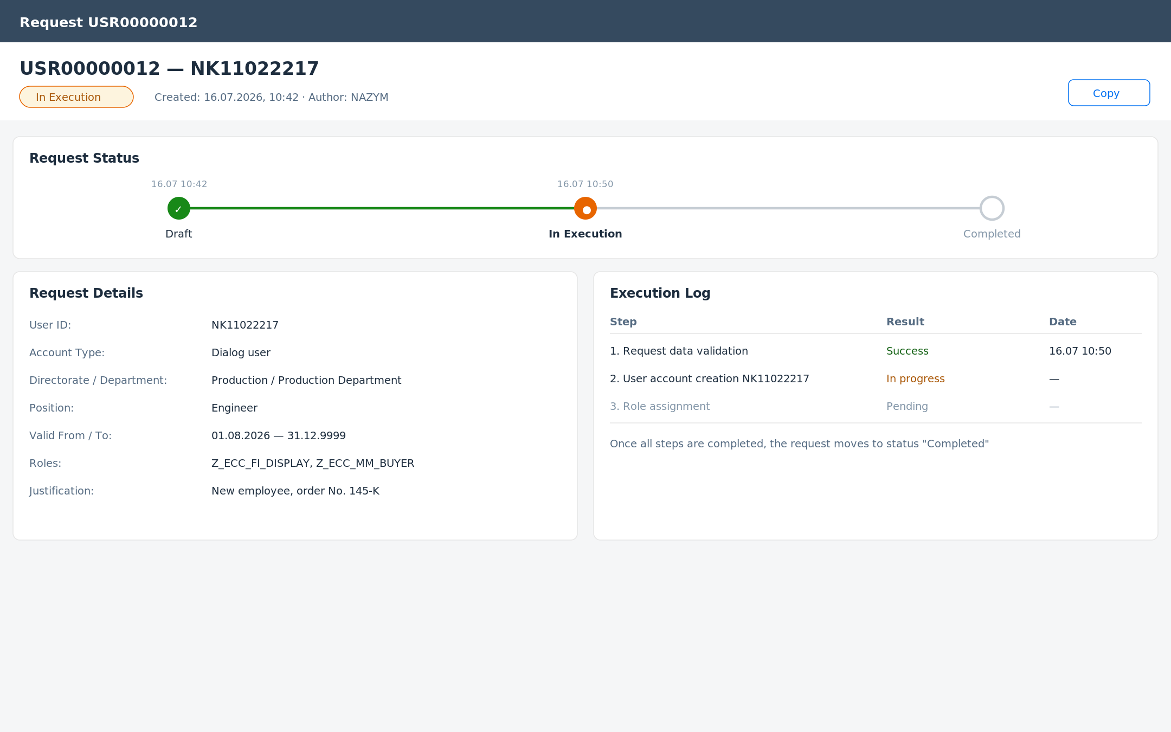
Fig. 3. Request page with status tracker and execution log

5. Integration and Notifications
- User account creation: BAPI_USER_CREATE1 in the target system via RFC.
- Role assignment: BAPI_USER_ACTGROUPS_ASSIGN.
- Org. structure: reading objects O/S from HRP1000, HRP1001 (relationships B002/B003).
- Execution runs in the background (bgPF / job) immediately after the request is created; every step is written to the execution log.
- Notifications: to the requester — when the request is completed and in case of an error; to the administrator — in case of an execution error.
- The initial password is generated by the target system and handed over to the user according to the company procedure (outside the portal).

6. Data Selection (Table/Field Details)
Table | Description
ZUSR_REQUEST | Request header (fields correspond to the UserRequest entity)
ZUSR_REQ_ROLE | Request roles (RequestRole)
ZUSR_EXEC_LOG | Execution log (ExecutionStep)
ZUSR_POS_ROLE | Position-to-SAP-role mapping
HRP1000 / HRP1001 | Org. units and positions (read)
AGR_DEFINE / AGR_TEXTS | Role catalog (read)
USR02 | User name availability check (read)

