Task 1 was concerned with getting acquinted with pennylane basics,and completeing the courses:“Introduction to Quantum Computing”, “Single-Qubit

Gates” and “Circuits with Many Qubits”.

**The first course: Introduction to Quantum Computing**

Introduction to Quantum Computing dealt with the basics of the field, qubits and unitary matrices.

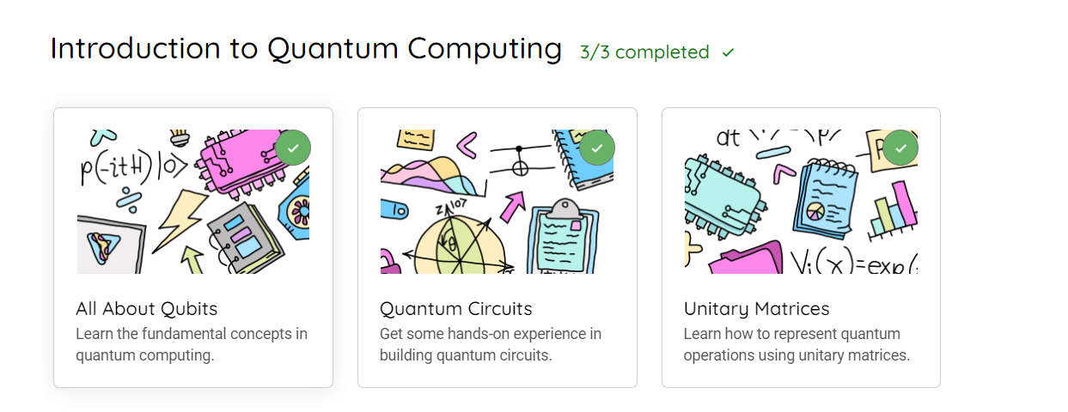

**The second Course: Single Qubit Gates**

This course dealt with the introduction of basic gates like X, H, and the universal gates. It also focused on applying basic gates using universal gates only, measurements, and expectation value calculation.

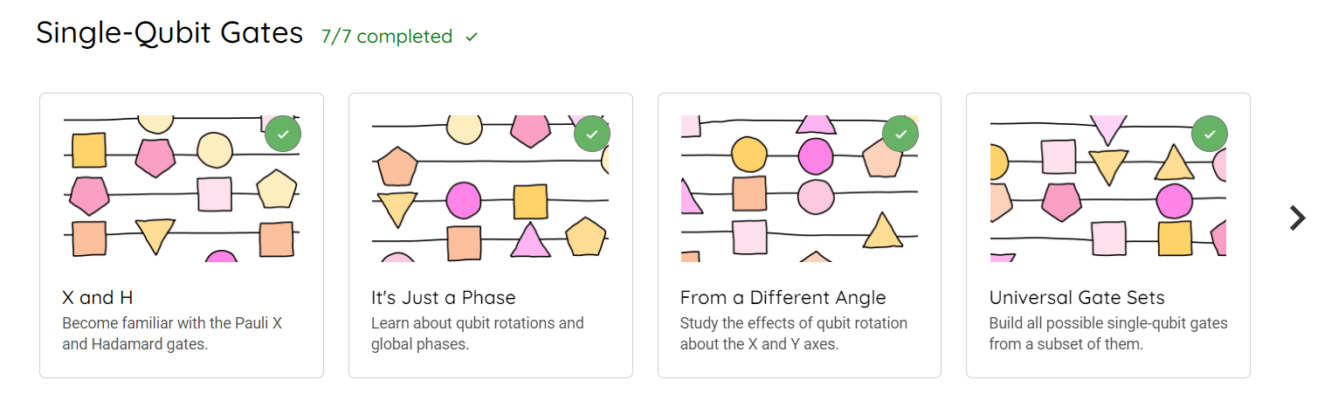

**The third course: Circuits with many Qubits**

This dealt with multi qubit circuits, and introduced controlled gates like CNOTs.

