# 2.3 Exercises

Given the following diagrams, create the relational schema for each diagram. Note: the diagrams may not be normalized

1. Bank

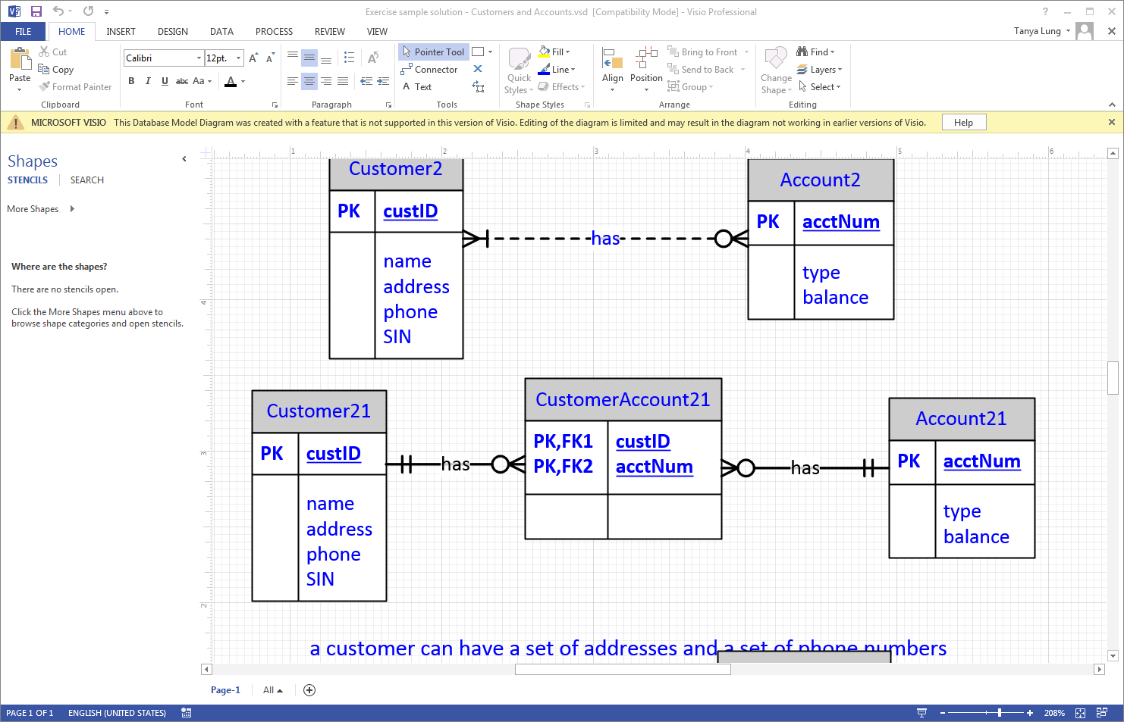

1.Change CustomerAccount PK from composite, to segregate key

Change name/address into more specific stuff

* Customer21(custID, firstName , LastName , middleName, street, addr, city, prov, phone, SIN)
  + Constraint:NA
* CustomerAccount21: (CustAccID, custID(FK), acctNum(FK))
  + Constraints:
    - CustomerAccount21(custID(FK)) references Customer21(custID)
    - CustomerAccount21(acctNum(FK)) references Account21(acctNum)
* Account21(acctNum, type, balance)

1. Farm

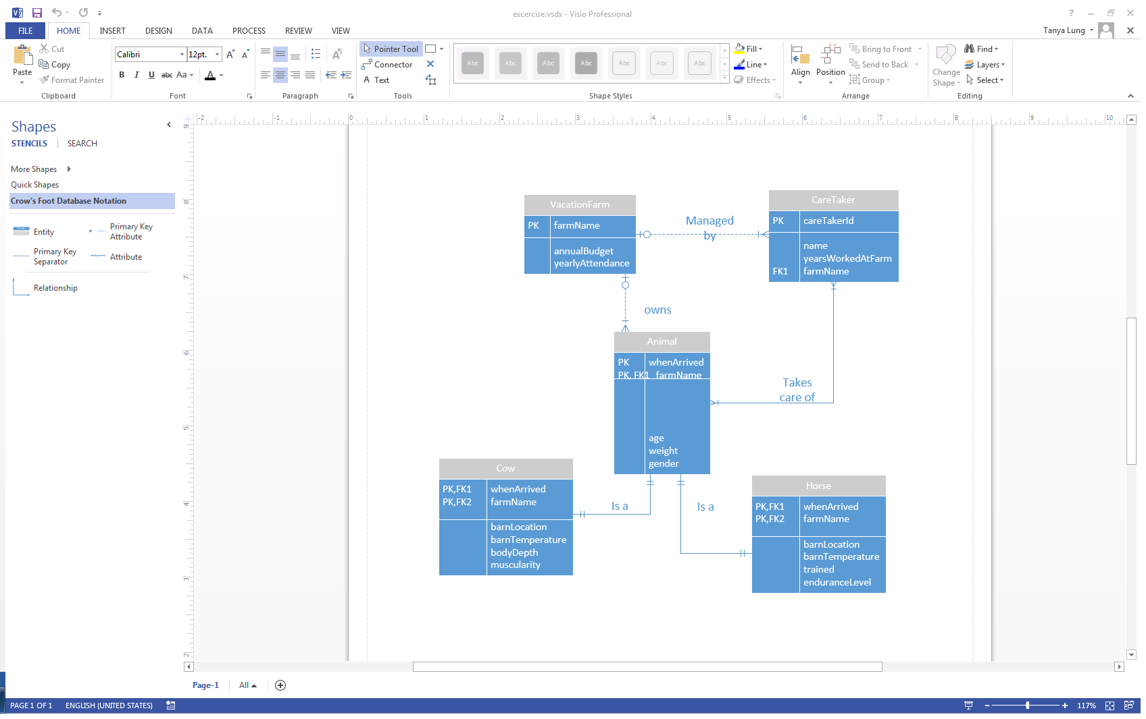

Don’t need this m-m

1.~~Add m-m table between animal-caretaker(animalhandler)~~ the VacationFarm serves the same purpose

Change composite keys to segregate keys

Add FK’s to cow and horse from Animal

~~AnimalHandler(AnimalhandlerID,careTakerID(FK), AnimalID(FK))~~

* VacationFarm(farmname, annualbudget, yearlyAttendance)
  + Constraints:NA
* CareTaker(careTakerID, farmName(FK), name, yearsWorkedAtFarm)
  + Constraints:
    - CareTaker(farmName(FK)) references VacationFarm(farmName)
* Animal(AnimalID, farmName(FK), whenArrived, age, weight, gender)
  + Constraints:
    - Animal(farmName(FK)) references VacationFarm(farmName)
* Cow(CowID, animalID(FK), whenArrived, barnLocation, barnTemp, bodyDepth, muscluraity)
  + Constraints:
    - Cow(animalID(FK)) references Animal(animalID)
* Horse(horseID, animalID(FK), whenArrived, barnLocation, barnTemp, trinaed, enduranceLevel)
  + Constraints:
    - Horse(animalID(FK)) references Animal(animalID)