Analyzing the updateability of a join view

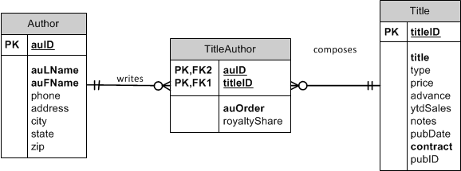

Consider this view:

CREATE OR REPLACE VIEW Oaklanders

AS

SELECT auFName AS First, auLName AS Last, t.titleID, title

FROM Author a JOIN TitleAuthor ta ON a.auID = ta.auID

JOIN Title t ON ta.titleID = t.titleID

WHERE city = 'Oakland'

AND state = 'CA';

|  |  |  |  |  |
| --- | --- | --- | --- | --- |
| Author Table | | TitleAuthorTable | Title Table | |
| aufName | aulName |  | titleId | Title |

Is this view updateable?

Is there grouping? Aggregate function? Many child tables?

Yes -

How Do you know?

-Title Author is the only key preserved table, is a child of both author and Title and is the only child table. Often key preserved tables are joining tables, like this case.

- A delete statement will work – deletes rows from the TitleAuthor table

-Insert will not work, none of the fields come from the TitleAuthor table

-Updates are not possible on any of the fields for the same reason.

Try it!

* Delete statement

DELETE FROM Oaklanders

WHERE titleID = 'BU1032';

*ROLLBACK;*

Consider this view:

CREATE OR REPLACE VIEW Oaklanders

AS

SELECT auFName AS First, auLName AS Last, ta.titleID, title

FROM Author a JOIN TitleAuthor ta ON a.auID = ta.auID

JOIN Title t ON ta.titleID = t.titleID

WHERE city = 'Oakland'

AND state = 'CA';

|  |  |  |  |
| --- | --- | --- | --- |
| Author | | Title Author | Title |
| AufName | aufLNamw | Titleid | title |

Is this view updateable?

Yes-one key preserved table, no aggregates, no grouping  
  
Why and how?

* Title author is the key preserved table ( same reasons as last example)
* Deletes will work against titleAuthor
* Updates can be done on titleID only, because it is mapped to title author, other fields cannot be updated as they map to other tables
* Inserts do not work because we are missing several NOT NULL / PK field from titleAuthor

Try it!

* Update statement

UPDATE Oaklanders

SET titleID = 'BU7832'

WHERE titleID = 'BU1032';

*ROLLBACK;*

* What happened?
* Insert a record so we can update our view

Insert into title (titleID, title, contract) values ('TL1111','DB is the best',1);

* Now update

UPDATE Oaklanders

SET titleID = 'TL1111'

WHERE titleID = 'BU7832';

* Check that our new row is there.

SELECT *

FROM TitleAuthor

WHERE titleID IN ('BU7832', 'TL1111');

*ROLLBACK;*

* Delete statement

DELETE FROM Oaklanders

WHERE titleID = 'BU1032';

*ROLLBACK;*

Consider this view:

CREATE OR REPLACE VIEW Oaklanders

AS

SELECT ta.auID, auFName AS First, auLName AS Last, ta.titleID, title, ta.auOrder

FROM Author a JOIN TitleAuthor ta ON a.auID = ta.auID

JOIN Title t ON ta.titleID = t.titleID

WHERE city = 'Oakland'

AND state = 'CA';

|  |  |  |  |  |  |
| --- | --- | --- | --- | --- | --- |
| Author | | TitleAuthor | | | Title |
| auFname | auLName | TitleID | **auID** | **auOrder** | Title |

Is this view updateable?

* Yes updatable No aggregate, no group by
* Yes, titleAuthor is key-oreserved

Why and how?

* Title author is a child of both author and Title and is the only child table.
* TitleAuthor is the only Key-preserved table, having first and last name may not be enough to have the key preserved for Author
* Can insert into TitleAuthor, aslong as there is valid VALUES
* Inserts works – all required fields are present in the view for the TitleAuthor table
* Deletes continue to work
* Updates can be done against the TitleAuthor Fields of auId, auOrder, and TitleID, but not the other fields from the other tables

Try it!

* INSERT

INSERT INTO Oaklanders (auID, titleID, auOrder)

VALUES ('213-46-8915', 'BU1111', 3);

*ROLLBACK;*

* INSERT

UPDATE Oaklanders

SET titleID = 'BU7832'

WHERE titleID = 'TL1111';

*ROLLBACK;*

* Delete statement

DELETE FROM Oaklanders

WHERE titleID = 'BU1032';

*ROLLBACK;*

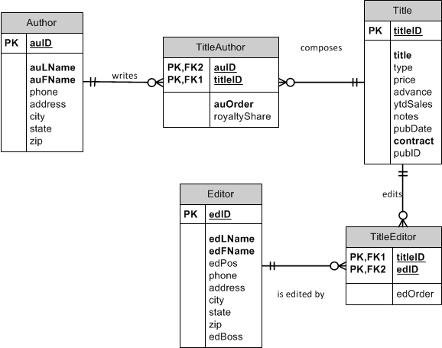

Consider this view:

CREATE OR REPLACE VIEW CompleteBookInfo

AS

SELECT a.auID, auLName AS AuthorLast, auOrder, t.titleID, title, e.edID, edLName AS EditorLast, edOrder

FROM Author a JOIN TitleAuthor ta ON a.auID = ta.auID

JOIN Title t ON ta.titleID = t.titleID

JOIN TitleEditor te ON t.titleID = te.titleID

JOIN Editor e ON te.edID = e.edID;

|  |  |  |  |  |  |  |  |
| --- | --- | --- | --- | --- | --- | --- | --- |
| Author | | TitleAuthor | Title | | Editor | | TitleEditor |
| auID | aulName | auOrder | titleID | Title | edID | edlName | edOrder |

Is this view updateable?

-No aggregates, group by, distinct

- More than 1 child table

Why?

* There is no key preserved table
* The key comes from the many/child side, which in this case is both TitleAuthor and TitleEditor: titleID, auID, edID
* Since no one table has that key, there is not a key preserved table. This happens when there are multiple child / join tables in the view