1.

(a)

This problem can be illustrated mathematically as a graph of 8 nodes, with each node having edges connected to its closest neighbours, shown as:

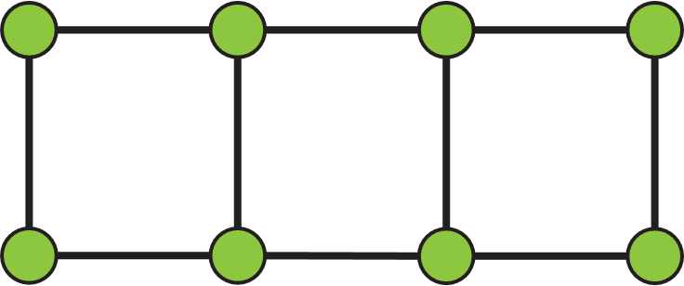

(b)

The number of Wi-Fi channels needed equals to the chromatic number of the above graph, which is 2.

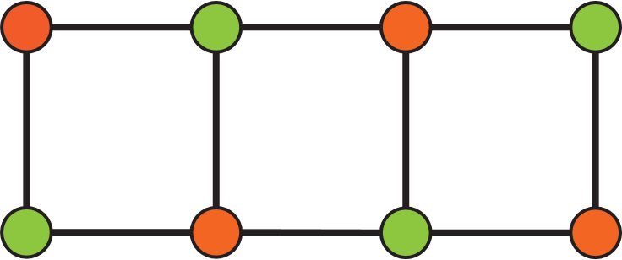

(c)

Each vertex will also be connected to its diagonal vertices.

The largest clique size will become 4, and the chromatic number will be 4.

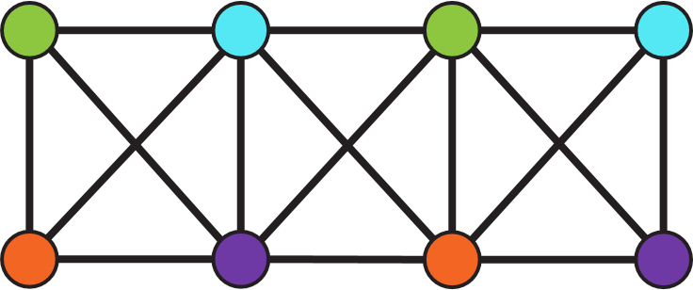

2.

(a)

*Av* = Pv,red∨ Pv,green∨ Pv,blue

(b)

*Bv*

= ¬ (Pv,red ∧ Pv,green) ∧ ¬ (Pv,red ∧ Pv,blue) ∧ ¬ (Pv,green ∧ Pv,blue)

= (¬ Pv,red ∨ ¬Pv,green) ∧ (¬ Pv,red ∨ ¬Pv,blue) ∧ (¬Pv,green ∨ ¬Pv,blue)

(c)

*Cu,v*

= ¬(Pu,red ∧ Pv,red) ∧ ¬(Pu,green ∧ Pv,green) ∧ ¬(Pu,blue ∧ Pv,blue) )

=(¬Pu,red ∨ ¬Pv,red) ∧ (¬Pu,green ∨ ¬Pv, green) ∧ (¬Pu,blue ∨ ¬Pv, blue)

(d)

With the three-color problem, each vertex has and only has 1 color (*Av* ∧ *Bv*), and each pair of vertices {u,v} ∈E must have different colors (*Cu,v*).

φG=

3.

(a)

(R) x ∨ x = x, x∈A

⊑ is reflective.

(AS) For x,y ∈A, if x ∨ y = y and y ∨ x = x:

∵ x ∨ y = y:

y ∨ x = y

∵ y ∨ x = x:

y ∨ x = y = x

∴ x = y

⊑ is asymmetry.

(T)

For x,y,z ∈A, if x ∨ y = y and y ∨ z = z:

y = x ∨ y

∵ y ∨ z = z

x ∨ y ∨ z = z

∵ y ∨ z = z

x ∨ z = z

⊑ is transisive.

Therefore, ⊑ is a partial order.

(b)

⊑ corresponds to x ⊆ y for x ⊆ X, y ⊆ X.

(c)

(x ∨ y) ↔ y

= (¬(x ∨ y) ∨ y) ∧ ((x ∨ y) ∨ ¬y)

= ((¬x ∧ ¬y) ∨ y) ∧ (x ∨ (y ∨ ¬y))

= (¬x ∧ ¬y) ∨ y

= (¬x ∨ y) ∧ (¬y ∨ y)

= ¬x ∨ y

= x → y

4.

(a)

[B] n=0:

add(n, 0) = n = 0

add(0, n) = add(0, 0) = 0

∴ for n=0, add(n, 0) = add(0, n) = 0

[I] ∀ n ∈ℕ, hypothesize P(n) → P(n + 1)

add(0, n + 1)

= add(0, n) + 1

= add(n, 0) + 1 (IH)

= n + 1

= add(n + 1, 0)

Conclusion: ∀ n ∈ℕ, add(n, 0) = add(0, n)

(b)

Thereom 1:

Let R(n) be proposition:

R(n): for n∈ℕ , hypothesize add(m+1, n) = add(m, n) + 1

[B] n = 0

add(m+1, 0) = m + 1

= add(m, 0) + 1

[I] ∀ n≥ 0 , R(n) → R(n + 1)

add(m + 1, n + 1)

= add(m + 1, n) + 1

= (add(m, n) + 1) + 1 (IH)

= add(m, n+1) + 1

Conclusion: for n ≥ 0 , add(m+1, n) = add(m, n) + 1

Thereom 2:

Let S(x) be proposition:

x∈ℤ, x+m ≥ 0, add(m + x, n) = add(m, n)+ x

[B]

x =0:

add(m, n) = add(m, n)

x =1:

add(m + 1, n) = add(m, n) + 1

x = -1 (m>0):

add(m, n)

= add(m-1 +1, n)

=add(m-1, n) +1

∴ add(m-1, n) = add(m, n) -1

[I]

∀ x ≥ 1, hypothesize S(x) → S(x + 1)

add(m + x + 1, n)

= add(m + x, n) + 1 (Thereom 1)

= (add(m, n) + x) + 1 (IH)

= add(m, n) + (x + 1)

∀ x ≤ -1, x + m ≥ 1, hypothesize S(x) → S(x - 1)

add(m + x, n)

= add(m + x - 1+1, n)

= add( m + x - 1, n) +1 (x + m ≥ 1)(Thereom 1)

∴ add( m + x - 1, n)

= add(m + x, n) -1 (x + m ≥ 1)

= add(m, n) + (x – 1) (IH)

Conclusion: For x∈ℤ, x+m ≥ 0, add(m + x, n) = add(m, n)+ x

Thereom 3:

Let T(x) be proposition:

x∈ℤ, x+n ≥ 0, add(m, n + x) = add(m, n)+ x

[B]

x =0:

add(m, n) = add(m, n)

x =1:

add(m, n + 1) = add(m, n) + 1

x = -1 (n>0):

add(m, n)

= add(m, n -1 + 1)

= add(m, n -1) +1

∴ add(m, n -1) = add(m, n) -1

[I]

∀ x ≥ 1, hypothesize T(x) → T(x + 1)

add(m, n + x + 1)

= add(m, n + x) + 1

= (add(m, n) + x) + 1 (IH)

= add(m, n) + (x + 1)

∀ x ≤ -1, x + n ≥ 1, hypothesize T(x) → T(x - 1)

add(m , n + x)

= add(m, n + x -1 + 1)

= add( m, n + x - 1) +1 (x + n ≥ 1)(Thereom 1)

∴ add( m, n + x -1)

= add(m, n + x) -1 (x + n ≥ 1)

= add(m, n) + (x-1) (IH)

Conclusion: For x∈ℤ, x+n ≥ 0, add(m, n + x) = add(m, n)+ x

Proof of question:

Let U(n) = P(n) ∧ Q(n)

U(n): If a + b = n and a, b ≥ 0 then add(a, b) = add(b, a), n ∈ℕ

[B] n = 0:

add(a, 0) = add(0, a)

[I] ∀ n ≥ 0 , hypothesize U(n) → U(n+1)

∵ n = a + b

Let x, y ∈ ℤ, x + y =1, x ≥ -a, y ≥ -b, a1 = a + x, b1 = b + y.

∴ a1 + b1 = n + 1, a1 ∈ ℕ, b1 ∈ ℕ

add(a1, b1)

= add(a + x, b + y)

= add(a, b + y) + x (Thereom 2)

= add(a, b) + x + y (Thereom 3)

= add(a, b) + x + y

add(b1, a1)

= add(b + y, a + x)

= add(b, a + x) + y (Thereom 2)

= add(b, a) + y + x (Thereom 3)

= add(a, b) + x + y (IH)

= add(a1, b1)

∵ a + b = n and a1 + b1 = n + 1,

U(n) → U(n+1)

Conclusion: ∀ n ∈ℕ, U(n)

(P(n) ∧ Q(n)) → Q(n)

= ¬P(n) ∨ ¬ Q(n) ∨ Q(n)

= T

∴ U(n) ⊧ Q(n)

∴ Q(n) holds for all n

5.

(a)

rec_a:

T(0) = O(1)

T(1) = O(1)

T(n)

= T(n-1) + T(n-2) + O(1)

= 2T(n-2) + T(n-3) + O(1)

= 3T(n-3) + 2T(n-4) + O(1)

= 5T(n-4) + 3T(n-5) + O(1)

= fib(x)(n-x+1) + fib(x-1)T(n-x) + O(1)

= ...

= $\sum_{x=0}^{n}{fib\left(x\right)}$ + n O(1)

fib is the fibonacci sequence, fib(x) = fib(x-1) + fib(x-2)

Hypothesize T(n) is polynomial, T(n) = na: a is a constant, a > 0, a ∈ ℝ

T(n+1)

= T(n) + T(n-1) + O(1)

= O(na + na-1)

∵ T(n+1) = O(na+1)

na+1 = na + na-1

n2-n-1 =0

This equation cannot apply for any arbitary n > 1

∴ T(n) is not polynomial.

Hypothesize T(n) is exponential, T(n) = an: a is a constant, a > 0, a ∈ ℝ

T(n+1)

= T(n) + T(n-1) + O(1)

= O(an + an-1)

= O((a+1)an-1)

∵ T(n+1) = O(an+1)

an+1 = (a+1)an-1

a2 = a+1

a2 – a - 1=0

a = (+1)/2

∴ Let F = ,

T(n) = O(Fn)

≈ O(1.6n)

Proof:

Thereom 1:

F2

= (+1)2/4

= (5+2+1)/4

= (4+2 $\sqrt{5}$ +2)/4

= 1+ ($\sqrt{5}$ +1)/2

= F + 1

Let proposition P(m):

n, m∈ℕ, ∀ m > 1:

∀ n ≤ m, T(n) = O(Fn)

[B]

T(0) = 1

T(1) = 1

T(2) = 5

[I]

∀ m > 1, hypothesize P(m) → P(m+1)

T(n+1)

= T(n) + T(n-1) + O(1)

= O(Fn) + O(Fn-1) + O(1) (IH)

= (F+1)O(Fn-1) + O(1)

= F2 O(Fn-1) + O(1) (Thereom 1)

= O(Fn+1)

Conclusion: ∀ m > 1, P(m)

iter_a:

T(n) = T(n-1) + O(n)

T(n) = O(n)

(b)

n an an +2n

0 0 1

1 1 3

2 5 9

3 19 27

4 65 81

5 211 243

6 665 729

7 2059 2187

8 6305 6561

........

Guess:

an + 2n = 3n, n = 0, 1, 2, 3, ...

an = 3n - 2n

Proof:

[B]

a0 = 0 = 30 - 20

a1 = 1 = 31 - 21

[I]

hypothesize an → an+1 for n∈ℕ

an+1

= 5 an – 6 an-1

= 5 * 3n – 5 * 2n – 6* (3n-1 - 2n-1)

= 15 * 3n-1 – 6 * 3n-1 - 10 * 2n-1 + 6* 2n-1

= 9 * 3n-1 – 4 * 2n-1

= 3n+1 – 2n+1

Conclusion: an = 3n - 2n

(c)

Use the binary power algorithm to directly compute: an = 3n - 2n .

p = 1

q = a

i = n

while i > 0 do{

if i is odd then

{p = p ∗ q}

q = q ∗ q

i = floor(i/2)

}

end while

return p

Complexity:

T(n) = T(n / 2) + O(1)

T(n) ∈O(logn).