1. The MicroProbe has changed its mounting and its position relative to the nozzle has changed, so we need to modify the offset of the MicroProbe, the limit size of the bed_mesh, the position of safe_z_home and the coordinates position_endstop after the X Y axis home.

* 1. Offsets for MicroProbe  
     x_offset: 0.0  
     y_offset: 25.0  
     z_offset （For reference）  
     [https://www.klipper3d.org/Probe_Calibrate.html#calibrating-probe-z-offset](https://www.klipper3d.org/Probe_Calibrate.html) （Calibration）  
     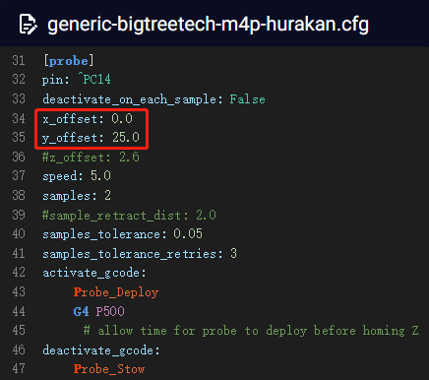
  2. Bed_mesh limit size  
     mesh_min: 15, 15  
     mesh_max: 220, 220  
     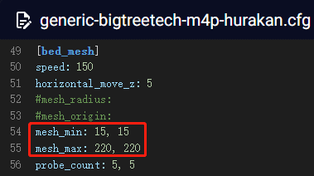
  3. Position of safe_z_home  
     home_xy_position: 117, 92  
     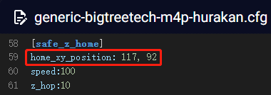
  4. Coordinate position_endstopX Y axis after home  
     [stepper_x]  
     position_endstop: 0  
     position_min: 0  
       
     [stepper_y]  
     position_endstop: -17  
     position_min: -17  
     position_max: 218  
     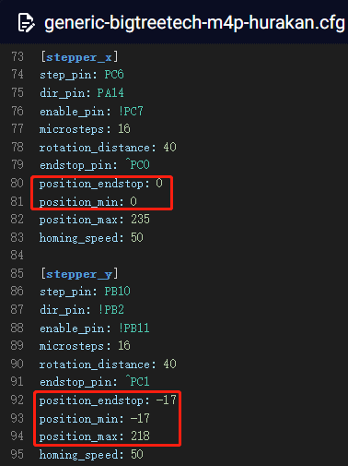

1. Modify the configuration of the extruder to set the reduction ratio of H2.  
   rotation_distance: 24.15  
   gear_ratio: 7:1 # New reduction ratio parameter 7:1  
   max_extrude_only_accel: 1000# Limit the maximum acceleration of the extruder to 1000 #