
TECHNICAL DESIGN + DEVELOPER HANDBOOK Persona 3 Reload AI Guide

A source-backed conversational companion for Persona 3 Reload
Technical Design Document | Software Requirements | Architecture Reference Developer Handbook | Portfolio Case Study | Engineering Retrospective

DOCUMENT SCOPE
This document describes the implementation present in the local repository as of June 6, 2026. It distinguishes active production paths, retained prototypes, current limitations, and planned extensions. Secret values are intentionally excluded.
Prepared for the solo developer and future maintainers

Document Control
Field | Value
Project | Persona 3 Reload AI Guide / Tartarus Guide RAG
Repository | Nchaudry123/Tartarus-Guide
Document date | June 6, 2026
Audience | Developer, reviewer, portfolio reader, future contributor
Status | Current implementation reference; some working-tree improvements are not guaranteed to match the latest deployed build
Primary stack | Next.js, TypeScript, Supabase Postgres, pgvector, Hugging Face embeddings, Groqcompatible chat generation
Design preset | compact_reference_guide with named navy/cyan project palette override
Distribution | Local PDF only; no upload performed
IMPORTANT IMPLEMENTATION NOTE
The active Next.js page reads the shared static HTML shell and hydrates it with public JavaScript and CSS. A React component prototype remains in the repository as an alternate implementation path. This handbook documents both and labels the active path explicitly.

Contents
Open this document in Word and update fields to refresh the table of contents.
- 1. Project Overview
- 2. Development Goals and Requirements
- 3. Complete Feature Inventory • 4. System Architecture
- 5. RAG System Documentation
- 6. Knowledge Base Documentation
- 7. User Experience Design
- 8. Database Documentation
- 9. API Documentation
- 10. AI System Design
- 11. Challenges and Engineering Decisions
- 12. Lessons Learned
- 13. Future Feature Roadmap
- 14. Scalability Considerations
- 15. Portfolio Case Study
- 16. Developer Retrospective
- Appendices: Runbook, Environment, File Map, Testing, Glossary

1. Project Overview
Why this project exists, who it serves, and what the experience is designed to feel like.

1.1 Project Purpose
Persona 3 Reload AI Guide is a personal passion project that turns conventional game-guide material into a conversational companion. A player can describe a problem in natural language, receive a direct strategy answer, and continue the conversation without translating the problem into exact guide keywords.
The project also functions as a learning vehicle for full-stack TypeScript development, production API design, data ingestion, vector search, structured fact extraction, prompt engineering, responsive interaction design, and responsible use of third-party guide sources.

1.2 Problem Being Solved
Traditional guides are accurate but fragmented. A player often needs to identify the right article, scan navigation-heavy pages, compare multiple sources, interpret terminology, and mentally combine details across bosses, schedules, Personas, requests, and Tartarus. This friction is especially visible on mobile devices during active play.
The guide reduces that cognitive cost. It accepts questions such as 'my team feels weak' or 'what should I do before the next full moon?', identifies the likely intent, asks for missing player context when needed, retrieves relevant evidence for exact claims, and translates that evidence into an actionable answer.

1.3 Target Users
- New players who need spoiler-aware explanations and do not yet know the game's terminology.
- Returning players who want quick weakness, fusion, schedule, request, or party advice.
- Completion-focused players who need dates, prerequisites, Social Link choices, rewards, and achievement planning.
- Mobile users who want a readable answer while playing rather than a long article search.
- The developer, who uses the project to learn modern AI application architecture through a concrete domain.

1.4 Core User Experience
The intended experience is closer to talking with an experienced Persona player than querying a search engine. The assistant should greet normally, remember recent context, recognize vague situations, ask targeted follow-up questions, avoid spoilers, provide compact strategic guidance, and reserve citations for an optional source drawer.
User input | Expected assistant behavior
Hi | Respond conversationally without triggering retrieval.
My team feels weak | Ask level, active party, difficulty, or immediate blocker before recommending changes.
What is Dancing Hand weak to? | Prioritize a structured affinity fact; do not guess from a broadly related article.
What should I do today? | Use known month/date and priorities, or request the missing calendar context.
Help with Priestess | Retrieve boss mechanics and deliver a short party and turn-plan recommendation with spoiler restraint.

1.5 Personal Motivation
The project deliberately avoids a startup narrative. Its value is the craft: making a niche guide more enjoyable, understanding where RAG succeeds and fails, designing a distinctive interface, and producing a portfolio-quality system with enough technical depth to expose real engineering tradeoffs.

2. Development Goals and Requirements
The engineering and experience targets that shape implementation decisions.

2.1 Technical Goals
- Build an end-to-end RAG system rather than a thin wrapper around an LLM.
- Learn semantic embeddings, vector similarity search, hybrid retrieval, and structured fact modeling.
- Create a safe server-side boundary for privileged Supabase and model credentials.
- Develop a repeatable ingestion pipeline with discovery, robots checks, rate limiting, caching, cleaning, deduplication, embeddings, fact extraction, and audits.
- Separate exact game facts from broad guide prose so weaknesses, dates, floors, and recipes are not generated from vague similarity alone.
- Build a conversational control layer that can answer directly, clarify, or retrieve according to the user's intent.
- Support deployment as an integrated Next.js application while retaining a static preview mode for rapid UI iteration.

2.2 User Experience Goals
- Reduce time spent navigating and scanning traditional guide pages.
- Allow natural, incomplete, and conversational questions.
- Provide short, useful responses first, with details and sources available on demand.
- Keep the visual identity consistent with Persona 3 Reload without sacrificing mobile usability.
- Avoid revealing retrieval mechanics in normal answer prose.
- Mark uncertainty and ask one useful question instead of inventing unsupported facts.
- Preserve player progress context during the current browser session.

2.3 Functional Requirements
ID | Requirement | Current status
FR-01 | Accept free-form chat questions | Implemented
FR-02 | Classify game intent and ambiguity | Implemented in API controller
FR-03 | Maintain recent conversation and player context | Implemented per browser session
FR-04 | Retrieve exact structured facts and semantic chunks | Implemented; coverage still growing
ID | Requirement | Current status
FR-05 | Generate a natural expert response using Groq | Implemented
FR-06 | Expose citations without cluttering the answer | Implemented as collapsible source details
FR-07 | Avoid unsupported exact weakness claims | Implemented guard; dependent on fact coverage
FR-08 | Operate in static/mock mode without credentials | Implemented
FR-09 | Support mobile viewport and keyboard behavior | Implemented and iteratively refined
FR-10 | Persist a profile across devices/accounts | Not implemented

2.4 Non-Functional Requirements
- Accuracy: exact claims should come from structured facts or strongly matching evidence.
- Responsiveness: routine conversational turns should bypass retrieval; indexed turns should remain usable on free or low-cost provider tiers.
- Maintainability: ingestion, retrieval, API orchestration, and UI should remain separable.
- Security: privileged keys remain server-side and are never included in client assets or documentation.
- Legal restraint: store small retrieval chunks and derived facts, not reconstructed full articles.
- Accessibility: preserve readable contrast, keyboard submission, focus behavior, scalable text, and mobile-safe touch targets.

3. Complete Feature Inventory
Implemented capabilities, their user value, technical shape, dependencies, and logical next step.

3.1 Persona-Styled Entrance Screen
Purpose: Creates a game-like first impression and transitions into the actual tool rather than a conventional marketing page.
User benefit: Users immediately understand the domain and tone.
Technical implementation: Shared HTML/CSS uses supplied visual assets, layered geometric panels, a SEES portrait seal, entrance transitions, and motion-reduction rules.
Dependencies: Static assets, CSS animations, browser storage.
Future improvement: Add a short skip setting and performance-aware animation quality.

3.2 Conversational Chat Interface
Purpose: Provides the primary experience for asking questions and reading multi-turn answers.
User benefit: The guide feels like an assistant instead of a document search.
Technical implementation: The active page injects index.html and loads public/script.js; messages render as user and assistant bubbles with a persistent composer.
Dependencies: Next.js page shell, JavaScript, CSS, /api/chat.
Future improvement: Migrate the active shell to a single typed React implementation after visual behavior stabilizes.

3.3 Casual Conversation Path
Purpose: Allows greetings, thanks, meta questions, and small talk to behave normally.
User benefit: Users can speak naturally without every turn becoming a database search.
Technical implementation: The API detects casual intent and returns a direct response before retrieval.
Dependencies: Intent heuristics and Groq controller.
Future improvement: Evaluate a compact intent model or structured classifier against real transcripts.

3.4 Intent and Action Controller
Purpose: Determines whether to answer directly, clarify, search guides, search facts, or search both.
User benefit: Vague language receives intelligent handling and exact questions receive evidence.
Technical implementation: A controller schema exposes five actions and domain intents, merging deterministic analysis with an LLM decision.
Dependencies: Groq-compatible chat API, route-level schemas.
Future improvement: Add controller evaluation fixtures and confidence calibration.

3.5 Clarification System
Purpose: Requests the smallest missing detail needed to make advice useful.
User benefit: Users are guided rather than rejected with 'provide more information'.
Technical implementation: Intent-specific follow-ups cover level, party, boss, month/date, and general blockers; prompts are limited and sanitized.
Dependencies: Controller plus profile extraction.
Future improvement: Rank clarification questions by expected information gain.

3.6 Session Context Memory
Purpose: Carries recent messages and inferred player details through the current session.
User benefit: Follow-up questions can refer to level, party, month, difficulty, playstyle, and recent bosses.
Technical implementation: The browser stores a player profile in sessionStorage and sends a rolling history window with each request.
Dependencies: Browser sessionStorage, ChatRequest history/profile fields.
Future improvement: Add optional user-controlled persistent profiles with deletion/export controls.

3.7 Player Profile Extraction
Purpose: Infers useful game state from ordinary language.
User benefit: The user does not need to complete a settings form before receiving personalized advice.
Technical implementation: The API merges explicit profile values with detected month, level, difficulty, party, playstyle, and recent boss updates.
Dependencies: Intent analysis and response companion metadata.
Future improvement: Add a profile review panel so users can correct mistaken inference.

3.8 Source-Backed RAG
Purpose: Grounds exact and strategic responses in the indexed guide corpus.
User benefit: Answers become more accurate and traceable than model-only generation.
Technical implementation: The route dynamically builds context from structured facts and vector/keyword chunks, then asks Groq to synthesize an answer.
Dependencies: Supabase, pgvector, Hugging Face, Groq.

Future improvement: Increase structured fact coverage and add retrieval evaluations.

3.9 Structured Fact Priority
Purpose: Separates exact game mechanics from broad prose.
User benefit: Weaknesses, dates, rewards, floors, and recipes are less likely to be hallucinated.
Technical implementation: Facts are typed, linked to entities and sources, ranked by confidence and source credibility, and searched before chunks.
Dependencies: entities/facts tables, searchFacts.ts.
Future improvement: Add conflict resolution and field-level freshness metadata.

3.10 Exact Weakness Safety Guard
Purpose: Prevents the model from inventing a weakness from loosely related text.
User benefit: A missing answer is safer than an incorrect tactical instruction.
Technical implementation: Exact affinity questions require structured affinity support; otherwise the route asks for a variant/floor or explains the evidence gap.
Dependencies: Controller, fact retrieval, subject-source matching.
Future improvement: Expand deterministic extraction and build an affinity regression suite.

3.11 Hybrid Chunk Retrieval
Purpose: Finds relevant guide prose even when wording differs.
User benefit: Broad strategy and walkthrough questions can be answered without exact keyword matching.
Technical implementation: The retriever combines pgvector similarity with keyword fallback, exact phrase boosts, deduplication, and source credibility tie-breaking.
Dependencies: match_chunks RPC, embedding service, Supabase.
Future improvement: Introduce reranking and query expansion while measuring latency.

3.12 Collapsible Sources
Purpose: Keeps references available without letting them dominate the response.
User benefit: Users can verify an answer when they care, while normal chat remains clean.
Technical implementation: Assistant cards render source metadata inside an expandable details control and keep retrieval terminology out of prose.
Dependencies: ChatResponse sources, static UI renderer.
Future improvement: Add cited claim highlighting and source freshness.

3.13 Suggested Replies
Purpose: Offers relevant next messages after clarifications or answers.
User benefit: Mobile users can continue quickly without typing long details.
Technical implementation: The API returns optional first-person suggestedPrompts; client code renders them as buttons and rejects assistant-style questions.
Dependencies: Companion response metadata.
Future improvement: Generate prompts from unresolved profile fields and current goal.

3.14 Responsive Mobile Composer
Purpose: Keeps the input usable around iOS browser chrome and the software keyboard.
User benefit: The primary action remains visible and readable on phones.
Technical implementation: CSS breakpoints, pointer detection, visualViewport listeners, keyboard-open state, dynamic viewport sizing, and larger mobile composer dimensions.
Dependencies: Modern browser Visual Viewport API.
Future improvement: Test across Safari/Chrome device matrix and add safe-area telemetry.

3.15 Static Preview and Mock Fallback
Purpose: Allows visual development without live credentials.
User benefit: The interface remains demonstrable and debuggable offline.
Technical implementation: The static shell calls a configured API URL or /api/chat and falls back to mock Persona-style data when unavailable; USE_MOCK_CHAT can force mock mode.
Dependencies: index.html, script.js, environment variables.
Future improvement: Make mock mode visually explicit only in developer builds.

3.16 Balanced Source Discovery
Purpose: Expands the corpus beyond a short hand-maintained URL list.
User benefit: More questions can be answered from real guide pages.
Technical implementation: Curated seeds feed an allowlisted crawler that scores links, balances domains/categories, rejects irrelevant paths, and caps total pages.
Dependencies: Cheerio, sourceCatalog.ts, discoverSources.ts.
Future improvement: Add crawl manifests and incremental recrawl scheduling.

3.17 Respectful Fetching and Local Cache
Purpose: Reduces repeated requests and honors publisher rules.
User benefit: Ingestion is more reliable and less disruptive to source sites.
Technical implementation: robots.txt checks, rate limits, timeouts, an explicit user agent, raw-page cache, and an IGN reader fallback are implemented.
Dependencies: robots-parser, fetch, local filesystem.
Future improvement: Add retry budgets, conditional requests, and per-domain health metrics.

3.18 Content Cleaning and Table Preservation
Purpose: Turns guide HTML into compact evidence without navigation and advertising noise.
User benefit: Retrieval focuses on useful game information.
Technical implementation: Scripts, styles, menus, ads, comments, breadcrumbs, related content, and sharing UI are removed; meaningful paragraphs, headings, and tables are preserved.
Dependencies: Cheerio, extractContent.ts.
Future improvement: Add per-site extraction fixtures and DOM-drift alerts.

3.19 Chunking, Hashing, and Synchronization
Purpose: Creates retrieval units with stable identities.
User benefit: Updates do not continually duplicate the index.
Technical implementation: Sections become roughly 240-700 token chunks; SHA-256 hashes enforce uniqueness; safe sync deletes stale chunks only after replacement succeeds.
Dependencies: chunkText.ts, embedChunks.ts, database constraints.
Future improvement: Add semantic boundary scoring and chunk-version lineage.

3.20 Structured Fact Extraction
Purpose: Derives typed records from guide content.
User benefit: The chatbot can answer exact questions with a stronger evidence model.
Technical implementation: Zod-valid LLM extraction is combined with deterministic affinity-table parsing, evidence checks, confidence thresholds, and deduplication.
Dependencies: Groq/OpenAI-compatible model, Zod, Supabase.
Future improvement: Broaden deterministic parsers for Social Links, requests, items, and schedules.

3.21 Ingestion Audit and Backfill Tools
Purpose: Makes corpus health observable and recoverable.
User benefit: The developer can identify missing categories and rebuild facts without refetching every page.
Technical implementation: CLI scripts report coverage and support clear/rebuild fact backfills, dry runs, list mode, force refresh, sync, and page limits.
Dependencies: tsx scripts and Supabase.
Future improvement: Store audit snapshots and regression thresholds in CI.

3.22 Terminal Q&A Workflow
Purpose: Provides a fast backend-only test path.
User benefit: Retrieval and generation can be debugged independently from the visual UI.
Technical implementation: npm run ask invokes a simpler terminal pipeline using the same retrieval building blocks.
Dependencies: src/ask.ts, environment configuration.
Future improvement: Unify terminal orchestration with the production controller to avoid behavioral drift.

3.23 Feature Status Summary
Area | Implemented | Partial / experimental | Not yet implemented
Conversation | Multi-turn session history, intent, clarification, casual chat | Profile inference quality | Cross-device memory and accounts
Retrieval | Fact-first plus hybrid chunk search | Corpus breadth and fact density | Automated evaluation and reranking service
Interface | Entrance, chat, sources drawer, responsive composer | Static/React duality | Unified typed React UI and accessibility audit
Operations | Ingest, backfill, audit, static mock  mode | Manual ingestion runs | Scheduled pipelines, dashboards, alerting

4. System Architecture
A layered view of the active application, retained prototype, services, and data boundaries.
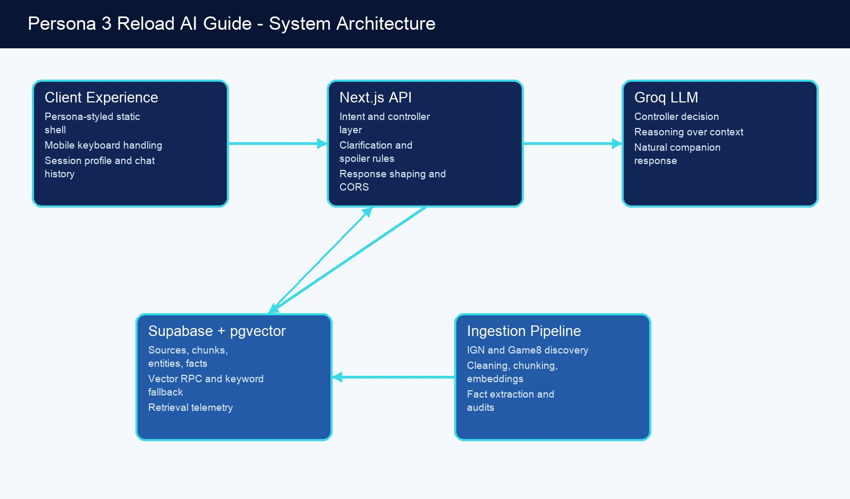
Figure 4-1. High-level architecture and primary data flow.

4.1 Frontend Architecture
The active rendering path is intentionally unusual. app/page.tsx reads the repository's index.html, extracts its body, injects that markup into the Next.js page, and loads /script.js. app/layout.tsx links /styles.css. This keeps the mature static visual implementation identical between a local static server and Vercel while still allowing the Next.js backend to share the deployment.
The repository also contains a componentized React prototype: ChatShell, Sidebar, ChatInput, MessageBubble, GuideAnswerCard, SourceCard, WeaknessTable, PersonaBackground, LoadingPersona, and SuggestionButton. These components demonstrate a cleaner future ownership boundary but are not the authoritative active shell today.
Frontend concern | Current implementation
Routing | Single primary page through Next.js App Router; POST API route under /api/chat.
State | Plain JavaScript state, sessionStorage profile, in-memory rolling chat history.
Styling | Large shared CSS system with desktop/mobile breakpoints, fixed Persona-inspired geometry, animations, and accessibility fallbacks.
Assets | Locally bundled JPEG menu art and a SEES portrait seal; no runtime third-party image dependency.
Frontend concern | Current implementation
Input behavior | Enter to submit, Shift+Enter for multiline behavior where supported, visualViewport keyboard adjustment.
Static compatibility | index.html + styles.css + script.js can run through a basic HTTP server and point to a remote API.

4.2 Backend Architecture
The backend is a serverless-friendly Next.js route. It validates requests, applies CORS, interprets conversation state, decides whether retrieval is necessary, builds context, invokes the chat provider, normalizes the model response, and returns a UI-oriented contract.
- Controller layer: intent, ambiguity, action, spoiler caution, profile updates, and suggested replies.
- Retrieval orchestration: fact search, chunk search, source deduplication, and retrieval logging.
- Generation layer: structured JSON response from an OpenAI-compatible endpoint, currently configured for Groq.
- Fallback layer: external RAG endpoint support, direct RAG, mock response, and explicit error/empty modes.
- Safety layer: exact-weakness support guard, response sanitization, confidence bounds, and no secret exposure.

4.3 Service and Deployment Topology
Service | Responsibility | Trust boundary
Vercel / Next.js | Hosts frontend and /api/chat server route | Public application; server environment holds secrets
Supabase | Postgres records, vector index, RPC search, retrieval logs | Service-role access is server-only
Hugging Face  Inference | Produces 384-dimensional query and ingestion embeddings | API token remains server/ingestion-side
Groq API | Controller and final response generation | Receives user prompt, compact history, profile, and retrieved context
IGN and Game8 | Authoritative external guide material | Fetched only during ingestion under allowlist/rate-limit rules
Local cache | Stores raw fetched pages during development | Gitignored; not served to users

4.4 Architectural Tension: Shared Static Shell vs. React
ENGINEERING DECISION

Keeping the static shell reduced deployment drift during rapid visual iteration, but it duplicates script/style files and weakens type safety. The practical migration path is to freeze visual acceptance tests, port one region at a time into ChatShell, and remove the injected HTML only after desktop and mobile parity is proven.

5. RAG System Documentation
The complete path from third-party guide discovery to a grounded conversational answer.
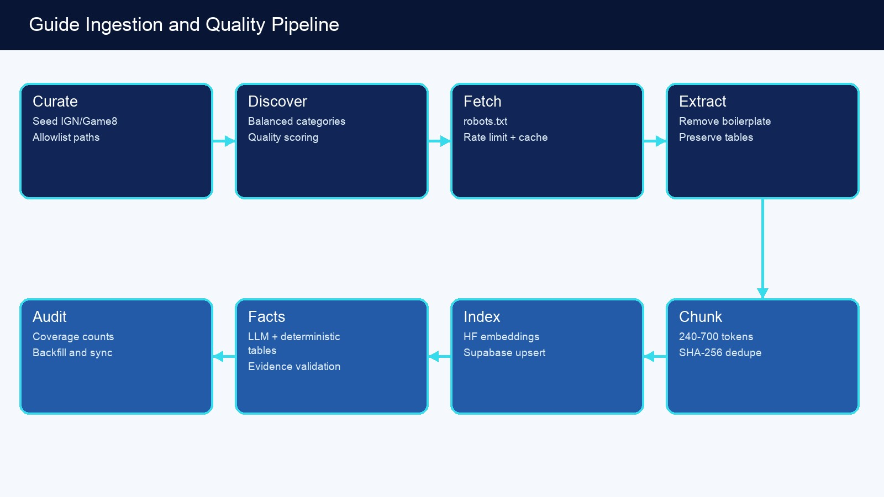
Figure 5-1. Offline ingestion and quality-control pipeline.
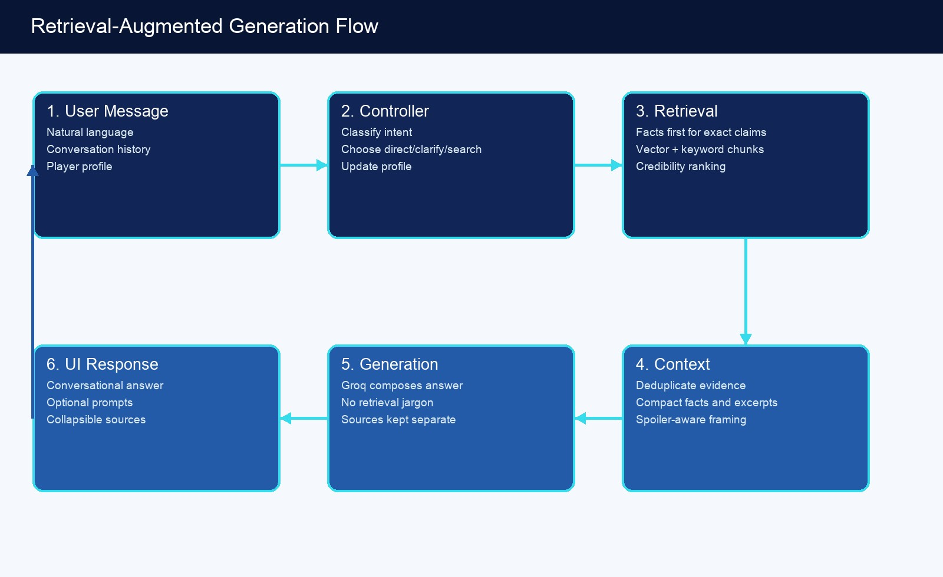
Figure 5-2. Online question routing, retrieval, reasoning, and presentation.

5.1 Data Collection
Curated seeds in src/ingest/urls.ts establish known high-value entry points. The discovery layer follows only approved IGN Persona 3 Reload wiki paths and Game8 Persona 3 Reload paths. It rejects generic news, comments, login pages, reviews, videos, unrelated games, and DLC-specific paths when those do not match the intended corpus.
Source metadata includes title, canonical URL, domain, category, source type, and credibility rank. IGN is assigned a stronger default rank than Game8 when otherwise comparable sources conflict. The design does not assume any publisher is infallible; credibility ranking is a deterministic tie-breaker, not proof.

5.2 Discovery and Fetching
- Discover links from selected seed pages while maintaining domain and category balance.
- Score high-value paths using terms associated with bosses, Tartarus, Personas, Social Links, requests, classroom answers, beginner strategy, and fusion.
- Canonicalize URLs before comparison so tracking parameters and fragments do not produce duplicate sources.
- Check robots.txt before fetching and use a descriptive ingestion user agent.
- Rate-limit requests and cache raw responses under .cache/raw-pages.
- For IGN, attempt the r.jina.ai reader representation first and fall back to direct HTML when required.

5.3 Content Processing
The extractor removes navigation, advertisements, scripts, styles, comments, breadcrumbs, newsletter prompts, related-content modules, video shells, and share controls. It keeps document title, meaningful headings, paragraphs, and table content. Game8 pages use a site-specific article root where available.
Tables receive special handling because affinity and schedule information is often lost when HTML is flattened. Cells are converted into explicit label/value text so downstream extraction can distinguish a boss's own affinity row from strategy prose about summoned enemies.

5.4 Chunking Strategy
Property | Current rule | Reason
Target size | Approximately 500 tokens | Enough context for strategy while remaining focused
Accepted range | Roughly 240-700 tokens; very small useful fragments may pass at about 70 tokens | Avoid both tiny context fragments and broad article-sized chunks
Boundary | Section headings and accumulated | Retains local semantic topic
Property | Current rule | Reason
 | paragraphs
Identity | SHA-256 of source URL, section title, and text | Stable deduplication and safe synchronization
Synchronization | Delete stale source chunks only after replacements embed successfully | Avoid an empty index after a partial failure

5.5 Embeddings
The default embedding model is sentence-transformers/all-MiniLM-L6-v2 through Hugging Face feature extraction. It produces 384-dimensional vectors, matching chunks.embedding vector(384) and the match_chunks RPC signature. Query embeddings are normalized to a single vector shape, dimensions are checked, and provider calls use exponential retry behavior.
MODEL MIGRATION CONSTRAINT
Changing the embedding model is a schema migration, not only an environment-variable edit. EMBEDDING_DIMENSIONS, the chunks column, the RPC argument, and all stored vectors must agree; existing chunks must be re-embedded.

5.6 Vector and Keyword Storage
Supabase pgvector stores embeddings beside source-linked chunks. The migration creates an IVFFlat cosine index with 100 lists. The production retriever also performs a keyword fallback and merges the two result sets, which protects against semantic misses for exact names and unusual game terminology.

5.7 Structured Fact Extraction
Structured facts are a second retrieval plane. An LLM extraction pass emits Zod-validated entity/fact candidates, but deterministic affinity-table parsing can override ambiguous prose. Candidate facts require supporting evidence, a minimum confidence threshold, and valid entity/fact types before insertion.
This distinction is central to accuracy. Broad strategy prose is appropriate for 'how should I approach this fight?' but unsafe for 'what is this enemy weak to?'. Exact affinity questions are therefore blocked from a confident answer unless structured affinity evidence exists.

5.8 Retrieval
- Normalize the user query and infer likely entity terms and fact types.
- Search entities and structured facts for exact factual intents.
- Embed the query and call match_chunks for semantic evidence.
- Run keyword search as a fallback or complement.
- Boost exact phrase matches, deduplicate chunks, and prefer credible sources on ties.
- Assemble a compact context package and record matched IDs in retrieval_logs.

5.9 Context Construction
buildContext combines fact matches and chunk matches into a concise evidence package. Sources are deduplicated separately for UI display. The final prompt receives only the evidence needed for the turn rather than full pages, which controls latency, model context usage, and article-reconstruction risk.

5.10 Response Generation
The Groq model is instructed to act as a normal chat assistant first and a Persona veteran second. It integrates facts naturally, does not say 'according to the database', avoids retrieval jargon, keeps mobile readability in mind, and returns a machine-readable structure containing answer text, optional sections/tables, confidence, missing information, profile updates, follow-up questions, and suggested prompts.

5.11 Corpus Checkpoint and Current Limitation

JUNE 6, 2026 PROJECT CHECKPOINT
A documented ingestion run selected 180 balanced pages, prepared 526 clean chunks and 459 fact candidates, embedded 526 chunks, and removed 280 stale chunks. A subsequent audit reported 184 source rows, 544 chunks, 14 entities, and 34 structured facts after the initial fact pass. These counts are a time-specific checkpoint, not a permanently current production total.
The principal bottleneck is now fact density, not page discovery. Broad guide coverage can retrieve relevant articles, but exact answers remain dependent on entity-level structured extraction. The next quality milestone is a validated fact backfill across enemies, bosses, requests, Social Links, schedules, items, and fusion rules.

5.12 Evaluation Strategy
Evaluation layer | Recommended metric | Example test
Discovery | Category/domain coverage and deadlink rate | At least one high-quality page for every major guide category
Extraction | Useful-text precision and table preservation | Affinity table remains distinguishable from nearby strategy text
Fact extraction | Precision by fact type | Priestess nullifies Ice; do not assign summoned-shadow

Evaluation layer | Recommended metric | Example test
 |  | weaknesses to Priestess
Retrieval | Recall@k and exact-subject precision | Dancing Hand query ranks the correct subject page above generic boss guides
Generation | Groundedness and actionability | Answer contains only supported exact claims and a practical next step
Conversation | Clarification usefulness and memory accuracy | Vague team question asks level/party once, then uses the answer

6. Knowledge Base Documentation
Information categories, data shape, relationships, and retrieval risks.
Category | Primary shape | Typical relationships | Retrieval challenge
Personas | Entity + facts/chunks | Fusion recipes, skills, unlocks, level and role | Names overlap; recipes vary with special conditions
Bosses | Boss entity + affinities  + strategy chunks | Location, phases, null/repel/drain, recommended party | Nearby enemy prose can contaminate boss facts
Enemies /  Shadows | Enemy entity + affinity facts | Weakness, resistance, location/floor | Variants may share similar names
Social Links | Entity + schedule/answer/prer  equisite facts | Availability, dialogue choice, unlock path | Calendar and spoiler sensitivity
Requests | Request entity + deadline/reward/prer equisite | Completion steps and reward | Request numbers and names must be normalized
Calendar Events | Activity/location + schedule facts | Date, time slot, prerequisite | Date parsing and route-dependent availability
Tartarus | Floor/location entities  + chunks | Block ranges, gatekeepers, rescue events, exploration tips | Floor terminology and procedural variation
Items | Item entity + item_effect/reward facts | Effect, source, use | Generic names and acquisition context
Equipment | Equipment entity + item_effect/chunks | Stats, effect, shop/drop source | Version or progression availability
Party Members | Party member entity + strategy chunks | Role, strengths, team synergy | Recommendations depend on level and unlocked roster
Fusion  Information | Persona facts + guide chunks | Recipe, prerequisite, inherited skills | Exact recipes and special fusions require structured support
Story Content | Guide chunks with spoiler caution | Progress guidance and ending requirements | High spoiler risk; progress inference can be wrong
Gameplay  Mechanics | Mechanic entity + tips/chunks | Theurgy, shifts, ailments, combat systems | Broad concepts can match many unrelated questions
Achievements | Activity/request/item entities + chunks | Unlock conditions and completion planning | Cross-system dependencies

6.1 Entity Normalization
Entities preserve the display name, normalized name, type, and aliases. The unique normalized_name/type pair prevents one textual subject from becoming multiple records while still allowing an enemy and an item to share a name if their types differ.

6.2 Source Relationships
Every chunk and fact links back to a source. This supports credibility ranking, source display, stalecontent cleanup, and future claim-level provenance. Source deletion cascades into dependent chunks and facts, making source synchronization predictable.

6.3 Conflict Handling
Current conflict behavior is primarily ranking-based: lower credibility_rank sources are preferred, and fact confidence provides a secondary signal. A mature implementation should model conflicting values explicitly, compare publication or last-checked time, and avoid silently selecting a value when equally credible sources disagree.

7. User Experience Design
How the interface balances game identity, speed, readability, and chat conventions.

7.1 Landing and Entrance Experience
The first screen is an immersive Persona-inspired entrance, not a promotional landing page. It uses the supplied character art, cyan/navy palette, angled geometry, layered shards, and an Enter Records action.
Motion creates presentation energy while prefers-reduced-motion provides a restrained alternative.

7.2 Chat Experience
The chat area follows familiar LLM conventions: the user's message appears separately, the assistant response occupies a larger readable surface, the composer remains visually stable, and new responses scroll into view. Game-specific styling is applied around this behavior rather than replacing it.
The default empty state includes a portrait seal, a clear question, a short description, and a small number of starter prompts. These prompts are onboarding aids rather than a second navigation system.

7.3 Navigation
A vertical Quick Menu provides domain entry points such as Shadows, Bosses, Personas, Social Links, Requests, and Tartarus. Category actions populate or submit relevant prompt language instead of navigating away from the conversation. On narrow screens the menu becomes an overlay controlled by a familiar hamburger button.

7.4 Mobile Experience
Problem | Current response | Remaining risk
iOS keyboard reduces viewport | visualViewport height/offset updates CSS state and scroll position | Safari browser chrome varies by device and launch context
Desktop geometry overflows | Mobile breakpoints resize hero, prompts, chat card, and composer | Long localized labels may still require dynamic sizing
Composer hidden behind browser UI | Safe-area spacing and keyboard-open adjustments | Standalone PWA and in-app browser need separate testing
Source cards overwhelm answer | Sources are collapsible | Large result sets need source caps and grouping
Touch targets too small | Buttons expand on mobile | Full accessibility audit is still pending

7.5 Error Handling and Empty States
- Mock mode: returns predictable sample answers when the live service is unavailable or deliberately disabled.
- Empty retrieval: says the exact information is not yet supported and asks for a useful narrowing detail.
- Provider failure: returns an error-mode response without exposing credentials or raw backend internals.
- Ambiguous message: asks a domain-specific question rather than a generic rejection.
- Status probe: __status__ reports whether the route is configured for RAG or mock behavior.

7.6 Accessibility Considerations
The interface includes visible text labels, keyboard submission, reduced-motion support, high contrast, scalable mobile layouts, and source details that use native disclosure behavior. The remaining work is a formal keyboard/focus audit, semantic landmark review, screen-reader labeling, contrast measurement on image-backed regions, and automated checks with axe or Lighthouse.

7.7 Design Tradeoff
GAME IDENTITY VS. TOOL ERGONOMICS
Persona-style typography, angles, and oversized headings create the desired atmosphere, but they can crowd small screens. The governing rule should be: preserve the identity in backgrounds, accents, transitions, and section shapes; preserve conventional chat behavior in reading order, input placement, focus, and scrolling.

8. Database Documentation
Supabase Postgres schema, pgvector search, relationships, and example data.
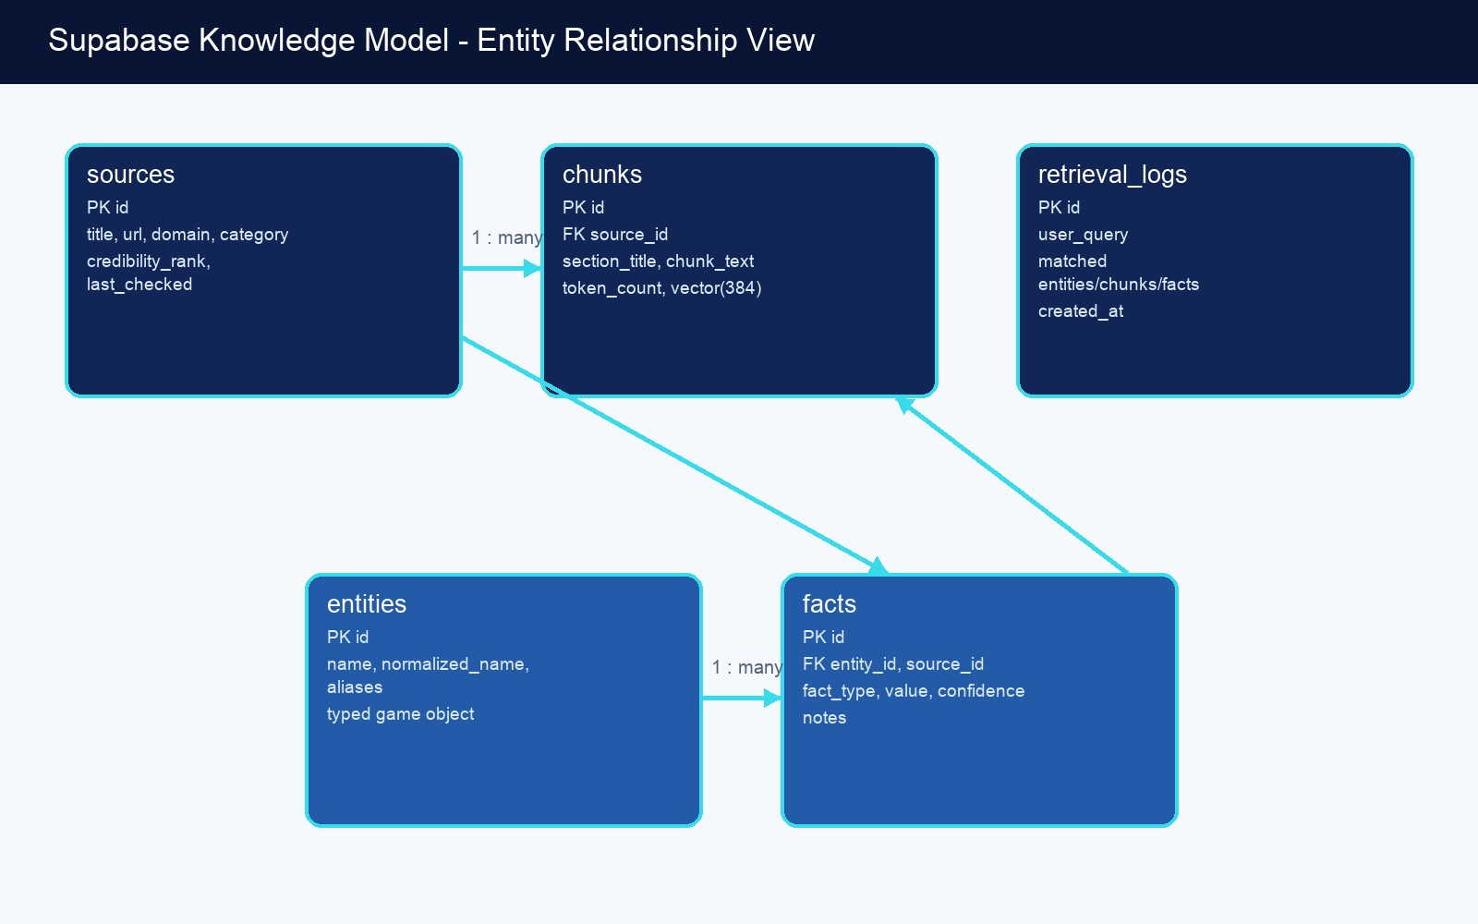
Figure 8-1. Knowledge-base entity relationship diagram.

8.1 sources
Registry of approved guide pages and their provenance.
Field | Type / constraint | Usage
id | uuid, primary key | Stable source identifier
title | text, required | Page title
url | text, unique, required | Canonical original URL
domain | text, required | Publisher domain
category | text, required | Guide taxonomy
source_type | text, default guide | Future source classification
credibility_rank | integer, default 50 | Lower values receive preference
last_checked | timestamptz | Future freshness signal
created_at | timestamptz | Insertion time
Example record: {"title":"Boss Guides - Persona 3 Reload","url":"https://www.ign.com/wikis/persona-3reload/Boss_Guides","domain":"ign.com","category":"bosses","credibility_rank":10}

8.2 chunks
Small, source-linked text units used for semantic and keyword retrieval.
Field | Type / constraint | Usage
id | uuid, primary key | Chunk identifier
source_id | uuid, FK -> sources | Cascade-owned source
section_title | text, optional | Local document heading
chunk_text | text, required | Clean retrieval content
chunk_hash | text, unique | SHA-256 deduplication identity
token_count | integer | Approximate chunk size
embedding | vector(384) | Semantic representation
created_at | timestamptz | Insertion time
Example record: {"source_id":"...","section_title":"Priestess
Strategy","chunk_text":"...","token_count":486,"embedding":[384 values]}

8.3 entities
Normalized game subjects that structured facts describe.
Field | Type / constraint | Usage
id | uuid, primary key | Entity identifier
name | text, required | Display name
type | checked text | enemy, boss, persona, social_link, request, item, equipment, location, mechanic, party_member, tartarus_floor, activity, or skill
aliases | text[] | Alternative names
normalized_name | text, required | Search/dedupe identity
created_at | timestamptz | Insertion time
Example record: {"name":"Priestess","type":"boss","aliases":["Arcana
Priestess"],"normalized_name":"priestess"}

8.4 facts
Typed, source-supported claims for exact retrieval.
Field | Type / constraint | Usage
id | uuid, primary key | Fact identifier
entity_id | uuid, FK -> entities | Subject
source_id | uuid, FK -> sources | Provenance
fact_type | checked text | Weakness, resistance, strategy, schedule, recipe, reward, and other supported types
value | text, required | Normalized factual value
Field | Type / constraint | Usage
confidence | numeric 0..1 | Extraction confidence
notes | text, optional | Qualification or evidence note
created_at | timestamptz | Insertion time
Example record:
{"entity_id":"...","source_id":"...","fact_type":"nullifies","value":"Ice","confidence":0.96,"notes":"Explicit affinity table value"}

8.5 retrieval_logs
Developer-facing retrieval telemetry for understanding misses and matches.
Field | Type / constraint | Usage
id | uuid, primary key | Log identifier
user_query | text, required | Original question
matched_entities | jsonb | Entity match summary
matched_chunks | jsonb | Chunk match summary
matched_facts | jsonb | Fact match summary
created_at | timestamptz | Request time
Example record: {"user_query":"What is Dancing Hand weak to?","matched_entities":
[],"matched_chunks":[...],"matched_facts":[]}

8.6 Relationships and Constraints
- sources 1 -> many chunks; deleting a source removes its chunks.
- sources 1 -> many facts; deleting a source removes its derived facts.
- entities 1 -> many facts; deleting an entity removes its facts.
- entities are unique by normalized_name and type.
- facts are practically unique by entity, source, type, and a case-insensitive hash of value.
- chunks are globally unique by chunk_hash.

8.7 Vector RPC
match_chunks(query_embedding vector(384), match_count integer default 8, similarity_threshold float default 0.72) joins chunks to sources, filters by cosine similarity, orders first by source credibility and then vector distance, and returns chunk text plus source metadata.

8.8 Security Model
The application uses the Supabase service-role key only in server-side code and ingestion scripts. The initial migration does not encode a complete Row Level Security policy set, so browser access must never use the service role and public Data API exposure should be reviewed. For a public multi-user version, enable RLS, restrict direct table access, and keep retrieval behind the application API.

9. API Documentation
Request contracts, response contracts, behavior modes, and examples.

9.1 POST /api/chat
Purpose: Primary conversational endpoint. It may answer directly, clarify, retrieve from Supabase, call an external RAG endpoint, or return a controlled fallback.
Authentication: No end-user authentication is currently required. Provider and Supabase credentials are server-side environment variables.
CORS: Origins are controlled by ALLOWED_ORIGINS when configured; OPTIONS is supported.

Request Body
Field | Type | Required | Description
question | string | Yes | Current user message; __status__ is reserved for configuration probing
conversationId | string | No | Optional client conversation identifier
history | array of role/content | No | Recent user and assistant messages
playerProfile | object | No | Month, level, difficulty, active party, recent boss, Social  Links, playstyle

Request Example

JSON
{"question":"My team feels weak","conversationId":"session-123","history":[{"role":"user","content":"I am in June"}],"playerProfile":{"currentMonth":"June","difficulty":"Normal","activeParty": ["Yukari","Junpei"]}}

Response Body
Field | Type | Description
answer | string | Primary natural-language response
sections | array | Optional titled supporting sections
tables | array | Optional exact lists, mainly weakness/item data
sources | array | Title, URL, and domain for expandable provenance
confidence | number | Bounded confidence signal
missingInfo | string | Information needed to improve the answer
retrievalMode | rag | empty | mock | error | Operational result state
companion | object | Intent, profile updates, follow-up questions, suggested prompts
Field | Type | Description

Response Example

JSON
{"answer":"Who is on your active team, and what level are you? Once I know that, I can tell whether the problem is coverage, equipment, or being underleveled.","sources":[],"retrievalMode":"rag","companion": {"intent":"Team Building","profileUpdates":{"currentMonth":"June"},"followUpQuestions":["What level are you right now, and who is on your active team?"],"suggestedPrompts":["I am level 18 with Yukari and Junpei"]}}

9.2 OPTIONS /api/chat
Returns the route's CORS preflight response. It allows the static shell to call a separately hosted API when the origin is approved.

9.3 Status Probe
POSTing question='__status__' returns whether the route is configured for live RAG or mock mode. This is an internal UI capability, not a public health standard. A future deployment should expose a dedicated, rate-limited health endpoint with no configuration detail.

9.4 Response and Error Modes
Mode | Meaning | Client behavior
rag | Live controller/retrieval/generation completed | Render answer and optional sources
empty | Route connected but exact/relevant evidence was insufficient | Render helpful limitation and clarification
mock | Mock mode forced or live credentials unavailable | Render development sample answer
error | Unexpected provider, validation, or backend failure | Render safe retry guidance without raw secrets

9.5 External RAG Compatibility
If RAG_CHAT_ENDPOINT is configured and mock mode is disabled, the route can delegate to a separate service accepting POST {question, conversationId}. This provides an escape hatch for moving retrieval into another runtime, but it introduces a second contract that must remain versioned and tested.

10. AI System Design
Prompting, control flow, context injection, hallucination prevention, and companion behavior.

10.1 Two-Stage LLM Use
The application treats the LLM as both a controller and a writer. The controller decides whether the turn requires direct chat, clarification, guide retrieval, structured retrieval, or both. The final generator receives the selected evidence and produces the answer. This is more efficient and natural than sending every message through retrieval.

10.2 Intent Taxonomy
Intent | Typical examples | Preferred action
Enemy Weakness | What is Dancing Hand weak to? | Structured facts + exact guard
Boss Help | How do I beat Priestess? | Facts and guide chunks
Team Building | My team feels weak | Clarify profile, then guide reasoning
Fusion Advice | What should I fuse next? | Clarify level/goals; exact recipes require facts
Social Links | Who should I prioritize? | Profile/date clarification + guide search
Daily Schedule Planning | What should I do today? | Clarify month/date/free time
Tartarus Navigation | Where should I stop tonight? | Guide/floor facts
Quest Help | How do I finish request 29? | Structured request facts + guide
Story Guidance | How do I get the good ending? | Guide search with spoiler caution
Achievement Hunting | What am I missing for platinum? | Guide search and progress clarification
General Discussion | Hi / thanks / what can you do? | Answer directly

10.3 Prompt Engineering
- Role: knowledgeable Persona 3 Reload veteran and strategic coach.
- Behavior: normal conversational assistant first; retrieval is a hidden implementation detail.
- Accuracy: use structured facts for exact mechanics and do not invent unsupported values.
- Style: direct, practical, concise, mobile-readable, and free of generic filler.
- Clarification: ask one or two targeted questions when player state changes the recommendation.
- Spoilers: avoid later-game details unless requested or already established by player progress.
- Output: JSON fields are normalized before reaching the client.

10.4 Context Injection
The final generation prompt includes the current question, compact recent history, merged player profile, controller decision, structured facts, cleaned guide excerpts, and source metadata. It does not provide full articles. The model is told to treat retrieved material as evidence for exact claims and to keep provenance outside normal prose.

10.5 Hallucination Prevention
Control | What it prevents | Limit
Fact-first retrieval | Treating broad prose as exact data | Only works when facts have been extracted
Exact affinity guard | Invented weakness/resistance answers | May refuse a correct answer if the fact index is incomplete
Evidence validation | Unsupported extracted facts | Source HTML ambiguity can still pass
Low temperature | Unnecessary variation | Does not guarantee factuality
Credibility ranking | Lower-quality source winning a tie | Ranking is manually configured
Missing-info path | Confident answers from insufficient context | Must remain helpful rather than repetitive
Source separation | Retrieval jargon in prose | Citations do not prove every generated sentence

10.6 Response Formatting
Most turns should be one natural answer with short paragraphs. Sections are optional. Tables are reserved for exact affinity or item lists. Sources are rendered separately and collapsed. Suggested prompts must be phrased as user replies, not as assistant questions.

10.7 Memory Model
Memory is currently session-scoped and client-owned. The browser stores playerProfile in sessionStorage and keeps only a recent rolling message window. This is inexpensive and privacy-friendly, but it is not durable across devices, browsers, or cleared sessions. There is no user identity, long-term vector memory, or server-side conversation table.

10.8 Model Choice
The configured main chat model is llama-3.3-70b-versatile through Groq's OpenAI-compatible API. Structured fact extraction can use a faster model such as llama-3.1-8b-instant with delay and fallback controls. This split recognizes that ingestion is batch work while the live companion benefits from stronger reasoning and language quality.

11. Challenges and Engineering Decisions
Major problems, chosen solutions, tradeoffs, and the next engineering move.
Problem | Why difficult | Current solution | Tradeoff | Future improvement
Third-party page variability | IGN and Game8 use different layouts and change over time. | Allowlisted discovery, site-aware extraction, boilerplate removal, and table conversion. | Site-specific logic adds maintenance. | DOM fixtures and extraction drift alerts.
Retrieval accuracy | A semantically similar boss page may not describe the exact enemy. | Hybrid retrieval, exact phrase boost, entity facts, and exactsubject guards. | Some valid answers become unavailable until facts are backfilled. | Build gold query sets and reranking.
Affinity  contamination | Strategy prose may mention another enemy's weakness near a boss name. | Explicit table values override nearby prose and evidence is checked. | Deterministic parsers are domain-specific. | Expand table parsers and regression tests.
Hallucinated exact answers | The LLM can sound confident even when evidence is weak. | Exact facts are required for weaknesses/dates/floors/recipes. | The assistant may ask for details more often. | Calibrated confidence and claim-level citations.
Vague user questions | The correct advice depends on level, party, date, and goal. | Intent-specific clarification plus profile memory. | Too many  clarifications can feel obstructive. | Information-gain ranking and profile correction UI.
Context length and cost | Sending too much guide content increases latency and confusion. | Small chunks, source dedupe, compact context, retrieval only when needed. | Compression can omit nuance. | Adaptive context budgets and reranking.
Source disagreement | Two guides may differ or be updated at different times. | Credibility rank and confidence ordering. | Current model does not fully represent conflicts/freshness. | Versioned facts with lastchecked and conflict records.
Mobile browser keyboard | iOS changes the visual viewport and browser chrome unpredictably. | visualViewport state, dynamic heights, safe-area spacing, mobile composer design. | Behavior varies by browser launch mode. | Device automation and PWA testing.
Static/React duplication | The polished shell and typed component prototype evolved separately. | Use the static shell as the active source of truth for now. | Duplicate CSS/JS and reduced type safety. | Incremental React migration with screenshot parity tests.
Free-tier provider limits | Batch fact extraction and live generation can hit rate limits. | Separate model choices, delays, retries, caching, and manual backfill sizes. | Ingestion takes longer and may require resumability. | Checkpointed job queue and provider abstraction.

11.1 Key Architectural Decision

REASON BEFORE RETRIEVE
The most important behavior change was replacing User -> Retrieve -> Summarize with User -> Intent/Context -> Decide -> Retrieve only if needed -> Reason -> Respond. This makes greetings and ambiguous situations feel conversational while preserving evidence for exact game knowledge.

12. Lessons Learned
What the project teaches about full-stack systems, RAG, user experience, and solo development.

12.1 Full-Stack Development
- A polished frontend can still fail if the API contract is unstable; response types and fallback modes should be designed early.
- Serverless deployment is convenient, but environment scope and redeployment behavior are part of application correctness.
- Keeping privileged data access behind one route is simpler and safer than exposing database clients to the browser.

12.2 AI Engineering
- A larger model improves language and reasoning but cannot compensate for missing or mislabeled evidence.
- Controller prompts and generator prompts solve different problems and should be evaluated separately.
- Structured output must be normalized and sanitized; provider-valid JSON is not automatically UIvalid behavior.

12.3 RAG Engineering
- More pages do not automatically produce more accurate answers. Fact density, entity normalization, and retrieval evaluation matter more after basic coverage.
- Hybrid retrieval is valuable because game names and identifiers are often better handled by lexical search than embeddings.
- Exact factual domains need typed records and deterministic parsing, not only vector chunks.

12.4 UI/UX
- Distinctive visual identity works best around familiar interaction patterns, not in place of them.
- Mobile software keyboards are a layout system of their own; testing screenshots without focus is insufficient.
- Sources should remain available but secondary to the answer.

12.5 Architecture
- Rapid prototypes can create duplicate active paths. Explicitly naming the source of truth prevents accidental drift.
- Batch ingestion deserves operational tooling from the beginning: dry runs, audit counts, sync safety, and resumability.
- A personal project still benefits from production boundaries when it touches secrets, external content, and public users.

12.6 Mistakes and What Would Be Done Differently
- Do not begin by treating all retrieved text as equally trustworthy. Introduce entity facts and evaluation fixtures earlier.
- Avoid maintaining two frontends longer than necessary. Establish screenshot baselines and migrate sooner.
- Do not expose operational labels such as RAG API or source-backed mode in the primary user experience.
- Build a test set before expanding the corpus. Otherwise ingestion success is measured by counts rather than answer quality.
- Keep secrets out of chats, screenshots, repositories, and client configuration from the first deployment step.

13. Future Feature Roadmap
A game-systems roadmap prioritized for user value, accuracy, and realistic solo-development effort.
# | Feature | Description | User value | Difficulty | Priority
1 | Gold retrieval evaluation set | Curated questions and expected facts/sources | Very high | Medium | P0
2 | Fact coverage dashboard | Coverage by entity/fact/category/source | Very high | Medium | P0
3 | Enemy affinity backfill | Validated weaknesses/resistances for Shadows | Very high | High | P0
4 | Boss mechanics backfill | Phases, affinities, party advice, locations | Very high | High | P0
5 | Request database expansion | Deadlines, rewards, prerequisites, steps | High | Medium | P0
6 | Profile correction panel | Let users review inferred level/party/date | High | Medium | P0
7 | Claim-level citations | Map factual sentences to evidence | High | High | P1
8 | Cross-encoder reranking | Rerank top chunks after hybrid retrieval | High | High | P1
9 | Query rewrite service | Generate entity-aware alternate searches | High | Medium | P1
10 | Persistent optional profile | Save progress across sessions/devices | High | High | P1
11 | Fusion calculator | Exact normal/special fusion planning | Very high | High | P1
12 | Fusion path optimizer | Cheapest or skill-preserving routes | High | High | P1
13 | Persona compendium tracker | Track owned and missing Personas | High | Medium | P1
14 | Social Link planner | Schedule priorities and prerequisites | Very high | High | P1
15 | Daily schedule optimizer | Recommend activities by date and goals | Very high | Very high | P1
16 | Spoiler level control | User-selectable strict/moderate/open detail | High | Medium | P1
17 | Tartarus floor tracker | Remember highest floor and gate progress | High | Medium | P1
18 | Party build  recommendations | Skills, gear, roles, and coverage | High | High | P1
19 | Equipment comparison | Compare owned gear and shop/drop options | Medium | High | P2
20 | Elizabeth request tracker | Checklist with deadlines and rewards | High | Medium | P1
21 | Achievement assistant | Progress checklist and missable warnings | High | High | P2
22 | Calendar notification view | Upcoming full moons, deadlines, rescues | High | Medium | P2
23 | Save-file import research | Parse supported save data locally | Very high | Very high | P3
24 | Screenshot recognition | Read enemy/menu screenshots for context | High | Very high | P3
25 | Voice companion | Hands-free questions during play | Medium | High | P3
26 | PWA install mode | App-like mobile launch and offline shell | Medium | Medium | P2
27 | Offline core facts | Bundle a compact weakness/request cache | High | High | P2
28 | Conversation export | Download a play-session strategy log | Medium | Low | P2
29 | Answer feedback | Helpful/incorrect controls tied to query logs | Very high | Medium | P1
30 | Correction workflow | Developer review queue for bad facts | Very high | Medium | P1
31 | Source freshness scheduler | Recheck changed pages incrementally | High | High | P2
32 | Conflict detection | Flag contradictory facts across sources | High | High | P2
33 | Additional trusted sources | Add fusion calculators and specialist references | High | Medium | P2
34 | Model/provider fallback | Fail over between compatible providers | Medium | Medium | P2
35 | Streaming responses | Display answer tokens progressively | Medium | Medium | P2
36 | Accessible theme mode | Simplified typography, motion, and geometry | High | Medium | P2
37 | Localization framework | Support translated UI and source sets | Medium | Very high | P3
38 | Community corrections | Moderated evidence-linked submissions | Medium | Very high | P3
39 | New Game Plus profile | Adjust advice for inherited progress | Medium | Medium | P3
40 | DLC content packs | Explicit opt-in knowledge partitions | Medium | Medium | P3

13.1 Recommended Sequence
- Accuracy foundation: evaluation set, fact dashboard, affinity/boss/request backfills, feedback loop.
- Personalization foundation: profile correction, optional persistence, spoiler setting, progress trackers.
- Game systems: fusion calculator, Social Link planner, schedule optimizer, party builds.
- Operational maturity: scheduled freshness, conflict detection, provider fallback, streaming.
- Experimental interfaces: screenshots, voice, save analysis, community contributions.

14. Scalability Considerations
How the architecture changes from one developer to a larger public audience.
Stage | Hosting and data | AI and retrieval | Operational changes
Personal use | Vercel hobby + Supabase free tier; manual ingestion | Groq/HF free or low-cost limits; small index | Local audits, no accounts, session  memory
Small  community | Paid limits as needed; scheduled ingestion | Request caching, provider rate control, evaluation suite | Basic analytics, abuse limits, feedback workflow
Hundreds of users | Connection pooling, regional strategy, larger vector resources | Streaming, reranking, prompt/result cache, async ingestion | Auth, quotas, monitoring, incident logs, RLS
Thousands of users | Dedicated database/vector capacity,  CDN/PWA, queue workers | Model routing, batch embeddings, cost budgets, multi-provider failover | SLOs, tracing, data retention, privacy controls, deployment environments

14.1 Performance
- Skip retrieval for casual and purely conversational turns.
- Cache embeddings for repeated normalized queries.
- Cap facts/chunks before generation and rerank rather than sending more context.
- Stream final responses when the UI and provider contract are unified.
- Move ingestion into resumable background jobs with per-source checkpoints.

14.2 Cost Controls
- Use a strong live model only for turns that benefit from it; use deterministic logic for status and known templates.
- Use a lower-cost batch model for fact candidates, then validate deterministically.
- Cache source HTML, embeddings, controller decisions for safe repeated intents, and stable final facts.
- Record token/provider usage per request before public growth.
- Introduce daily provider budgets and graceful degradation rather than uncontrolled retries.

14.3 Security and Privacy at Scale
A larger audience changes the threat model. Add authenticated profiles only with explicit consent, RLS, deletion/export paths, retention limits, rate limiting, input size limits, prompt-injection defenses for retrieved text, and clear separation between public source content and private player state.

14.4 Vector Storage Evolution
The current Supabase pgvector design is appropriate for the corpus size. Growth should first tune indexes and query plans, then partition by game/content pack if necessary. A separate vector service is justified only when measured latency, filtering, scale, or operational needs exceed Postgres capabilities.

15. Portfolio Case Study
A polished, factual project narrative for resumes, GitHub, LinkedIn, and personal sites.

15.1 Project Summary
Built a full-stack AI companion for Persona 3 Reload that combines a distinctive game-inspired chat interface with a source-backed RAG pipeline. The system ingests approved IGN and Game8 guides, cleans and chunks content, generates Hugging Face embeddings, stores vectors and structured facts in Supabase, and uses a Groq-hosted LLM to decide when retrieval is needed and compose conversational strategy answers.

15.2 Technical Highlights
- Designed a two-stage controller/generator flow so normal conversation does not behave like search.
- Implemented hybrid retrieval across typed facts, pgvector similarity, keyword fallback, exact phrase boosts, and source credibility.
- Built a legal-safer ingestion pipeline with allowlists, robots checks, rate limiting, local caching, content cleaning, stable hashes, and safe synchronization.
- Added deterministic affinity table parsing and an exact-weakness guard to reduce tactical hallucinations.
- Created a responsive Persona-inspired interface with session context, collapsible citations, suggested replies, and iOS visual viewport handling.
- Deployed a server-side API boundary that protects Supabase service-role, embedding, and chat credentials.

15.3 Technology Stack
TypeScript, Next.js 16, React 19, Supabase Postgres, pgvector, Hugging Face Inference, Groq OpenAIcompatible chat completions, Cheerio, Zod, robots-parser, Tailwind/PostCSS, Framer Motion, Lucide, Vercel, and GitHub.

15.4 Resume Bullets
- Engineered a Persona 3 Reload conversational guide using Next.js, TypeScript, Groq, Hugging Face embeddings, Supabase, and pgvector, with hybrid fact/vector retrieval and source-linked responses.
- Built a respectful web-ingestion pipeline for 180+ curated/discovered guide pages, including robots checks, rate limiting, HTML cleaning, chunk hashing, vector synchronization, structured fact extraction, and corpus auditing.
- Reduced exact-answer hallucination risk through typed entity facts, deterministic affinity-table parsing, source credibility ranking, and an exact-weakness evidence guard.
- Designed a responsive game-inspired chat experience with session memory, intelligent clarification, optional citations, and mobile software-keyboard handling.

15.5 GitHub README Case Study Block

SUGGESTED COPY
Tartarus Guide is a source-backed Persona 3 Reload AI companion. Instead of searching long guide articles, players can describe what they are trying to do and receive concise, contextual strategy. The project combines a Next.js chat application with a Supabase/pgvector knowledge base, Hugging Face embeddings, Groq generation, and a custom ingestion pipeline for trusted IGN and Game8 material. It is a solo learning and portfolio project focused on conversational UX, retrieval accuracy, and game-domain reasoning.

15.6 LinkedIn / Personal Website Summary
I built a conversational Persona 3 Reload guide to explore what it takes to make RAG feel like an actual expert companion instead of a search box. The interesting work was not just connecting an LLM: it was cleaning guide data, separating exact facts from broad prose, designing retrieval safeguards, preserving player context, and making the experience usable on mobile while retaining the game's visual personality.

15.7 Honest Project Weaknesses
The corpus is broader than the structured fact layer, persistent profiles are not implemented, source conflicts are not modeled explicitly, automated retrieval evaluations are still needed, and the active frontend uses a static-shell bridge rather than the cleanest React architecture. Presenting these limits is part of the case study because they identify the real next engineering work.

16. Developer Retrospective
A personal engineering reflection rather than a product pitch.

16.1 Why This Was Built
The project began with a simple frustration: useful Persona 3 Reload information exists, but finding the right fragment while playing interrupts the experience. Building a companion created an opportunity to solve that small problem while learning the systems behind modern AI applications.

16.2 Most Interesting Technical Challenge
The hardest problem was not generating fluent text. It was deciding when fluent text was allowed to contain an exact claim. A related guide page can make an answer sound plausible while still being wrong. Introducing structured facts, deterministic affinity parsing, exact-subject checks, and clarification behavior changed the architecture from 'search and summarize' into a more defensible reasoning system.

16.3 Favorite Features
- The controller that lets a simple greeting remain a simple greeting.
- The source drawer, because it preserves trust without making the interface feel like a database viewer.
- The Persona-inspired entrance and portrait seal, because they make the tool feel made for this specific game.
- Safe chunk synchronization and deterministic table parsing, because they solve quiet backend problems that directly improve answer quality.

16.4 What Comes Next
The next phase should prioritize evidence quality over more visual features: establish a gold evaluation set, increase structured fact coverage, build a correction loop, and let users review the profile the assistant has inferred. Once those foundations are reliable, fusion and schedule planning become valuable higher-level systems rather than new surfaces built on uncertain data.

16.5 Advice for Similar Projects
- Choose a domain you genuinely care about; the edge cases will require patience.
- Do not measure a RAG system only by how many documents it indexed.
- Create typed representations for facts that must never be guessed.
- Design the missing-information response as carefully as the successful answer.
- Keep provider secrets and service-role credentials server-side from day one.
- Build evaluation examples before tuning prompts or changing models.
- Let the product identity be expressive, but keep core interaction patterns familiar.

CLOSING REFLECTION
This project is strongest when treated as an evolving engineering notebook: every incorrect answer becomes a retrieval test, every mobile layout failure becomes a UX constraint, and every new feature is an opportunity to make the companion more truthful, useful, and natural.

Appendix A. Developer Runbook
Common local, ingestion, validation, and deployment operations.

A.1 Local Application
Task | Command / location
Install dependencies | npm install
Run Next.js locally | npm run dev
Build production bundle | npm run build
Run production server | npm run start
Type-check | npm run typecheck
Static preview | python3 -m http.server 4173
Terminal question | npm run ask -- "What is Dancing Hand weak to?"

A.2 Ingestion
Task | Command
Normal ingestion | npm run ingest
Balanced broad sync | npm run ingest -- --max-pages=180 --skip-facts --sync
Dry run | npm run ingest -- --max-pages=180 --dry-run
Refresh raw cache | npm run ingest -- --force
Curated seeds only | npm run ingest -- --no-discover
Audit coverage | npm run ingest:audit
Backfill facts | npm run ingest:facts -- --clear-existing --max-fact-chunks=180

A.3 Deployment Checklist
- Confirm secrets exist in Production and Preview environment scopes as intended.
- Set USE_MOCK_CHAT=false once live Supabase, embedding, and chat credentials are present.
- Run npm run typecheck and npm run build.
- Deploy the latest Git commit to Vercel without reusing stale build cache after environment changes.
- POST __status__ and confirm retrievalMode=rag.
- Run a greeting, vague clarification, exact affinity, boss strategy, and mobile keyboard smoke test.
- Verify no service role, Hugging Face, Groq, or GitHub token appears in client assets or logs.

Appendix B. Environment Variable Reference
Names and purposes only. Secret values must never be committed or embedded in client code.
Variable | Purpose | Scope
SUPABASE_URL | Supabase project base URL | Server/ingestion
SUPABASE_SERVICE_ROLE_KEY | Privileged server-side database key | Secret
EMBEDDING_PROVIDER | huggingface or compatible provider selector | Server/ingestion
EMBEDDING_API_KEY | Embedding provider credential | Secret
EMBEDDING_BASE_URL | Embedding endpoint base | Server/ingestion
EMBEDDING_MODEL | Embedding model identifier | Server/ingestion
EMBEDDING_DIMENSIONS | Expected vector length; currently 384 | Schema-sensitive
CHAT_API_KEY | Groq/OpenAI-compatible chat credential | Secret
CHAT_BASE_URL | Chat completions API base | Server
CHAT_MODEL | Live companion model; configured for llama-3.3-70b-versatile | Server
FACT_EXTRACTION_MODEL | Batch fact extraction model | Ingestion
FACT_EXTRACTION_DELAY_MS | Rate-control delay for fact calls | Ingestion
INGEST_USER_AGENT | Descriptive crawler identity/contact | Ingestion
INGEST_DELAY_MS | Per-request crawl delay | Ingestion
RAW_CACHE_DIR | Local raw-page cache path | Ingestion
RAG_CHAT_ENDPOINT | Optional external RAG service | Server
USE_MOCK_CHAT | Force mock behavior when true | Server
ALLOWED_ORIGINS | Permitted cross-origin frontend origins | Server
CREDENTIAL HYGIENE
Any credential pasted into a chat, screenshot, issue, or commit should be revoked and regenerated. This document intentionally contains no secret values.

Appendix C. Repository Map
The most important implementation files and their responsibilities.
Path | Responsibility
app/page.tsx | Active Next page; injects the static shell
app/api/chat/route.ts | Conversation controller, RAG orchestration, generation, fallback
index.html / public copy | Shared chat and entrance markup
script.js / public copy | Client state, rendering, mobile viewport, API integration
styles.css / public copy | Persona visual system and responsive layout
components/* | Retained typed React component prototype
src/db/client.ts | Supabase, embedding, and chat provider clients
src/retrieval/buildContext.ts | Fact/chunk assembly and retrieval logging
src/retrieval/searchFacts.ts | Entity/fact lookup
src/retrieval/searchChunks.ts | Vector and keyword hybrid search
src/ingest/discoverSources.ts | Balanced allowlisted link discovery
src/ingest/fetchPages.ts | robots, rate limiting, cache, fetch fallback
src/ingest/extractContent.ts | Readable content and table extraction
src/ingest/chunkText.ts | Token-sized chunks and stable hashes
src/ingest/embedChunks.ts | Embeddings, upsert, safe sync
src/ingest/extractFacts.ts | LLM and deterministic structured fact extraction
src/ingest/auditIndex.ts | Coverage auditing
src/ingest/backfillFacts.ts | Fact rebuild from existing chunks
supabase/migrations/001_init.sql | Database schema and vector RPC

Appendix D. Testing Strategy
A practical test pyramid for the next stage of the project.

D.1 Unit Tests
- URL allowlist, canonicalization, categorization, and rejection rules.
- Chunk boundaries, token estimates, hash stability, and synchronization decisions.
- Intent classification and player-profile extraction fixtures.
- Suggested-prompt sanitation and response normalization.
- Exact-affinity support checks and subject matching.

D.2 Integration Tests
- Supabase migration and match_chunks behavior against a disposable project or local Postgres.
- Embedding dimension and provider response-shape validation.
- Ingestion fixture from saved HTML through chunks and facts.
- POST /api/chat in direct, clarify, RAG, empty, mock, and provider-error modes.

D.3 End-to-End Tests
- Desktop entrance, chat submission, answer rendering, source expansion, and scrolling.
- Mobile menu, prompt cards, composer focus, keyboard open/close, submission, and auto-scroll.
- Cross-origin static frontend calling the Vercel API.
- Regression screenshots at representative desktop and mobile viewports.

D.4 Accuracy Regression Set
Maintain a versioned JSON dataset with question, intent, profile, expected clarification or answer facts, forbidden claims, and expected source subjects. Run it before changing prompts, models, chunking, fact extraction, or retrieval thresholds.

Appendix E. Glossary
Project-specific terminology.
Term | Definition
Chunk | A small source-linked section of cleaned guide text used for retrieval.
Embedding | A numeric vector representing semantic meaning; currently 384 dimensions.
Entity | A normalized game subject such as a boss, Persona, request, or item.
Fact | A typed, source-supported claim attached to an entity.
Hybrid retrieval | Combining semantic vector search with lexical/keyword search.
RAG | Retrieval-Augmented Generation: retrieving evidence before generating an answer.
Controller | The decision stage that chooses direct response, clarification, or retrieval.
Groundedness | The degree to which answer claims are supported by provided evidence.
Credibility rank | A manually assigned ordering signal; lower values receive preference.
Exact affinity guard | A rule that blocks exact weakness/resistance answers without structured support.
Session profile | Browser-session player context such as month, level, party, and difficulty.
Static shell | The HTML/CSS/JavaScript UI shared by local preview and the active Next page.

