TASK 2 DOCUMENTATION

Project Title:
Exploratory Data Analysis (EDA) on Dataset for Data Analytics

Abstract
Exploratory Data Analysis (EDA) is an important step in the data analytics process that helps analysts understand the structure, patterns, and characteristics of a dataset. This project focuses on analyzing the Dataset for Data Analytics using descriptive statistics and trend analysis. The analysis was performed to identify patterns, detect outliers, analyze sales trends, and derive meaningful insights from the dataset.

1. Introduction
Data analysis begins with understanding the dataset before applying advanced analytical or machine learning techniques. Exploratory Data Analysis (EDA) is the process of examining data through statistical summaries and analytical techniques to uncover hidden patterns, trends, and relationships.
This project involves performing EDA on the Dataset for Data Analytics using Python libraries such as Pandas. The analysis helps in understanding the characteristics of the dataset and supports informed decision-making.

2. Objectives
- To understand the structure and characteristics of the dataset.
- To calculate descriptive statistical measures.
- To identify trends and patterns in the dataset.
- To detect potential outliers.
- To analyze sales and order trends.
- To summarize key observations and insights.

3. Problem Statement
Organizations collect large amounts of data that often contain valuable information. However, without proper analysis, it is difficult to understand trends, patterns, and relationships within the data. The objective of this project is to perform Exploratory Data Analysis (EDA) to extract meaningful insights and support data-driven decision-making.

4. Dataset Description
Dataset Name: Cleaned Dataset for Data Analytics
The cleaned dataset obtained after the Data Cleaning and Preprocessing phase was used for Exploratory Data Analysis. The dataset was analyzed to understand its statistical properties, identify trends, detect outliers, and derive meaningful insights.

Dataset Information
- Dataset Name: Cleaned Dataset for Data Analysis
- File Format: Excel (.xlsx)
- Domain: Data Analytics
- Purpose: Exploratory Data Analysis

5. Tools and Technologies Used
- Jupyter Notebook
- Pandas
- Microsoft Excel

6. Methodology

Step 1: Data Loading
The dataset was imported into Jupyter Notebook using Pandas.
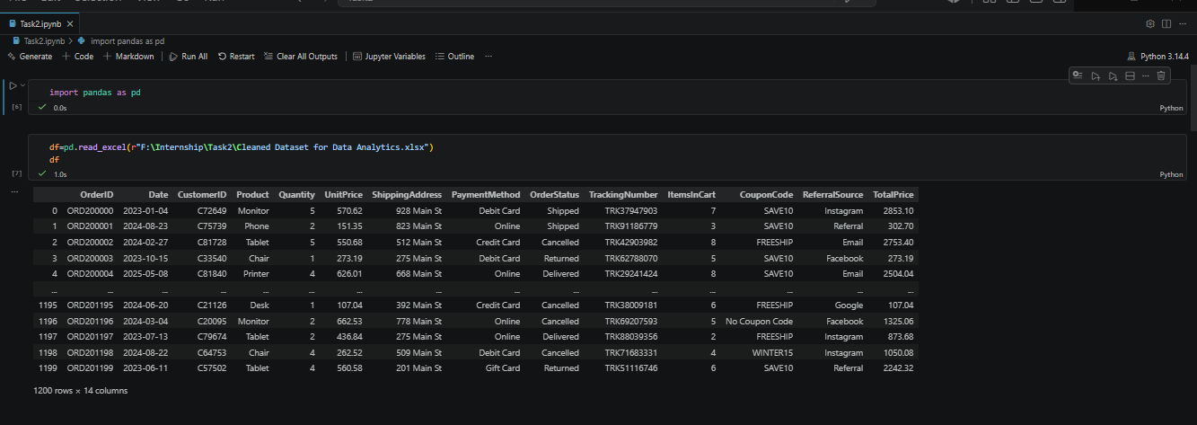

Step 2: Data Inspection
The dataset structure was examined using:
- Shape of dataset
- Information about dataset
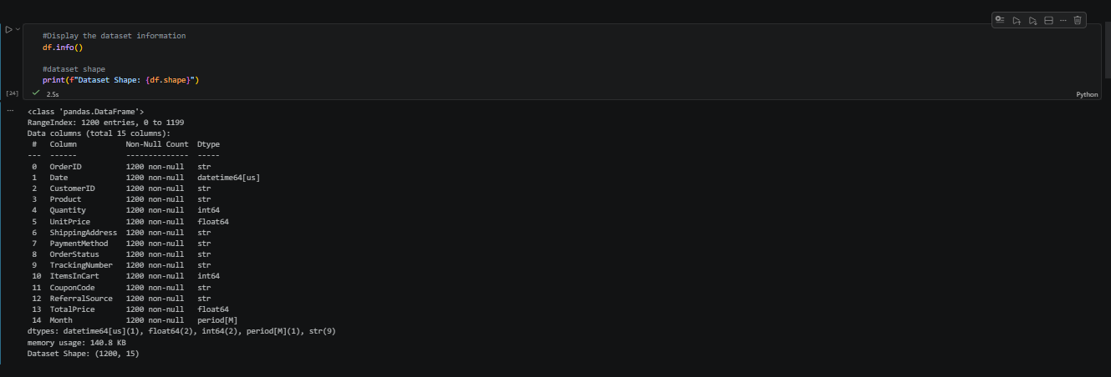

7. Exploratory Data Analysis Tasks Performed

Descriptive Statistics
- Calculated mean values.
- Calculated median values.
- Analyzed minimum and maximum values.
- Examined count and spread of data.
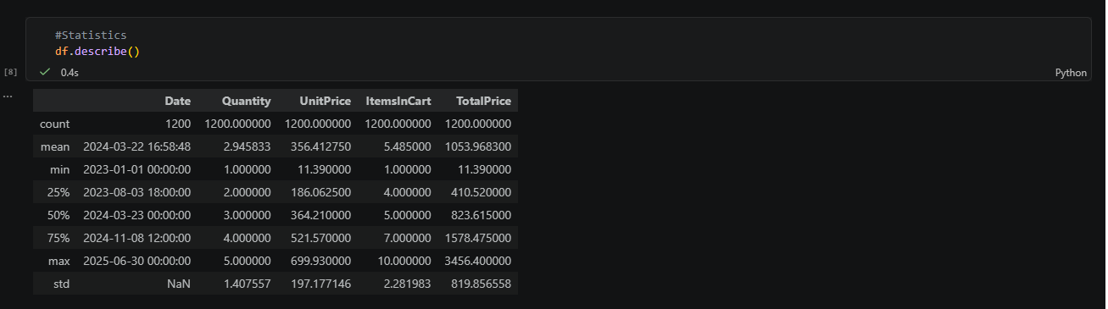

Product Sales Analysis
- Calculated total quantity sold for each product.
- Identified the most sold and least sold products.
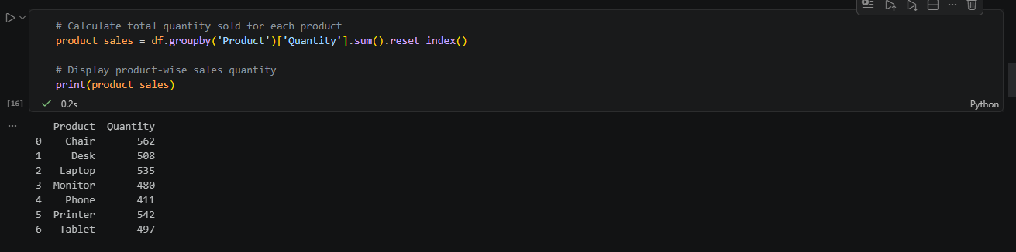

Daily Sales Analysis
- Calculated total sales for each day.
- Analyzed daily sales trends.
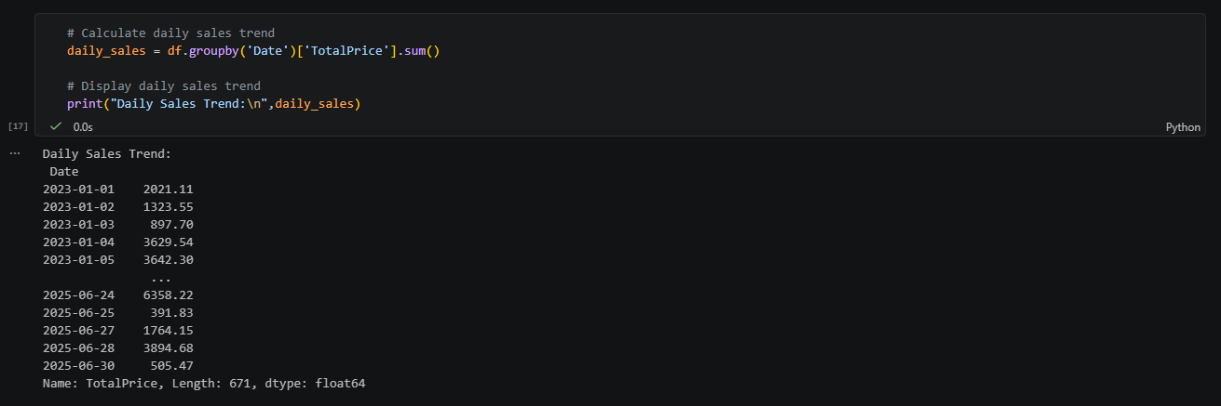

Monthly Sales Analysis
- Calculated total sales for each month.
- Identified months with highest and lowest sales.
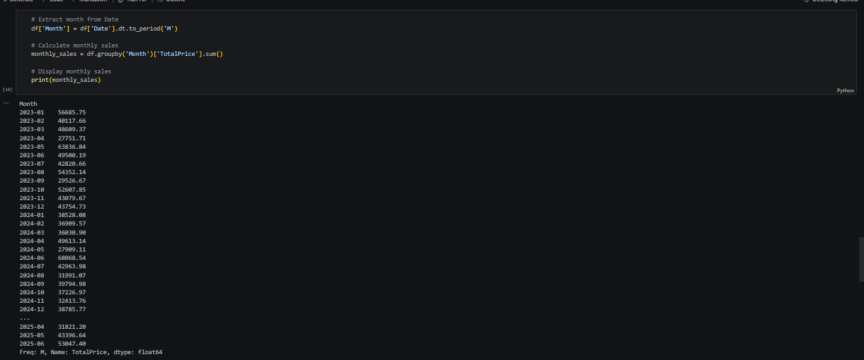

Monthly Order Analysis
- Counted orders placed each month.
- Analyzed monthly order trends.
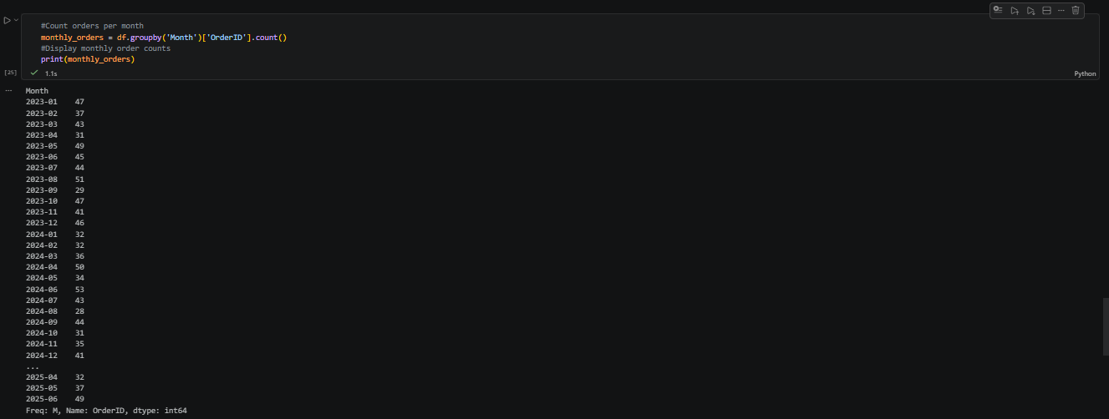

Order Status Analysis
- Analyzed frequency of different order statuses.
- Identified the most common order status.
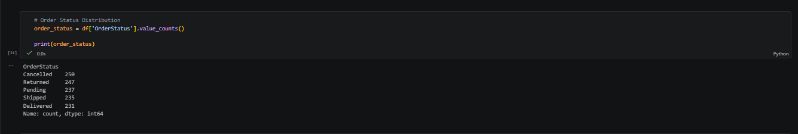

Payment Method Analysis
- Analyzed payment method usage.
- Identified the most preferred payment method.
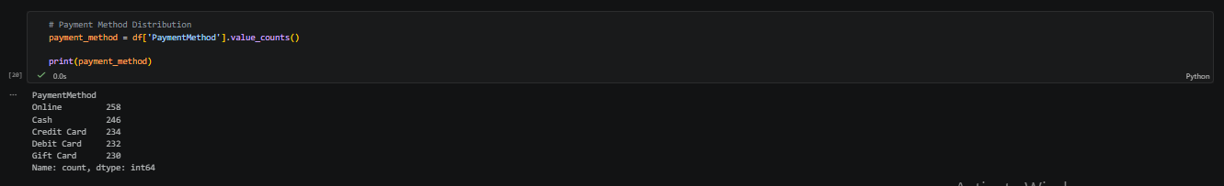

Outlier Detection
- Detected unusual values.
- Analyzed their impact on the dataset.
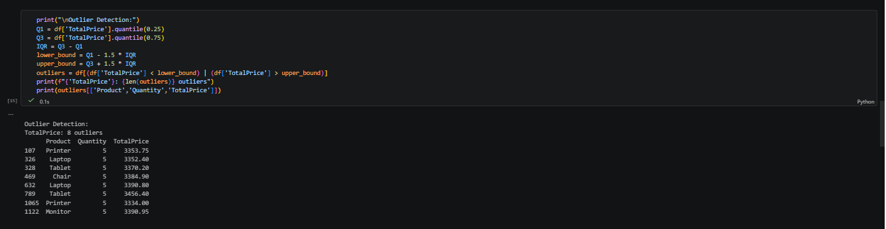

8. Results
The Exploratory Data Analysis revealed:
- Statistical characteristics of the dataset.
- Product sales trends.
- Daily sales patterns.
- Monthly sales trends.
- Monthly order trends.
- Order status distribution.
- Payment method preferences.
- Presence of outliers.
- Key insights useful for decision-making.

9. Key Observations
- Product sales varied significantly across products.
- Daily and monthly sales trends were identified.
- Order volumes differed across months.
- Certain payment methods were used more frequently than others.
- Statistical summaries provided valuable insights into dataset behavior.
- Potential outliers were identified in numerical columns.

10. Challenges Faced
- Identifying significant outliers.
- Analyzing large volumes of data.
- Interpreting sales and order trends accurately.
- Extracting meaningful insights from the dataset.

11. Conclusion
The Exploratory Data Analysis project successfully examined the Dataset for Data Analytics and provided valuable insights into its structure, sales trends, order patterns, payment preferences, and overall behavior. Statistical analysis and trend analysis helped uncover important patterns and identify outliers. The findings can support further analysis, reporting, and business decision-making activities.

12. References
- Pandas Documentation
- Jupyter Notebook Documentation
- Microsoft Excel Documentation
- DecodeLabs Industrial Training Kit

