TASK1 DOCUMENTATION

Project Title:
Data Cleaning and Preprocessing of Dataset for Data Analytics

Abstract
Data cleaning is a crucial step in the data analytics process, as the quality of data directly affects the accuracy of analysis and decision-making. The objective of this project is to clean and preprocess the "Dataset for Data Analytics" by identifying and handling missing values, removing duplicate records, correcting inconsistencies, and ensuring data quality. The cleaned dataset can be effectively used for data analysis, visualization, and predictive modeling.

1. Introduction
Data collected from various sources often contains errors, missing values, duplicate records, and inconsistencies. These issues can lead to inaccurate analytical results and poor decision-making. Data cleaning is the process of detecting and correcting such issues to improve the quality and reliability of data.
This project focuses on cleaning and preprocessing the "Dataset for Data Analytics" using Python and Pandas. Various techniques were applied to identify and handle data quality issues and prepare the dataset for further analysis.

2. Objectives
- To identify and handle missing values in the dataset.
- To detect and remove duplicate records.
- To standardize data formats and data types.
- To improve the quality and reliability of the dataset.
- To prepare the dataset for further analysis and visualization.

3. Problem Statement
Raw datasets frequently contain missing values, duplicate records, inconsistent formatting, and incorrect entries. Such issues negatively impact data analysis and machine learning models. The objective of this project is to clean and preprocess the dataset to improve its quality and usability.

4. Dataset Description
Dataset Name: Dataset for Data Analytics
The dataset contains records that require cleaning and preprocessing before analysis. The dataset was examined to identify missing values, duplicate records, formatting inconsistencies, and other data quality issues.

Dataset Information
- Dataset Name: Dataset for Data Analytics
- File Format: Excel (.xlsx)
- Domain: Data Analytics
- Purpose: Data Cleaning and Preprocessing

5. Tools and Technologies Used
- Jupyter Notebook
- Python
- Pandas
- Microsoft Excel

6. Methodology
The project was completed through the following steps:

Step 1: Data Loading
The dataset was imported into Jupyter Notebook using the Pandas library.
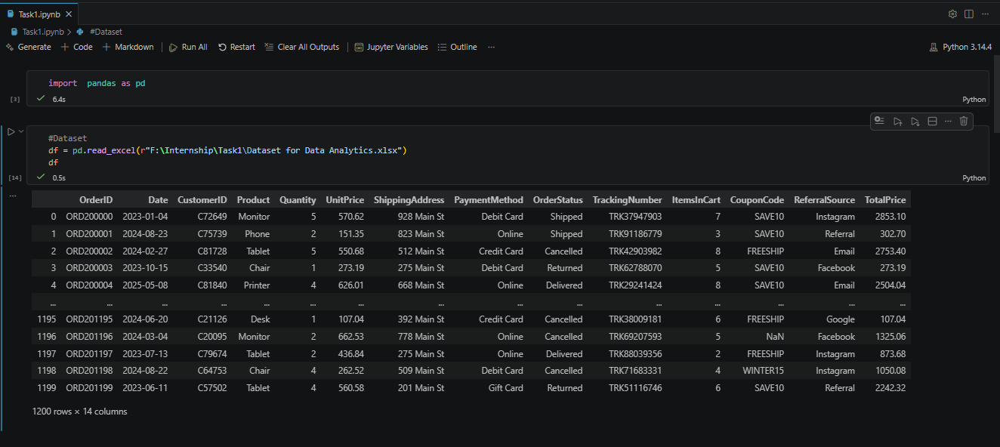

Step 2: Data Inspection
The structure of the dataset was examined using:
- Duplicates analysis
- Dataformat check
- Missing Value Analysis
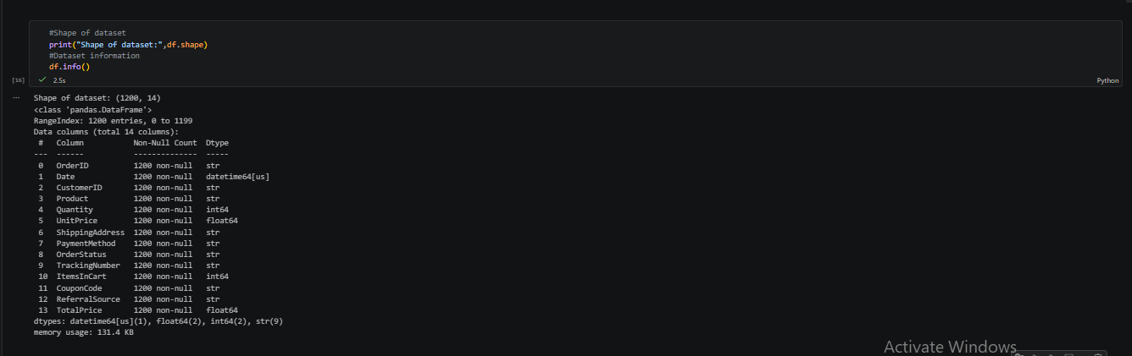

Step 3: Missing Value Detection
Null values were identified using Pandas functions and analyzed column-wise.
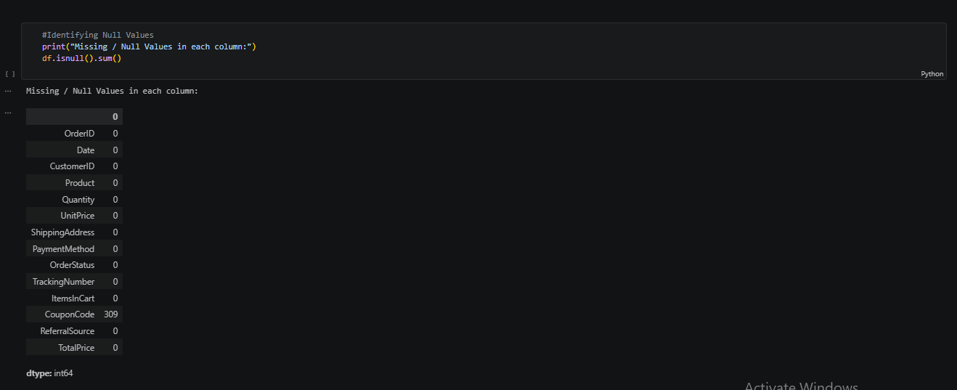
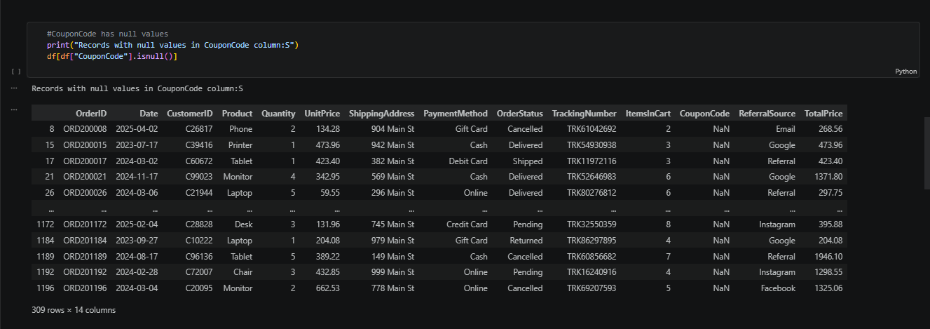

Step 4: Duplicate Record Detection
Duplicate records were identified and removed to improve data consistency.
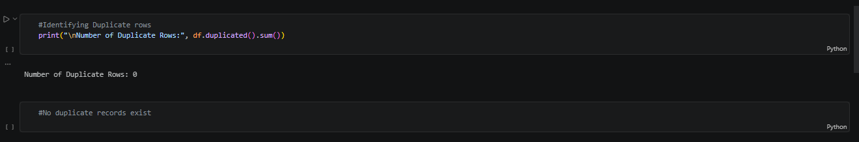

Step 5: Data Type Validation
Columns were checked and converted into appropriate data types where necessary.
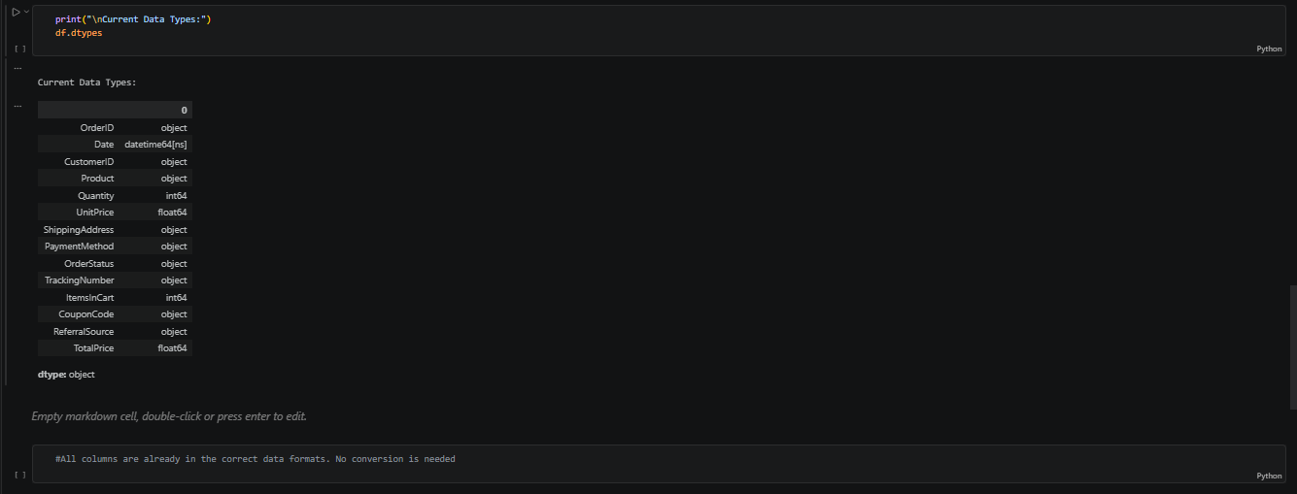

Step 6: Data Cleaning
Data inconsistencies were corrected and data formatting was standardized.
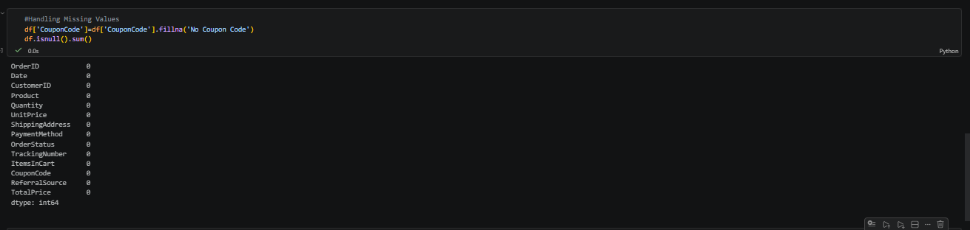

Step 7: Verification
The cleaned dataset was verified to ensure accuracy and consistency.

7. Data Cleaning Tasks Performed

Missing Value Analysis
- Identified missing values in the dataset.
- Analyzed the impact of missing data.
- Applied suitable handling techniques.

Duplicate Record Removal
- Checked for duplicate records.

DataType Check
- Examined data for inconsistencies.
- Ensured columns had appropriate data types.

Data Validation
- Verified the accuracy and completeness of the cleaned dataset.

8. Results
After performing data cleaning operations:
- Missing values were identified and handled.
- Duplicate records were removed.
- Data types were standardized.
- Dataset quality was significantly improved.
- Dataset became suitable for further analysis and visualization.

9. Key Observations
- Data quality improved after cleaning.
- No duplicate records were identified in the datasaet.
- Missing value issues were addressed.
- Dataset consistency increased.
- The cleaned dataset became more reliable for analytics.

10. Challenges Faced
- Identifying suitable techniques for handling missing values.
- Detecting data inconsistencies.
- Maintaining data integrity while cleaning.
- Ensuring accuracy after preprocessing.

11. Conclusion
The Data Cleaning and Preprocessing project successfully improved the quality of the "Dataset for Data Analytics". Missing values, duplicate records, and inconsistencies were identified and handled appropriately.The dataset was also checked for duplicate records and no duplicates were found. The final cleaned dataset is accurate, reliable, and ready for further analysis, visualization, and machine learning applications.

13. References
- Python Documentation
- Pandas Documentation
- Data Analytics Course Materials
- Jupyter Notebook Documentation
- DecodeLabs Industrial Training Kit

