- Introduction
In the context of Health Analytics, linear regression models provide a useful way of understanding how variables relate to one another. Not only can the associations between predictors and outcomes be examined, but these statistical models also allow for predictions about future costs to be made (Fernandes et al., 2023). Like any model, however, linear regression relies on a set of underlying assumptions. For a predictive model, the most critical to address are linearity, independence of observations, and homoscedasticity. The presence of multicollinearity is also checked to aid in the interpretation of predictor variables. While these assumptions are important for ensuring valid inference, this report goes beyond simply checking them. Using the insurance dataset, first the data is explored through visualizations and correlation analysis, then regression models are developed to predict medical charges. The main focus in this report is on prediction accuracy, interpretation of key variables such as smoking status and BMI, and reflection on the limitations of linear regression as a method. While this dataset is based on population and lifestyle variables, it is especially crucial to reflect on the broader advantages & limitations of applying linear regression to health-related cost data.
- Methodology
2.1 Prerequisite Assumptions
In simple regression modelling, there is typically a dependent variable which responds to an independent variable (Roustaei, 2024). However, in most cases a single predictor is inadequate for reliable predictions. This motivates the use of multivariate linear regression, where the dependent variable is influenced by several independent variables. (Bazdaric et al., 2021).
As mentioned in the introduction, linear regression relies on a number of assumptions. The first is linearity, which requires that the relationship between predictors and the outcome be linear, and this can be examined using scatter plots (Casson and Farmer, 2014). The second is independence of observations, meaning the error from one observation does not influence another. Third, homoscedasticity assumes that the variance of residuals is constant across all levels of the predictors. If not, heteroscedasticity is present, and results may be biased (Flatt and Jacobs, 2019). Lastly, multicollinearity occurs when independent variables are highly correlated with one another, which complicates the interpretation of coefficients (Shrestha, 2020).
  - Dataset Processing.
Crucial preprocessing steps are required before modelling to extract valuable insights from the dataset (Qu, 2024). The analysis begins with an overview of the dataset using pandas for data handling and scikit-learn for preprocessing. Exploratory analysis is conducted through visualizations generated with matplotlib and seaborn, including:
- Distribution plots for age, charges, sex, and smoker status,
- A boxplot comparing charges by sex,
- A heatmap of correlations among numerical variables,
- A regression plot of age versus charges.
These plots are not only exploratory but also assist in checking assumptions such as linearity and variance. For model building, categorical variables (sex, smoker, region) are one-hot encoded, and numeric features (age, bmi, children) are standardized. Standardization is especially important when applying Ridge, Lasso, and ElasticNet, since these regularized models are sensitive to differences in scale. The target variable, medical charges, is log-transformed where appropriate to address skewness and improve the model fit. The dataset is then split into training and testing subsets using an 80/20 split to evaluate generalization performance. Finally, model performance is assessed using mean absolute error (MAE), root mean squared error (RMSE), and the coefficient of determination (R²). These metrics together provide a balanced view of accuracy, error magnitude, and explanatory power.
- Results
Table 1. Numeric variables Table 2. Categorical Variables
 | Age | BMI | Children | Charges
Count | 1338 | 1338 | 1338 | 1338
Mean | 39.21 | 30.66 | 1.09 | 13270.42
S.D | 14.05 | 6.1 | 1.21 | 12110.01
Min | 18 | 15.96 | 0 | 1121.87
P25 | 27 | 26.3 | 0 | 4740.29
P50 | 39 | 30.4 | 1 | 9382.03
P75 | 51 | 34.69 | 2 | 16639.91
Max | 64 | 53.13 | 5 | 63770.43
 | Sex | Smoker | Region
Count | 1338 | 1338 | 1338
Unique | 2 | 2 | 4
Top | Male | No | Southeast
Frequent | 676 | 1064 | 364
Table 1 presents the descriptive statistics for the numeric variables in the dataset. The average age of individuals is 39 years, with a minimum of 18 and a maximum of 64, indicating that the dataset covers a broad range of adulthood. The average BMI is 30.66, which falls in the overweight range, and varies between 15.96 and 53.13. On average, individuals have around one dependent child, though the maximum is five. Medical charges show substantial variation, with a mean of 13 270.42 but a wide standard deviation (12 110.01), reflecting a highly skewed distribution. The quartiles (P25 = 4 740.29; P50 = 9 382.03; P75 = 16 639.91) highlight that while many individuals incur relatively moderate costs, a smaller proportion face substantially higher expenses.
Table 2 summarizes the categorical variables. The dataset contains 1 338 observations with two categories for sex (male and female), two categories for smoking status (yes/no), and four geographic regions. The most frequent category is male (676 observations) for sex, non-smokers (1 064 observations) for smoking status, and the southeast region (364 observations) for location. This distribution shows that the dataset is relatively balanced by gender, but there is a clear predominance of non-smokers. Regional representation is uneven, with the southeast contributing the highest number of cases.
Figure 1. Distribution of Sex.
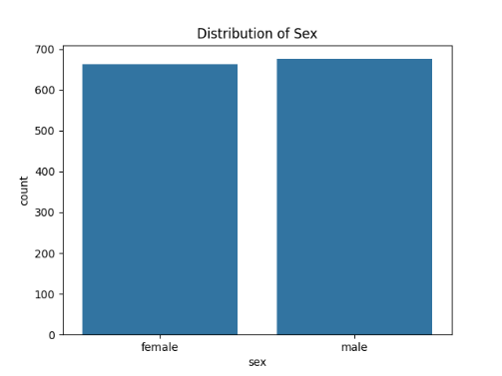
Figure 1 on the left indicates that the dataset is relatively balanced by gender, with a near-equal number of males and females. This balance reduces the likelihood of bias in gender-related comparisons of medical charges, allowing for more generalized inferences across both groups. The absence of significant imbalance in sex categories suggests that the dataset is suitable for exploring relationships between demographic variables and healthcare costs without undue skewness toward one gender.
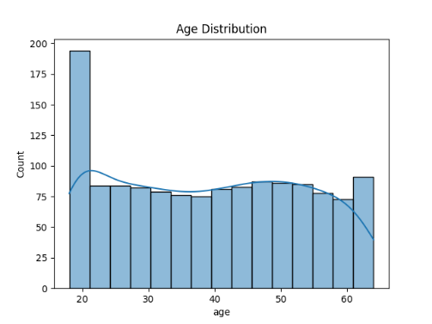
Figure 2. Age Distribution.
Figure 2 on the right displays the age distribution.The histogram indicates that the data covers a wide range of adult ages, from 18 to 64, with a few observations at extremes. This distribution suggests that the dataset captures a diverse representation of ages, which is crucial for analyzing how medical charges evolve across different life stages.
Figure 3. Charges by Sex.
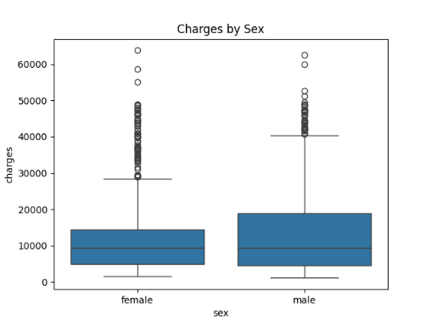
Figure 3 on the left is a box plot that shows the distribution of medical charges by sex. While the median charges for both groups appear relatively similar, the interquartile range (IQR) for males is wider, indicating greater variability in costs. Additionally, males exhibit more extreme outliers particularly in the upper range which suggests that some incur exceptionally high medical expenses. This pattern highlights potential gender-based disparities in healthcare.
Figure 4. Correlation Heatmap.
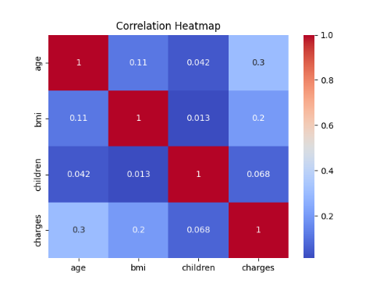
Figure 4 displays the correlation heatmap for the numeric variables in the dataset: age, BMI, number of children, and medical charges. Age shows the strongest association (r ≈ 0.3), followed by BMI (r ≈ 0.2). The number of children has a negligible correlation with charges (r ≈ 0.068). Notably, the predictors themselves display minimal correlation with each other (all r < 0.12), indicating low multicollinearity. This absence of strong interdependency among independent variables satisfies a key assumption of linear regression.
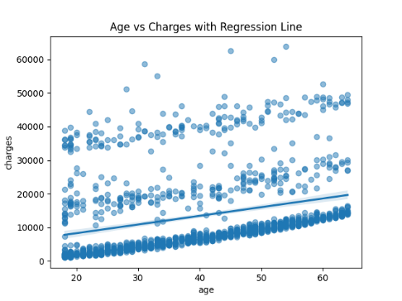
Figure 5. Regression Line
Figure 5 below illustrates the relationship between age and medical charges, overlayed with a linear regression line. Medical charges generally increase with age, which aligns with the correlation heatmap (r ≈ 0.3). However, the wide dispersion of points around the regression line suggests that age alone is an incomplete predictor of healthcare costs. Additionally, the presence of outliers, particularly younger individuals with high charges may violate assumptions of homoscedasticity.
Table 3. Prediction Accuracy
 | RMSE | MAE | R²
Regression | 7814.06 | 3888.44 | 0.61
Ridge | 7753.86 | 3877.07 | 0.61
Lasso | 13053.72 | 8603.16 | -0.1
ElasticNet | 13053.72 | 8603.16 | -0.1
As can be seen in Table 3 the Linear Regression achieved an RMSE of 7 814 and an R² of 0.61, indicating that around 61% of the variation in medical charges was explained by the predictors. Ridge regression produced very similar results, with a slightly lower RMSE and MAE. In contrast, Lasso and ElasticNet performed poorly, with high error and negative R² values. This outcome indicates that aggressive coefficient shrinkage was unsuitable for this dataset, likely due to the importance of multiple predictors. Overall, the baseline Linear Regression and Ridge models offered the most reliable performance.
Table 4. Top Predictors.
Feature | Regression | Ridge | Lasso | ElasticNet
Smoker | 1.55 | 1.54 | 0 | 0
Age | 0.48 | 0.48 | 0 | 0
Children | 0.11 | 0.11 | 0 | 0
BMI | 0.08 | 0.08 | 0 | 0
Region | 0.08 | 0.08 | 0 | 0
Table 4 presents the standardized coefficients across the four models. For both Linear Regression and Ridge, smoking status was by far the strongest predictor of medical charges, followed by age, number of children, and BMI. Regional differences and sex had comparatively small effects. These findings align with expectations from health analytics, where smoking and obesity are known to drive healthcare costs. In contrast, Lasso and ElasticNet shrank almost all coefficients to zero, which explains their poor predictive performance noted earlier. This suggests that the inclusion of multiple predictors is necessary to capture variation in medical charges.
- Discussion and Conclusion.
This study applied linear regression techniques to the insurance dataset in order to model the drivers of medical charges. The exploratory analysis showed that charges are highly skewed, with a small subset of individuals incurring extremely high costs. Smoking status emerged as the most influential categorical variable, while BMI and age displayed moderate positive associations with charges. Sex and regional variables appeared to have comparatively minor effects.
In terms of predictive performance, around 61% of the variation in medical charges was explained by the predictors. Ridge regression yielded almost identical performance, suggesting that multicollinearity was not a significant issue in this dataset. In contrast, Lasso and ElasticNet performed poorly, with near-zero or negative R² values, as both approaches shrank coefficients aggressively towards zero. These results highlight that the dataset requires multiple predictors to adequately explain variation in charges, and that simple coefficient shrinkage is not appropriate in this context (James et al., 2021).
Interpretation of coefficients reinforced these findings. Smoking status had the largest positive effect, with smokers predicted to incur substantially higher costs than non-smokers. BMI and age also contributed positively, consistent with established links between obesity, ageing, and increased healthcare expenditure. The number of children had a smaller positive effect, while sex and regional indicators were weak predictors. These outcomes align with expectations from health analytics literature, where lifestyle and behavioural risk factors often outweigh demographic variables in driving medical costs.
4.1 Limitations.
While linear regression provides interpretability and simplicity, it also comes with well-known limitations. The method is highly sensitive to outliers, which can disproportionately influence the regression line and distort predictions. It also assumes linear relationships between predictors and the target, which may not fully capture complex interactions found in healthcare data. Furthermore, linear regression is prone to noise in the data, and when too many correlated predictors are included, overfitting can occur. Although regularization techniques such as Ridge and Lasso help mitigate some of these issues, their performance in this dataset was limited. These factors highlight the need for cautious interpretation and suggest that non-linear models may provide more robust alternatives in future work (Raschka & Mirjalili, 2020; Kuhn & Silge, 2022).
In conclusion, linear regression provided a useful, interpretable framework for predicting medical charges in this dataset. The strongest predictor was smoking status, followed by BMI and age, while demographic variables such as sex and region played a limited role. Although the models explained a moderate proportion of variance, heteroscedasticity and skewness highlight the limitations of applying linear regression to cost data. Future work could explore non-linear methods such as decision trees or random forests, and extend the feature set to include clinical conditions, income, or health behaviours. Such extensions may improve both predictive accuracy and the ability to capture the complex drivers of healthcare costs (Lundberg et al., 2020; Christodoulou et al., 2019).
REFERENCES:
Bazdaric K, Sverko D, Salaric I, Martinovic A, Lucijanic M (2021) The ABC of linear regression analysis: What every author and editor should know. European Science Editing 47: e63780. https://doi.org/10.3897/ese.2021.e63780.
Casson, R.J. and Farmer, L.D.M. (2014) 'Understanding and checking the assumptions of linear regression: a primer for medical researchers', Clinical & Experimental Ophthalmology, 42(6), pp. 590-596. doi:10.1111/ceo.12358.
Christodoulou, E., Ma, J., Collins, G. S., Steyerberg, E. W., Verbakel, J. Y., & Van Calster, B. (2019). A systematic review shows no performance benefit of machine learning over logistic regression for clinical prediction models. Journal of Clinical Epidemiology, 110, 12–22.
Fernandes, A.C.P., Fonseca, A.R., Pacheco, F.A.L. and Sanches Fernandes, L.F. (2023) 'Water quality predictions through linear regression - A brute force algorithm approach', MethodsX, 10, p. 102153. Available at: https://doi.org/10.1016/j.mex.2023.102153.
Flatt, C. and Jacobs, R.L. (2019) 'Principle assumptions of regression analysis: testing, techniques, and statistical reporting of imperfect data sets', Advances in Developing Human Resources, 21(4), pp. 484-502. doi:10.1177/1523422319868915.
James, G., Witten, D., Hastie, T., & Tibshirani, R. (2021). An Introduction to Statistical Learning with Applications in R (2nd ed.). Springer.
Kuhn, M., & Silge, J. (2022). Tidy Modeling with R. O’Reilly Media.
Lundberg, S. M., Erion, G., Chen, H., et al. (2020). From local explanations to global understanding with explainable AI for trees. Nature Machine Intelligence, 2(1), 56–67.
Qu, K. (2024) 'Research on linear regression algorithm', in MATEC Web of Conferences. EDP Sciences, 395, p. 01046. Available at: https://doi.org/10.1051/matecconf/202439501046.
Raschka, S., & Mirjalili, V. (2020). Python Machine Learning (3rd ed.). Packt Publishing.

Roustaei, N. (2024) 'Application and interpretation of linear-regression analysis', Medical Hypothesis Discovery and Innovation in Ophthalmology, 13(3), pp. 151-159. Available at: https://doi.org/10.51329/mehdiophthal1506.
Shrestha, N. (2020) 'Detecting multicollinearity in regression analysis', American Journal of Applied Mathematics and Statistics, 8(2), pp. 39-42. doi:10.12691/ajams-8-2-1.
Wooldridge, J. M. (2020). Introductory Econometrics: A Modern Approach (7th ed.). Cengage.

