Introduction.
Cardiovascular disease remains a leading cause of morbidity and mortality worldwide, with heart failure posing a significant burden on healthcare systems (Virani et al., 2021). Annually, 17 million people worldwide succumb to cardiovascular diseases (Chicco and Jurman, 2020). Early identification of patients at higher risk of adverse outcomes is critical to improving survival rates and optimizing the use of medical resources. Data-driven approaches have become increasingly valuable in this context, allowing clinicians and researchers to analyse large datasets, identify risk patterns, and support clinical decision-making (Shah et al., 2017).
This report applies a decision tree model to the Heart Failure Clinical Records dataset, which contains medical records of patients with diagnosed heart failure. The aim is to build a predictive model that estimates the likelihood of death events based on patient characteristics and clinical measurements. In doing so, the report will demonstrate the application of decision trees to healthcare data, evaluate the model’s predictive performance, and reflect on its strengths, limitations, and potential improvements for future work.
Methodology.
The dataset used in this study is the Heart Failure Clinical Records dataset, obtained from the University of California (UCI) Machine Learning Repository. It consists of records from 299 patients diagnosed with heart failure, each described by 12 predictors where the binary target variable indicates whether the patient experienced a death event during the follow-up period.
Prior to modelling, the dataset was inspected for missing values, inconsistencies, and datatype errors. No missing values were detected therefore eliminating the need for imputation strategies, and all categorical attributes such as anaemia, diabetes, high_blood_pressure, sex, and smoking were verified as binary (0/1). The remaining predictors which are numerical features were left unscaled, as tree-based algorithms are invariant to the scale of the features.
The time column, representing follow-up duration in days, was excluded from analysis. Although it is strongly correlated with the target outcome, retaining it could introduce data leakage by allowing the model to learn outcomes based on survival time rather than baseline characteristics. As Saravanan, Sathish and Balajee (2018) note, data leakage is particularly problematic as it ensues in overly optimistic and consequently invalid predictive models. The final feature set therefore consisted of 11 predictors and one binary target variable.
The dataset was split into training and testing sets using an 80/20 ratio, with stratification applied to preserve the class balance of the target variable (Varoquaux et al., 2015). This ensured that both subsets reflected the imbalanced distribution of outcomes, with fewer patients experiencing death events compared to survivors.
Model development was conducted using the DecisionTreeClassifier from the scikit-learn library. This implementation was chosen as it provides a reliable, well-documented framework for constructing decision trees with minimal preprocessing requirements. A single decision tree model was trained on the stratified training data and evaluated on the unseen test data. To establish a baseline for comparison, a dummy classifier predicting the majority class was also implemented. Model performance was assessed using multiple metrics, including accuracy, precision, recall, and F1-score. These measures were selected to account for the imbalanced nature of the dataset and to provide a more nuanced evaluation than accuracy alone (Saito and Rehmsmeier, 2015). A confusion matrix was also analyzed to specifically quantify the number of false negatives, a critical error type in medical prognosis.
Results.
Table 1. Dataset features.
Feature | Description
Age | Patient age
Anaemia | Does patient have anaemia? 0=No, 1=Yes.
High Blood Pressure | Does patient have hypertension? 0=No, 1=Yes
Creatinine Phosphokinase (CPK) | Level of CPK enzyme in the patient’s blood (mcg/L)
Diabetes | Does the patient have diabetes? 0=No, 1=Yes
Ejection Fraction | Percentage of blood leaving the heart at each contraction.
Sex | Patient gender. 0=Female, 1=Male
Platelets | Platelets in the blood (kiloplatelets/mL)
Serum Creatine | Level of creatinine in the blood (mg/dL)
Serum Sodium | Level of sodium in patient’s blood (mEq/L)
Smoking | Does patient smoke? 0=No, 1=Yes
As shown in table 1, a total of 299 instances and 11 features are represented in this dataset, excluding the time feature. Summary statistics provide an overview of the dataset’s distribution. The majority of patients (203, approximately 68%) survived, while 96 patients (32%) experienced a death event which highlights an immediate class imbalance. The mean patient age was approximately 61 years (standard deviation is around 11.9), with values ranging from 40 to 95 years. The median ejection fraction was 38%, with some patients exhibiting values as low as 14%, indicating severe impairment in cardiac function. Serum creatinine levels ranged from 0.5 to 9.4 mg/dL, reflecting the presence of renal dysfunction in several cases. Platelet counts showed a wide variation, with a mean of 263,000 platelets/mL and a standard deviation of 97,000. Among the categorical variables, 43% of patients were female, 45% had anaemia, and 35% presented with hypertension. Overall, the dataset captures a broad spectrum of demographic and clinical characteristics, which makes it suitable for developing predictive models in heart failure prognosis (Chicco and Jurman, 2020).
Figure 1. Age by death event.
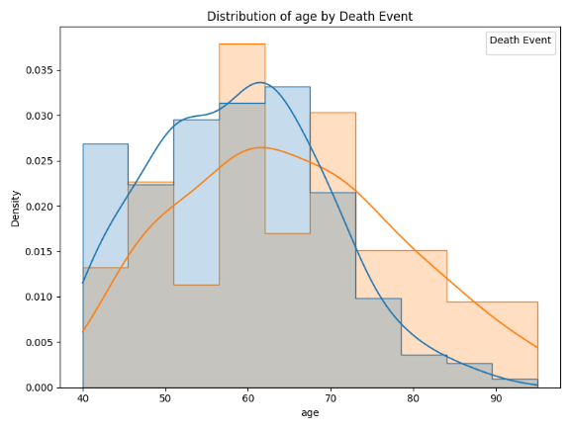
Using the feature importance attribute, this report focuses on the strongest predictors of death events which are age, ejection fraction and serum creatinine respectively. Figure 1 shows the distribution of patient age stratified by survival outcome. Patients who experienced a death event tended to be older, with a noticeable shift of the distribution curve toward higher ages compared to survivors. This aligns with clinical evidence that age is a major risk factor for adverse outcomes in heart failure, as older patients often present with reduced physiological resilience and more comorbid conditions (Savarese and Lund, 2017). Although there is some overlap between the two groups, the higher concentration of death events among elderly patients suggests that age is likely to emerge as an important predictor in the decision tree model.

Figure 2. Ejection fraction.
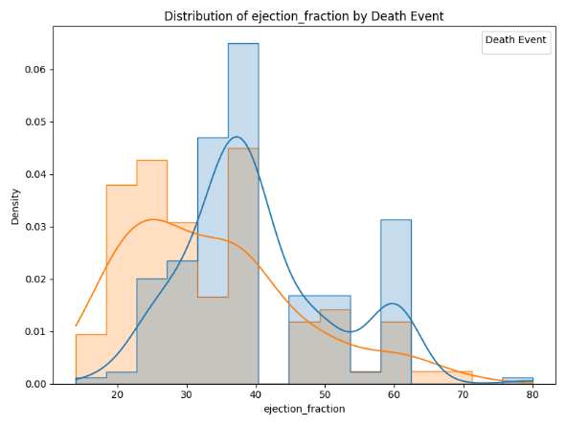
Figure 2 presents the distribution of ejection fraction (EF) values between patients who survived and those who experienced a death event. A clear separation is observed, with patients who died tending to have substantially lower EF values. Survivors generally exhibited higher EF levels, clustering around 40–50%, whereas non-survivors were concentrated below 35%. This finding is consistent with the clinical understanding that reduced ejection fraction is a strong predictor of mortality in heart failure, as it reflects impaired left ventricular function and diminished cardiac output (Ponikowski et al., 2016). The distinct difference between the two groups suggests that EF will likely be a key splitting variable in the decision tree model.
Figure 3. Serum creatinine levels.
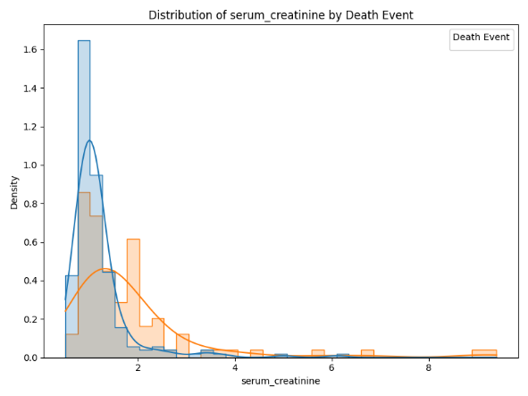
Figure 3 illustrates the distribution of serum creatinine levels by survival outcome. Patients who experienced a death event tended to have higher serum creatinine values compared to survivors. Elevated creatinine reflects impaired kidney function, which is a common comorbidity in patients with advanced heart failure. The distribution shows that many survivors had creatinine values clustered near the lower range (around 1.0 mg/dL), whereas non-survivors exhibited a broader spread, including values above 2.0 mg/dL. This suggests that renal dysfunction may be an important factor contributing to mortality risk, reinforcing the clinical relevance of including biochemical markers in predictive modelling.
Figure 4. Confusion matrix.
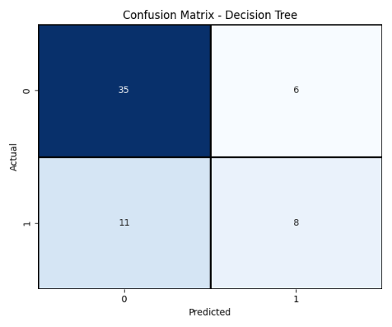
Figure 4 shows that the model correctly classified the majority of survival cases but misclassified a non-negligible number of death events as survivals (false negatives). From a clinical perspective, false negatives represent a critical concern, as failing to identify a patient at risk of death could prevent timely intervention and worsen outcomes (Kwon et al., 2018). On the other hand, false positives (predicting death when the patient survives) may lead to unnecessary monitoring but pose less immediate clinical risk. These findings highlight the trade-offs inherent in predictive modelling for healthcare, where sensitivity to high-risk patients often outweighs overall accuracy
Table 2. Performance comparison.
Model | Accuracy | Precision | Recall | F1-score
DummyClassifier | 0.68 | 0 | 0 | 0
DecisionTreeClassifier | 0.72 | 0.57 | 0.42 | 0.48
Table 2 compares the performance of the decision tree classifier with a dummy baseline model. As expected, the dummy classifier, which simply predicts the majority class (survival), achieved an accuracy of approximately 68%. However, it completely failed to identify any death events, resulting in precision, recall, and F1-scores of zero for the positive class. This highlights the inadequacy of accuracy as a standalone metric in imbalanced datasets, since a trivial model can appear to perform reasonably well by exploiting the class imbalance.
In contrast, the decision tree classifier achieved a markedly higher overall accuracy of 72%, along with corresponding results in precision (57%), recall (42%), and F1-score (48%). Most importantly, the tree was able to correctly identify a proportion of patients who experienced death events, demonstrating its value over the baseline. Although the recall for the positive class was not perfect, the model’s ability to capture at-risk patients represents a clinically significant improvement over the dummy approach, where all such patients were missed. These results illustrate the importance of using more sophisticated classifiers in clinical prediction tasks, where the cost of false negatives can be substantial (Kwon et al., 2018).
Discussion.
The decision tree model demonstrated several strengths in this study. Firstly, it achieved higher accuracy, recall, and F1-scores compared to the dummy baseline, showing that it could meaningfully identify patients at risk of death events. More importantly, decision trees are highly interpretable as rule-based decision paths can be easily understood by clinicians. This transparency is crucial in healthcare, where explainability is often as important as predictive performance (Lundberg et al., 2018). Additionally, decision trees handle both numerical and categorical data without requiring extensive preprocessing, making them well-suited to heterogeneous clinical datasets like this one.
However, there are several limitations that must be acknowledged. The dataset is relatively small (299 instances), which increases the risk of overfitting and reduces the generalisability of results. Decision trees are also inherently unstable, meaning small changes in the data may lead to different splits, potentially limiting reproducibility. Moreover, while the model captured some death events, recall remained modest, indicating that a significant number of high-risk patients were misclassified as survivors. In a clinical context, such false negatives carry serious consequences, as they may prevent early intervention and treatment escalation (Kwon et al., 2018). Finally, the dataset exhibits class imbalance, which may bias the model towards predicting survival. Although stratified splitting was used to mitigate this, more advanced techniques could further address imbalance.
Future work could address these limitations in several ways. First, collecting and incorporating larger and more diverse datasets would improve model robustness and generalisability. Second, ensemble methods such as random forests or gradient boosting could be explored, as they reduce overfitting and improve stability while maintaining interpretability through feature importance (Chen and Guestrin, 2016). Third, techniques such as cost-sensitive learning or resampling (e.g., SMOTE) could be employed to better handle class imbalance, thereby improving recall for death events. Finally, while decision trees provide a useful baseline, comparing their performance with other models such as logistic regression or neural networks could provide valuable insights into the trade-offs between accuracy and interpretability.
Conclusion.
This study applied a decision tree classifier to the Heart Failure Clinical Records dataset from the UCI repository to predict patient mortality. After preprocessing and exploratory data analysis, the model was trained and evaluated against a dummy baseline. Results demonstrated that the decision tree achieved superior performance, correctly identifying a portion of patients who experienced death events, and providing interpretable decision rules based on clinically relevant features such as ejection fraction, serum creatinine, and age.
While limitations such as small sample size, class imbalance, and modest recall highlight the need for caution, the model nonetheless illustrates the potential of machine learning in clinical decision support. Importantly, the interpretability of decision trees makes them particularly suitable for healthcare contexts, where transparency and explainability are essential. Future studies incorporating larger datasets and ensemble techniques could further improve predictive performance while retaining clinical relevance. Overall, this project demonstrates that decision trees offer a useful baseline approach for mortality prediction in heart failure patients, balancing simplicity, interpretability, and predictive power.
References:
Chen, T. and Guestrin, C. (2016) ‘XGBoost: A scalable tree boosting system’, Proceedings of the 22nd ACM SIGKDD International Conference on Knowledge Discovery and Data Mining, San Francisco, 13–17 August. New York: ACM, pp. 785–794. doi:10.1145/2939672.2939785
Chicco, D. and Jurman, G. (2020) ‘Machine learning can predict survival of patients with heart failure from serum creatinine and ejection fraction alone’, BMC Medical Informatics and Decision Making, 20(16), pp. 1–16. doi:10.1186/s12911-020-1023-5
Kwon, J.M., Kim, K.H., Jeon, K.H. and Lee, S.E. (2018) ‘Artificial intelligence algorithm for predicting mortality of patients with acute heart failure’, PLOS ONE, 13(7), p. e0200986. doi:10.1371/journal.pone.0200986
Lundberg, S.M., Erion, G., Chen, H., DeGrave, A., Prutkin, J.M., Nair, B., Katz, R., Himmelfarb, J., Bansal, N. and Lee, S.I. (2018) ‘Explainable AI for trees: From local explanations to global understanding’, Nature Machine Intelligence, 2(1), pp. 56–67. doi:10.1038/s42256-019-0138-9
Ponikowski, P., Voors, A.A., Anker, S.D., Bueno, H., Cleland, J.G.F., Coats, A.J.S., González-Juanatey, J.R., Harjola, V.P., Jankowska, E.A. and Jessup, M. (2016) ‘2016 ESC guidelines for the diagnosis and treatment of acute and chronic heart failure’, European Heart Journal, 37(27), pp. 2129–2200. doi:10.1093/eurheartj/ehw128
Saito, T. and Rehmsmeier, M. (2015) ‘The precision-recall plot is more informative than the ROC plot when evaluating binary classifiers on imbalanced datasets’, PLOS ONE, 10(3), p. e0118432. doi:10.1371/journal.pone.0118432
Saravanan, N., Sathish, G. and Balajee, J.M. (2018) ‘Data wrangling and data leakage in machine learning for healthcare’, Journal of Emerging Technologies and Innovative Research, 5(8), pp. 553–557. Available at: https://www.jetir.org/papers/JETIRC006413.pdf (Accessed: 4 September 2025).
Savarese, G. and Lund, L.H. (2017) ‘Global public health burden of heart failure’, Cardiac Failure Review, 3(1), pp. 7–11. doi:10.15420/cfr.2016:25:2
Shah, S.J., Katz, D.H., Selvaraj, S., Burke, M.A., Yancy, C.W., Gheorghiade, M. and Bonow, R.O. (2017) ‘Phenomapping for novel classification of heart failure with preserved ejection fraction’, Circulation, 131(3), pp. 269–279. doi:10.1161/CIRCULATIONAHA.114.010637
Varoquaux, G., Grisel, O., Louppe, G., Blondel, M., Pedregosa, F. and Mueller, A. (2015) ‘Scikit-learn: Machine learning without learning the machinery’, GetMobile: Mobile Computing and Communications, 19(1), pp. 29–33. doi:10.1145/2786984.2786989
Virani, S.S., Alonso, A., Aparicio, H.J., Benjamin, E.J., Bittencourt, M.S., Callaway, C.W., Carson, A.P., Chamberlain, A.M., Cheng, S., Delling, F.N. and Elkind, M.S.V. (2021) ‘Heart disease and stroke statistics—2021 update: A report from the American Heart Association’, Circulation, 143(8), pp. e254–e743. doi:10.1161/CIR.0000000000000950

