Introduction
Advances in air-quality monitoring and data science have greatly expanded the ability to characterize pollution in space and time (Wei et al., 2023). Unsupervised machine learning and clustering in particular, is a natural tool for this problem because it groups observations by similarity without requiring labelled outcomes. K-means clustering is widely used in air-quality research to identify pollution regimes, separate source-related behaviours (e.g., traffic vs. industrial vs. wildfire influences), and guide monitoring or intervention strategies; reviews of the literature show k-means among the most common techniques applied to pollutant time series and sensor networks. Practical applications have included grouping days or sites by pollutant mix, detecting co-occurrence patterns among PM₂.₅, NO₂, O₃ and other species, and simplifying complex datasets for downstream analysis.
This report applies k-means clustering to the provided airpoll dataset with three aims: (1) to describe the dataset and visualise pollutant distributions and inter-relationships, (2) to determine a justified and reproducible choice of cluster number using standard diagnostics (Elbow method) and to run a well-documented k-means workflow, and (3) to interpret the resulting clusters in terms of pollutant fingerprints and potential real-world meaning (e.g., high-PM₂.₅ vs. high-ozone regimes), while clearly stating limitations (sensitivity to scaling, outliers, and the algorithm’s spherical-cluster assumption). The analysis prioritises transparency and reproducibility so that results can support monitoring decisions or hypothesis generation for follow-up studies.
Methodology
The analysis was conducted using NumPy, Pandas, Matplotlib, Seaborn, and scikit-learn libraries. The workflow comprised of data preprocessing, exploratory data analysis (EDA), cluster determination, model fitting, and evaluation.
Upon inspection of the dataset, no missing values, inconsistent data types, and duplicates were found. Since k-means clustering is sensitive to variable scales, all features were standardised using z-score normalisation via StandardScaler. Standardisation ensures that pollutants measured on different units (e.g., µg/m³ for particulate matter versus ppb for gases) contribute equally to the clustering process (Jain, 2010). Outlier patterns were also reviewed, as extreme values can disproportionately influence cluster centroids.
Descriptive statistics were generated to summarise the central tendency and dispersion of each pollutant. Pairwise correlations were computed and visualised with a heatmap to reveal linear associations between pollutants. Histograms with kernel density estimates were plotted to show distributional shapes and detect skewness or multimodality, which provide context for later interpretation of clusters.
To select the number of clusters (k) the Elbow Method was used and assessed within-cluster sum of squares (inertia) across candidate k values. This method is widely recommended in practice for determining an appropriate k (Grace et al., 2016).
With the chosen k, the k-means algorithm was run using the Lloyd–Forgy method with multiple random initialisations (n_init=10) to mitigate sensitivity to centroid starting points. Cluster assignments were added to the dataset and visualised in two dimensions using Principal Component Analysis (PCA) for interpretability.
Cluster sizes and pollutant averages within each cluster were analysed to aid interpretation (e.g., distinguishing “high particulate” versus “high ozone” clusters). Finally, the clustered dataset was exported as an Excel file to support reproducibility and further analysis.
Results
Table 1. Descriptive statistics.
 | SO₂ | NO₂ | O₃ | PM₂.₅ | PM₁₀
Mean | 15.46 | 30.23 | 49.05 | 30.84 | 53.07
Std Dev | 7.96 | 9.84 | 13.68 | 10.88 | 19.50
Min | 2.44 | 5.31 | 14.31 | 7.25 | 12.46
P25 | 9.82 | 23.34 | 38.96 | 23.27 | 39.29
P50 | 13.67 | 28.62 | 47.99 | 29.13 | 49.78
P75 | 19.21 | 35.27 | 57.86 | 36.26 | 63.60
Max | 63.57 | 80.81 | 103.91 | 80.61 | 131.75

Table 1 summarises the distribution of pollutant concentrations across 3,347 observations. Average concentrations were moderate, with mean values ranging from 15.46 µg/m³ for SO₂ to 53.07 µg/m³ for PM₁₀. Variability was highest for PM₁₀ (SD = 19.50) and lowest for SO₂ (SD = 7.96). Extreme values were observed across all pollutants, such as SO₂ reaching 63.6 µg/m³ andPM₁₀ exceeding 130 µg/m³, which may indicate episodic high-pollution events.
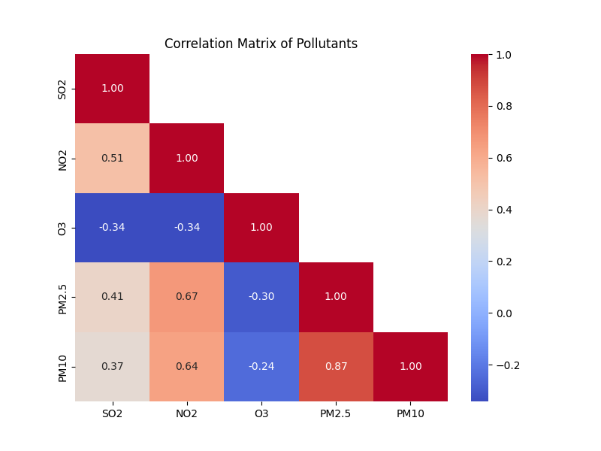
Figure 1. Correlation of pollutants.
The correlation heatmap (Figure 1) revealed positive associations among most pollutants. Notably, PM₂.₅ and PM₁₀ were strongly correlated, consistent with their shared particulate nature (Cabello-Torres et al., 2024). SO₂ and NO₂ also showed moderate correlation, suggesting common combustion-related sources. In contrast, ozone (O₃) demonstrated weaker correlations, consistent with its secondary atmospheric formation.
Figure 2. PM2.5 Pollutant Distribution.
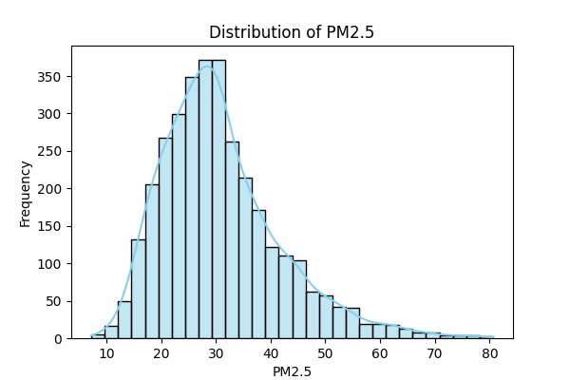
The distribution of PM₂.₅ concentrations (Figure 2) displayed a right-skewed pattern, with most daily averages concentrated between 20–40 µg/m³ but occasional peaks exceeding 70 µg/m³. This skewness reflects the episodic nature of fine particulate pollution, where typical background levels are punctuated by short-term events such as biomass burning, traffic congestion, or adverse meteorological conditions (Huang et al., 2021). The observed distribution therefore highlights both the relative stability of most observations and the potential public health implications of the extreme values.
Figure 3. Elbow Method.
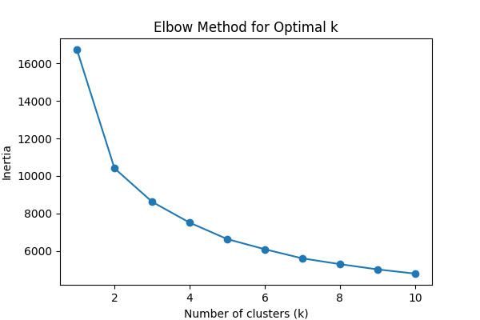
The Elbow Method results (Figure 3) revealed a marked decline in within-cluster inertia as the number of clusters increased from k = 1 to k = 3, after which reductions became progressively smaller. This inflection point suggests that k = 3 provides a parsimonious balance between model complexity and explanatory power. Such a pattern is consistent with the principle that additional clusters beyond the “elbow” often capture noise rather than meaningful structure in the data (Kodinariya and Makwana, 2013). These findings justified the selection of three clusters for the subsequent analysis.
Figure 4. Cluster Scatter Plot.
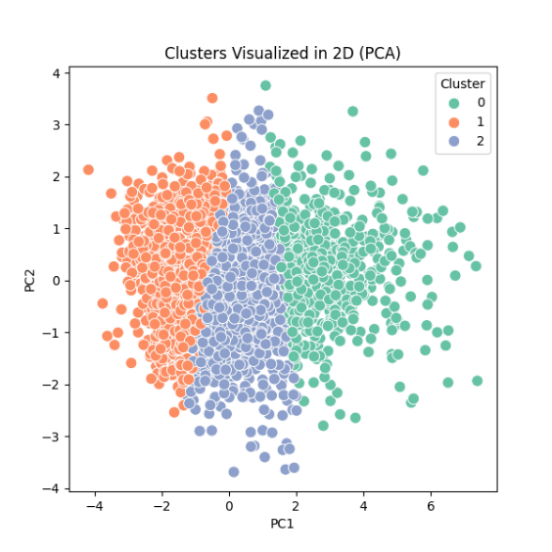
The two-dimensional cluster visualisation obtained through Principal Component Analysis (PCA) is shown in Figure 4. By reducing the dataset to its first two principal components, which together captured the majority of variance in pollutant concentrations, the scatter plot provided an interpretable view of the k-means results. The plot revealed three distinct and reasonably well-separated clusters, supporting the validity of the chosen k = 3. Inspection of the clusters indicated that one group was dominated by elevated particulate matter (PM₂.₅ and PM₁₀), another by higher ozone concentrations, and the third by relatively lower pollution levels across all variables. This separation underscores the capacity of k-means to identify meaningful regimes in complex multivariate environmental data.
Discussion
The results demonstrate that k-means clustering can effectively uncover distinct pollution regimes within the airpoll dataset. The three-cluster solution separated observations into (1) high-particulate conditions dominated by elevated PM₂.₅ and PM₁₀, (2) ozone-rich conditions, and (3) generally lower-pollution conditions. The correlation analysis further supported this interpretation, with strong associations between particulate species but weaker relationships between ozone and primary pollutants.
An important strength of the approach is its ability to simplify complex multivariate data into interpretable regimes. This can aid in designing targeted interventions: for instance, clusters dominated by particulates may point toward combustion-related controls, whereas ozone-rich clusters suggest a focus on photochemical precursors.
In addition to interpretability, the algorithm allows for warm-starting centroid positions, meaning previously fitted cluster centres can be used as initialisation points for subsequent runs. This is particularly advantageous when working with time-series air-quality data, where clusters identified in an earlier period can provide a stable baseline for analysing new observations without fully retraining the model (Celebi et al., 2013).
Second, k-means can smoothly adapt to new examples, making it efficient for updating clusters as new pollution data become available. Since air-quality monitoring systems often collect data continuously, this adaptability reduces computational costs and supports near-real-time applications such as alert systems or adaptive regulatory interventions (Arthur and Vassilvitskii, 2007).
However, several limitations warrant caution. First, k-means assumes spherical clusters of similar size and density, which may not fully reflect the underlying complexity of atmospheric processes. Second, the algorithm is sensitive to scaling and outliers, though standardisation helped mitigate this issue. Third, the analysis was restricted to five pollutants without incorporating meteorological variables, which are known to strongly influence ozone formation and particulate accumulation (Huang et al., 2021). Including such variables in future work may improve cluster interpretability and robustness. Finally, the method’s unsupervised nature means that clusters must be interpreted post hoc, which introduces some subjectivity.
Overall, the clustering results align with established atmospheric science, while also highlighting the utility of unsupervised learning methods for environmental health analytics.
Conclusion
This report applied k-means clustering to the airpoll dataset to identify natural groupings among five common air pollutants (SO₂, NO₂, O₃, PM₂.₅, PM₁₀). Following standard preprocessing and exploratory analyses, the optimal number of clusters was determined to be three using the Elbow Method. The final clustering revealed interpretable regimes: one dominated by particulate matter, one by elevated ozone, and one representing generally lower pollutant concentrations. These patterns are consistent with known atmospheric processes and highlight the capacity of unsupervised learning to extract meaningful insights from complex environmental data.
K-means demonstrated several advantages in this context. Its ability to warm-start centroid positions and adapt smoothly to new data makes it especially practical for dynamic, continuously updated air-quality monitoring systems. At the same time, the method’s assumptions and sensitivity to scaling and outliers emphasise the importance of careful preprocessing and critical interpretation of results.
Overall, this study illustrates the value of clustering methods for health analytics. By simplifying large, multivariate datasets into a small number of interpretable regimes, k-means can support targeted interventions, guide regulatory strategies, and provide a foundation for further research that integrates meteorological factors or health outcome data.

References:
Arthur, D. and Vassilvitskii, S. (2007) ‘k-means++: The advantages of careful seeding’, Proceedings of the Eighteenth Annual ACM-SIAM Symposium on Discrete Algorithms. ACM, pp. 1027–1035.
Cabello-Torres, R.J., Carbo-Bustinza, N., Romero-Cabello, E.A., Tolentino, J.M.U., Armas, E.A.T., Turpo-Chaparro, J.E., Canas Rodrigues, P. and López-Gonzales, J.L. (2024) ‘An exploratory analysis of PM₂.₅/PM₁₀ ratio during spring 2016–2018 in Metropolitan Lima’, Scientific Reports, 14, 9285. Available at: https://doi.org/10.1038/s41598-024-59831-9.
Celebi, M.E., Kingravi, H.A. and Vela, P.A. (2013) ‘A comparative study of efficient initialization methods for the k-means clustering algorithm’, Expert Systems with Applications, 40(1), pp. 200–210. https://doi.org/10.1016/j.eswa.2012.07.021.
Grace, K.R., Manimegalai, R., Devasena, M.S.G., Rajathi, S., Usha, K. and Baseria, N.R. (2016) ‘Air pollution analysis using enhanced K-means clustering algorithm for real time sensor data’, 2016 IEEE Region 10 Conference (TENCON), Singapore, 22–25 November. IEEE, pp. 1945–1948. https://doi.org/10.1109/TENCON.2016.7845030.
Huang, X., Ding, A., Gao, J., Zheng, B., Zhou, D., Qi, X., Tang, R., Wang, J., Ren, C., Nie, W., Chi, X., Xu, Z., Chen, L., Li, Y. and Wang, S. (2021) ‘Enhanced secondary pollution offset reduction of primary emissions during COVID-19 lockdown in China’, National Science Review, 8(2), nwaa137. https://doi.org/10.1093/nsr/nwaa137.
Jain, A.K. (2010) ‘Data clustering: 50 years beyond K-means’, Pattern Recognition Letters, 31(8), pp. 651–666. https://doi.org/10.1016/j.patrec.2009.09.011.
Kodinariya, T.M. and Makwana, P.R. (2013) ‘Review on determining number of clusters in K-means clustering’, International Journal of Advanced Research in Computer Science and Management Studies, 1(6), pp. 90–95.
Wei, J., Li, Z., Lyapustin, A., Wang, J., Dubovik, O., Schwartz, J., Sun, L., Li, C., Liu, S. and Zhu, T. (2023) ‘First close insight into global daily gapless 1 km PM₂.₅ pollution, variability, and health impact’, Nature Communications, 14(1), 8349. https://doi.org/10.1038/s41467-023-43862-3.

