Programming 2B POE Part 2

# Name: Titus

# Surname: Ndaba

# Student Number: ST10448883

# Module Code: PROG6212

# Lecture Claim Submission

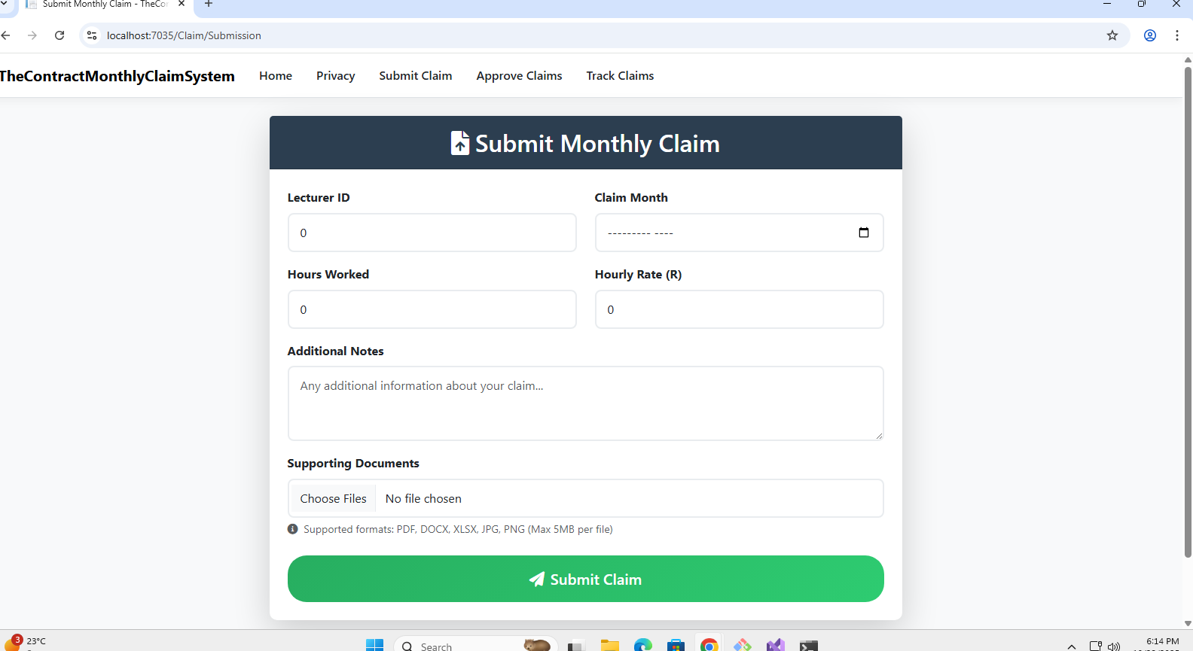

# Programmer Coordinators and managers view

# Lectures Document upload

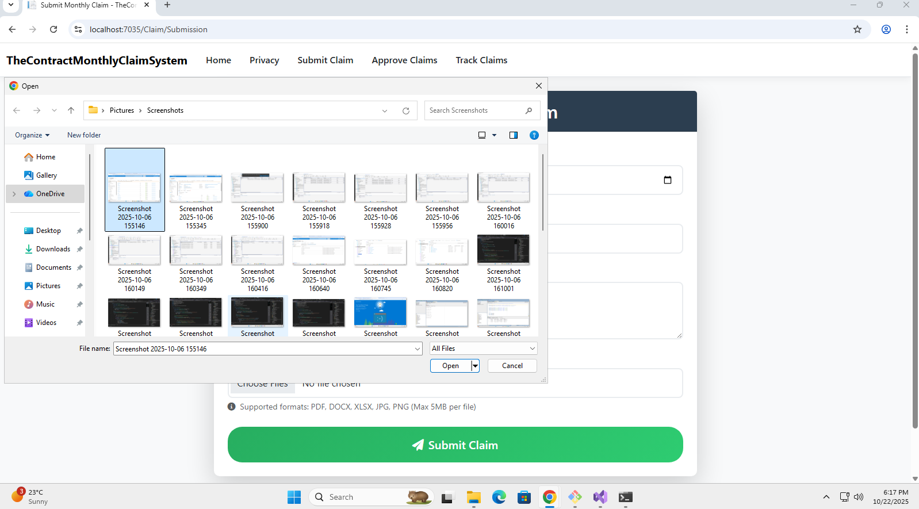

# Lecture Document upload error handling and display

# Claim status tracking.

