Cloud Development B Ice Task 3

# Name: Titus

# Surname: Ndaba

# Student Number: ST10448883

# Module Code: CLDV6212

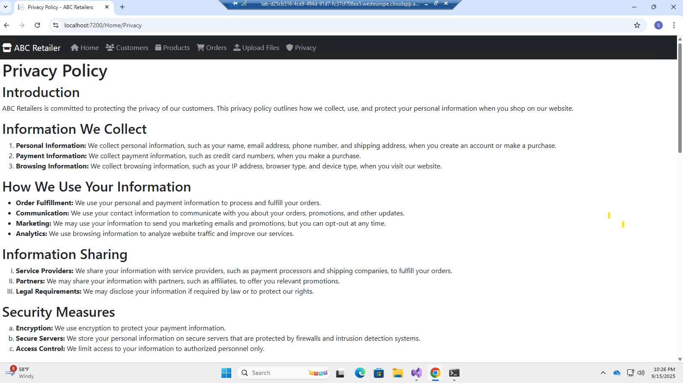

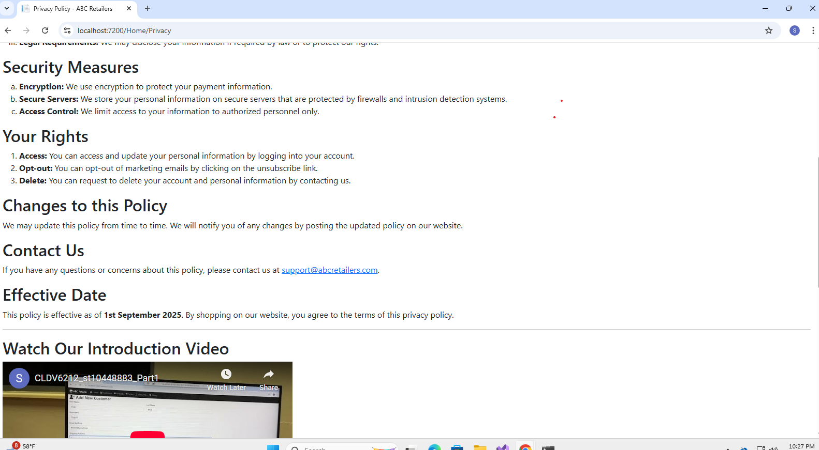

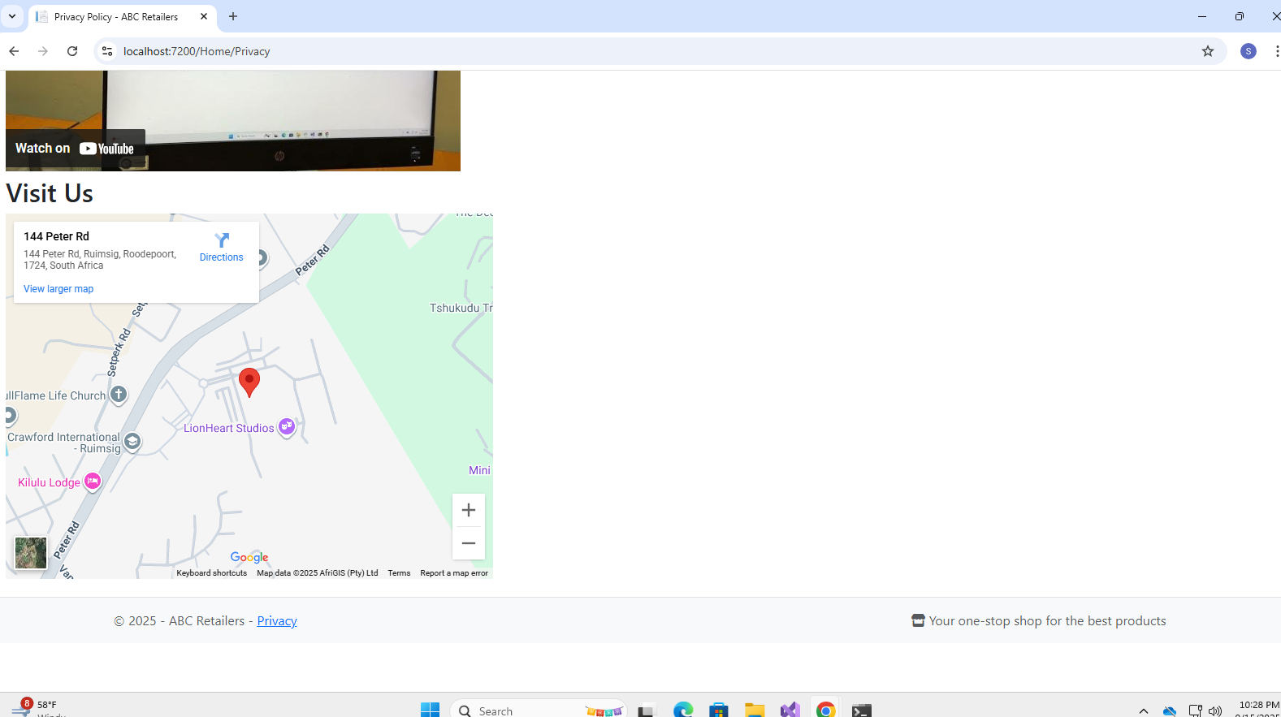

@{

ViewData["Title"] = "Privacy Policy";

}

<h1>@ViewData["Title"]</h1>

<h2>Introduction</h2>

<p>

ABC Retailers is committed to protecting the privacy of our customers.

This privacy policy outlines how we collect, use, and protect your personal

information when you shop on our website.

</p>

<h2>Information We Collect</h2>

<ol>

<li>

<strong>Personal Information:</strong> We collect personal information, such as your name, email

address, phone number, and shipping address, when you create an account or make a purchase.

</li>

<li>

<strong>Payment Information:</strong> We collect payment information, such as credit card

numbers, when you make a purchase.

</li>

<li>

<strong>Browsing Information:</strong> We collect browsing information, such as your IP address,

browser type, and device type, when you visit our website.

</li>

</ol>

<h2>How We Use Your Information</h2>

<ul>

<li>

<strong>Order Fulfillment:</strong> We use your personal and payment information to process and

fulfill your orders.

</li>

<li>

<strong>Communication:</strong> We use your contact information to communicate with you about

your orders, promotions, and other updates.

</li>

<li>

<strong>Marketing:</strong> We may use your information to send you marketing emails and

promotions, but you can opt-out at any time.

</li>

<li>

<strong>Analytics:</strong> We use browsing information to analyze website traffic and improve

our services.

</li>

</ul>

<h2>Information Sharing</h2>

<ol type="I">

<li>

<strong>Service Providers:</strong> We share your information with service providers, such as

payment processors and shipping companies, to fulfill your orders.

</li>

<li>

<strong>Partners:</strong> We may share your information with partners, such as affiliates, to

offer you relevant promotions.

</li>

<li>

<strong>Legal Requirements:</strong> We may disclose your information if required by law or to

protect our rights.

</li>

</ol>

<h2>Security Measures</h2>

<ol type="a">

<li><strong>Encryption:</strong> We use encryption to protect your payment information.</li>

<li>

<strong>Secure Servers:</strong> We store your personal information on secure servers that are

protected by firewalls and intrusion detection systems.

</li>

<li><strong>Access Control:</strong> We limit access to your information to authorized personnel only.</li>

</ol>

<h2>Your Rights</h2>

<ol>

<li>

<strong>Access:</strong> You can access and update your personal information by logging into your

account.

</li>

<li><strong>Opt-out:</strong> You can opt-out of marketing emails by clicking on the unsubscribe link.</li>

<li>

<strong>Delete:</strong> You can request to delete your account and personal information by

contacting us.

</li>

</ol>

<h2>Changes to this Policy</h2>

<p>

We may update this policy from time to time. We will notify you of any changes by posting the updated

policy on our website.

</p>

<h2>Contact Us</h2>

<p>

If you have any questions or concerns about this policy, please contact us at

<a href="mailto:support@abcretailers.com">support@abcretailers.com</a>.

</p>

<h2>Effective Date</h2>

<p>

This policy is effective as of <strong>1st September 2025</strong>. By shopping on our website, you

agree to the terms of this privacy policy.

</p>

<hr />

<h2>Watch Our Introduction Video</h2>

<iframe width="560" height="315"

src="https://www.youtube.com/embed/IqHd6K0xacU"

title="YouTube video player"

frameborder="0"

allowfullscreen>

</iframe>

<h2>Visit Us</h2>

<iframe src="https://www.google.com/maps?q=144+Peter+Road,+Ruimsig,+Roodepoort&output=embed"

width="600"

height="450"

style="border:0;"

allowfullscreen

loading="lazy">

</iframe>