**NAMIBIA UNIVERSITY OF SCIENCE & TECHNOLOGY**



**FACULTY OF COMPUTING AND INFORMATICS**

**DEPARTMENT OF INFORMATICS**

Name: Ndamononghenda Shipena

Student number: 201068966

**Tololi Online shop recommended system**

**Abstract**

A recommendation systems are the hearts of almost every online business today. They are providing some good recommendations, such as friends on Facebook, movies on Netflix, groceries at amazon and other online businesses. It define user experience and enticing their customers to use and buy from their platform. (Banik, 2018). A recommendation is an artificial intelligence algorithm, associated with [machine learning](https://www.youtube.com/watch?v=ukzFI9rgwfU), that uses [big](https://datasciencedegree.wisconsin.edu/data-science/what-is-big-data/) data to suggest or recommend additional products to customers. These can be based on various criteria, such as past purchases, search history, demographic information, and other factors. Recommended systems are highly useful as they help users discover products and services that they might have not found on their own. Recommended collaborative systems are trained to understand the preferences, previous decisions, and characteristics of people and products using data gathered about their interactions. Because of their capability to predict consumer interests and desires on a highly personalized level, recommended systems are a favorite with content and product providers. They can drive customers to just about any product or service that interests them, from books to videos to health classes to clothing etc. This report is a proposal of a Tololi online shop in Namibia item based recommended system.

**Keywords: item-based, recommended, systems, collaborative**

**Introduction**

[Recommender system](https://www.sciencedirect.com/topics/computer-science/recommender-systems) is defined as a decision making strategy for users under complex information environments. It was also defined from the perspective of E-commerce as a tool that helps users search through records of knowledge which is related to users’ interest and preferences. This system I defined as a means in assisting and augmenting the social process of using recommendations of others to make choices when there is no sufficient personal knowledge or experience of the alternatives. The recommended systems handle the problem of information overload that users normally encounter by providing them with personalized, exclusive content and [service recommendations](https://www.sciencedirect.com/topics/computer-science/service-recommendation). The purpose of recommender systems is recommending new things that are not seen before from people. it predicts the likelihood that a user would prefer an item, based on previous user behaviors. In this system, instead of finding relationship between users, used items like books, movies or products are compared with each other’s. The item based recommendation systems, movies, books or groceries does not change. Therefore, recommendation is easier. Collaborative filtering is one of the most popular implementations for Recommendation engines and is based on the assumption that people that were in agreement in the past will be in agreement in the future, and as a result they will like similar kinds of items as they liked in the past.

In this project we are focusing on the item-based filtering recommended systems, meaning If a group of people have rated two items similarly, then the two items must be similar. Therefore, if a person likes one particular item, they’re likely to be interested I the other item too. This is the principle on which item-based filtering work. Amazon and Netflix are one of the company that makes a good use of this model by recommending products to you based on your browsing and purchase history.

**Related work**

In item based recommendation systems, we need to make user vs item matrix that we use also in user based recommender systems. Each row is user and each column is items like movie, product or websites.However, at this time instead of calculating similarity between rows you calculate similarity between columns that are items like movies or stuffs.This is how the item based recommended systems works. Firstly, there are similarities between book one and book six because both are liked by three different people. There is a similarity point between these two books.If the similarity is high enough, we can recommend book 6 to other people who only watched book one as well.

Recently, various approaches for building recommendation systems have been developed, which can utilize either collaborative filtering, content-based filtering or hybrid filtering. Collaborative filtering technique is the most mature and the most commonly implemented. Collaborative filtering recommends items by identifying other users with similar taste; it uses their opinion to recommend items to the active user. Collaborative recommended systems have been implemented in different application areas. The system uses collaborative filtering method to overcome scalability issue by generating a table of similar items offline through the use of item-to-item matrix. The system then recommends other products which are similar online according to the users’ purchase history.

Collaborative filtering and content-based filtering approaches are widely used today by implementing content-based and collaborative techniques differently and the results of their prediction later combined or adding the characteristics of content-based to collaborative filtering and vice versa. collaborative filtering was combined with an information filtering agent. (Isinkaye, Folajimi, & Ojokoh, 2015).

**Methods**

Item-item collaborative filtering is one kind of recommendation method which looks for similar items based on the items users have already liked or positively interacted with (qutbuddin, 2020). To experiment a recommender system (Algorithm) requires these 3 basic building data, a set of **users, items in this case project is books and ratings** (Badrul, George, Konstan', & John) The system can suggest a book to a user based on rating provided by the other users. Tololi online shop recommended algorithm is developed using

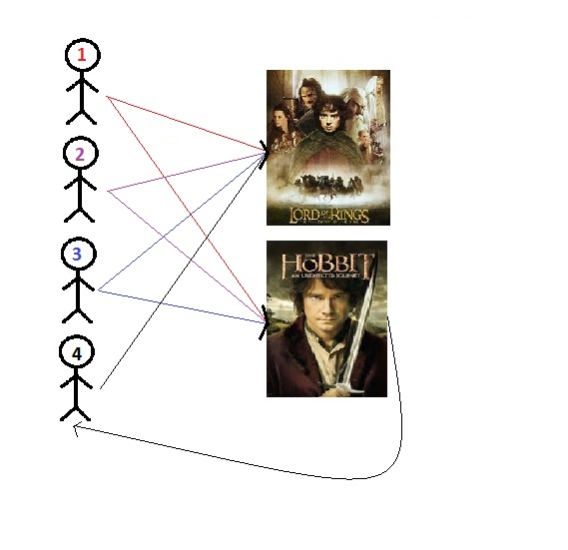

**Results / Discussion**

The use of efficient and accurate recommendation techniques is very important for a system that will provide good and useful recommendation to its individual users.

Below are the libraries used to create the recomended system

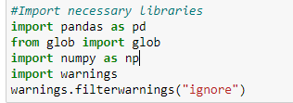

Below: data was scrapped from amazon website and saved in a form of csv in a local drive

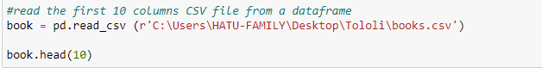

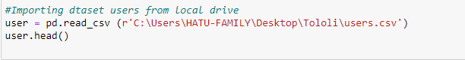

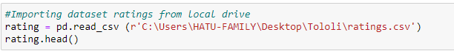

**C:\Users\HATU-FAMILY\Pictures\Capture.PNG**

#### Extract users and ratings of more than 200

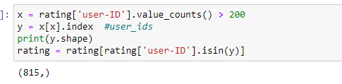

Merging dataset rating and dataset books with ISBN column

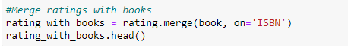

#Merging dataset rating and dataset users with user-ID

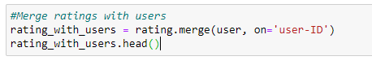

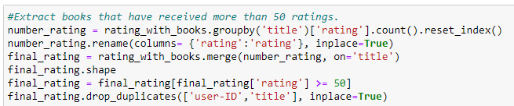

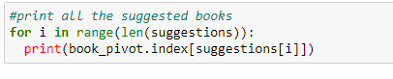

**Output:** Chatbot results

GitHub link:

**Conclusion**

The main objective of this recommended system was to develop an item-based collaborative algorithm which can scale up from a massive datasets and provide real time data

# References

Badrul, S., George, K., Konstan', J., & John, R. (n.d.). tem-Based Collaborative Filtering Recommendation. Retrieved from realpython.

Banik, R. (2018). *Hands-On Recommendation Systems with Python.* Packt publishing.

Isinkaye, F., Folajimi, Y., & Ojokoh, B. (2015). Recommendation systems: Principles, methods and. *Egyptian Informatics journal*, 265.

qutbuddin, m. (2020, March 07). *TowardsDataScience*. Retrieved from https://towardsdatascience.com/comprehensive-guide-on-item-based-recommendation-systems-d67e40e2b75d