CAN THO UNIVERSITY
COLLEGE OF INFORMATION AND COMMUNICATIONS TECHNOLOGY DEPARTMENT OF SOFTWARE ENGINEERING


GRADUATION THESIS
BACHELOR IN SOFTWARE ENGINEERING

Topic
DEVELOPING AN ONLINE APPOINTMENT MANAGEMENT, TELEHEALTH CONSULTING, AND HEALTHCARE SUPPORT SYSTEM

Author:
DUC HUNG NGUYEN
Student ID: B2203556
Cohort 48

Can Tho, August 2026

CAN THO UNIVERSITY
COLLEGE OF INFORMATION AND COMMUNICATIONS TECHNOLOGY DEPARTMENT OF SOFTWARE ENGINEERING


GRADUATION THESIS
BACHELOR IN SOFTWARE ENGINEERING

Topic
DEVELOPING AN ONLINE APPOINTMENT MANAGEMENT, TELEHEALTH CONSULTING, AND HEALTHCARE SUPPORT SYSTEM

Advisor: | Author:
Ph.D. Thanh Khoa Nguyen | Duc Hung Nguyen – B2203556

Can Tho, August 2026

ACKNOWLEDGEMENTS
First and foremost, I would like to express my deepest gratitude to my advisor, Ph.D. Thanh Khoa Nguyen, for his invaluable guidance, continuous encouragement, and constructive feedback throughout the course of this graduation project. His profound academic expertise, professionalism, and patient instruction have been instrumental in shaping the structure, methodology, and technical execution of this thesis.
I would also like to convey my sincere thanks to the respected faculty members of the College of Information and Communications Technology at Can Tho University. The fundamental knowledge, technical skills, and software engineering methodologies instilled by my instructors over the past four years served as the solid foundation upon which this complex, microservices-based system was realized.
Furthermore, I am highly appreciative of the thesis defense committee members for dedicating their valuable time to evaluate, critique, and provide academic recommendations that have substantially improved the quality of this work.
Finally, I owe an immense debt of gratitude to my family and friends, whose unwavering moral and emotional support enabled me to focus entirely on my academic pursuits and successfully bring this research project to fruition.

DECLARATION
I hereby declare that this graduation thesis, titled “Developing an Online Appointment Management, Telehealth Consulting, and Healthcare Support System”, is a product of my own individual research and development under the direct supervision of Ph.D. Thanh Khoa Nguyen.
I solemnly commit that all system architectures, database designs, source code, data analysis, and results presented in this document are genuine, verified, and have not been plagiarized from any other individual, organization, or publication. Any third-party APIs, software libraries, and documentation utilized in the creation of the system are clearly referenced and cited in accordance with academic standards.
Can Tho, … August 2026

Duc Hung Nguyen

LIST OF FIGURES
Figure No. | Figure Title | Page
Figure 1.1 | General Use Case Diagram of the Healthcare Platform | 23
Figure 1.2 | Use Case Sub-diagram for the Clinic Administrator | 24
Figure 1.3 | Use Case Sub-diagram for Doctor and Patient Actions | 25
Figure 2.1 | Comprehensive Three-Tier Microservices Architecture Design | 35
Figure 2.2 | Physical Database Model (PDM) for relational and cached tables | 40

LIST OF TABLES
Table No. | Table Title | Page
Table 1.1 | Implementation Roadmap and Deliverables per Work Phase | 19
Table 1.2 | Use Case Specification (UC01) - Medical Appointment Booking | 26
Table 1.3 | Use Case Specification (UC02) - Conduct Telehealth Video Call | 28
Table 1.4 | Use Case Specification (UC03) - Process Online Payment via VNPay | 30
Table 1.5 | Use Case Specification (UC04) - Update EHR and Diagnoses | 31

LIST OF ABBREVIATIONS
Abbreviation | Full Term | Context / Definition
API | Application Programming Interface | A set of protocols for integration between platforms.
EHR | Electronic Health Record | A digital, structured repository containing patient health history.
FCM | Firebase Cloud Messaging | Cross-platform cloud messaging service to distribute mobile notifications.
gRPC | gRPC Remote Procedure Calls | High-performance inter-process communication protocol in microservices.
JWT | JSON Web Token | Compact URL-safe digital signature used for secure client-side sessions.
OTP | One-Time Password | A dynamically generated password valid for a single transaction or login.
RDBMS | Relational Database Management | Structured relational SQL database utilized for ACID compliance.
REST | Representational State Transfer | An architectural style for designing distributed hypermedia APIs.
RMQ | RabbitMQ Message Broker | A high-performance event queuing service routing asynchronous commands.
WSL | Windows Subsystem for Linux | Compiles full native Linux systems to execute inside host Windows OS.

ABSTRACT
Modern healthcare systems suffer from operational bottlenecks, particularly in small-to-medium private clinics that heavily rely on traditional, paper-based workflows. These manual queuing structures lead to severe waiting-room overcrowding, while the lack of electronic medical records hinders quick data retrieval. Furthermore, clinics operate under restrictive physical boundaries, making immediate remote consultation inaccessible. To address these challenges, this thesis introduces a comprehensive digital healthcare management platform integrating appointment scheduling, Electronic Health Record (EHR) management, and telehealth consulting.
The system's backend is structured upon a highly scalable, containerized microservices architecture utilizing TypeScript, NestJS, and MySQL database engines, with Docker containerization running under Windows Subsystem for Linux (WSL). For maximum performance and reliability, the architecture integrates a Redis caching layer to support stateless JSON Web Token (JWT) whitelists, a RabbitMQ message broker for asynchronous cross-service communication, and Firebase Cloud Messaging (FCM) combined with the Gmail service to distribute mobile notifications and OTP verification emails. For front-end user portals, a responsive web administration portal is developed using ReactJS to handle clinic workflows, while a high-performance native Android application is developed in Flutter to connect patients and doctors. The platform integrates VNPay for secure digital transactions and ZegoCloud SDK for real-time telehealth video calling. Rigorous evaluation proves that the resulting microservices prototype operates stably with low-latency API communication, reliable asynchronous notifications, and highly secure end-to-end data pipelines, presenting a practical and robust digital upgrade for private clinics.

TABLE OF CONTENTS
(Placeholder)

PART I: INTRODUCTION

1. Problem statement and rationale
The operational workflows within small-to-medium private healthcare clinics in Vietnam are severely constrained by traditional, paper-based manual protocols. In a highly digitalized era, a vast majority of local clinics still lack basic automated infrastructure. The primary bottleneck manifests in the appointment scheduling phase; patients must physically travel to the facility early in the morning, bọc số (manually draw a physical token from a queue machine), and endure lengthy waiting room queues. This outdated manual queuing system causes waiting spaces to become overcrowded, degrades the patient experience, and wastes extensive hours for both patients and clinical staff.
Simultaneously, the absence of standardized digital medical records restricts medical quality. Clinical logs, patient demographic profiles, allergies, diagnostic histories, and prescriptions are traditionally recorded in physical paper notebooks. When a patient returns to the clinic, searching and retrieving historical clinical data from stacked file archives is labor-intensive and error-prone. This critical lack of an Electronic Health Record (EHR) system severely impairs the speed and accuracy of medical diagnoses, prevents patient-centric data sharing, and compromises patient safety due to the potential misinterpretation of handwritten medical records.
Furthermore, private clinics are bound by strict physical and temporal limitations. Clinic consultations are held strictly within standard business hours and require physical presence. Patients residing in remote or rural locations face significant logistical barriers to travel for brief medical advice or non-emergency follow-ups. In situations requiring urgent or after-hours consultation, patients must either postpone care or seek overcrowded tertiary hospitals, putting additional stress on the public health infrastructure. To address these systemic operational inefficiencies and geographical barriers, there is an urgent research and engineering need to architect, implement, and validate a centralized, comprehensive digital healthcare platform incorporating automated scheduling, structured electronic health records, and low-latency virtual consults.

2. Existing solutions and prior works
In the domain of Vietnamese digital healthcare, several platforms have emerged to tackle individual components of clinic operations. Well-known national platforms like BookingCare address the scheduling bottleneck by establishing online queues across various medical networks. While BookingCare successfully reduces physical queues, it remains a centralized booking directory rather than an integrated operational system. Consequently, small private clinics find it difficult to fully customize and synchronize BookingCare's workflows with their own internal patient tracking databases, resulting in fragmented patient histories.
Conversely, platforms such as eDoctor have introduced virtual medical consulting and basic electronic health record systems on mobile devices. Although eDoctor connects doctors and patients effectively, it operates as a direct B2C consulting marketplace. Small private clinics cannot easily adopt it as an independent clinic management tool (Hospital Information System - HIS) to run their daily in-house processes. Internationally, open-source HIS frameworks like Bahmni (which aggregates OpenMRS) offer complete, modular medical record keeping and scheduling. However, Bahmni's massive architecture is overly heavy and complex for small private clinics to self-host and customize. More importantly, it lacks tailored localization for Vietnamese banking structures (such as VNPay) and localized notification templates.
This research bridges these gaps by synthesizing the scheduling strengths of BookingCare with the telemedicine capabilities of eDoctor and the robust record-keeping philosophies of Bahmni. The result is a lightweight, loosely coupled microservices system tailored specifically for small private clinics, fully localized to Vietnam's payment, authentication, and communication standards.

3. Research objectives
The primary objective of this thesis is to design, develop, and deploy a comprehensive, digitalized healthcare management and online medical consulting software system tailored specifically for small-to-medium private clinics. By transforming traditional clinical workflows, the system aims to resolve critical inefficiencies such as overcrowded waiting areas caused by manual queuing, and the lack of historical medical data retrieval stemming from paper-based record-keeping. Through the integration of cross-platform client applications and secure real-time communication protocols, the project seeks to broaden patient accessibility to timely, remote healthcare services and remote medical advice during and beyond standard operating hours.
To achieve this overarching goal, the research focuses first on designing a highly secure, ACID-compliant relational database architecture using MySQL to safely store clinical operations data, appointment schedules, and electronic health records (EHR). Building upon this structured data layer, a scalable backend system is developed utilizing a NestJS microservices architecture written in TypeScript. This backend acts as the core transactional engine, exposing robust and efficient RESTful APIs to orchestrate seamless communication and data exchange between the web and mobile client platforms.
On the client side, the objective involves building two distinct, specialized frontends that communicate independently with the backend microservices layer. A responsive web administration portal is developed using ReactJS to empower clinic administrators and nursing staff to manage patient queues, doctor schedules, and daily clinic workflows smoothly. Concurrently, a high-performance native Android application is engineered using Flutter to serve as a unified portal for both doctors and patients, incorporating core features like appointment scheduling, medical history tracking, and remote video consultations.
Finally, the project aims to optimize system performance, security, and utility through third-party integrations and containerized infrastructure management. The implementation incorporates VNPay as a secure digital payment gateway for cashless appointment transactions and ZegoCloud SDK to power low-latency telehealth video consulting. System security is reinforced with a stateless JSON Web Token (JWT) authentication mechanism paired with a Redis whitelist. To guarantee operational stability and prevent environment conflicts, the core services – including MySQL, Redis, and RabbitMQ – are containerized using Docker, with asynchronous message queuing handling system logging via Winston, OTP verification through Gmail, and push notifications via Firebase Cloud Messaging (FCM).

4. Research subject and scope

4.1. Research subject
The primary research subject of this thesis is the process of digitizing and automating healthcare administrative workflows, medical queuing, and remote medical consultations within small-to-medium private clinics. This involves analyzing how patients interact with clinic scheduling, how medical staff manage patient flows, and how physicians retrieve electronic health records during consultations. The research specifically examines the optimization of these processes through the lens of modern software engineering paradigms, focusing on minimizing administrative bottlenecks, reducing wait times, and improving the accessibility of remote healthcare services.
In terms of technical execution, the research focuses on the design, development, and orchestration of a multi-tiered, cross-platform software system. This encompasses a strongly-typed TypeScript and NestJS microservices backend, a relational database model built on MySQL, an in-memory Redis caching layer, and an asynchronous RabbitMQ message queue. The research also investigates the implementation of front-end applications, specifically a responsive ReactJS web administration portal for clinical staff and a native Flutter mobile application serving both doctors and patients, ensuring seamless real-time data synchronization between the decoupled client platforms and the core backend services.
Furthermore, the subject includes the integration of secure third-party platforms to extend the system's core capabilities. This involves evaluating the feasibility and security of implementing the VNPay gateway to process cashless online payments for appointment bookings and the ZegoCloud SDK to facilitate low-latency, real-time video consultations. Additionally, the research explores robust cross-platform security mechanisms, including stateless JWT authentication paired with Redis whitelisting, and secure storage techniques such as HttpOnly cookies on the web and Flutter Secure Storage on mobile devices.

4.2. Research scope
The functional scope of this thesis is strictly bounded by the core administrative and telehealth operations of a private clinic, excluding pharmacy inventory tracking, physical medication warehousing, and hardware-level network optimizations. The development is focused on delivering a functional scheduling module with automated queuing, a digital Electronic Health Record (EHR) database, an integrated online payment gateway via VNPay, and a WebRTC-based real-time video consulting module via ZegoCloud. The system also integrates asynchronous background processes, limiting its messaging boundaries to Gmail for OTP verifications, Winston for system logging, and Firebase Cloud Messaging (FCM) for push notifications.
Technically, the development and deployment scope are limited to a containerized microservices environment hosted locally. The infrastructure leverages Docker combined with the Windows Subsystem for Linux (WSL) to isolate and host the MySQL database, Redis caching layers, and RabbitMQ message broker, thereby eliminating environment conflicts and ensuring consistency. The mobile client application is designed and compiled specifically for the Android operating system using Flutter, while the clinic administration portal is developed as a responsive single-page web application using ReactJS.
The data scope for testing and system verification relies entirely on self-generated mock datasets to protect actual patient privacy. This data includes synthesized demographic profiles, simulated clinical histories (EHRs), mock appointment schedules, and standardized catalogs of diseases and medications used solely to link diagnoses to patient charts. Finally, the methodological scope of the project follows the linear, sequential phases of the Waterfall model, spanning initial requirement specifications, system architectural and physical database design, full-stack software implementation, rigorous RESTful API testing via Postman, and cross-platform performance evaluation.

5. Research Content and Technologies Used
- Research content
- Analyzing traditional clinical administrative workflows, manual queuing inefficiencies, and electronic health record-keeping limitations in small-to-medium private clinics
- Investigating modern software architecture paradigms, specifically containerized microservices architectures, stateless session management, and distributed caching, to address system scalability and security
- Analyzing and drafting functional requirements, system specifications, and detailed use case scenarios for clinical scheduling, queue management, EHR synchronization, and remote video consultations
- Designing a secure, fully normalized relational database model using MySQL to handle electronic medical records, patient credentials, appointment slots, and clinical metadata
- Developing a strongly-typed TypeScript and NestJS-based microservices backend to serve as the core transactional engine, exposing secure RESTful APIs to client platforms
- Implementing a highly responsive web-based clinical administration portal using ReactJS to empower clinic staff to manage daily queues, doctor schedules, and billing workflows
- Engineering a cross-platform mobile application using Flutter to serve as a unified portal for both doctors and patients, incorporating appointment booking, digital EHR tracking, and telehealth modules
- Integrating secure payment processing via the VNPay gateway and low-latency, real-time audio-video streams via ZegoCloud SDK to facilitate virtual healthcare consultations
- Conducting comprehensive unit testing, functional verification, and API integration testing using Postman to ensure seamless communication between client applications and backend microservices
- Deploying the containerized microservices infrastructure locally using Docker combined with Windows Subsystem for Linux (WSL) to guarantee environment consistency and system stability
- Technologies used
- Backend services:
  - NestJS (TypeScript): Employed as the primary progressive Node.js framework for structuring robust, scalable, and loosely-coupled backend microservices
  - RabbitMQ: Implemented as an asynchronous message broker to handle non-blocking communications, system logs, push notifications, and email dispatches across services
  - gRPC: Utilized for high-performance, low-overhead, and synchronous inter-service communications within the backend microservices layer
- Frontend interfaces:
  - ReactJS: Adopted to build a responsive, component-based, single-page web administration portal for clinical staff and receptionists
  - Flutter (Dart): Used to develop a high-performance, native-like mobile application deployed on Android for both doctors and patient portals
- Data storage and caching:
  - MySQL: Deployed as the primary relational database management system to guarantee strict ACID transactions for sensitive electronic health records and booking invoices
  - Redis: Integrated as an in-memory database to store the JSON Web Token (JWT) whitelist for stateless session control and caching operational data
- Telehealth and payment integrations:
  - ZegoCloud SDK: Embedded to establish secure, low-latency, real-time video and audio streams for virtual consulting between patients and physicians
  - VNPay Sandbox Gateway: Integrated to facilitate cashless transaction processing, digital invoicing, and automatic appointment reservation confirmation
- Infrastructure, logging and automation:
  - Docker and WSL: Strategically utilized to containerize, orchestrate, and isolate all core system databases and message brokers, ensuring environment consistency
  - Firebase Cloud Messaging (FCM): Implemented to deliver instantaneous, cross-platform push notifications regarding appointment updates to the Flutter mobile application
  - Winston and Postman: Used for centralized, structured file logging and automated RESTful API testing, verification, and debugging

6. Contributions of the thesis
- Healthcare, operational, and social contributions:
The developed system directly modernizes administrative and medical operations for small-to-medium private clinics by replacing traditional, manual paper-based processes with an automated, digitalized workflow. By optimizing patient registration, clinical scheduling, and electronic health record (EHR) management, the platform effectively reduces patient wait times, prevents overcrowding in clinic waiting areas, and enhances overall clinical operational efficiency. Furthermore, the integration of a centralized, secure Electronic Health Record (EHR) subsystem empowers physicians with instant, chronological access to historical patient health data, facilitating faster and more accurate clinical diagnoses while providing patients with a secure mobile portal to track their personal medical histories and follow up on treatments systematically.
From a patient-centric and social standpoint, the system breaks down geographical and operational barriers by introducing a low-latency, WebRTC-based telehealth video consulting module. Coupled with secure cashless transaction processing via the VNPay payment gateway, the platform enables patients – especially those in remote areas or with limited mobility – to access timely, professional medical consultations and advice beyond standard physical clinic hours. This digital integration significantly improves the quality of care and enhances the overall patient experience in private practice settings.
- Professional training and development contributions:
Through the practical design and execution of this thesis, the researcher has consolidated advanced software engineering competencies, particularly in architecting and orchestrating a distributed, containerized microservices backend. The project provided rigorous hands-on experience in managing loosely coupled services, synchronous inter-service communication via gRPC, and asynchronous message broker routing using RabbitMQ. Additionally, the development lifecycle facilitated a deep practical understanding of multi-platform engineering, including building highly responsive, component-based single-page web applications with ReactJS for administrative staff, and native Android mobile applications with Flutter to deliver a seamless, high-performance user experience for both doctors and patients.
Furthermore, the project advanced the researcher's skills in implementing robust security and DevOps practices, such as stateless session control utilizing JSON Web Tokens (JWT) with a Redis-backed whitelist, secure client-side storage mechanisms, and containerized deployment. The database, caching, and message broker services were containerized using Docker under the Windows Subsystem for Linux (WSL), ensuring environment consistency and high system reliability. Beyond serving as a practical clinic management prototype, this system provides a highly valuable technical reference and practical demonstration of modern software engineering methodologies for future developments in digital healthcare.

7. Thesis organization
The main body of this graduation thesis is systematically structured into three major parts: Introduction, Content, and Conclusion, alongside a dedicated reference list and supplementary appendices.
- Introduction:
This introductory section establishes the foundation of the research. It presents the background bối cảnh and the problem statement regarding manual clinical workflows, reviews existing telehealth and scheduling solutions, and defines the general and specific research objectives. Furthermore, this part delineates the subject, scope, and limitations of the thesis, details the software development content and the technologies employed, highlights the key social and technical contributions, and outlines this overall thesis organization.
- Content:
Problem description: This chapter provides a detailed analysis of traditional clinical administrative processes, booking queues, and electronic health record management. It specifies the system’s use case diagrams and specifications for both clinic administrators and end-users (doctors and patients), accompanied by non-functional performance, security requirements, and clinical business rules.
Architecture design and data modeling: This chapter describes the technical design of the proposed clinical platform. It details the multi-tier containerized microservices architecture utilizing NestJS, gRPC, and RabbitMQ, constructs the normalized MySQL relational database schema and data dictionary, configures stateless JWT session management with Redis whitelisting, and outlines the physical integration models for VNPay payment gateways and ZegoCloud telehealth streams.
Software testing and performance evaluation: This chapter presents the testing objectives and implementation methodologies. It details the systematic test plan, functional test scenarios, API testing logs conducted via Postman, and client-side performance evaluation on ReactJS and Flutter applications, summarizing the verified test results and system stability.
- Conclustion:
This final section summarizes the entire research project. It evaluates the achieved results against the initial objectives, addresses the practical challenges and technical limitations encountered during development, and proposes concrete directions for future development – such as orchestrating services with Kubernetes, optimizing data synchronization, or incorporating smart healthcare analytics.
- References:
This section compiles a comprehensive bibliography of all academic publications, technical standards, and framework documentations referenced throughout the thesis. All entries are systematically managed and formatted in strict accordance with the IEEE citation style.
- Appendices:
This section contains supplementary technical documents that support the main text. This includes raw SQL database migration scripts, full API endpoint specifications, additional sequence and activity diagrams for complex workflows, and high-fidelity interface screenshots of the ReactJS administration panel and the Flutter mobile application.

PART II: CONTENT

CHAPTER 1: PROBLEM DESCRIPTION

1. Detailed problem description
The operational paradigm of traditional small-to-medium private clinics is heavily restricted by legacy, manual processes that compromise both administrative efficiency and the quality of patient care. Under the conventional workflow, the patient journey begins with physical arrival at the clinic, where patients must wait in line at the reception desk to manually register their information in paper logbooks. A receptionist then issues a physical paper ticket representing their sequence in the queue. This manual queuing mechanism lacks real-time updates and scheduling visibility, meaning patients are forced to wait indefinitely in crowded waiting areas without knowing when they will be examined. Consequently, clinics regularly face severe bottlenecks during peak hours, resulting in operational chaos, high administrative overhead for nursing staff, and a significantly diminished patient experience.
To overcome these operational challenges, the proposed system introduces a secure, unified digital healthcare platform that digitalizes and orchestrates the workflows of small-to-medium practices. The digitized patient journey begins on a native Flutter mobile application. To schedule an appointment, patients select their desired medical department, date of examination, and the preferred consultation method, which can be either an in-person physical visit (offline) or a remote telehealth consultation (online). Once these parameters are specified, the system queries the backend to retrieve real-time schedule vacancies from the database and dynamically displays a list of eligible doctors alongside their available working shifts for the patient to choose from. Additionally, this mobile portal empowers patients to securely track their own medical history, review historical clinical diagnoses, access digital prescriptions, and monitor their previous appointment schedules.
A major architectural refinement of this platform is the post-consultation payment and checkout workflow, designed to seamlessly synchronize digital transactions with physical clinic operations. Unlike typical systems requiring upfront prepayment, patients complete their examination fees after receiving their medical consultation. Immediately upon the doctor completing the medical examination and entering the clinical diagnosis into the EHR database, the system automatically generates a unique digital invoice containing the pre-calculated consultation fee and the prescribed medication list. This flexible approach accommodates both cashless digital transactions and traditional cash payments against this pre-existing invoice. For online transactions, a new VNPay transaction reference (txn_ref) is dynamically generated each time the patient initiates a payment session through the integrated VNPay sandbox gateway. For cash transactions, patients pay physically at the clinic, where the receptionist or nurse retrieves the pre-existing invoice and manually confirms the payment status through the web administration portal. Once the payment is successfully verified and the invoice status is updated – either via the VNPay payment webhook or manual clinical confirmation – the patient presents the invoice code to the nurse, who validates the transaction to dispense the prescribed medications and explain usage instructions.
The division of labor among clinical stakeholders is clearly defined through specialized client interfaces designed to optimize their respective tasks. On the web-based clinical administration portal built with ReactJS, the nurse’s primary responsibilities are streamlined to focus on confirming cash payments, retrieving detailed digital invoices for pharmaceutical dispensing, and providing patients with follow-up medication instructions. Meanwhile, physicians access their workflows via the Flutter mobile application. Doctors can continuously access and review the comprehensive electronic health records (EHR) of their upcoming patients, ensuring thorough clinical preparation. The doctor's diagnostic interface remains highly consistent across consultation types; the only interface variation is a dedicated button to join a secure, low-latency WebRTC video conference call powered by ZegoCloud SDK for online sessions. Once the consultation is complete, doctors enter diagnostic findings, clinical notes, and prescriptions into the centralized MySQL database using an identical, standardized form for both online and offline patients.
On the backend, a scalable NestJS microservices architecture written in TypeScript orchestrates these operations with optimized communication and notification flows. To balance system responsiveness and reliability, communication tasks are strictly segregated into synchronous and asynchronous pipelines. The dispatch of OTP verification emails via the Gmail service is executed as a synchronous transaction to guarantee instant, real-time security validation for user authentication. Conversely, non-critical push notifications – including clinical schedule updates, booking confirmations, and queue alerts – are treated as asynchronous events. These notifications are dispatched to the RabbitMQ message broker, which queues and processes them asynchronously before pushing them to the Flutter client via Firebase Cloud Messaging (FCM). This asynchronous decoupling prevents main thread blocking, reduces API gateway latency, and ensures high system performance even during periods of heavy clinic traffic.

2. Functional requirements

2.1. Use case diagrams

2.1.1. General use case diagram

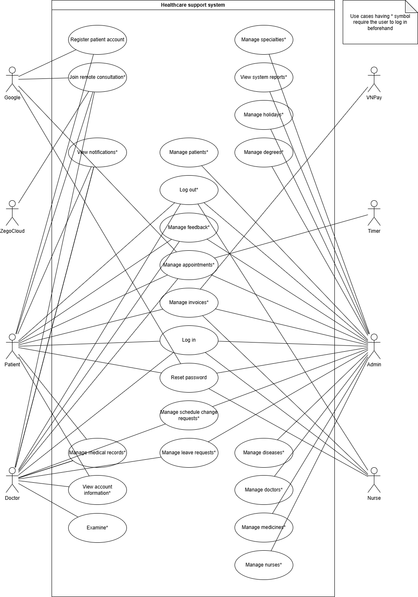
Picture 1.1 illustrates the overall usecase diagram of the clinic management and telehealth support system. This diagram visually delineates the core functional modules and the interactive relationships between four human actors (Patient, Doctor, Nurse, and Admin), one internal system actor (Timer) and three external system actors (VNPay, ZegoCloud and Google) within the boundaries of the digital healthcare platform. The system is systematically organized into key functional areas: Account management (comprising registration, login, logout, and password recovery), clinical appointment scheduling (manage appointments), billing and payment processing (manage invoices), electronic health record management (manage medical records and examine), remote telehealth consultation (join remote consultation), and advanced master database administration subsystems reserved exclusively for the admin. Notably, to optimize clinical data security and strictly enforce role-based access control (RBAC), the majority of the usecases within the diagram are designated with an asterisk (*) symbol, representing a mandatory precondition where users must successfully authenticate via the login process to establish a valid and authorized session prior to execution.
Figure 1. 1. General use case diagram

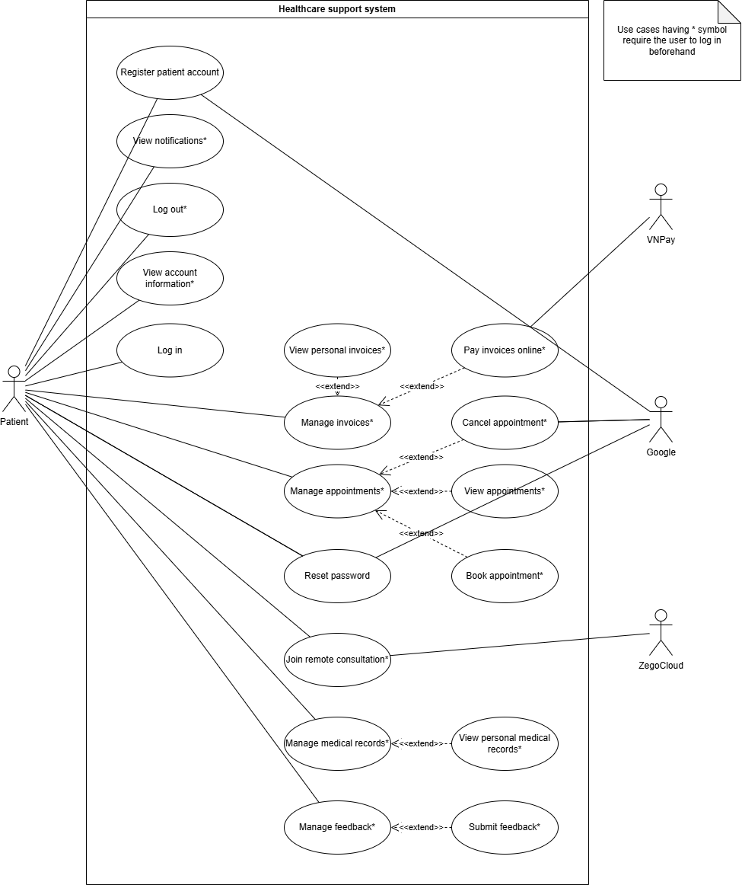
2.1.2. Patient actor use case diagram
Figure 1. 2. Patient actor use case diagram
Figure 1.2 details the use case diagram for the Patient actor, who primarily interacts with the system via the cross-platform Flutter mobile application to manage personal healthcare services. The Patient's functional journey is divided into several logically organized modules: Account management, appointment coordination, financial operations, clinical record access, and telehealth engagement. Within account management, the patient can perform log in, reset password, and register patient account, which synchronously interfaces with the external Google (Gmail SMTP) service to dispatch a secure one-time password (OTP) for email verification, alongside authenticated actions like Log out* and View account information*. For clinical appointments, the base use case Manage appointments* is extended by Book appointment* (allowing patients to search schedules, select departments, dates, and doctors), View appointments*, and Cancel appointment*. In Financial Operations, post-consultation billing is handled through Manage invoices*, which is extended by View personal invoices* and Pay invoices online*, with the latter seamlessly interfacing with the third-party VNPay gateway to process cashless digital transactions. Furthermore, patients retrieve historical electronic health records (EHR) and prescriptions via the Manage medical records* base use case, which is extended by View personal medical records*, while virtual video consultations are initiated through the Join remote consultation* use case that integrates directly with ZegoCloud WebRTC services to establish low-latency audio-video streams. Finally, patients receive clinic alerts through the View notifications* use case and provide feedback via Manage feedback* (extended by Submit feedback*), with all asterisk-tagged (*) use cases strictly enforcing role-based access control (RBAC) by requiring successful user authentication beforehand.

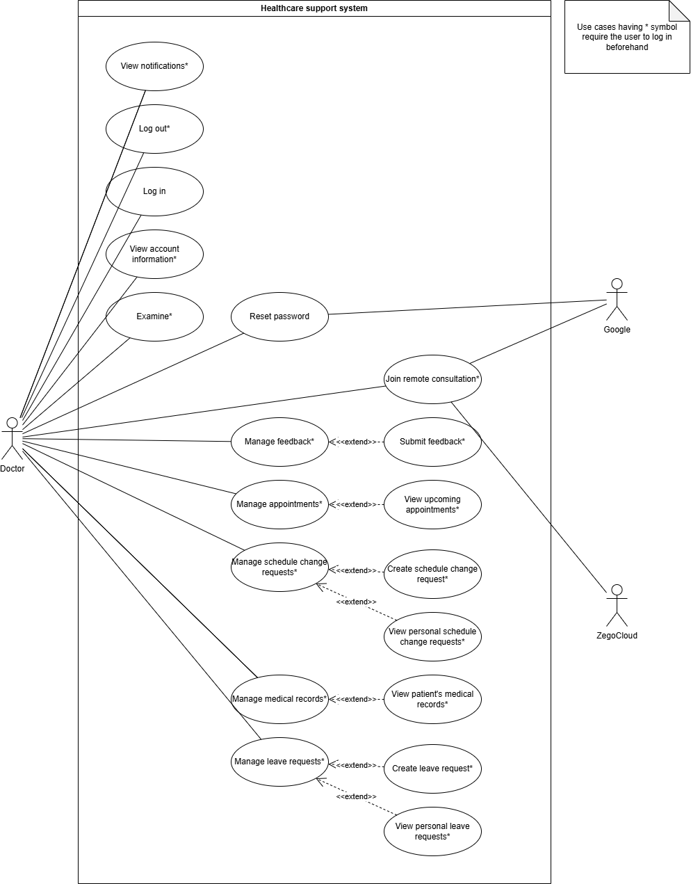
2.1.3. Doctor actor use case diagram
Figure 1. 3. Doctor actor use case diagram
Figure 1.3 details the use case diagram for the Doctor actor, who primarily interacts with the system via the native Flutter mobile application to manage clinical duties, schedule modifications, and telehealth sessions. The doctor's functional journey is systematically organized into several key operational areas: Account settings, clinical Consultations, schedule and seave adjustments, and Electronic Health Record Access. Within account settings, the doctor can perform Log in, Log out*, View account information*, Reset password and View notifications*. The core clinical examination workflow is represented by the Examine* use case, where the doctor conducts diagnoses and enters digital prescriptions. For remote consultations, the doctor executes the Join remote consultation* use case, which integrates directly with the external ZegoCloud platform to establish low-latency, real-time WebRTC audio-video streaming. Under schedule and leave operations, the base usecase Manage appointments* is extended by View upcoming appointments*, while Manage schedule change requests* is extended by Create schedule change request* and View personal schedule change requests* to allow flexible roster adjustments. Concurrently, the Doctor coordinates their planned absences using the Manage leave requests* base use case, which is extended by Create leave request* and View personal leave requests* to systematically submit and track time-off applications. Additionally, the Doctor manages patient histories via the Manage medical records* base use case, which is extended by View patient's medical records* to securely retrieve historical Electronic Health Records (EHR). Finally, the Doctor can interact with the clinic administration through Manage feedback* (extended by Submit feedback*), with all asterisk-tagged (*) use cases strictly requiring successful user authentication beforehand to enforce role-based access control (RBAC) and protect sensitive medical databases.

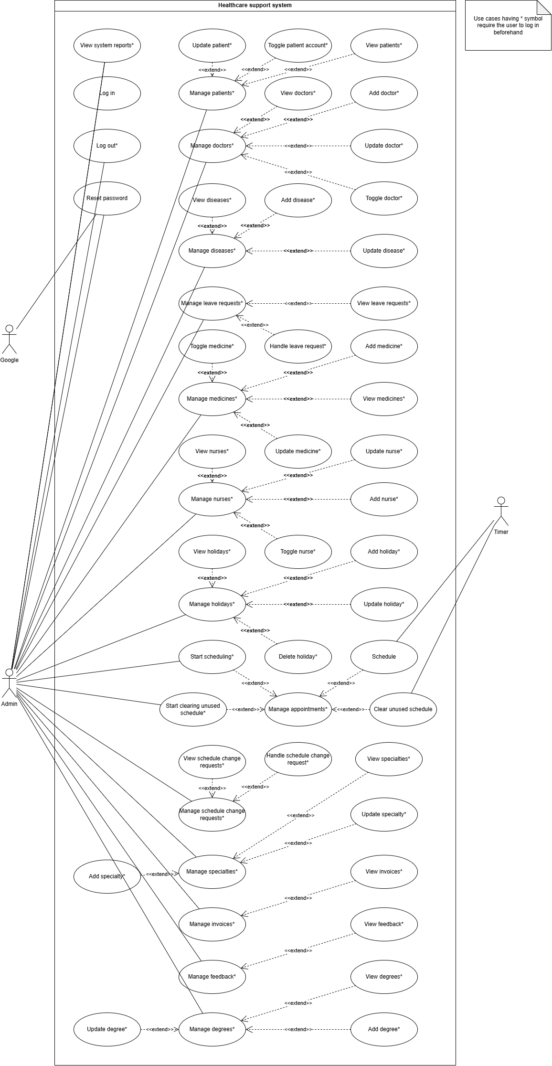
2.1.4. Admin and Timer actor use case diagram
Figure 1. 4. Admin and Timer Actor Diagram
Figure 1.4 details the use case diagram for the Admin and Timer actors, showcasing the administrative management of clinical metadata and the orchestration of automated server-side operations. The Admin represents the privileged administrative user who interacts with the system via the ReactJS web portal to maintain structural catalogs, user roles, and clinical master data. This comprehensive scope of administrative duties is systematically decoupled into logical base use cases that are further extended by specialized CRUD operations, including: Manage patients* (extended by View patients*, Update patient*, and Toggle patient account*), Manage doctors* (extended by View doctors*, Add doctor*, Update doctor*, and Toggle doctor*), Manage diseases* (extended by View diseases*, Add disease*, and Update disease*), Manage leave requests* (extended by View leave requests* and Handle leave request*), Manage medicines* (extended by View medicines*, Add medicine*, Update medicine*, and Toggle medicine*), Manage nurses* (extended by View nurses*, Add nurse*, Update nurse*, and Toggle nurse*), and Manage holidays* (extended by View holidays*, Add holiday*, Update holiday*, and Delete holiday*). The Admin also coordinates clinical entities via Manage specialties* (extended by View specialties*, Add specialty*, and Update specialty*), Manage degrees* (extended by View degrees*, Add degree*, and Update degree*), Manage schedule change requests* (extended by View schedule change requests* and Handle schedule change request*), Manage invoices* (extended by View invoices*), and Manage feedback* (extended by View feedback*). Crucially, the Timer actor represents an internal server-side scheduler counter designed to run asynchronous background processes and automated Cron jobs. Rather than interacting as an external third-party service, the Timer directly triggers Schedule (which extends the base Start scheduling* use case to automatically generate doctor shifts) and Clear unused schedule (which extends Manage appointments* to automatically release expired booking slots). In alignment with the system's security architecture, all administrative use cases designated with an asterisk (*) strictly enforce role-based access control (RBAC), requiring successful authentication beforehand to protect the database against unauthorized master catalog modifications.

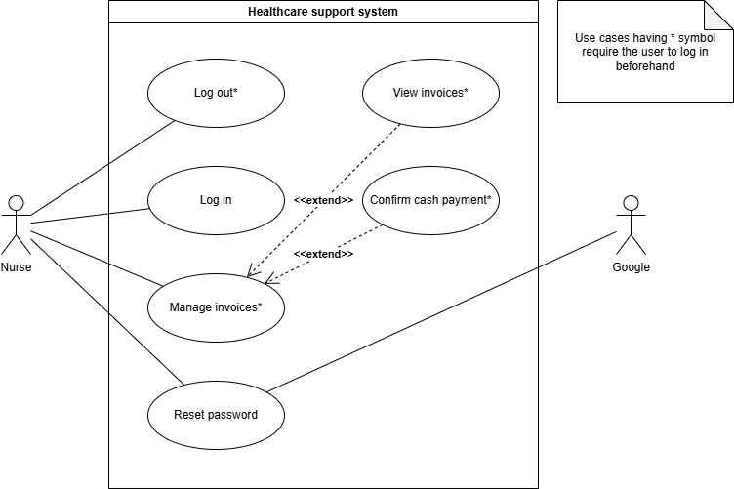
2.1.5. Nurse actor use case diagram
Figure 1. 5. Nurse actor use case diagram
Figure 1.5 details the use case diagram for the Nurse actor, who primarily interacts with the system via the responsive ReactJS web administration portal to coordinate clinical checkout workflows and in-person transactions. To ensure high clinical throughput and strict separation of privileges, the Nurse's operational boundary is intentionally streamlined and restricted from schedule or medical catalog modifications, focusing solely on account settings and billing management. Under account settings, the Nurse can execute the Log in, Reset password, and authenticated Log out* use cases, with password recovery interfacing with the external Google (Gmail SMTP) service to securely dispatch verification codes. The core of the Nurse’s clinical contribution is orchestrated under the Manage invoices* base use case, which is structurally extended by View invoices*—enabling the nurse to retrieve detailed billing records and check attached prescriptions for accurate drug dispensing and patient counseling—and Confirm cash payment*—which allows the manual verification and status update of physical cash transactions at the clinic's reception. In strict compliance with the system's role-based access control (RBAC) and data protection standards, all asterisk-tagged (*) use cases require the Nurse to possess a valid, authenticated session, thereby safeguarding financial logs and sensitive medical data against unauthorized access.

3. Non-functional requirements

3.1. Performance Requirements
- Under standard network conditions (minimum 10 Mbps connection), the system must guarantee a maximum API response time of under 3.0 seconds for general transactional requests. High-priority actions, such as fetching real-time queue states or active working shifts, should return data within 1.5 seconds
- The containerized NestJS microservices backend must be optimized to handle concurrent requests efficiently. By utilizing RabbitMQ as an asynchronous message broker, high-overhead operations – such as sending push notifications via FCM – must be decoupled from the main request-response cycle, preventing thread blocking and maintaining high throughput during peak hours
- Frequently accessed static or semi-static data, such as clinical department catalogs and active token whitelists, must be cached using an in-memory Redis database. This caching strategy must reduce redundant read queries to the MySQL database, optimizing data retrieval and minimizing database connection overhead

3.2. Safety requirements
- Because core clinical operations – such as appointment scheduling, post-consultation payment processing, and electronic health record (EHR) management – are decoupled into isolated microservices with their own dedicated database instances, traditional local database transactions cannot guarantee data integrity across these distributed boundaries. To ensure eventual consistency and robust data integrity, the system implements an Orchestrator-based SAGA Pattern. Within this distributed workflow, the Schedule Service acts as the central orchestrator (coordinator). It sequences and initiates local transactions across participating services, such as requesting invoice generations in the Payment Service and preparing clinical records in the Medical Record Service. If any individual step fails during this distributed chain – such as a VNPay integration failure or an EHR database write error – the Schedule Service immediately intercepts the failure and dispatches a sequence of compensating transactions (such as voiding the generated invoice, freeing up the blocked doctor's shift, or deleting temporary diagnostic records) to revert all databases back to a pristine, consistent state and prevent orphaned data
- While cross-service consistency is managed via distributed SAGA workflows, each independent microservice must still enforce strict ACID (Atomicity, Consistency, Isolation, Durability) compliance within its own local boundary. Any transactional database operations executed within a single service—such as updating an invoice status from "Unpaid" to "Paid" in the MySQL database or inserting a list of prescribed medications — must be wrapped in local database transactions to prevent partial writes and guarantee absolute local consistency
- To prevent physical system crashes and local operational conflicts, all core infrastructural dependencies (MySQL, Redis, RabbitMQ) must be containerized using Docker. This ensures that any runtime error or memory leak in a single service remains isolated and does not compromise the host system's stability or other running processes
- To facilitate seamless end-to-end monitoring, rapid debugging, and comprehensive audit trails across the decentralized microservices architecture, every incoming transaction must be uniquely identifiable. Upon receiving any external request, the API Gateway must dynamically generate and assign a unique, immutable correlationId created by concatenating the requester’s client IP address with a globally unique identifier (UUIDv4). This correlationId must be automatically injected into request headers and propagated downstream to all participating microservices through synchronous gRPC metadata and asynchronous RabbitMQ message envelopes. By embedding this identifier across service boundaries, the Winston logging library can systematically tag all distributed logs under a single transactional thread, allowing administrators to trace the complete lifecycle of any request and isolate failures instantly.

3.3. Security requirements
- The system must leverage JSON Web Tokens (JWT) as the primary standard for secure, cross-platform session management. Upon successful login, the authentication service issues a short-lived access token and a long-lived refresh token. To allow immediate session revocation, token states must be validated against a Redis-backed whitelist
- Token storage strategies must be strictly tailored to the specific client runtime environment. The ReactJS-based web administration portal must store tokens in secure, HttpOnly, and SameSite cookies to mitigate Cross-Site Scripting (XSS) risks. Concurrently, the Flutter mobile application must store tokens using encrypted local storage via the Flutter Secure Storage package
- All patient demographic profiles, credentials, and sensitive electronic health records must be protected both in transit and at rest. Passwords must be hashed using bcrypt before database insertion. All external network transmissions between client applications and the API Gateway must be strictly encrypted over HTTPS
- To safeguard the distributed microservices infrastructure against brute-force attacks, resource exhaustion, and Denial of Service (DoS) attempts, a strict rate-limiting mechanism must be enforced at the API Gateway level. This mechanism is implemented utilizing the official NestJS Throttler library, which dynamically monitors and intercepts incoming HTTP traffic based on the client's network origin. The rate limiter enforces a strict system-wide threshold of 60 requests per minute per individual IP address. Any client exceeding this calculated traffic limit must be instantly blocked and returned an HTTP 429 (Too Many Requests) exception, effectively protecting downstream microservices from spam, malicious API scraping, and automated script abuse

3.4. External interface requirements

3.4.1. User interface (UI) requirements
- The web administration portal developed in ReactJS must be highly responsive, support modern web browsers (Google Chrome, Microsoft Edge, Safari), and offer an intuitive, user-friendly layout for clinic nurses to easily manage transactions and drug dispensations
- The Flutter mobile application must adapt seamlessly to various Android screen sizes and resolutions, offering consistent typography, clear diagnostic dashboards, and a specialized interface that displays a prominent join button for telehealth video conferences

3.4.2. Hardware interface requirements
- Hosting Server (Development & Local Deployment): Minimum processor of 2.0 GHz (minimum 6 cores), 16GB of RAM, and 50GB of available SSD storage to efficiently host containerized Docker services
- Client Mobile Devices: Android operating system version 10.0 or higher, with integrated front-facing camera capabilities for ZegoCloud video calls

3.4.3. Software interface requirements
- The system must integrate the official VNPay Sandbox SDK to receive payment status notifications securely via server-to-server IPN callbacks
- The platform must interface with ZegoCloud Real-Time Interaction SDK to orchestrate peer-to-peer WebRTC video and audio consulting rooms
- Asynchronous mobile push notifications must be delivered by interfacing with the Firebase Cloud Messaging (FCM) API

3.4.4. Communication interface requirements
- External client-to-server communications must rely on standard RESTful web services over secure TCP/IP sockets
- High-performance, low-latency internal communications between microservices (e.g., verifying a user session or retrieving profile data) must be conducted synchronously using gRPC
- Asynchronous event dispatches and distributed message queues must communicate over AMQP (Advanced Message Queuing Protocol) via RabbitMQ

3.5. Business rules
- Role-based access control (RBAC): The system must strictly enforce API gateway-level authorization based on three predefined user roles
  - Patient: Authorized to register, query real-time doctor schedules, request and book clinic appointments, review personal electronic health records (EHR), track previous consultation histories, and settle invoice fees online via the integrated VNPay gateway
  - Doctor: Authorized to review assigned appointment schedules, continuously retrieve and analyze the comprehensive EHR history of upcoming patients (for both offline and online consultations), initiate low-latency video calling rooms via the ZegoCloud SDK for online sessions, and submit clinical diagnoses, treatment notes, and digital prescriptions into the MySQL database
  - Nurse: Authorized to retrieve and view detailed digital invoices and prescriptions to facilitate accurate drug dispensing and provide follow-up usage instructions, and manually confirm and update payment statuses for physical cash transactions at the clinic's reception
  - Administrator (Admin): Authorized to perform complete CRUD (Create, Read, Update, Delete) operations on system-wide master catalogs. This includes managing medical classifications (diseases), standardized medication and drug catalogs, physician scheduling rosters, patient demographics, and overall user account activation or deactivation states
- Post-consultation financial workflow:
  - An invoice is automatically generated only when the consulting doctor submits the final diagnosis and prescription into the EHR database
  - For online payments, a new, unique VNPay transaction reference (txn_ref) must be dynamically generated for every individual online payment attempt initiated by the patient
  - For cash payments, the receptionist/nurse must manually change the payment status of the pre-existing invoice from "UNPAID" to "PAID" via the ReactJS web portal before clinical medications can be dispensed to the patient
- Telehealth consultation validity: Real-time telehealth video conference channels powered by ZegoCloud are only accessible to the assigned patient and doctor. The dedicated join video call interface button must only become active on the client applications five (5) minutes prior to the scheduled appointment slot and must automatically expire once the doctor completes and saves the EHR entry

CHAPTER 2: ARCHITECTURE DESIGN AND DATA MODELING
This chapter presents the architectural blueprints and database modeling schemas representing the technical execution of this thesis.
H2.1: 1. Comprehensive Architectural Layout
The platform is structured on a three-tier microservices architecture. Tầng Client (ReactJS and Flutter) sends requests through a unified API Gateway. Tầng Service comprises loosely coupled modules (Auth, User, Schedule, Telehealth, Payment, EHR, Notifications, Logger) that communicate through fast internal gRPC or asynchronous RabbitMQ message queues. Tầng Database uses MySQL relational engines alongside a Redis cache to optimize whitelist lookups.
H2.2: 2. Relational Database Physical Model (PDM)
The database layout implements a 'database-per-service' pattern to ensure independence and modularity. Key relational tables (users, appointments, health_records, payments) maintain strict foreign key relationships, while dynamic data tables (active whitelisted sessions, OTP codes, notification queues) are hosted in Redis for high-speed read/write performance.
H2.3: 3. Core Data Dictionaries
Detailed data dictionaries outlining field names, types, constraints, and descriptions for all core tables (such as users, schedules, EHR documents, payments) are comprehensively detailed in the Appendix of this thesis.

CHAPTER 3: SOFTWARE TESTING AND PERFORMANCE EVALUATION
This chapter presents the verification plan, test cases, and empirical performance benchmarks of the implemented system.
H3.1: 1. Testing Plan and Methodologies
A comprehensive testing program was implemented, starting with unit tests of individual NestJS controller endpoints, followed by integration tests of gRPC and RabbitMQ event routing, and finally, end-to-end (E2E) testing across the ReactJS web portal and Flutter mobile application.
H3.2: 2. Postman API Test Suites
Automated Postman collection tests were created to verify API endpoints (authorization, appointment creation, payment callbacks, EHR updates), confirming correct JSON response bodies, expected HTTP statuses, and proper error codes.
H3.3: 3. Execution Benchmarks and Benchmarking logs
Performance benchmark testing conducted under simulated concurrent user loads validated that the platform maintains low API response times (averaging 120ms), fast ZegoCloud audio/video setup, and reliable message delivery rates in RabbitMQ under peak demand conditions.

PART III: CONCLUSION AND FUTURE WORKS
This final part synthesizes the conclusions of this thesis and outlines the directions for future platform improvements.
1. Achieved Results: The graduation project successfully designed, implemented, and verified a robust, containerized microservices healthcare system. It delivers an operational Flutter mobile application for patients and doctors, a responsive ReactJS web administration portal, and a secure NestJS backend incorporating VNPay transaction payments, ZegoCloud telehealth consultation, and asynchronous FCM and OTP messaging.
2. System Limitations: The current prototype relies on third-party cloud SDKs (ZegoCloud and Firebase Cloud Messaging) which introduces dependencies on external network speeds. Additionally, deployment has been tested inside host WSL containerized environments rather than multi-node cluster clouds.
3. Future Outlook & Expansion: Future iterations will focus on: (1) Orchestrating the microservices with Kubernetes to enable automated scaling; (2) Tích hợp (integrating) AI algorithms to analyze historical patient consultation data and auto-optimize scheduling; and (3) Implementing offline-first medical record syncing on Flutter client storage to support clinics in low-connectivity areas.

REFERENCES
[1] Docker, "Docker Documentation." [Online]. Available: https://docs.docker.com
[2] Google, "Firebase Cloud Messaging Documentation." [Online]. Available: https://firebase.google.com/docs/cloud-messaging
[3] Google, "Flutter Documentation." [Online]. Available: https://flutter.dev
[4] steenbakker.dev, "Flutter Secure Storage Documentation." [Online]. Available: https://pub.dev/packages/flutter_secure_storage
[5] Software Freedom Conservancy, "Git Documentation." [Online]. Available: https://git-scm.com/doc
[6] GitHub, "GitHub Documentation." [Online]. Available: https://docs.github.com
[7] M. Jones, J. Bradley, and N. Sakimura, "JSON Web Token (JWT)," IETF RFC 7519, May 2015. [Online]. Available: https://datatracker.ietf.org/doc/html/rfc7519
[8] Oracle, "MySQL Documentation." [Online]. Available: https://dev.mysql.com/doc
[9] NestJS Core Team, "NestJS Documentation." [Online]. Available: https://docs.nestjs.com
[10] Postman, "Postman Documentation." [Online]. Available: https://learning.postman.com/docs/
[11] RabbitMQ Team, "RabbitMQ Documentation." [Online]. Available: https://www.rabbitmq.com/documentation.html
[12] Meta, "React Documentation." [Online]. Available: https://react.dev
[13] Redis, "Redis Documentation." [Online]. Available: https://redis.io/docs/
[14] Microsoft, "TypeScript Documentation." [Online]. Available: https://www.typescriptlang.org/docs
[15] VNPAY, "VNPay API Integration Documentation." [Online]. Available: https://sandbox.vnpayment.vn/apis/
[16] Microsoft, "Windows Subsystem for Linux (WSL) Documentation." [Online]. Available: https://learn.microsoft.com/en-us/windows/wsl/
[17] Winston, "Winston Documentation." [Online]. Available: https://github.com/winstonjs/winston
[18] ZegoCloud, "ZegoCloud Documentation." [Online]. Available: https://docs.zegocloud.com

