Diabetes Prediction

Nimisha Agarwal
Abstract:

This project explores the feasibility of applying machine learning algorithms in predicting diabetes at an early stage so that it can help a person to take the necessary precautions and change his/her lifestyle to either prevent the occurence of this disease or control the disease.

- Introduction:

Diabetes is a very common metabolic disease. Usually onset of type 2 diabetes happens in middle age and sometimes in old age. But nowadays incidences of this disease are reported in children as well. There are several factors for developing diabetes like genetic susceptibility, body weight, food habit and sedentary lifestyle. Undiagnosed diabetes may result in very high blood sugar level referred as hyperglycemia which can lead to complication like diabetic retinopathy, nephropathy, neuropathy, cardiac stroke and foot ulcer. So, early detection of diabetes is very important to improve quality of life of patients and enhancement of their life expectancy.
The learning process starts with the gathering of data by different means, from various resources. Then the next step is to prepare the data, that is pre-process it in order to fix the data related issues and to reduce the dimensinality of the space by removing the irrelevant data. Next step is testing the model to calculate the accuracy and performance of the system. And finally optimization of the system, i.e. improvising the model by using new rules or data set. The techniques of machine learning are used for classification, prediction and pattern recognition.
My model is implemented using supervised machine learning techinques in Python for Pima Indian diabetes dataset to understand patterns for knowledge discovery process in diabetes. This dataset discusses the Pima Indian population’s medical record regarding the onset of diabetes. It includes several independent variables and one dependent variable i.e class value of diabetes in terms of 0 and 1.

- Purpose:

Our purpose in this project to train a dataset to predict Diabetes at an early stage so that it can help a person to take the necessary precautions and change their lifestyle to either prevent the occurence of diabetes or control this disease.

- Methods and Models

3.1 Data Preparation
As a Data Scientist, the most tedious task which we encounter is the acquiring and the preparation of a data set. Even though there is an abundance of data in this era, it is still hard to find a suitable data set that suits the problem you are trying to tackle. We will be using a data set called the “Pima Indians Diabetes Database”.

3.2 Data Exploration and Cleaning
We will use pandas and matplotlib for exploring and visualizing our dataset. We will start by finding correlation of every pair of features, and visualize the correlations using heatmap.
Let’s start by finding correlation of every pair of features (and the outcome variable), and visualize the correlations using a heatmap.
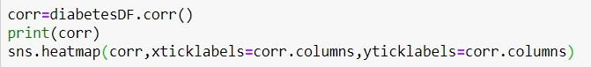
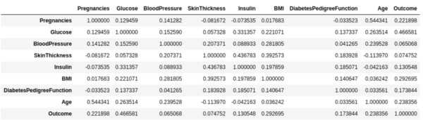
Output of features and correlation
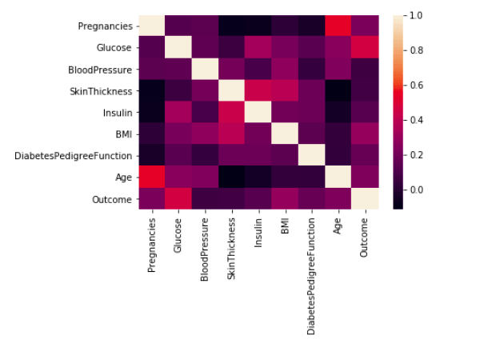
In above heatmap, brighter colors indicate more correlation and it is clear from above that glucose levels, age, BMI and number of pregnancies have significant correlation with outcome.

The next step is data cleaning. We will start by finding missing or null data points using pandas .isnull() function.
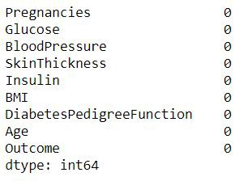
From fig it is clear that null data points don’t exist
Now look for zeroes in dataset, if found then we will remove those rows.
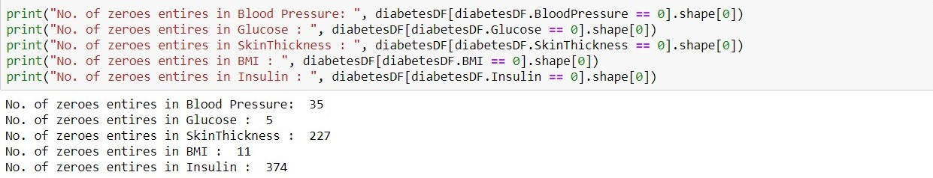

We will remove the rows which the “BloodPressure”, “BMI” and “Glucose” are zero.

3.3 Feature Engineering

Feature engineering creates more input features from the existing features and also combines several features to produce more intuitive features to feed the model.
In the data set, features are - ‘Pregnancies’, ‘Glucose’, ‘Blood Pressure’, ‘Skin Thickness’, ‘Insulin’, ‘BMI’, ‘Diabetes Pedigree Function’, ‘Age’
By a crude observation, we can say that the ‘Skin Thickness’ is not an indicator of diabetes. But we can’t deny the fact that it is unusable at this point.
Therefore we will use all the features available. We separate the data set into features and the response that we are going to predict. We will assign the features to the X variable and the response(outcome) to the y variable.

3.4 Modal Selection, Normalization, Training and Evaluating Model
In this step we select the model which performs best for the data set at hand. First, we will be calculating the “Classification Accuracy (Testing Accuracy)” of a given set of classification models with their default parameters to determine which model performs better with the diabetes data set.
We will initialize the classifier models with their default parameters and add them to a model list.
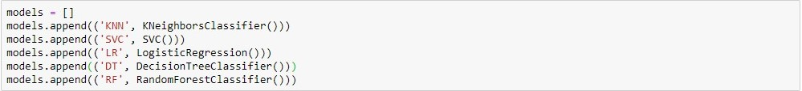
Now we will split out dataset in training and test set. It can be implemented in:-
1)Train/Test Split
2)K-Fold Cross-Validation
Train/Test Split
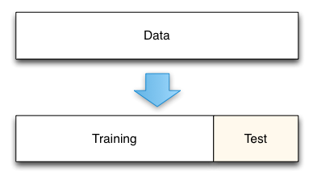
Normalization: Now we will normalize our training and test data set to change the values of numeric in data set to common scale, without distorting differences in the range of values.
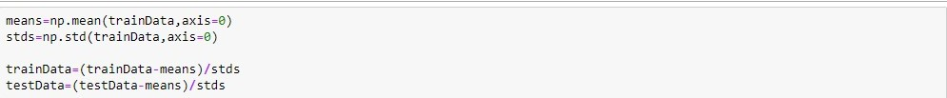
Then we fit each model in a loop and calculate the accuracy of the respective model using the “accuracy_score”.
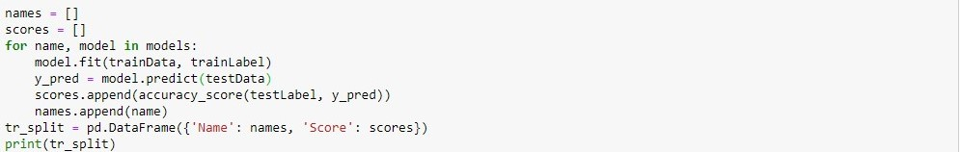

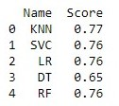
Fig — Train/Test Split Accuracy Scores

K-Fold Cross-Validation
This method splits the data set into K equal partitions (“folds”), then use 1 fold as the testing set and the union of the other folds as the training set. Then the model is tested for accuracy. The process will follow the above steps K times, using different folds as the testing set each time. The average testing accuracy of the process is the testing accuracy.
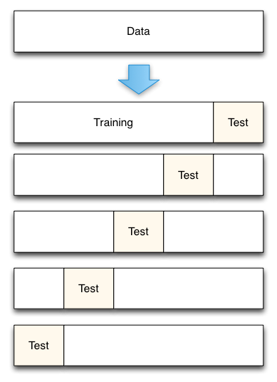
Fig— 5-Fold cross validation process

K-Fold Cross Validation with Scikit Learn :
We will move forward with K-Fold cross validation as it is more accurate and use the data efficiently. We will train the models using 10 fold cross validation and calculate the mean accuracy of the models. “cross_val_score” provides its own training and accuracy calculation interface.
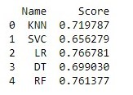
Fig — K-Fold Cross Validation Accuracy Scores
We can plot the accuracy scores using seaborn
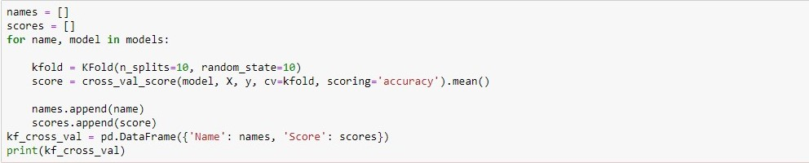

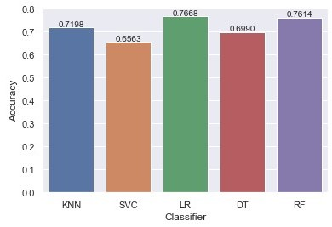
Fig — Accuracy of Classifiers
We can see the Logistic Regression, Gaussian Naive Bayes, Random Forest and Gradient Boosting have performed better than the rest. From the base level we can observe that the Logistic Regression performs better than the other algorithms.
At the baseline Logistic Regression managed to achieve a classification accuracy of 76.68 %.

3.5 Saving the Model And Testing Our Model
As we saw that Logistic Regression model is more accurate so we will save it for future using joblib.

Now let us check whether our model is predicting correctly or not.
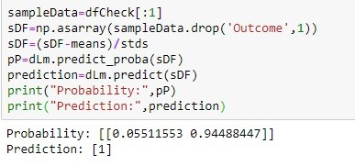 The prediction comes out to be true.
.

- Conclusion
Diabetes is a heterogeneous group of diseases. It’s characterized by chronic elevation of glucose in the blood. To support the lives of the people all over the world, we are trying to detect and prevent the complications of diabetes at the early stage through predictive analysis by improving the classification techniques. My proposed work also performs the analysis of the features in the dataset and selects the optimal features based on the correlation values. Using Logistic Regression model which gives an accuracy of 76.68%.

