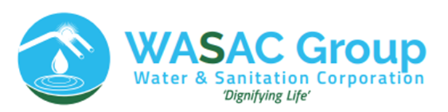

**Names:** Benjamin NDEKEZI

**ID:** 23556

**Web Tech Final Project**

**Name Of The Project:** AquaCare Report Hub

The Wassac Pipes Care Report Hub project is a comprehensive solution designed to address issues related to damaged or blocked water pipes, with a primary focus on preventing water misuse. The purpose of this initiative is to streamline the process of reporting and repairing damaged pipes while fostering citizen engagement in water conservation efforts.

**Key Features:**

**User-Friendly Interface:** The project features a user-friendly website where citizens can easily report damaged or blocked water pipes. The interface is designed to be intuitive, allowing users to upload pictures of the problematic pipes.

**Photo Submission:** Citizens are encouraged to take pictures of the pipes that require repair and submit them through the website. This visual information assists the authorities in assessing the severity of the issue before dispatching a repair team.

**Online Reporting System:** The project includes an online reporting system that allows citizens to submit details about the location, nature of the problem, and any other relevant information regarding the damaged pipes.

**Automated Email Notifications:** Upon receiving a report, the admin system generates automated email notifications to inform the citizens about the status of their request. This includes an estimated time for when the repair team will address the issue.

**Efficient Scheduling:** The system enables efficient scheduling of repair teams based on the severity and urgency of reported issues. This helps in prioritizing critical cases and minimizing water wastage.

**Water Conservation Awareness:** The project aims to raise awareness about water conservation by actively involving citizens in the repair process. Regular updates and communication through the platform emphasize the importance of responsible water usage.

**Problems Addressed:**

**Water Misuse:** By promptly addressing and repairing damaged pipes, the project aims to reduce instances of water misuse, promoting responsible water consumption in the community.

**Delayed Repairs:** The system addresses the problem of delayed repairs by streamlining the reporting process and providing a transparent communication channel between citizens and the water utility authorities.

**Lack of Citizen Engagement:** Wassac Pipes Care Report Hub encourages citizens to actively participate in the maintenance of water infrastructure, fostering a sense of responsibility and community involvement.

**To use the Wassac Pipes Care Report Hub, follow these steps:**

**Account Creation:**

**Go to the Wassac Pipes Care Report Hub website**.

Click on the **"Sign Up"** or "Create Account" option.

Fill in the required information, including your full name, phone number, email address, and a secure password.

**Choose the account type as "User."**

**Login:**

After creating your account, return to the website's main page.

Click on the "Login" option.

Enter your registered email address and password.

Click "Login" to access your account.

**Report an Issue:**

Once logged in, navigate to the "Report an Issue" section.

Provide details about the location of the damaged or blocked water pipe.

Use the option to upload pictures of the issue if available.

Include any additional information that might be helpful for the repair team.

**Submit the Report:**

Review the information you provided to ensure accuracy.

Click on the "Submit" or "Report" button to send the report to the system.

Communication with Repair Team:

If needed, you can use the communication features on the platform to interact with the repair team or receive any further instructions.

**Registration Form:**  
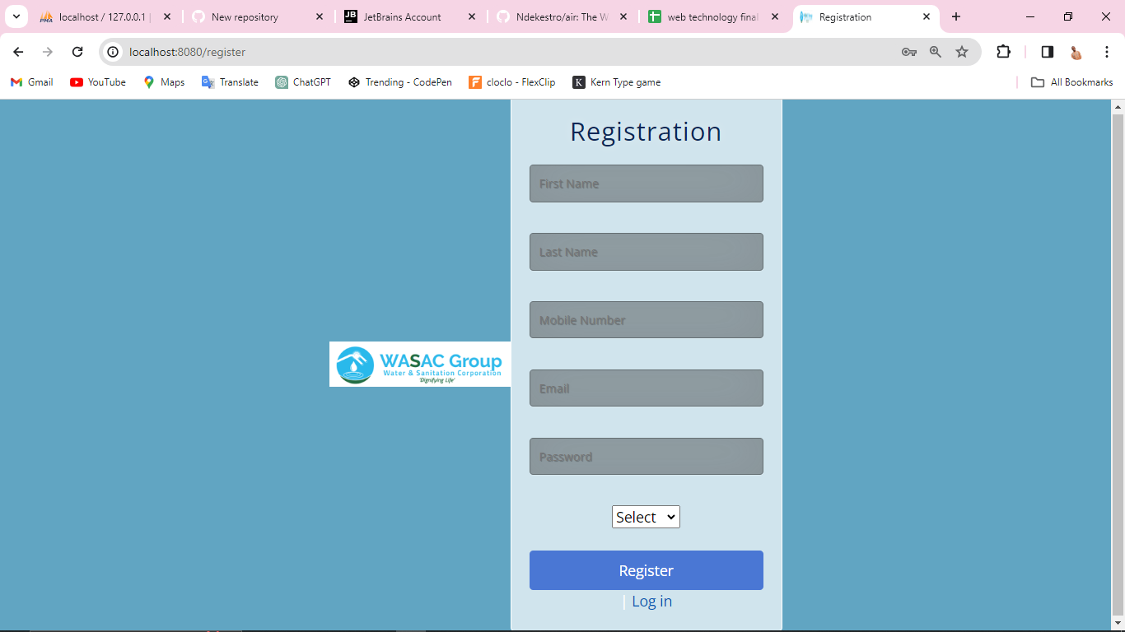

**User DashBoard:**

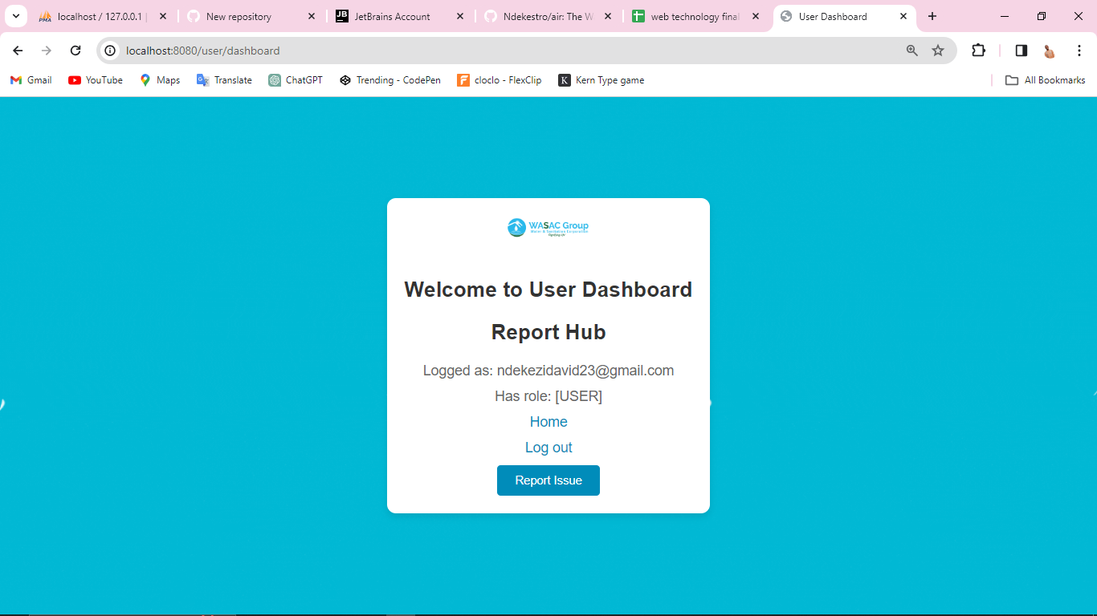

**Report Form:**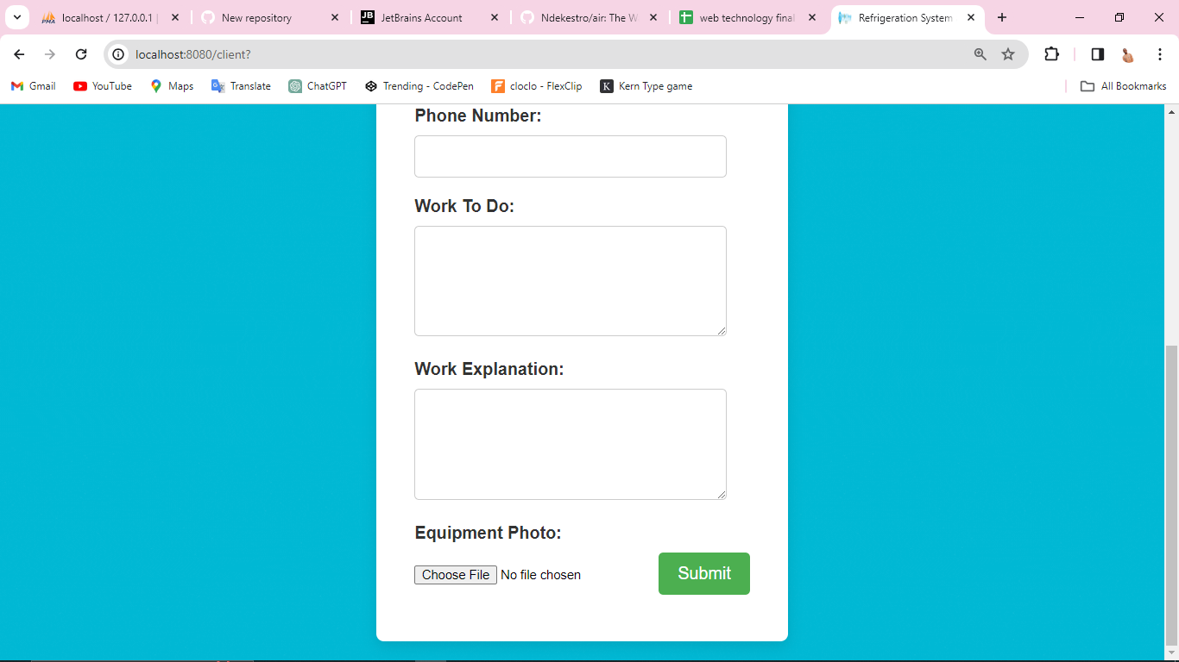

**Login page:**

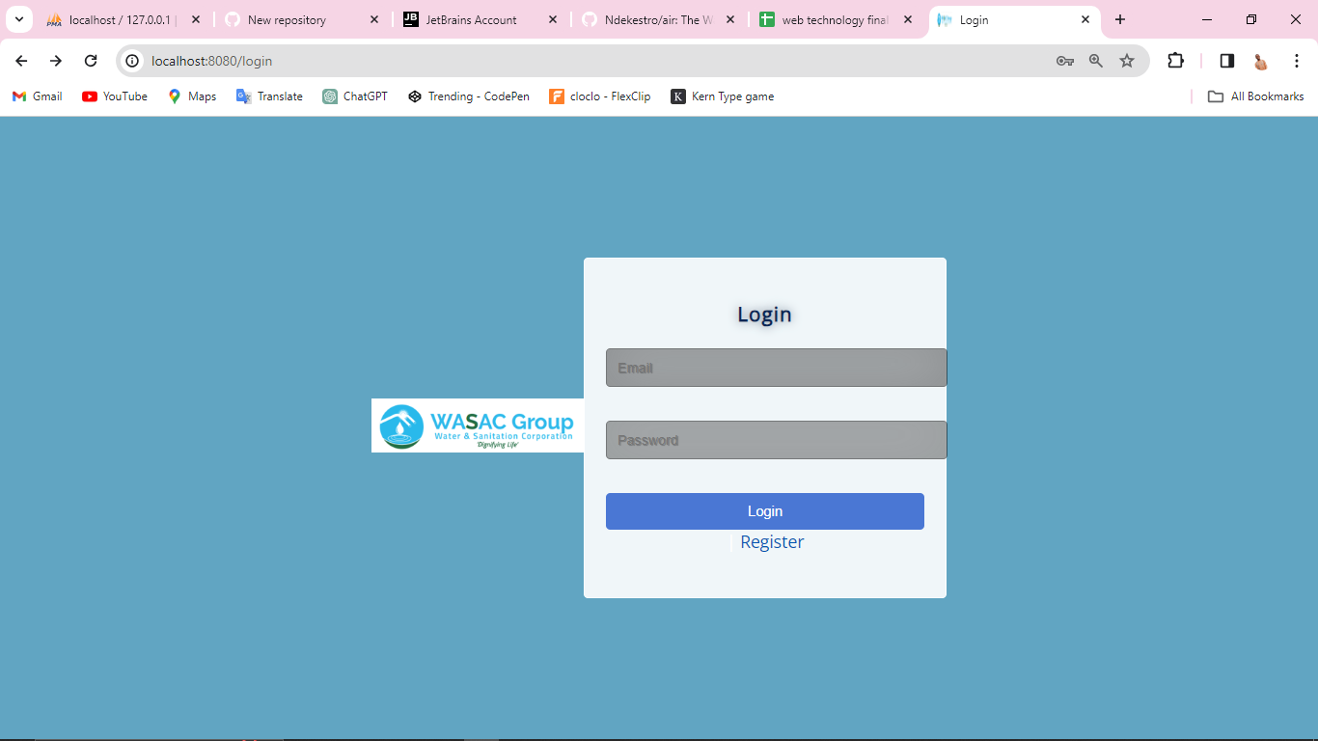

**Admin Dashboard:**

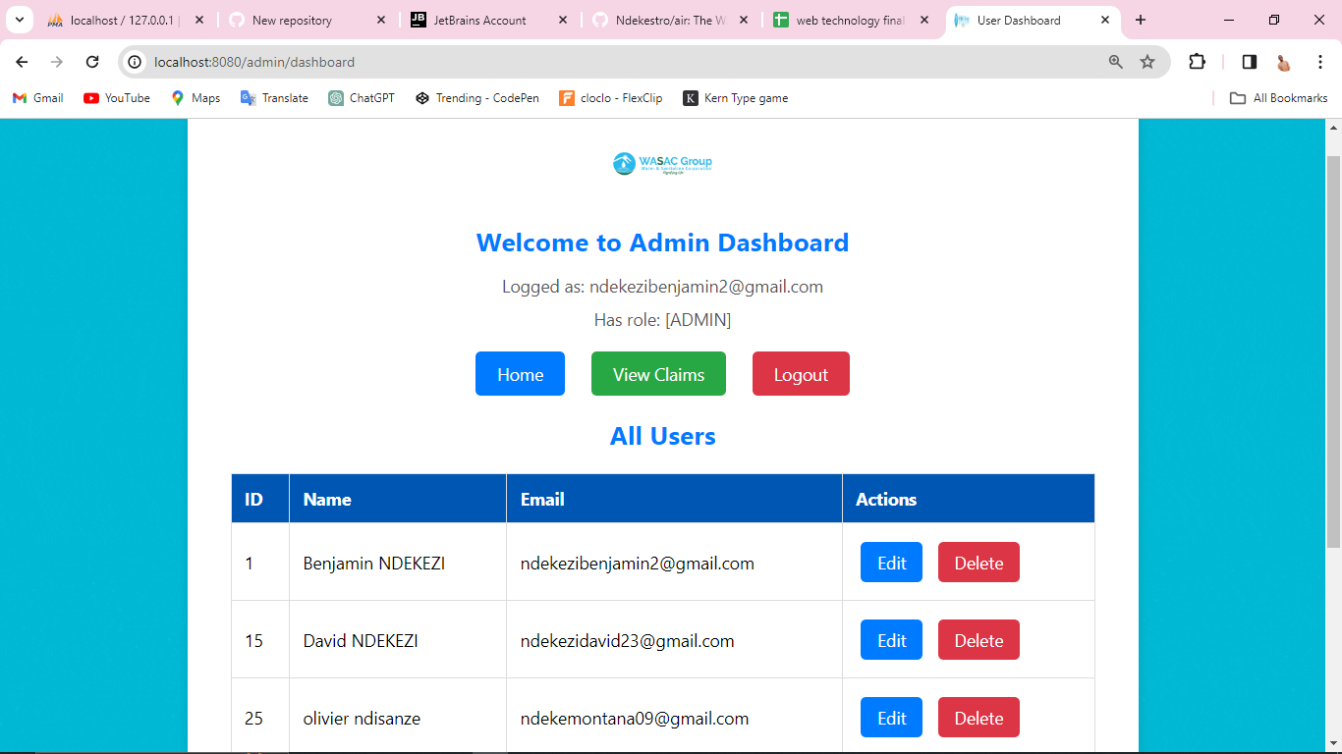 **Claims Form: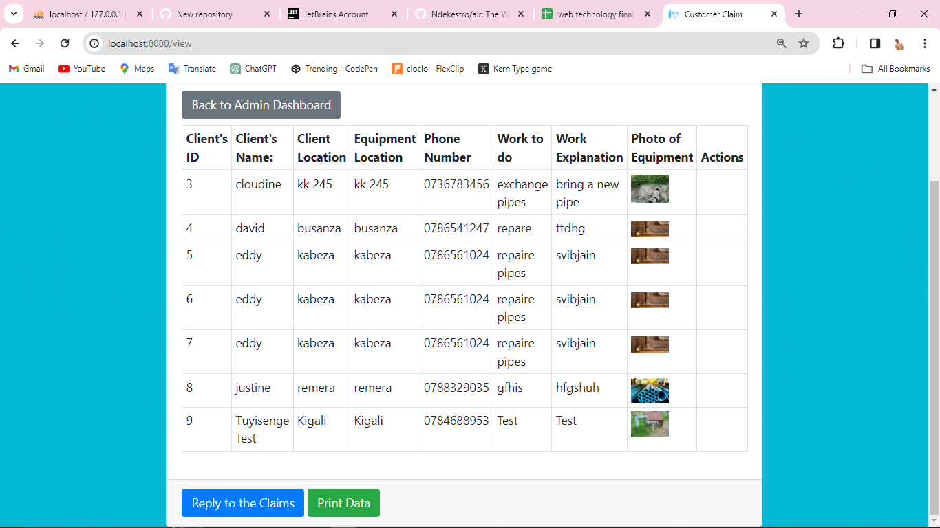 Claims Reply Form:**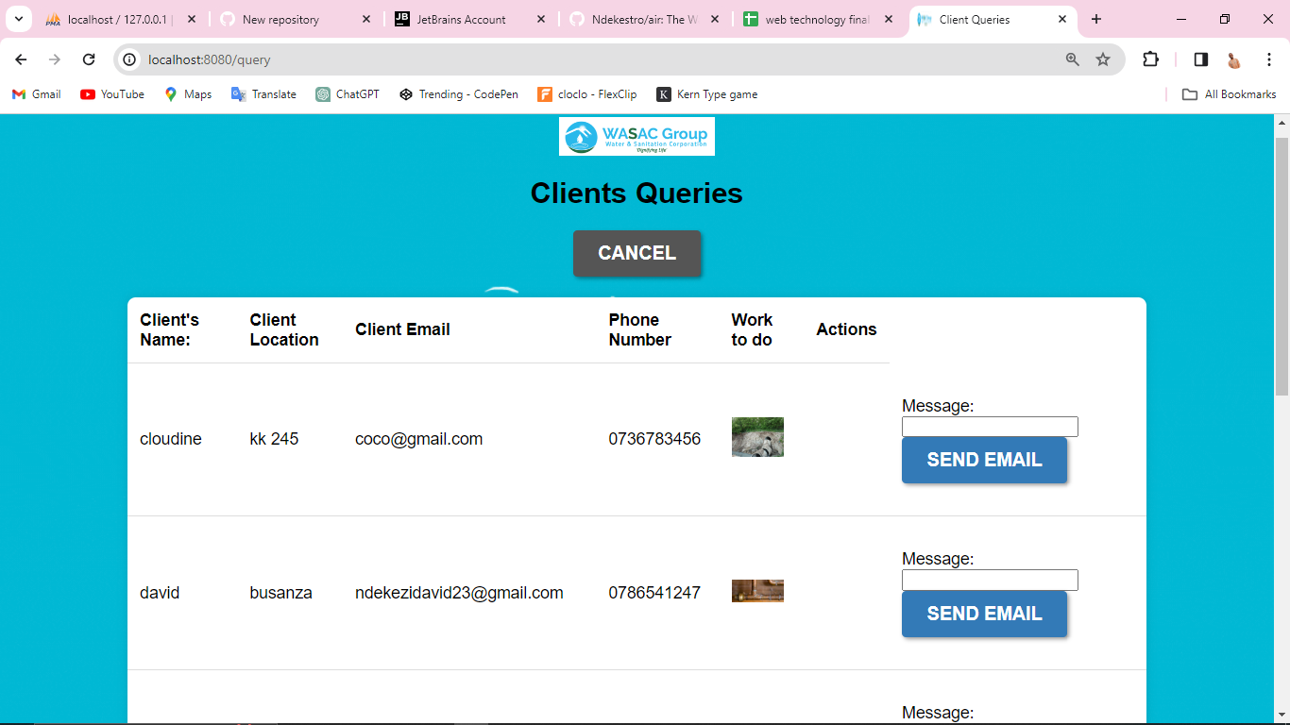

**In summary, the Wassac Pipes Care Report Hub project utilizes technology to create an efficient, transparent, and engaging platform for citizens to report and address issues related to damaged water pipes, ultimately contributing to water conservation efforts and minimizing water wastage.**