**Conceptual Schema (Version 4)  
Based on: Analysis Version 2**

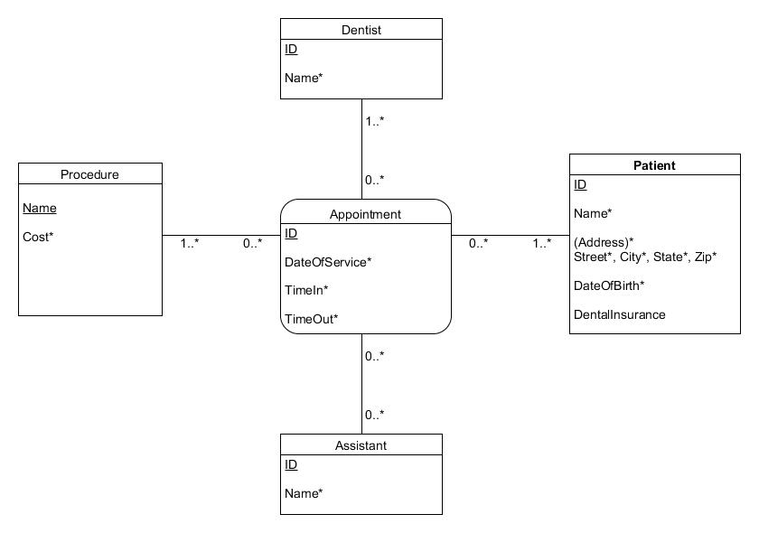

**Dentist:** Dentists of the dental office will be represented by the Dentist entity.

**Assistant:** The dental assistants of the dental office will be represented by the Assistant entity.

**Procedure:** The various procedures that the dental office offers will be represented by the Procedure entity. Cost will be used to calculate the monthly bill for each patient.

**Patient:** Patients of the dental office will be represented by the Patient entity. DentalInsurance will be used to check if the patient is insured or not for billing purposes.

**Appointment:** This associative identity representing a quarternary relationship acts as an “appointment” between a dentist and a patient where a procedure is being done and an assistant may be involved in. ID is used as an ID attribute because no combination of DateOfService, TimeIn, and TimeOut can guarantee uniqueness.