EnrollmentServiceTest

CountByClassIdTests
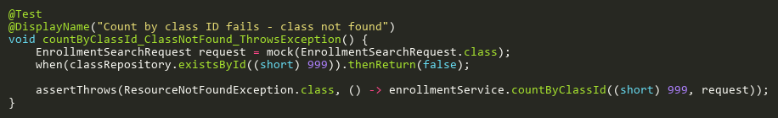
Figure: countByClassId_ClassNotFound_ThrowsException
Reference: Sheet "ES_countByClassId", Test Case TC03

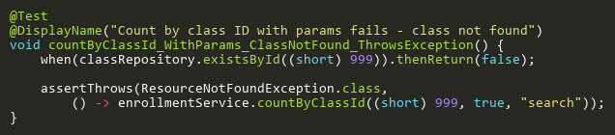
Figure: countByClassId_WithParams_ClassNotFound_ThrowsException
Reference: Sheet "ES_countByClassId", Test Case TC04

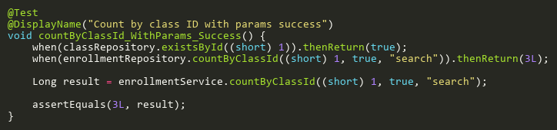
Figure: countByClassId_WithParams_Success
Reference: Sheet "ES_countByClassId", Test Case TC02

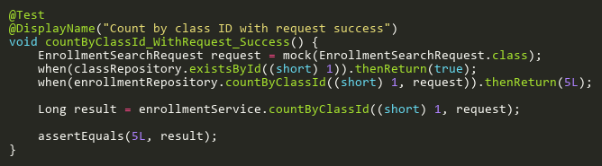
Figure: countByClassId_WithRequest_Success
Reference: Sheet "ES_countByClassId", Test Case TC01

CreateTests
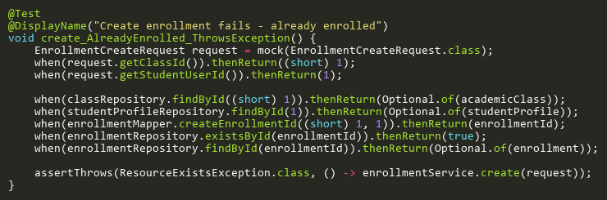
Figure: create_AlreadyEnrolled_ThrowsException
Reference: Sheet "ES_create", Test Case TC08

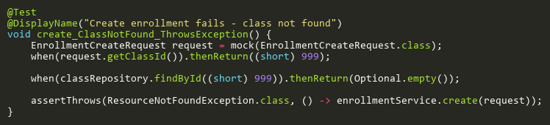
Figure: create_ClassNotFound_ThrowsException
Reference: Sheet "ES_create", Test Case TC02

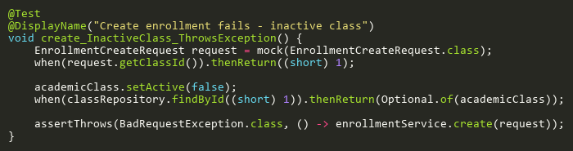
Figure: create_InactiveClass_ThrowsException
Reference: Sheet "ES_create", Test Case TC03

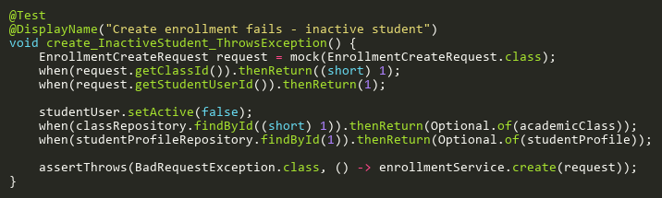
Figure: create_InactiveStudent_ThrowsException
Reference: Sheet "ES_create", Test Case TC05

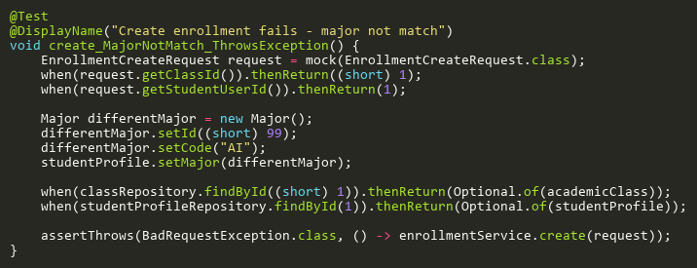
Figure: create_MajorNotMatch_ThrowsException
Reference: Sheet "ES_create", Test Case TC06

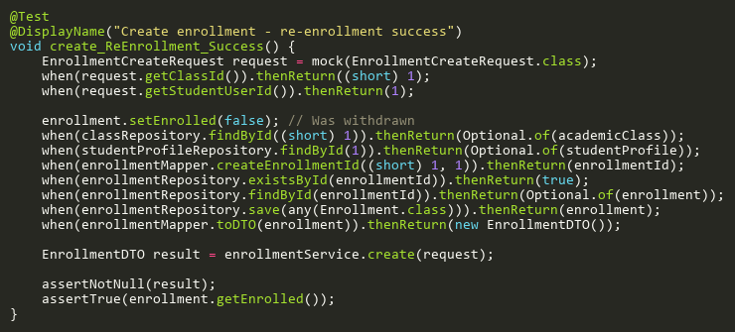
Figure: create_ReEnrollment_Success
Reference: Sheet "ES_create", Test Case TC09

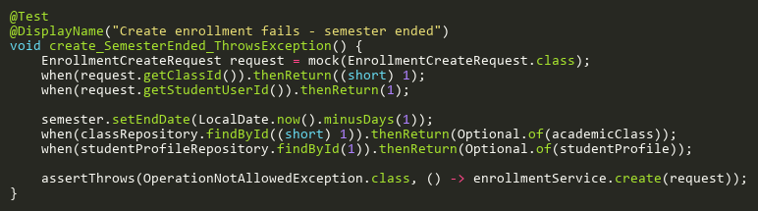
Figure: create_SemesterEnded_ThrowsException
Reference: Sheet "ES_create", Test Case TC07

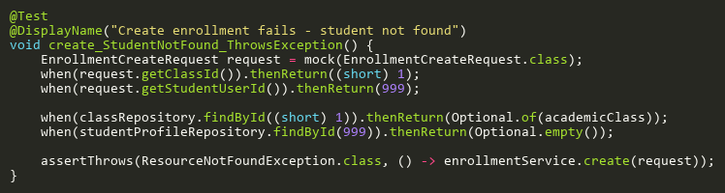
Figure: create_StudentNotFound_ThrowsException
Reference: Sheet "ES_create", Test Case TC04

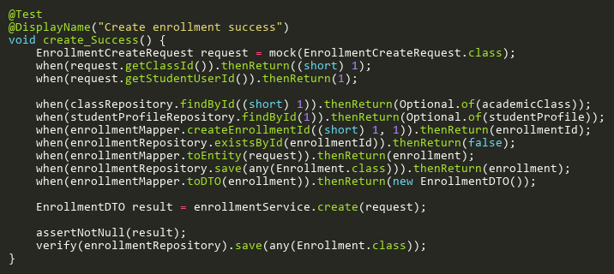
Figure: create_Success
Reference: Sheet "ES_create", Test Case TC01

DeleteTests
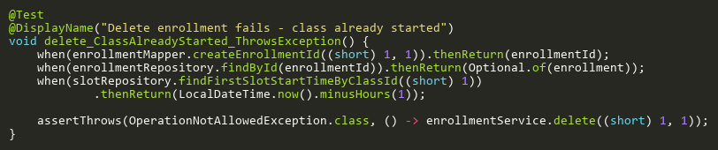
Figure: delete_ClassAlreadyStarted_ThrowsException
Reference: Sheet "ES_delete", Test Case TC04

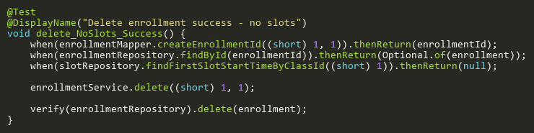
Figure: delete_NoSlots_Success
Reference: Sheet "ES_delete", Test Case TC01

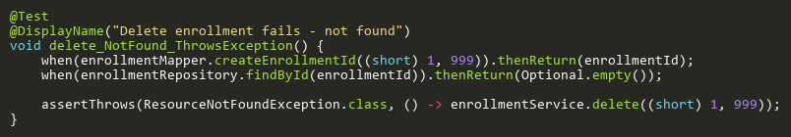
Figure: delete_NotFound_ThrowsException
Reference: Sheet "ES_delete", Test Case TC03

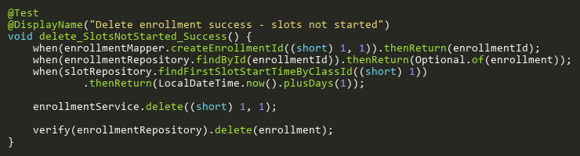
Figure: delete_SlotsNotStarted_Success
Reference: Sheet "ES_delete", Test Case TC02

FindByClassIdTests
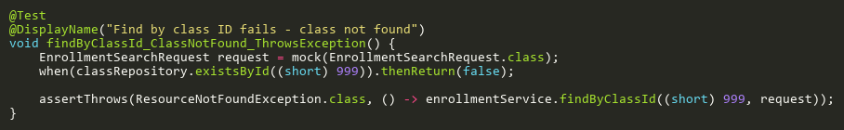
Figure: findByClassId_ClassNotFound_ThrowsException
Reference: Sheet "ES_findByClassId", Test Case TC02

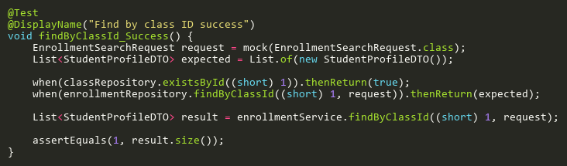
Figure: findByClassId_Success
Reference: Sheet "ES_findByClassId", Test Case TC01

UpdateTests
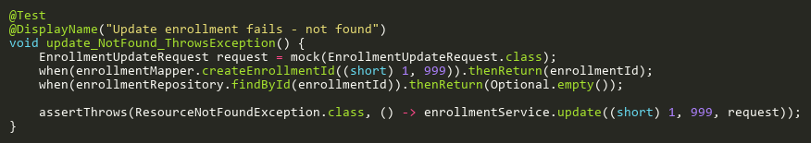
Figure: update_NotFound_ThrowsException
Reference: Sheet "ES_update", Test Case TC02

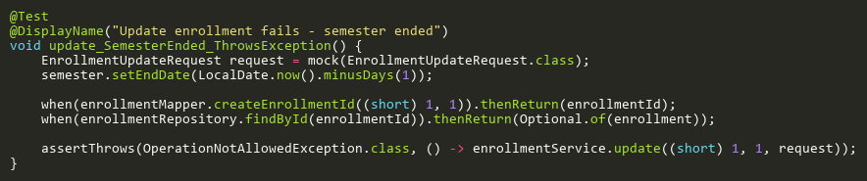
Figure: update_SemesterEnded_ThrowsException
Reference: Sheet "ES_update", Test Case TC03

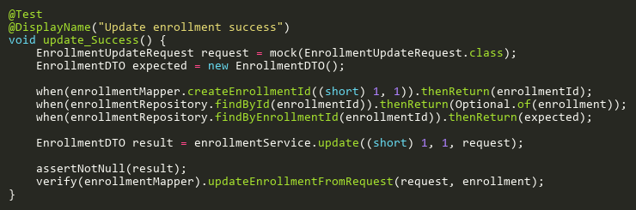
Figure: update_Success
Reference: Sheet "ES_update", Test Case TC01

