EvidenceStorageServiceTest

DeleteEvidenceTests
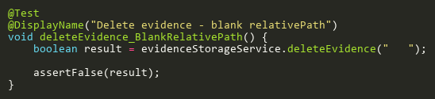
Figure: deleteEvidence_BlankRelativePath
Reference: Sheet "ESST_deleteEvidence", Test Case TC03

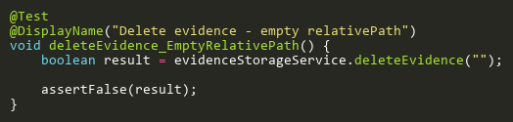
Figure: deleteEvidence_EmptyRelativePath
Reference: Sheet "ESST_deleteEvidence", Test Case TC05

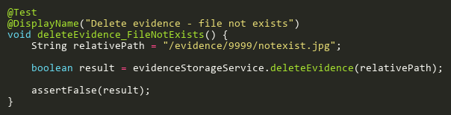
Figure: deleteEvidence_FileNotExists
Reference: Sheet "ESST_deleteEvidence", Test Case TC04

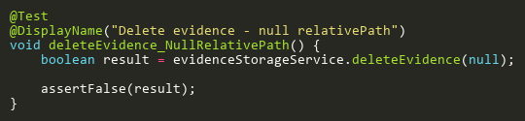
Figure: deleteEvidence_NullRelativePath
Reference: Sheet "ESST_deleteEvidence", Test Case TC02

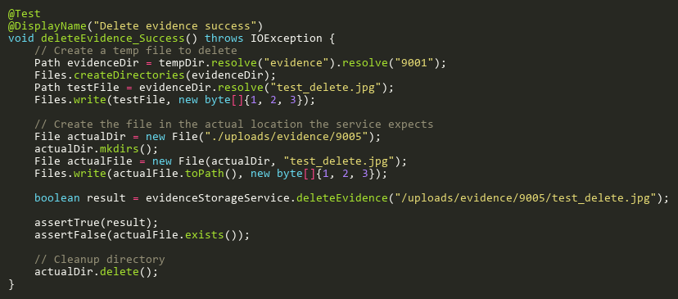
Figure: deleteEvidence_Success
Reference: Sheet "ESST_deleteEvidence", Test Case TC01

DownloadAndSaveEvidenceTests
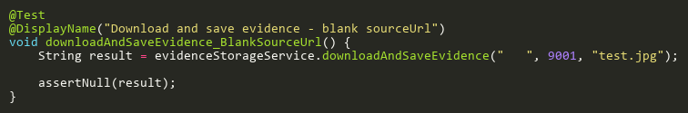
Figure: downloadAndSaveEvidence_BlankSourceUrl
Reference: Sheet "ESST_downloadAndSave", Test Case TC03

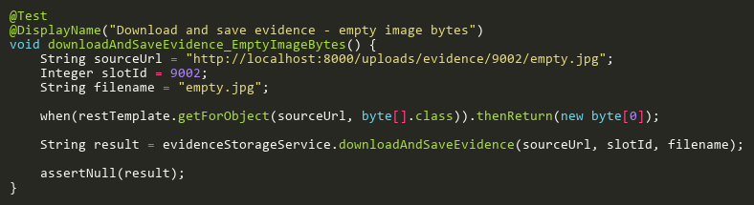
Figure: downloadAndSaveEvidence_EmptyImageBytes
Reference: Sheet "ESST_downloadAndSave", Test Case TC04

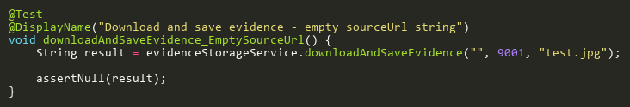
Figure: downloadAndSaveEvidence_EmptySourceUrl
Reference: Sheet "ESST_downloadAndSave", Test Case TC07

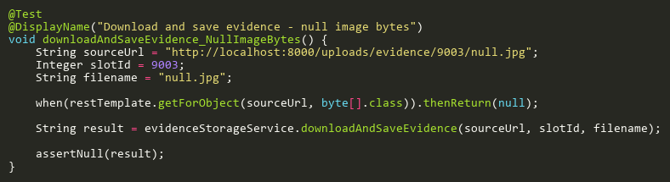
Figure: downloadAndSaveEvidence_NullImageBytes
Reference: Sheet "ESST_downloadAndSave", Test Case TC05

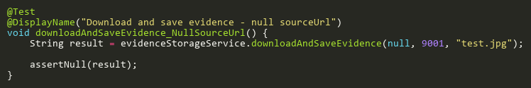
Figure: downloadAndSaveEvidence_NullSourceUrl
Reference: Sheet "ESST_downloadAndSave", Test Case TC02

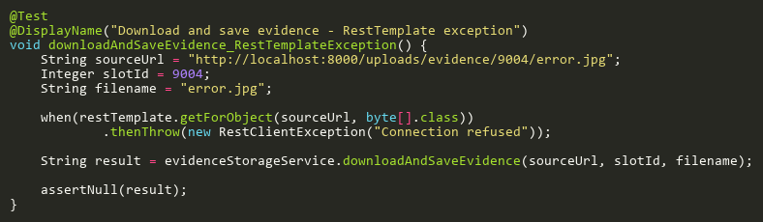
Figure: downloadAndSaveEvidence_RestTemplateException
Reference: Sheet "ESST_downloadAndSave", Test Case TC06

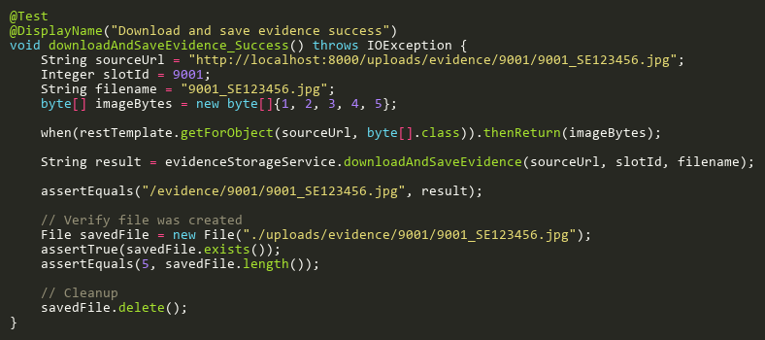
Figure: downloadAndSaveEvidence_Success
Reference: Sheet "ESST_downloadAndSave", Test Case TC01

ExtractFilenameFromUrlTests
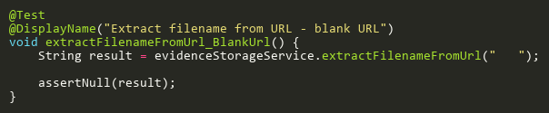
Figure: extractFilenameFromUrl_BlankUrl
Reference: Sheet "ESST_extractFilename", Test Case TC03

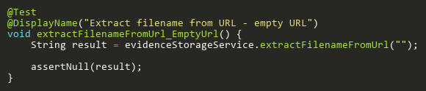
Figure: extractFilenameFromUrl_EmptyUrl
Reference: Sheet "ESST_extractFilename", Test Case TC07

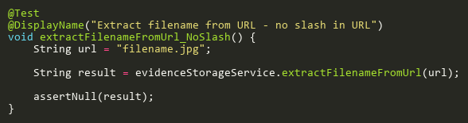
Figure: extractFilenameFromUrl_NoSlash
Reference: Sheet "ESST_extractFilename", Test Case TC05

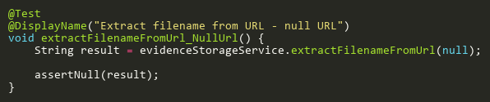
Figure: extractFilenameFromUrl_NullUrl
Reference: Sheet "ESST_extractFilename", Test Case TC02

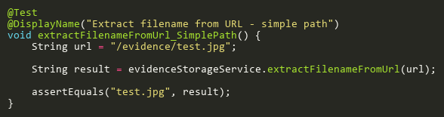
Figure: extractFilenameFromUrl_SimplePath
Reference: Sheet "ESST_extractFilename", Test Case TC06

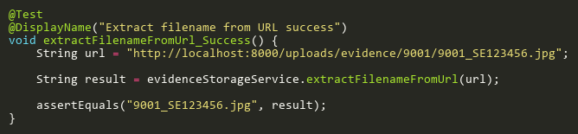
Figure: extractFilenameFromUrl_Success
Reference: Sheet "ESST_extractFilename", Test Case TC01

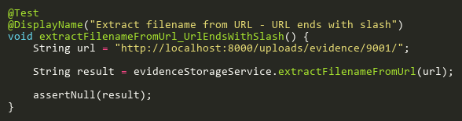
Figure: extractFilenameFromUrl_UrlEndsWithSlash
Reference: Sheet "ESST_extractFilename", Test Case TC04

