ExamAttendanceReportServiceTest

GetExamAttendanceReportForUserTests
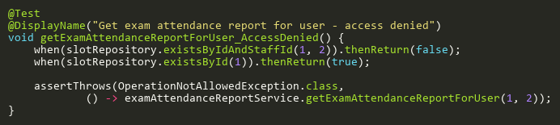
Figure: getExamAttendanceReportForUser_AccessDenied
Reference: Sheet "EARST_getReportForUser", Test Case TC07

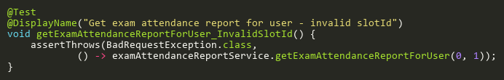
Figure: getExamAttendanceReportForUser_InvalidSlotId
Reference: Sheet "EARST_getReportForUser", Test Case TC03

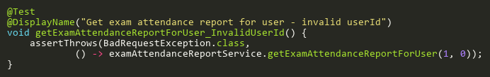
Figure: getExamAttendanceReportForUser_InvalidUserId
Reference: Sheet "EARST_getReportForUser", Test Case TC05

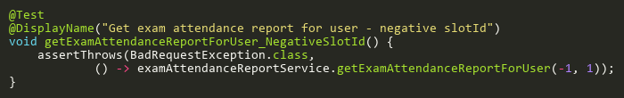
Figure: getExamAttendanceReportForUser_NegativeSlotId
Reference: Sheet "EARST_getReportForUser", Test Case TC08

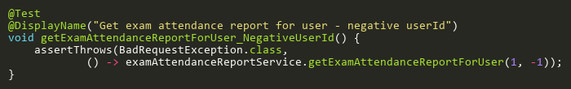
Figure: getExamAttendanceReportForUser_NegativeUserId
Reference: Sheet "EARST_getReportForUser", Test Case TC09

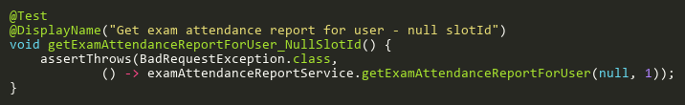
Figure: getExamAttendanceReportForUser_NullSlotId
Reference: Sheet "EARST_getReportForUser", Test Case TC02

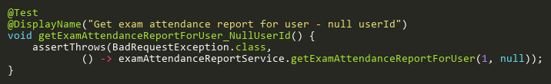
Figure: getExamAttendanceReportForUser_NullUserId
Reference: Sheet "EARST_getReportForUser", Test Case TC04

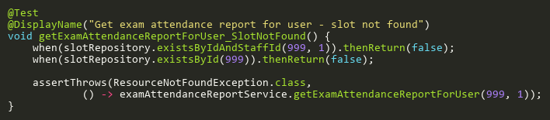
Figure: getExamAttendanceReportForUser_SlotNotFound
Reference: Sheet "EARST_getReportForUser", Test Case TC06

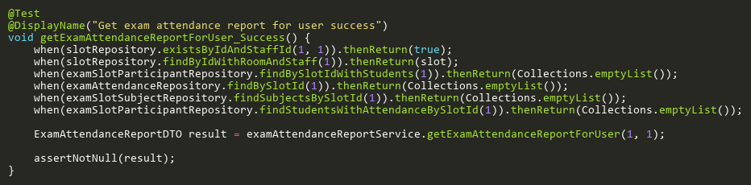
Figure: getExamAttendanceReportForUser_Success
Reference: Sheet "EARST_getReportForUser", Test Case TC01

