ExamAttendanceServiceTest

ApplyRescanReviewFlagsTests
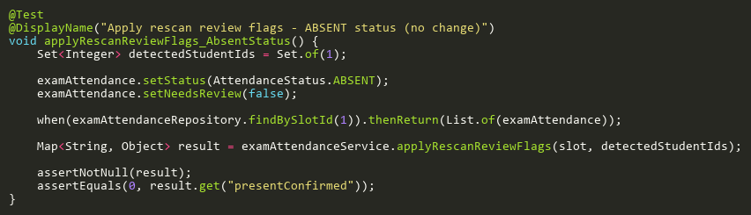
Figure: applyRescanReviewFlags_AbsentStatus
Reference: Sheet "EAST_applyRescanFlags", Test Case TC05

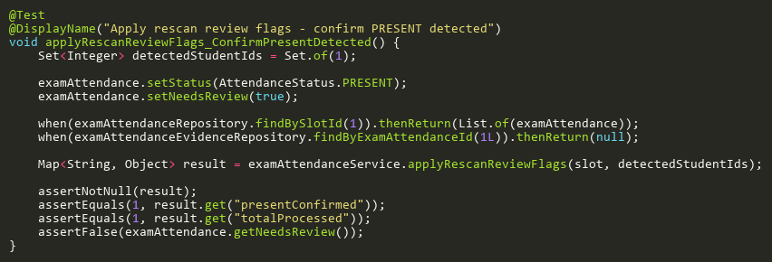
Figure: applyRescanReviewFlags_ConfirmPresentDetected
Reference: Sheet "EAST_applyRescanFlags", Test Case TC01

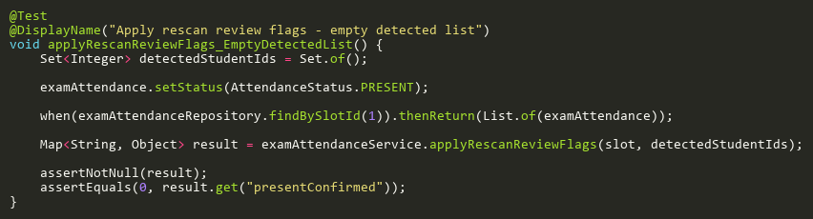
Figure: applyRescanReviewFlags_EmptyDetectedList
Reference: Sheet "EAST_applyRescanFlags", Test Case TC03

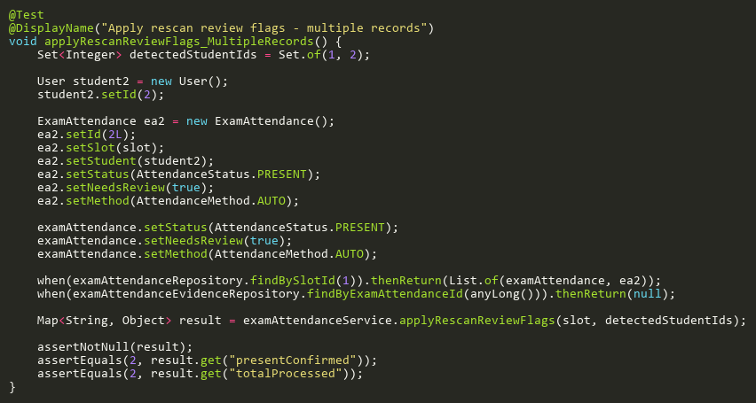
Figure: applyRescanReviewFlags_MultipleRecords
Reference: Sheet "EAST_applyRescanFlags", Test Case TC07

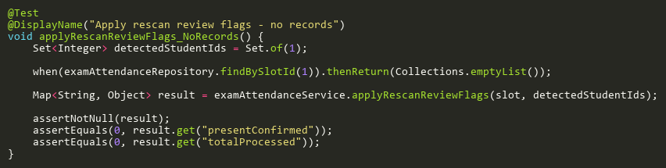
Figure: applyRescanReviewFlags_NoRecords
Reference: Sheet "EAST_applyRescanFlags", Test Case TC04

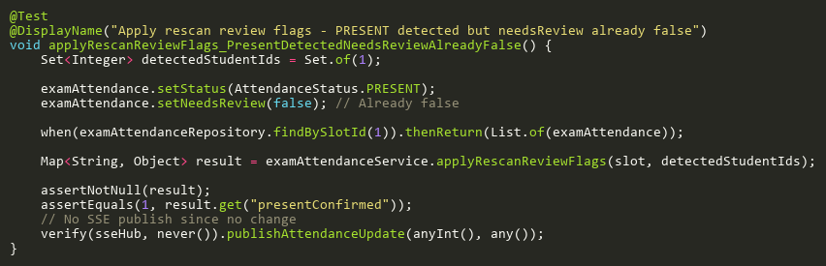
Figure: applyRescanReviewFlags_PresentDetectedNeedsReviewAlreadyFalse
Reference: Sheet "EAST_applyRescanFlags", Test Case TC06

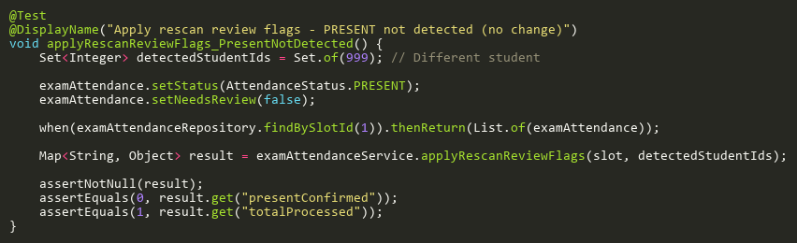
Figure: applyRescanReviewFlags_PresentNotDetected
Reference: Sheet "EAST_applyRescanFlags", Test Case TC02

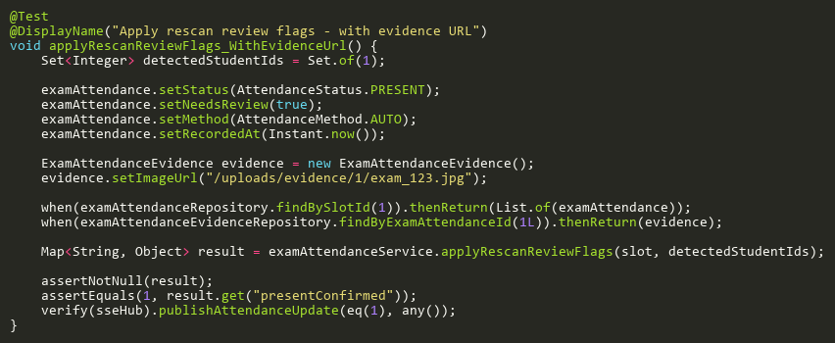
Figure: applyRescanReviewFlags_WithEvidenceUrl
Reference: Sheet "EAST_applyRescanFlags", Test Case TC08

FindByIdTests
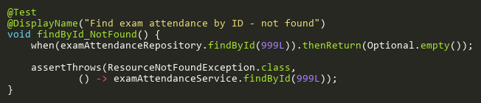
Figure: findById_NotFound
Reference: Sheet "EAST_findById", Test Case TC02

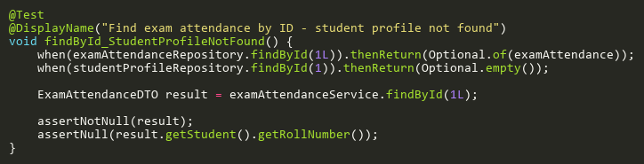
Figure: findById_StudentProfileNotFound
Reference: Sheet "EAST_findById", Test Case TC03

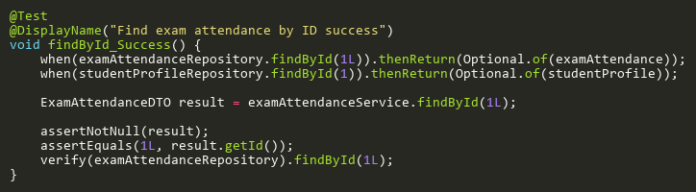
Figure: findById_Success
Reference: Sheet "EAST_findById", Test Case TC01

ProcessRecognitionResultsTests
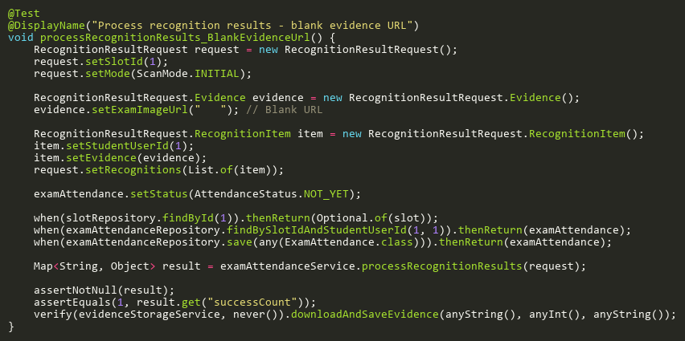
Figure: processRecognitionResults_BlankEvidenceUrl
Reference: Sheet "EAST_processRecognition", Test Case TC14

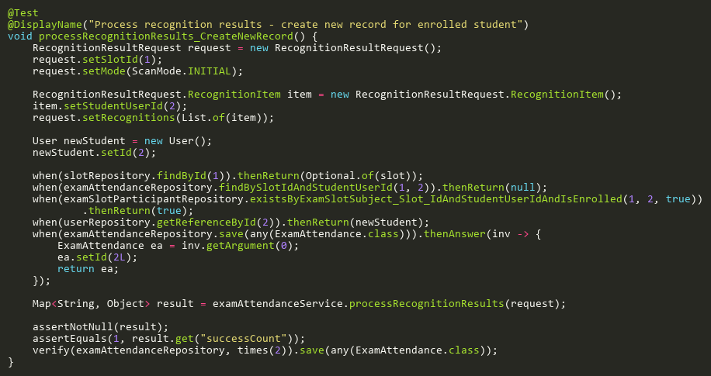
Figure: processRecognitionResults_CreateNewRecord
Reference: Sheet "EAST_processRecognition", Test Case TC05

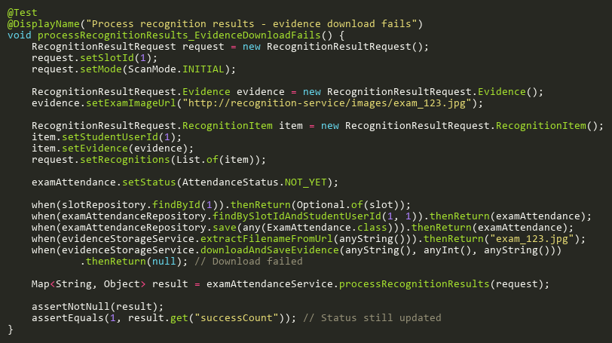
Figure: processRecognitionResults_EvidenceDownloadFails
Reference: Sheet "EAST_processRecognition", Test Case TC10

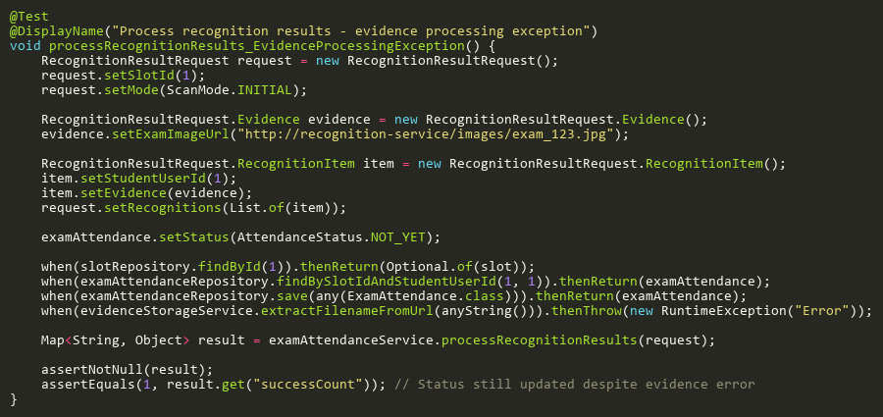
Figure: processRecognitionResults_EvidenceProcessingException
Reference: Sheet "EAST_processRecognition", Test Case TC13

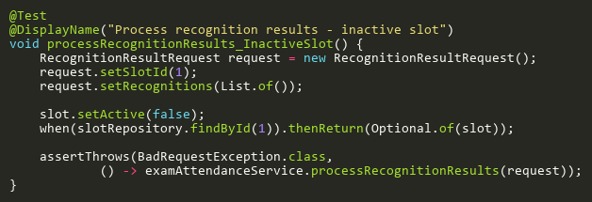
Figure: processRecognitionResults_InactiveSlot
Reference: Sheet "EAST_processRecognition", Test Case TC03

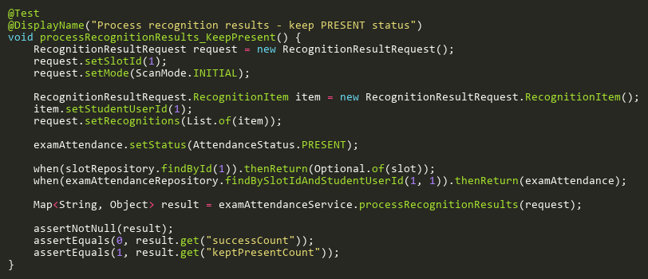
Figure: processRecognitionResults_KeepPresent
Reference: Sheet "EAST_processRecognition", Test Case TC07

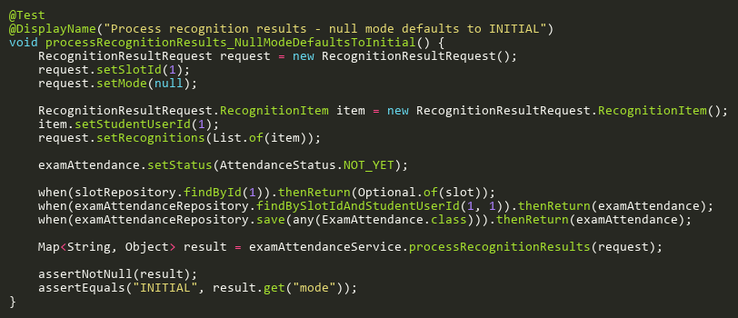
Figure: processRecognitionResults_NullModeDefaultsToInitial
Reference: Sheet "EAST_processRecognition", Test Case TC12

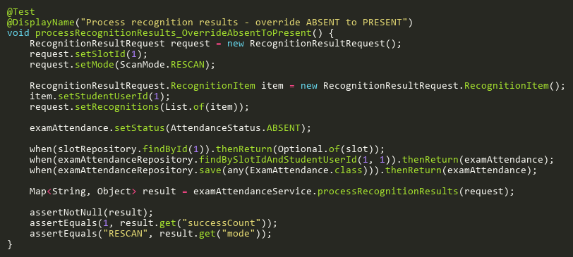
Figure: processRecognitionResults_OverrideAbsentToPresent
Reference: Sheet "EAST_processRecognition", Test Case TC06

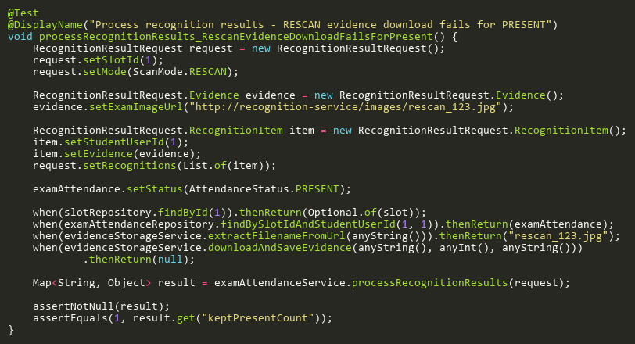
Figure: processRecognitionResults_RescanEvidenceDownloadFailsForPresent
Reference: Sheet "EAST_processRecognition", Test Case TC16

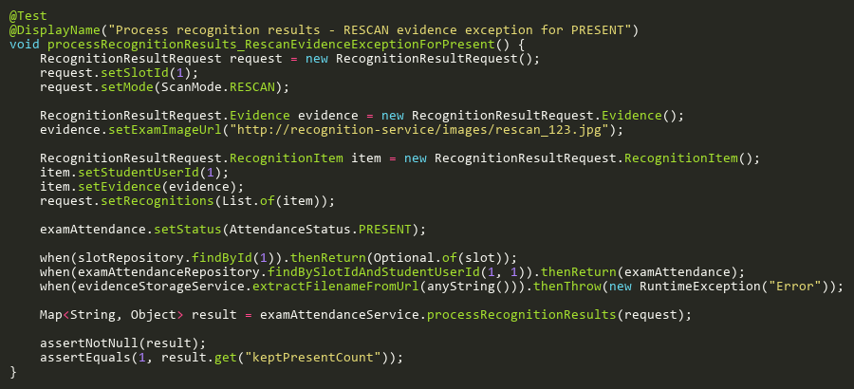
Figure: processRecognitionResults_RescanEvidenceExceptionForPresent
Reference: Sheet "EAST_processRecognition", Test Case TC15

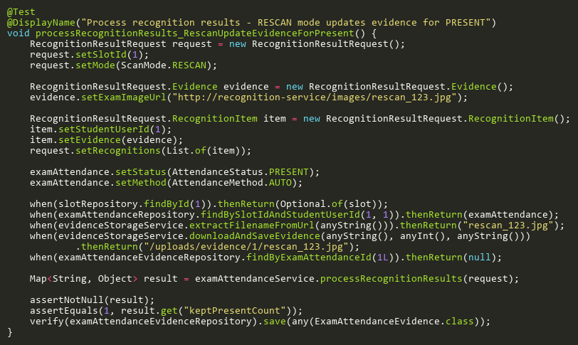
Figure: processRecognitionResults_RescanUpdateEvidenceForPresent
Reference: Sheet "EAST_processRecognition", Test Case TC11

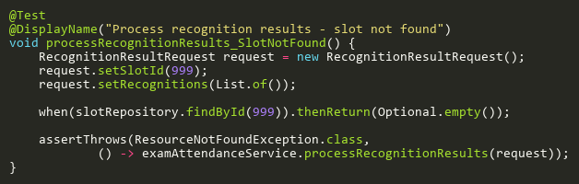
Figure: processRecognitionResults_SlotNotFound
Reference: Sheet "EAST_processRecognition", Test Case TC02

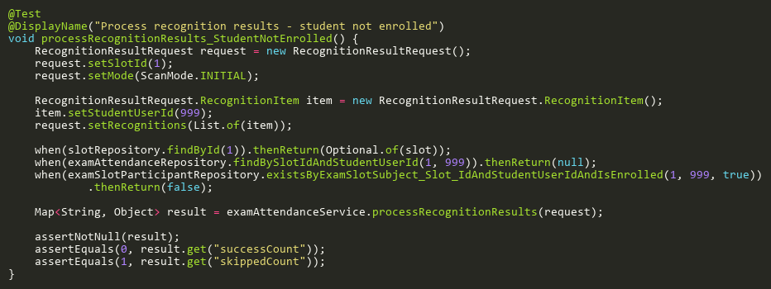
Figure: processRecognitionResults_StudentNotEnrolled
Reference: Sheet "EAST_processRecognition", Test Case TC04

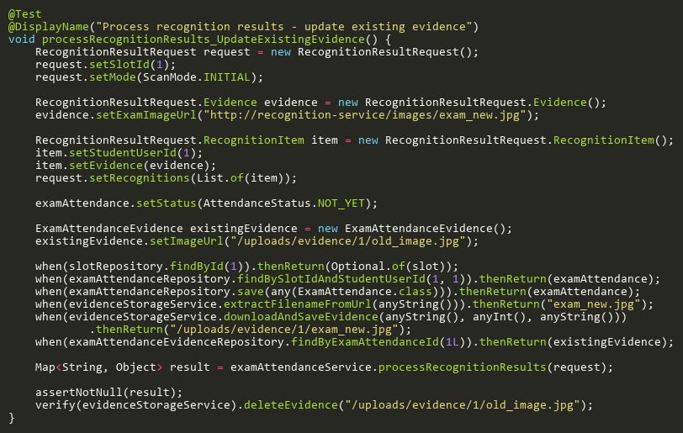
Figure: processRecognitionResults_UpdateExistingEvidence
Reference: Sheet "EAST_processRecognition", Test Case TC09

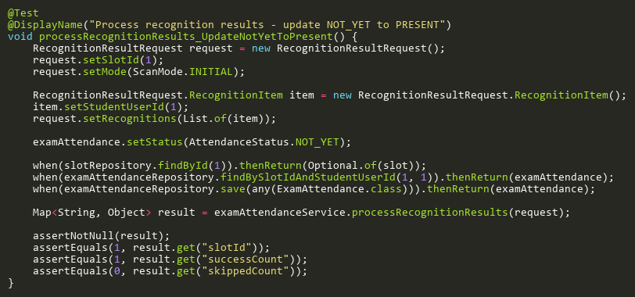
Figure: processRecognitionResults_UpdateNotYetToPresent
Reference: Sheet "EAST_processRecognition", Test Case TC01

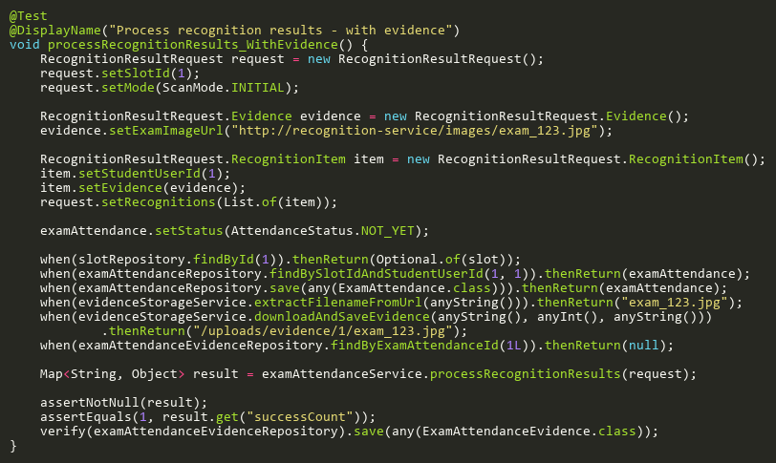
Figure: processRecognitionResults_WithEvidence
Reference: Sheet "EAST_processRecognition", Test Case TC08

UpdateStatusTests
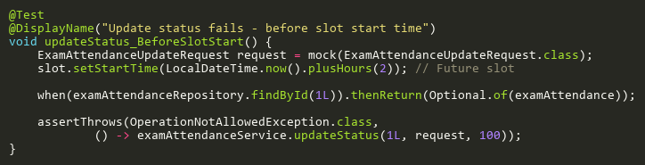
Figure: updateStatus_BeforeSlotStart
Reference: Sheet "EAST_updateStatus", Test Case TC05

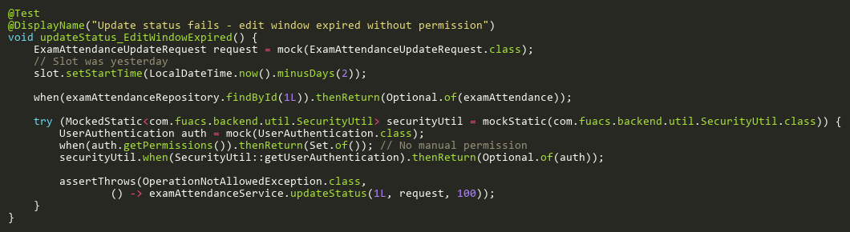
Figure: updateStatus_EditWindowExpired
Reference: Sheet "EAST_updateStatus", Test Case TC06

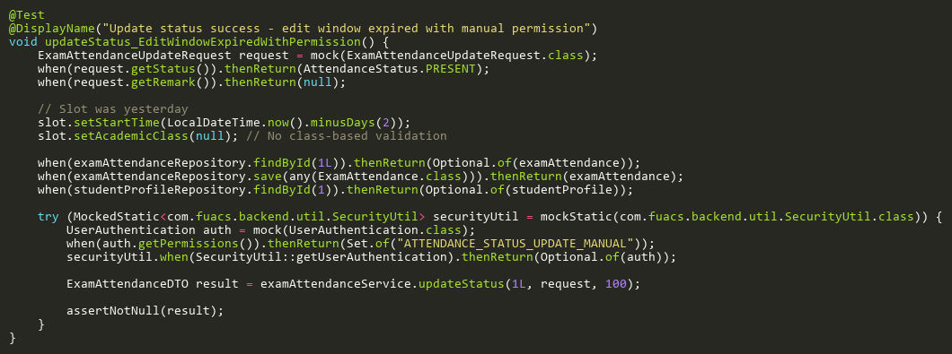
Figure: updateStatus_EditWindowExpiredWithPermission
Reference: Sheet "EAST_updateStatus", Test Case TC07

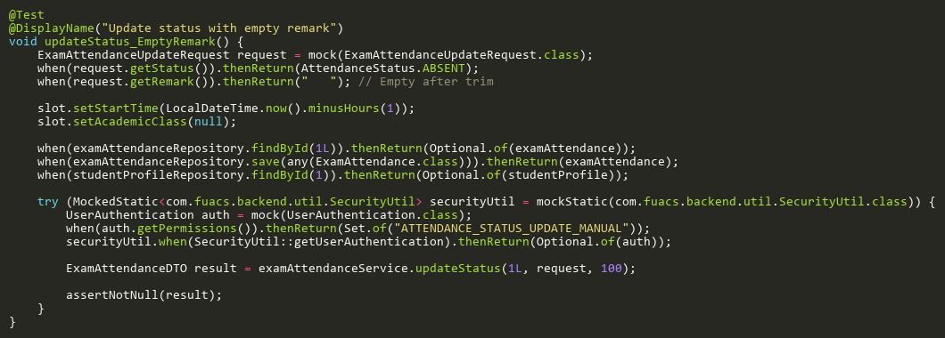
Figure: updateStatus_EmptyRemark
Reference: Sheet "EAST_updateStatus", Test Case TC10

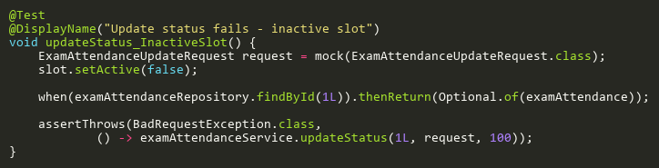
Figure: updateStatus_InactiveSlot
Reference: Sheet "EAST_updateStatus", Test Case TC03

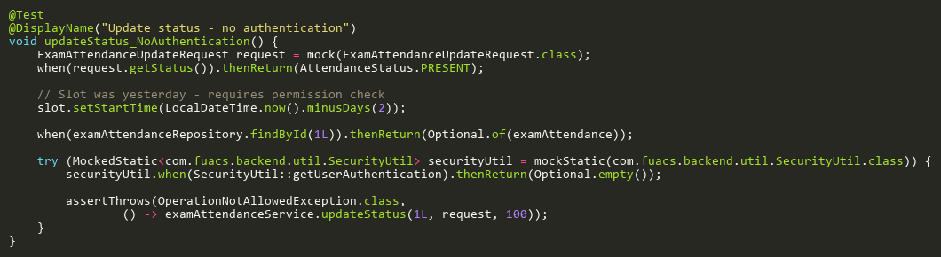
Figure: updateStatus_NoAuthentication
Reference: Sheet "EAST_updateStatus", Test Case TC11

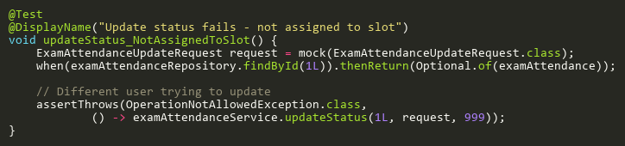
Figure: updateStatus_NotAssignedToSlot
Reference: Sheet "EAST_updateStatus", Test Case TC04

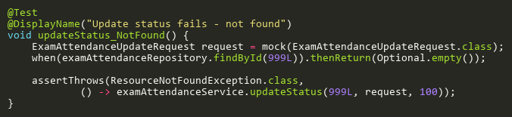
Figure: updateStatus_NotFound
Reference: Sheet "EAST_updateStatus", Test Case TC02

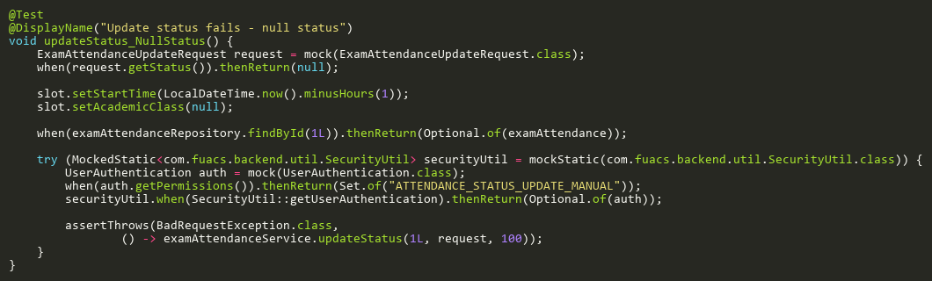
Figure: updateStatus_NullStatus
Reference: Sheet "EAST_updateStatus", Test Case TC09

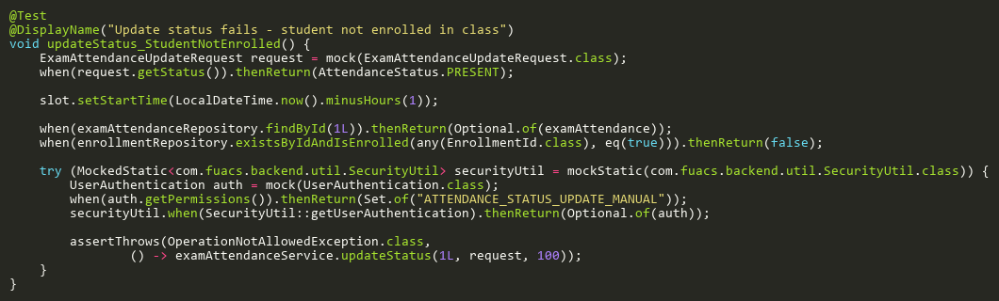
Figure: updateStatus_StudentNotEnrolled
Reference: Sheet "EAST_updateStatus", Test Case TC08

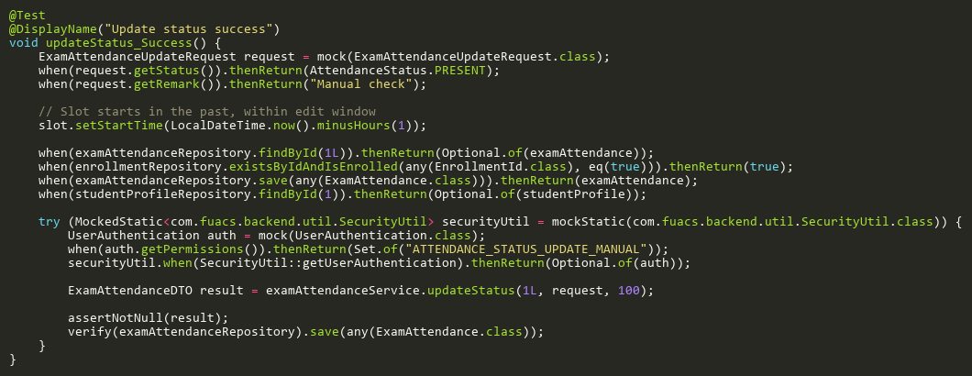
Figure: updateStatus_Success
Reference: Sheet "EAST_updateStatus", Test Case TC01

