ExamSlotServiceTest

AddParticipantTests
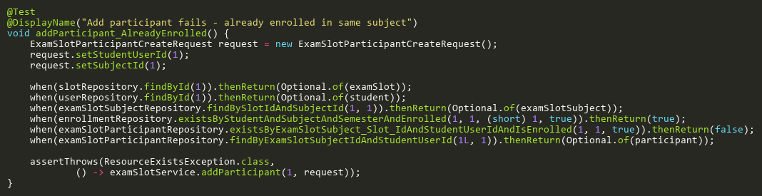
Figure: addParticipant_AlreadyEnrolled
Reference: Sheet "EXSS_addParticipant", Test Case TC12

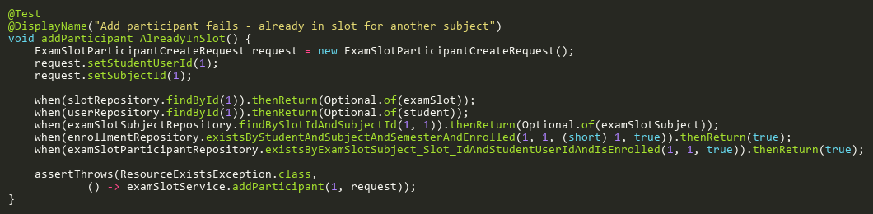
Figure: addParticipant_AlreadyInSlot
Reference: Sheet "EXSS_addParticipant", Test Case TC11

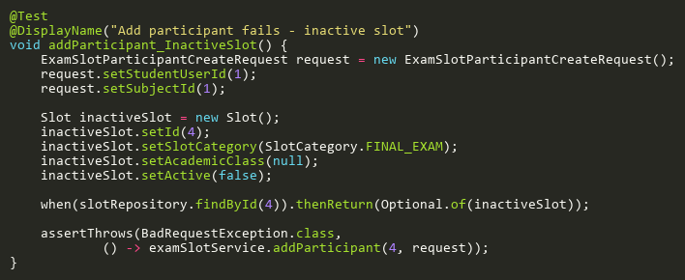
Figure: addParticipant_InactiveSlot
Reference: Sheet "EXSS_addParticipant", Test Case TC04

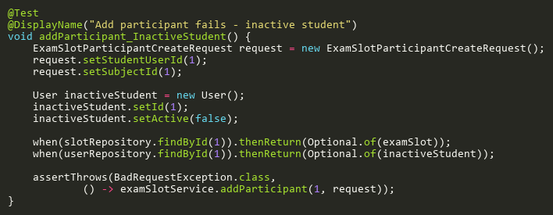
Figure: addParticipant_InactiveStudent
Reference: Sheet "EXSS_addParticipant", Test Case TC07

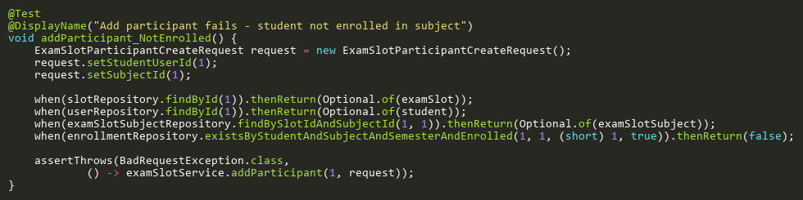
Figure: addParticipant_NotEnrolled
Reference: Sheet "EXSS_addParticipant", Test Case TC10

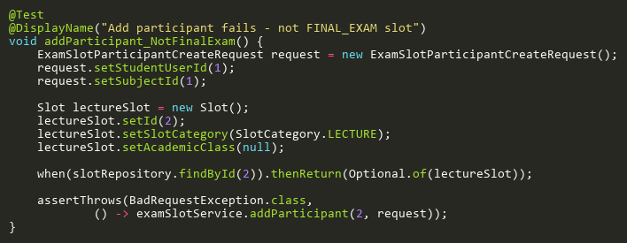
Figure: addParticipant_NotFinalExam
Reference: Sheet "EXSS_addParticipant", Test Case TC03

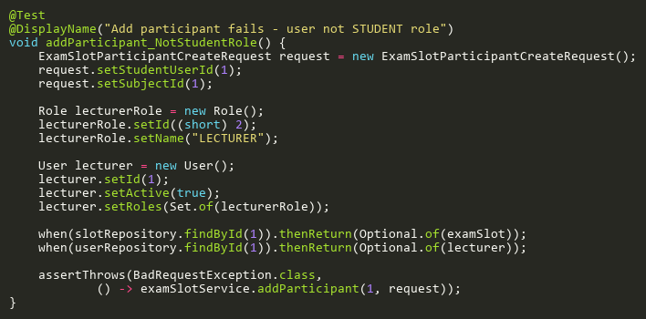
Figure: addParticipant_NotStudentRole
Reference: Sheet "EXSS_addParticipant", Test Case TC08

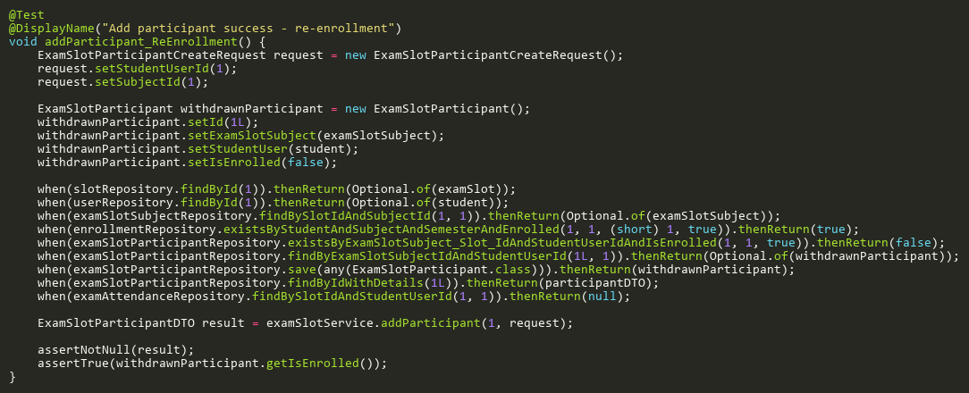
Figure: addParticipant_ReEnrollment
Reference: Sheet "EXSS_addParticipant", Test Case TC13

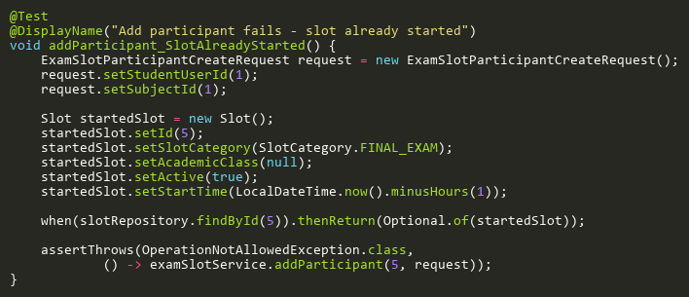
Figure: addParticipant_SlotAlreadyStarted
Reference: Sheet "EXSS_addParticipant", Test Case TC05

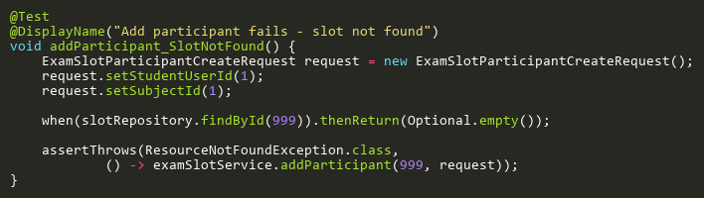
Figure: addParticipant_SlotNotFound
Reference: Sheet "EXSS_addParticipant", Test Case TC02

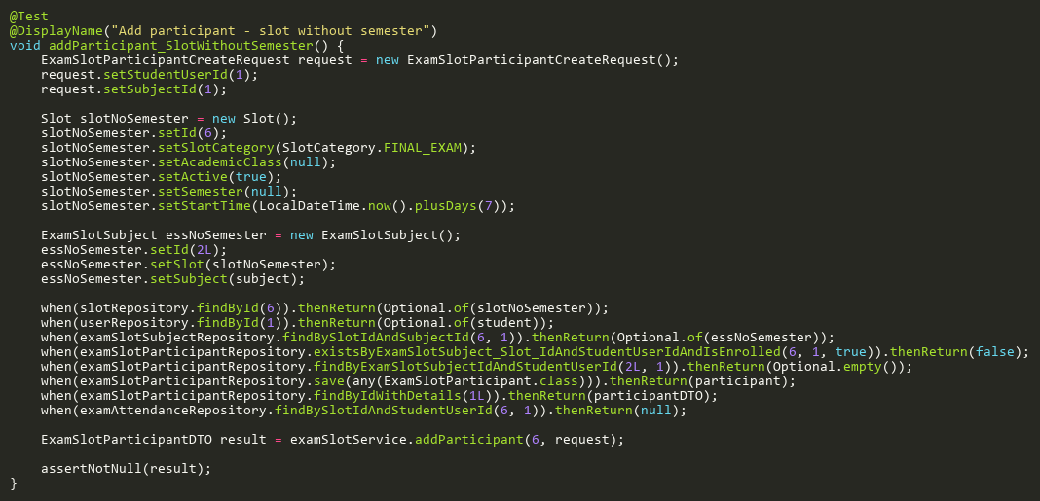
Figure: addParticipant_SlotWithoutSemester
Reference: Sheet "EXSS_addParticipant", Test Case TC14

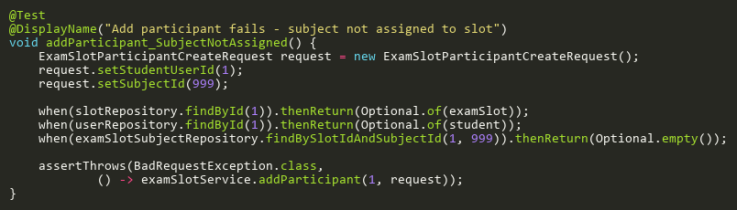
Figure: addParticipant_SubjectNotAssigned
Reference: Sheet "EXSS_addParticipant", Test Case TC09

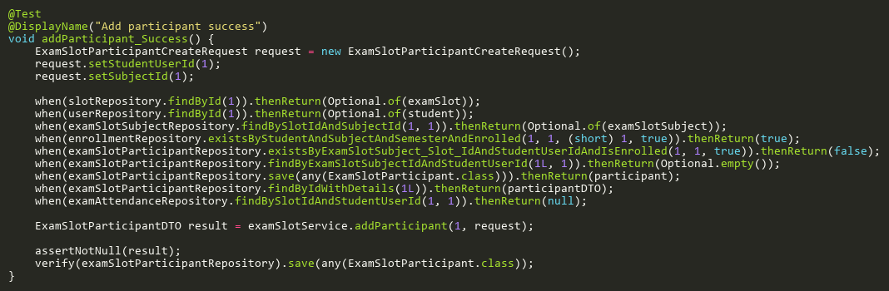
Figure: addParticipant_Success
Reference: Sheet "EXSS_addParticipant", Test Case TC01

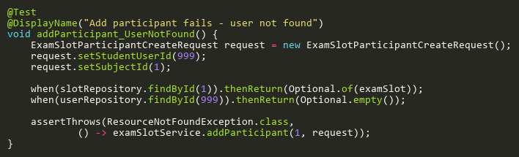
Figure: addParticipant_UserNotFound
Reference: Sheet "EXSS_addParticipant", Test Case TC06

AssignSubjectsToSlotTests
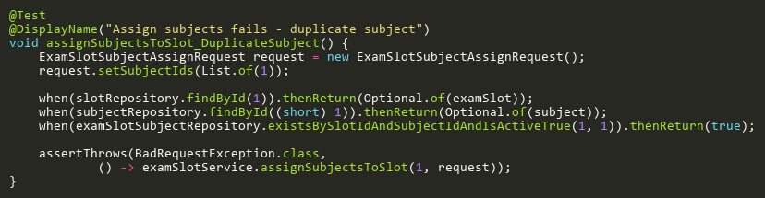
Figure: assignSubjectsToSlot_DuplicateSubject
Reference: Sheet "EXSS_assignSubjects", Test Case TC08

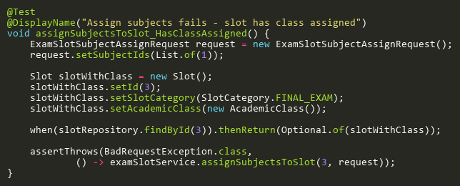
Figure: assignSubjectsToSlot_HasClassAssigned
Reference: Sheet "EXSS_assignSubjects", Test Case TC04

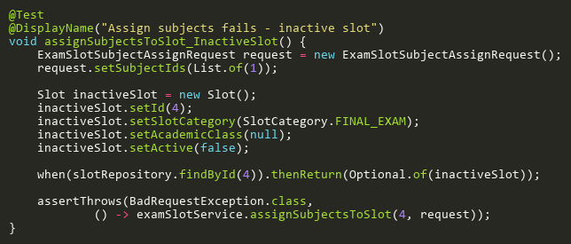
Figure: assignSubjectsToSlot_InactiveSlot
Reference: Sheet "EXSS_assignSubjects", Test Case TC05

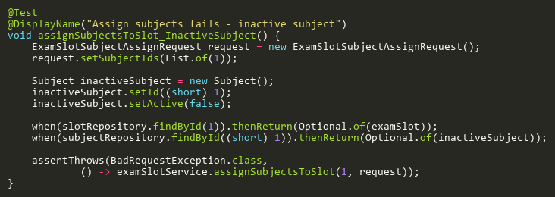
Figure: assignSubjectsToSlot_InactiveSubject
Reference: Sheet "EXSS_assignSubjects", Test Case TC07

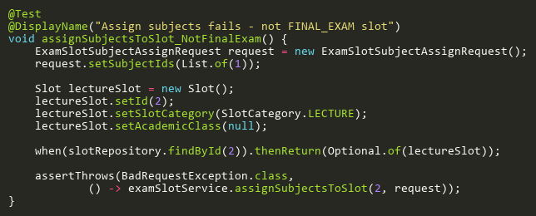
Figure: assignSubjectsToSlot_NotFinalExam
Reference: Sheet "EXSS_assignSubjects", Test Case TC03

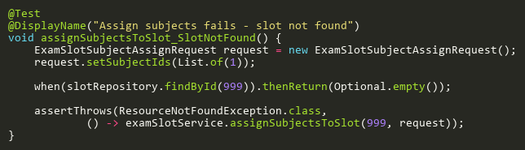
Figure: assignSubjectsToSlot_SlotNotFound
Reference: Sheet "EXSS_assignSubjects", Test Case TC02

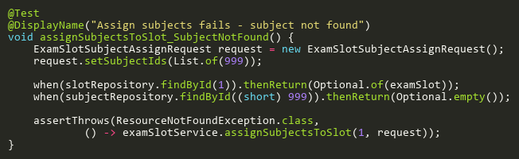
Figure: assignSubjectsToSlot_SubjectNotFound
Reference: Sheet "EXSS_assignSubjects", Test Case TC06

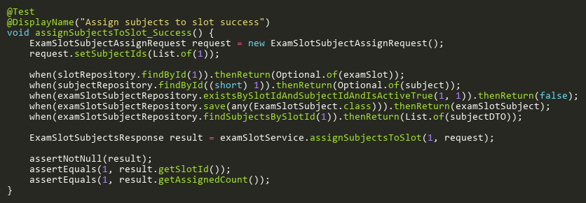
Figure: assignSubjectsToSlot_Success
Reference: Sheet "EXSS_assignSubjects", Test Case TC01

GetParticipantByIdTests
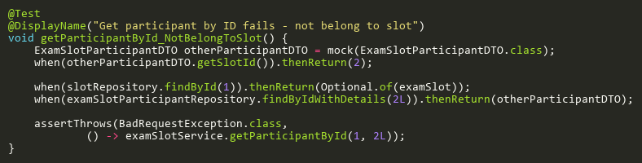
Figure: getParticipantById_NotBelongToSlot
Reference: Sheet "EXSS_getParticipantById", Test Case TC04

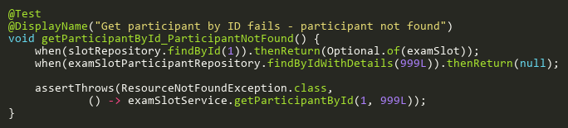
Figure: getParticipantById_ParticipantNotFound
Reference: Sheet "EXSS_getParticipantById", Test Case TC03

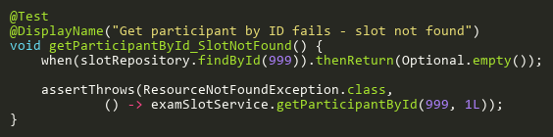
Figure: getParticipantById_SlotNotFound
Reference: Sheet "EXSS_getParticipantById", Test Case TC02

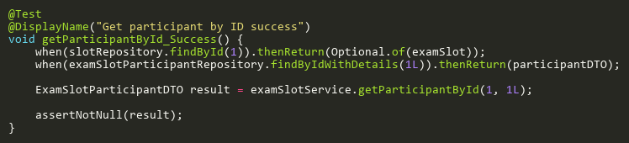
Figure: getParticipantById_Success
Reference: Sheet "EXSS_getParticipantById", Test Case TC01

RemoveParticipantTests
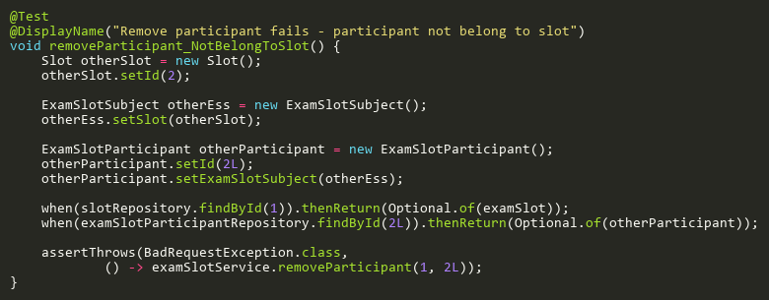
Figure: removeParticipant_NotBelongToSlot
Reference: Sheet "EXSS_removeParticipant", Test Case TC05

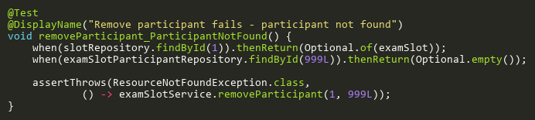
Figure: removeParticipant_ParticipantNotFound
Reference: Sheet "EXSS_removeParticipant", Test Case TC04

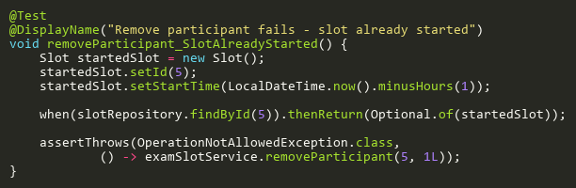
Figure: removeParticipant_SlotAlreadyStarted
Reference: Sheet "EXSS_removeParticipant", Test Case TC03

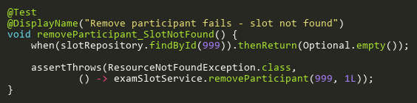
Figure: removeParticipant_SlotNotFound
Reference: Sheet "EXSS_removeParticipant", Test Case TC02

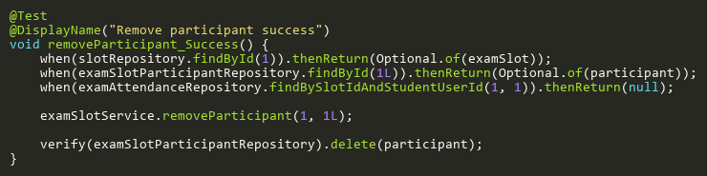
Figure: removeParticipant_Success
Reference: Sheet "EXSS_removeParticipant", Test Case TC01

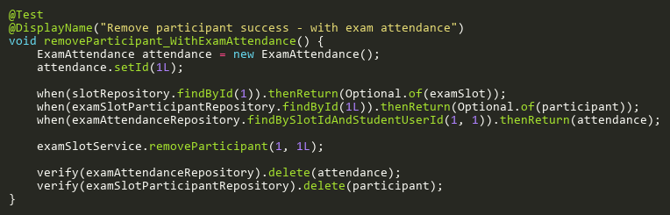
Figure: removeParticipant_WithExamAttendance
Reference: Sheet "EXSS_removeParticipant", Test Case TC06

RemoveSubjectFromSlotTests
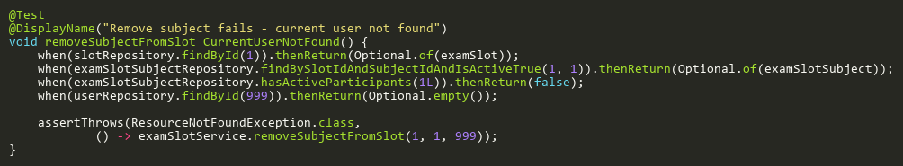
Figure: removeSubjectFromSlot_CurrentUserNotFound
Reference: Sheet "EXSS_removeSubject", Test Case TC06

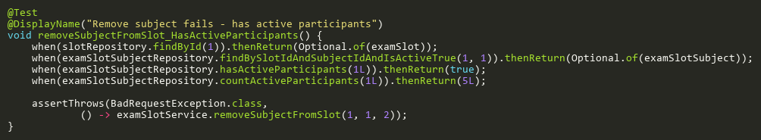
Figure: removeSubjectFromSlot_HasActiveParticipants
Reference: Sheet "EXSS_removeSubject", Test Case TC05

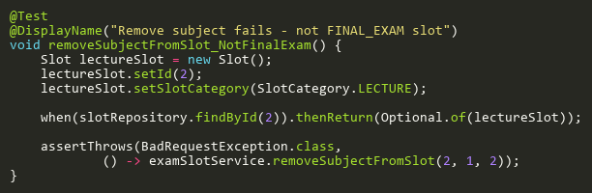
Figure: removeSubjectFromSlot_NotFinalExam
Reference: Sheet "EXSS_removeSubject", Test Case TC03

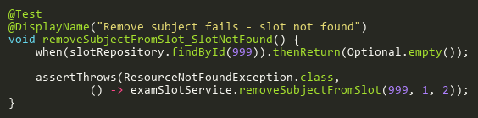
Figure: removeSubjectFromSlot_SlotNotFound
Reference: Sheet "EXSS_removeSubject", Test Case TC02

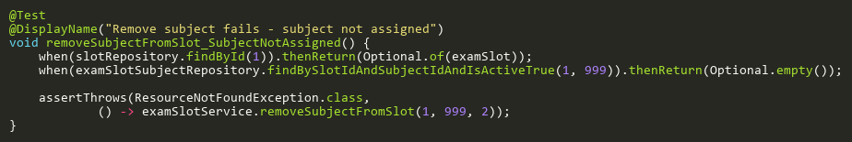
Figure: removeSubjectFromSlot_SubjectNotAssigned
Reference: Sheet "EXSS_removeSubject", Test Case TC04

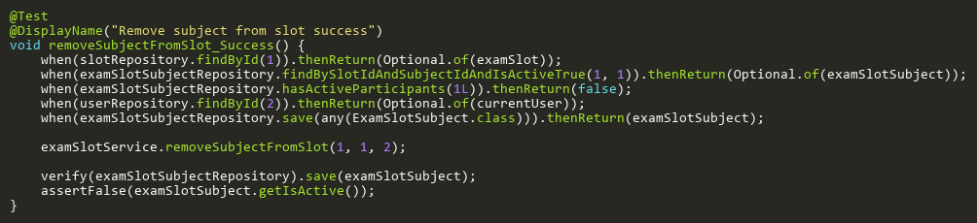
Figure: removeSubjectFromSlot_Success
Reference: Sheet "EXSS_removeSubject", Test Case TC01

UpdateParticipantTests
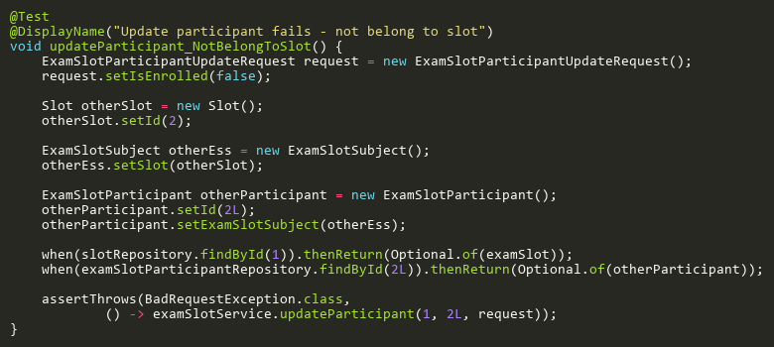
Figure: updateParticipant_NotBelongToSlot
Reference: Sheet "EXSS_updateParticipant", Test Case TC04

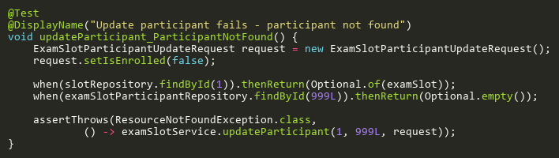
Figure: updateParticipant_ParticipantNotFound
Reference: Sheet "EXSS_updateParticipant", Test Case TC03

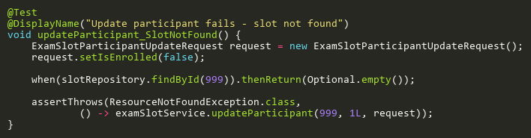
Figure: updateParticipant_SlotNotFound
Reference: Sheet "EXSS_updateParticipant", Test Case TC02

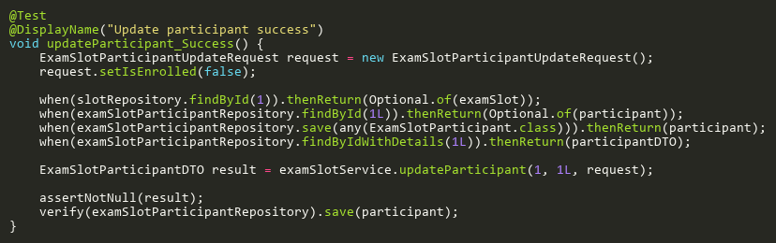
Figure: updateParticipant_Success
Reference: Sheet "EXSS_updateParticipant", Test Case TC01

