ExcelServiceTest

ImportStudentsTests
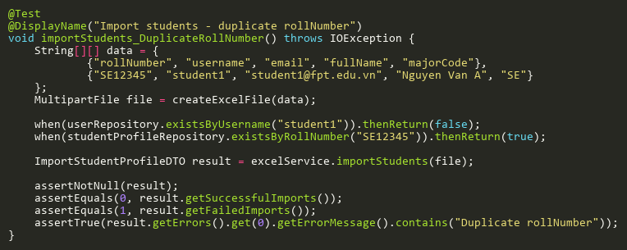
Figure: importStudents_DuplicateRollNumber
Reference: Sheet "EXCST_importStudents", Test Case TC06

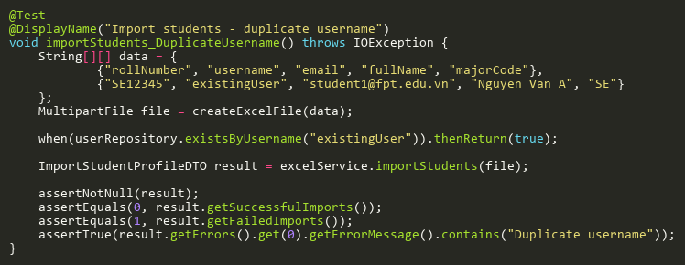
Figure: importStudents_DuplicateUsername
Reference: Sheet "EXCST_importStudents", Test Case TC05

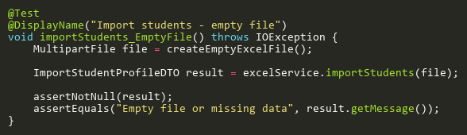
Figure: importStudents_EmptyFile
Reference: Sheet "EXCST_importStudents", Test Case TC02

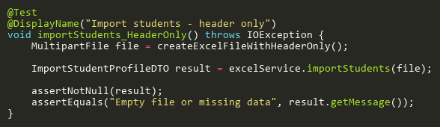
Figure: importStudents_HeaderOnly
Reference: Sheet "EXCST_importStudents", Test Case TC03

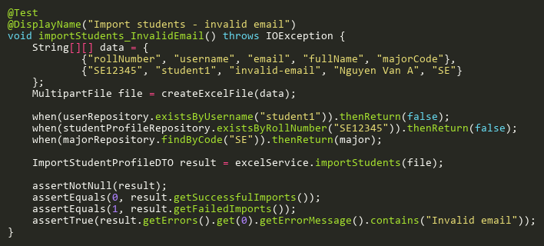
Figure: importStudents_InvalidEmail
Reference: Sheet "EXCST_importStudents", Test Case TC08

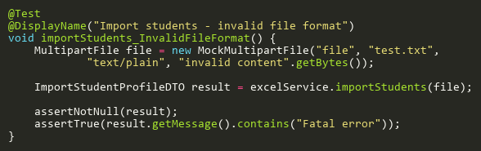
Figure: importStudents_InvalidFileFormat
Reference: Sheet "EXCST_importStudents", Test Case TC10

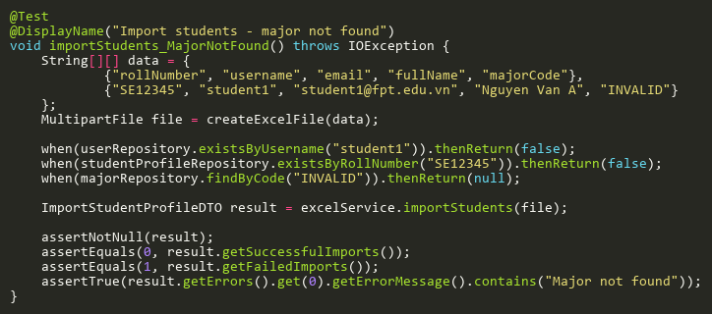
Figure: importStudents_MajorNotFound
Reference: Sheet "EXCST_importStudents", Test Case TC07

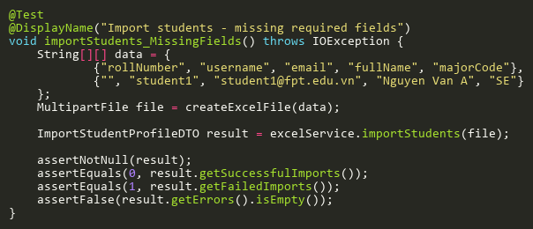
Figure: importStudents_MissingFields
Reference: Sheet "EXCST_importStudents", Test Case TC04

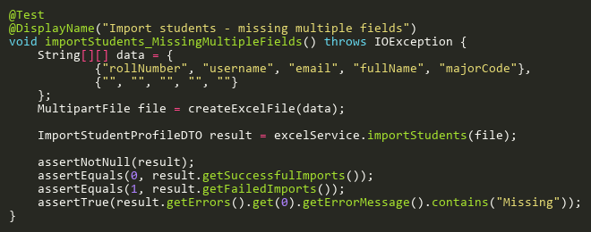
Figure: importStudents_MissingMultipleFields
Reference: Sheet "EXCST_importStudents", Test Case TC12

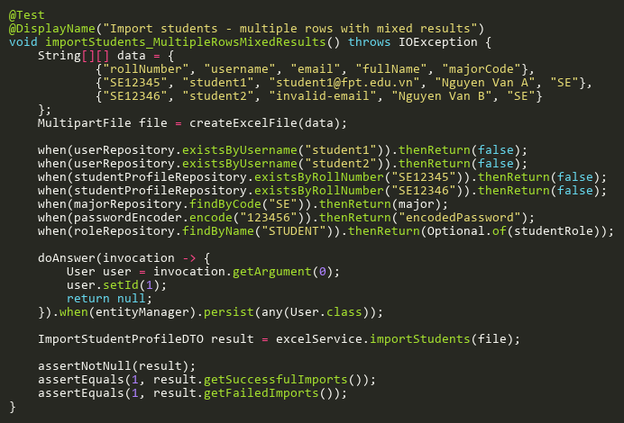
Figure: importStudents_MultipleRowsMixedResults
Reference: Sheet "EXCST_importStudents", Test Case TC09

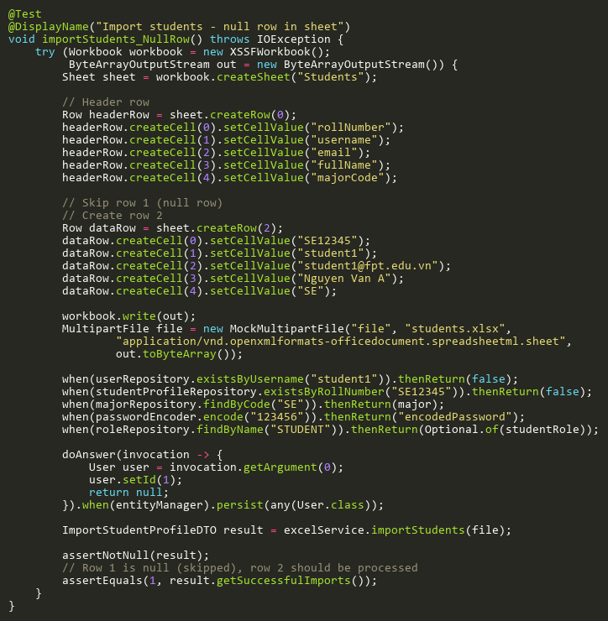
Figure: importStudents_NullRow
Reference: Sheet "EXCST_importStudents", Test Case TC11

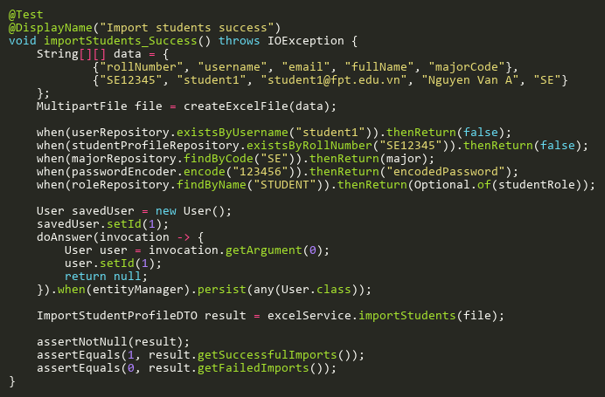
Figure: importStudents_Success
Reference: Sheet "EXCST_importStudents", Test Case TC01

