FaceEmbeddingServiceTest

GenerateAndSaveEmbeddingTests
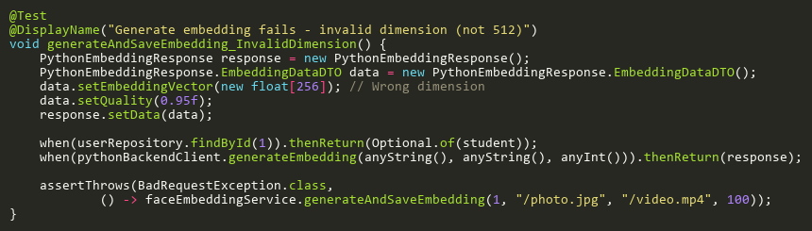
Figure: generateAndSaveEmbedding_InvalidDimension
Reference: Sheet "FEST_generateAndSave", Test Case TC06

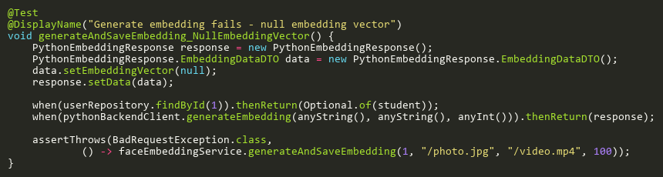
Figure: generateAndSaveEmbedding_NullEmbeddingVector
Reference: Sheet "FEST_generateAndSave", Test Case TC05

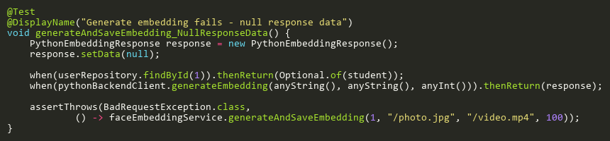
Figure: generateAndSaveEmbedding_NullResponseData
Reference: Sheet "FEST_generateAndSave", Test Case TC04

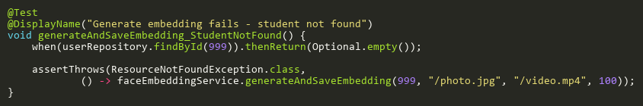
Figure: generateAndSaveEmbedding_StudentNotFound
Reference: Sheet "FEST_generateAndSave", Test Case TC03

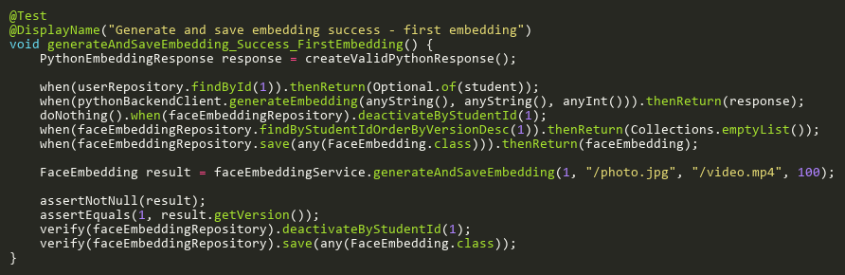
Figure: generateAndSaveEmbedding_Success_FirstEmbedding
Reference: Sheet "FEST_generateAndSave", Test Case TC01

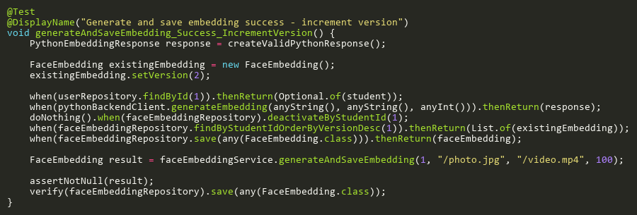
Figure: generateAndSaveEmbedding_Success_IncrementVersion
Reference: Sheet "FEST_generateAndSave", Test Case TC02

HasActiveEmbeddingTests
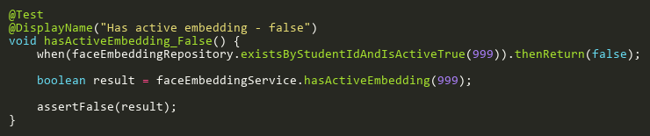
Figure: hasActiveEmbedding_False
Reference: Sheet "FEST_hasActiveEmbedding", Test Case TC02

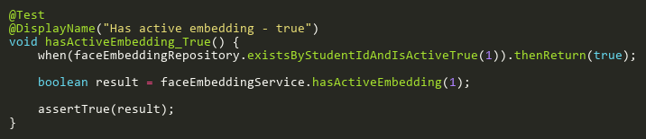
Figure: hasActiveEmbedding_True
Reference: Sheet "FEST_hasActiveEmbedding", Test Case TC01

SaveEmbeddingTests
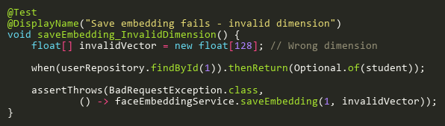
Figure: saveEmbedding_InvalidDimension
Reference: Sheet "FEST_saveEmbedding", Test Case TC04

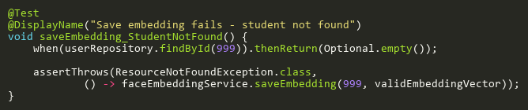
Figure: saveEmbedding_StudentNotFound
Reference: Sheet "FEST_saveEmbedding", Test Case TC03

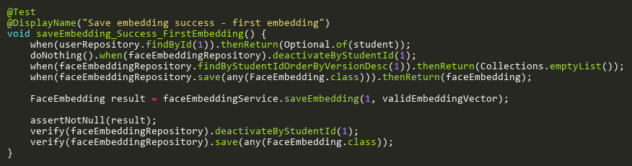
Figure: saveEmbedding_Success_FirstEmbedding
Reference: Sheet "FEST_saveEmbedding", Test Case TC01

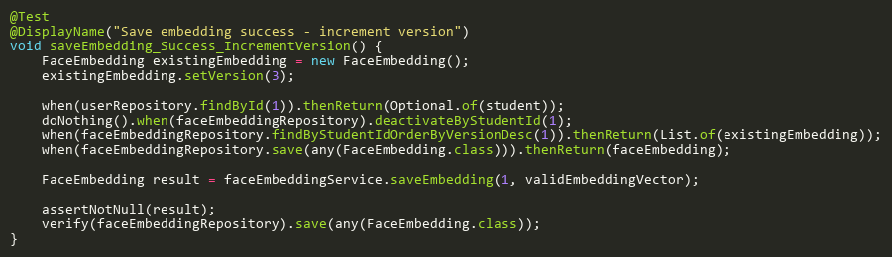
Figure: saveEmbedding_Success_IncrementVersion
Reference: Sheet "FEST_saveEmbedding", Test Case TC02

