LecturerServiceTest

GetLecturerSemestersWithClassesByUserIdTests
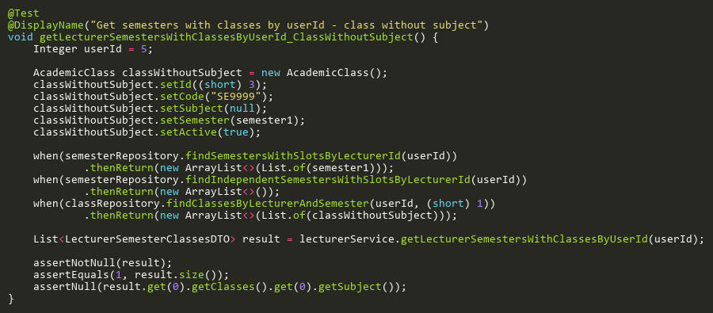
Figure: getLecturerSemestersWithClassesByUserId_ClassWithoutSubject
Reference: Sheet "LST_getSemestersByUserId", Test Case TC06

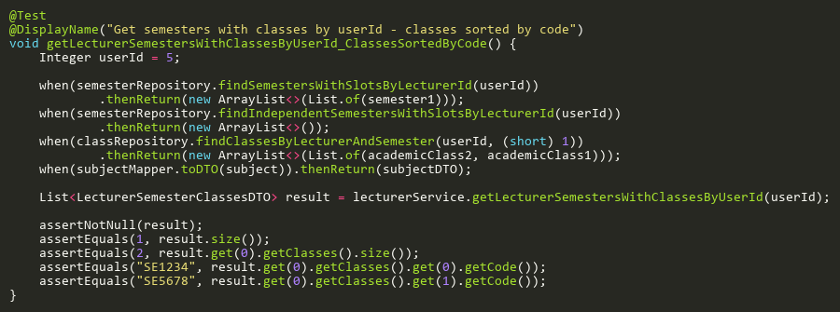
Figure: getLecturerSemestersWithClassesByUserId_ClassesSortedByCode
Reference: Sheet "LST_getSemestersByUserId", Test Case TC04

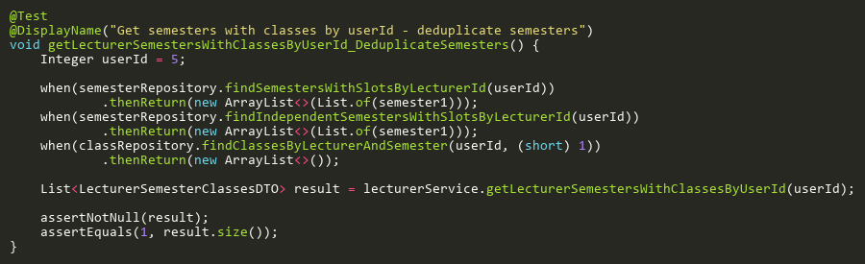
Figure: getLecturerSemestersWithClassesByUserId_DeduplicateSemesters
Reference: Sheet "LST_getSemestersByUserId", Test Case TC05

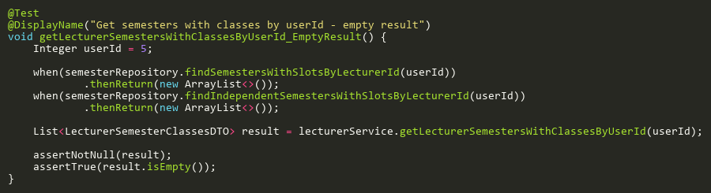
Figure: getLecturerSemestersWithClassesByUserId_EmptyResult
Reference: Sheet "LST_getSemestersByUserId", Test Case TC02

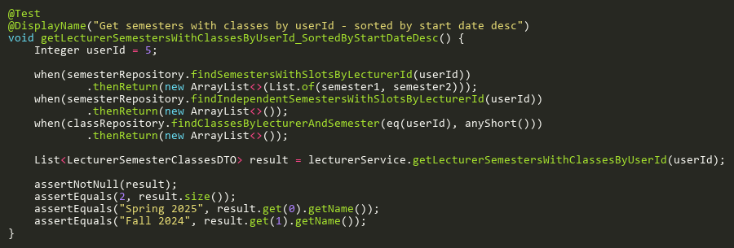
Figure: getLecturerSemestersWithClassesByUserId_SortedByStartDateDesc
Reference: Sheet "LST_getSemestersByUserId", Test Case TC03

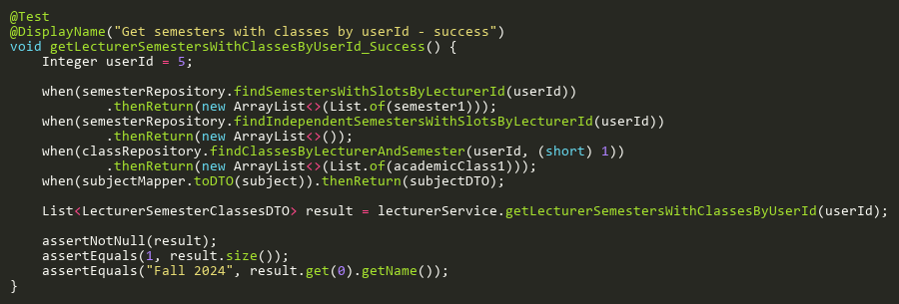
Figure: getLecturerSemestersWithClassesByUserId_Success
Reference: Sheet "LST_getSemestersByUserId", Test Case TC01

GetLecturerSemestersWithClassesTests
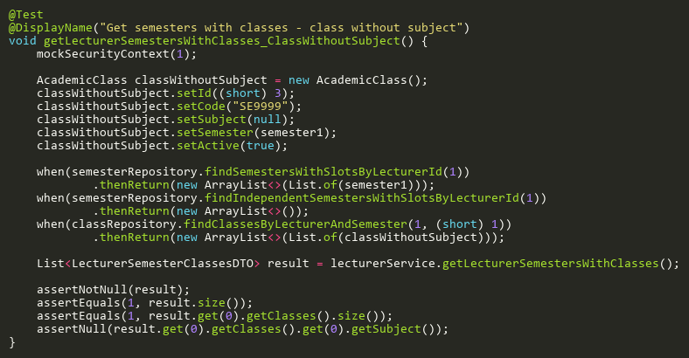
Figure: getLecturerSemestersWithClasses_ClassWithoutSubject
Reference: Sheet "LST_getSemestersClasses", Test Case TC06

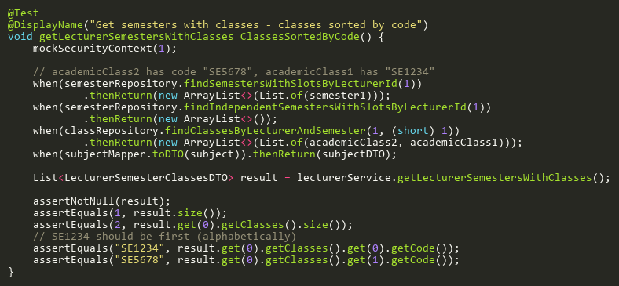
Figure: getLecturerSemestersWithClasses_ClassesSortedByCode
Reference: Sheet "LST_getSemestersClasses", Test Case TC05

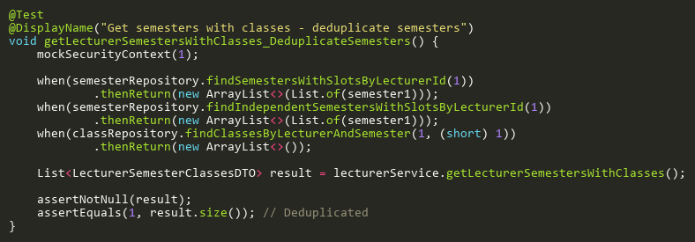
Figure: getLecturerSemestersWithClasses_DeduplicateSemesters
Reference: Sheet "LST_getSemestersClasses", Test Case TC07

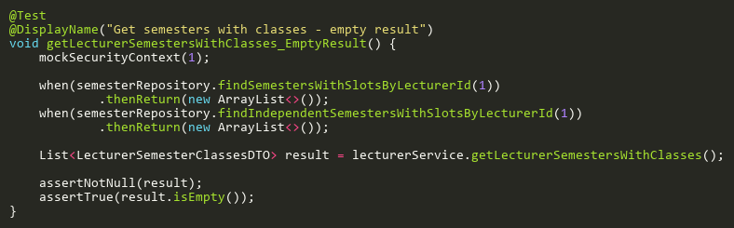
Figure: getLecturerSemestersWithClasses_EmptyResult
Reference: Sheet "LST_getSemestersClasses", Test Case TC03

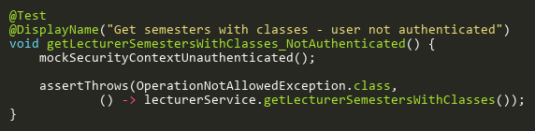
Figure: getLecturerSemestersWithClasses_NotAuthenticated
Reference: Sheet "LST_getSemestersClasses", Test Case TC02

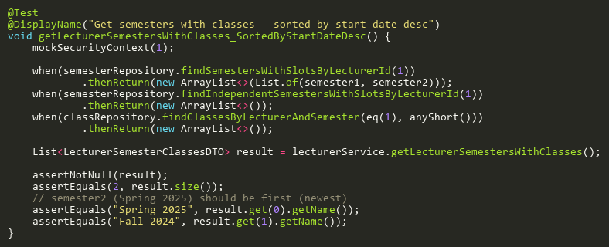
Figure: getLecturerSemestersWithClasses_SortedByStartDateDesc
Reference: Sheet "LST_getSemestersClasses", Test Case TC04

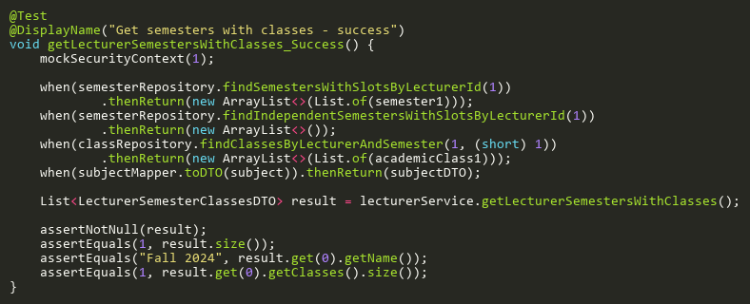
Figure: getLecturerSemestersWithClasses_Success
Reference: Sheet "LST_getSemestersClasses", Test Case TC01

