MajorServiceTest

CreateTests
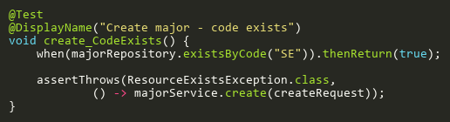
Figure: create_CodeExists
Reference: Sheet "MJST_create", Test Case TC02

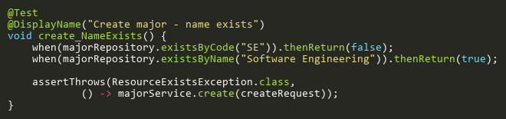
Figure: create_NameExists
Reference: Sheet "MJST_create", Test Case TC03

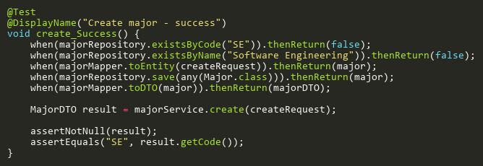
Figure: create_Success
Reference: Sheet "MJST_create", Test Case TC01

DeleteTests
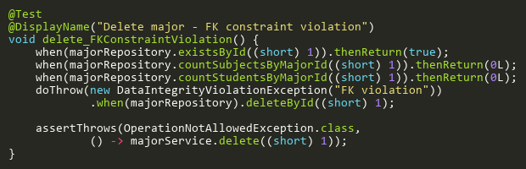
Figure: delete_FKConstraintViolation
Reference: Sheet "MJST_delete", Test Case TC05

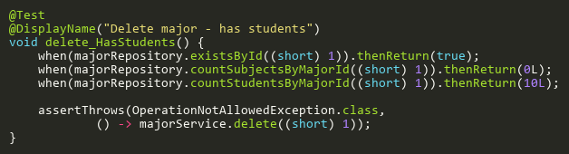
Figure: delete_HasStudents
Reference: Sheet "MJST_delete", Test Case TC04

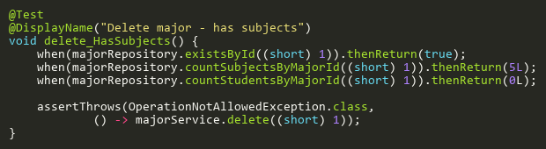
Figure: delete_HasSubjects
Reference: Sheet "MJST_delete", Test Case TC03

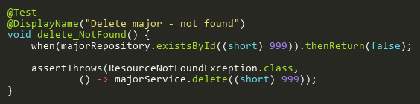
Figure: delete_NotFound
Reference: Sheet "MJST_delete", Test Case TC02

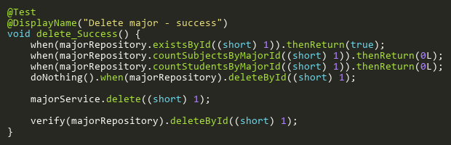
Figure: delete_Success
Reference: Sheet "MJST_delete", Test Case TC01

FindByIdTests
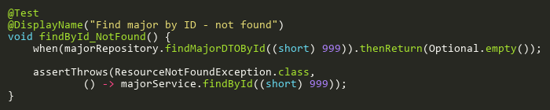
Figure: findById_NotFound
Reference: Sheet "MJST_findById", Test Case TC02

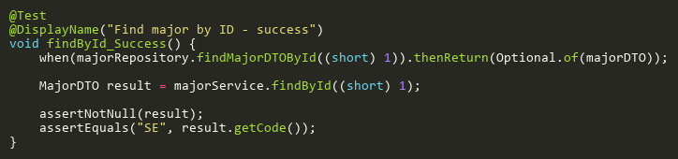
Figure: findById_Success
Reference: Sheet "MJST_findById", Test Case TC01

SearchTests
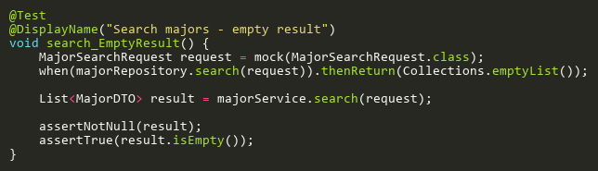
Figure: search_EmptyResult
Reference: Sheet "MJST_search", Test Case TC02

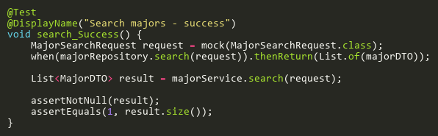
Figure: search_Success
Reference: Sheet "MJST_search", Test Case TC01

UpdateTests
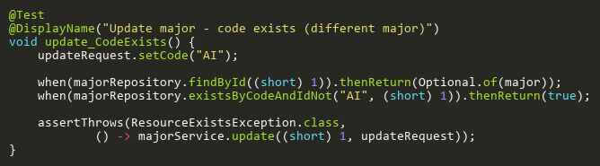
Figure: update_CodeExists
Reference: Sheet "MJST_update", Test Case TC03

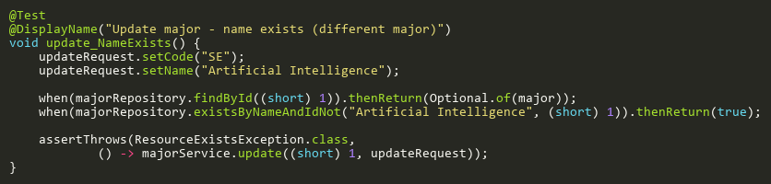
Figure: update_NameExists
Reference: Sheet "MJST_update", Test Case TC04

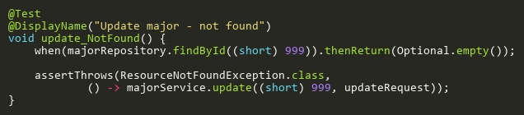
Figure: update_NotFound
Reference: Sheet "MJST_update", Test Case TC02

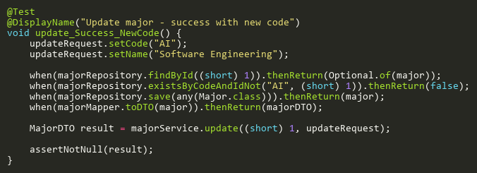
Figure: update_Success_NewCode
Reference: Sheet "MJST_update", Test Case TC05

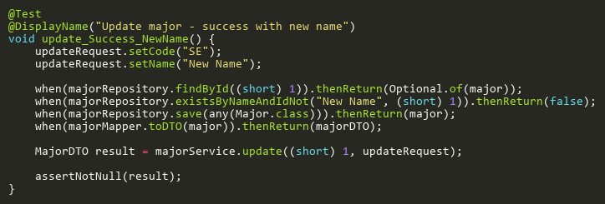
Figure: update_Success_NewName
Reference: Sheet "MJST_update", Test Case TC06

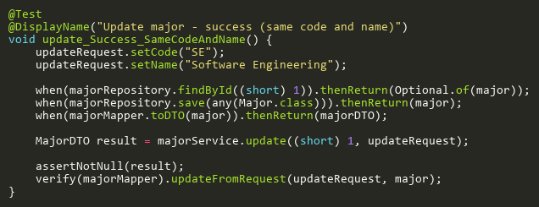
Figure: update_Success_SameCodeAndName
Reference: Sheet "MJST_update", Test Case TC01

