NotificationServiceTest

NotifyExamAttendanceFinalizedTests
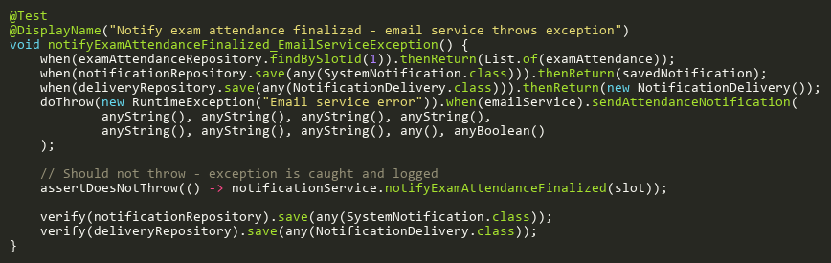
Figure: notifyExamAttendanceFinalized_EmailServiceException
Reference: Sheet "NST_notifyExam", Test Case TC05

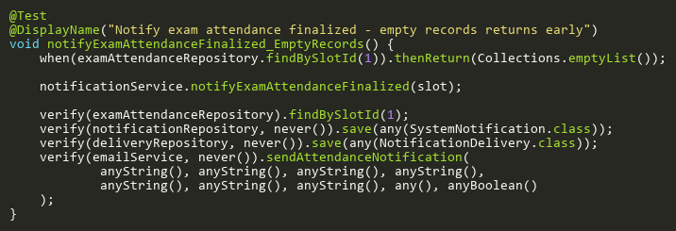
Figure: notifyExamAttendanceFinalized_EmptyRecords
Reference: Sheet "NST_notifyExam", Test Case TC02

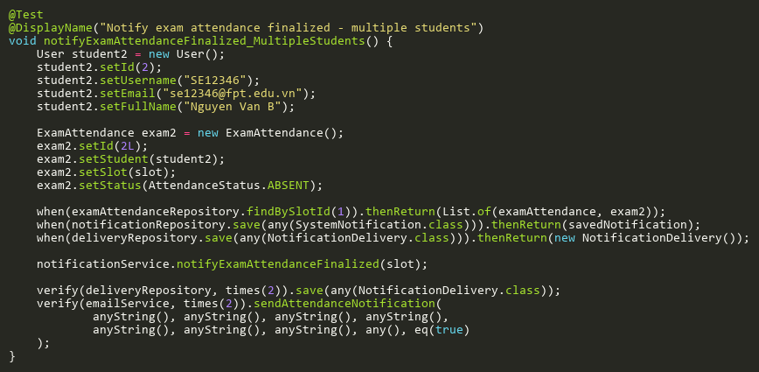
Figure: notifyExamAttendanceFinalized_MultipleStudents
Reference: Sheet "NST_notifyExam", Test Case TC03

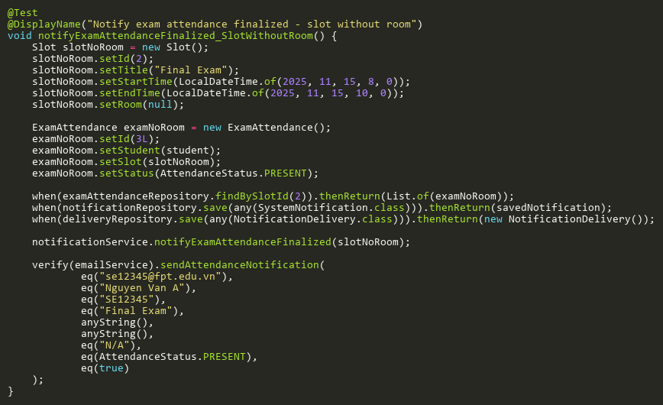
Figure: notifyExamAttendanceFinalized_SlotWithoutRoom
Reference: Sheet "NST_notifyExam", Test Case TC04

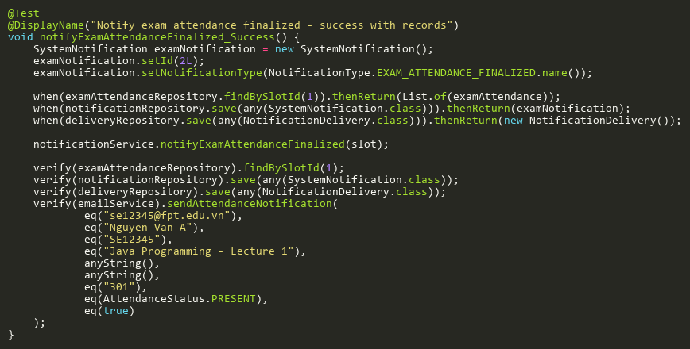
Figure: notifyExamAttendanceFinalized_Success
Reference: Sheet "NST_notifyExam", Test Case TC01

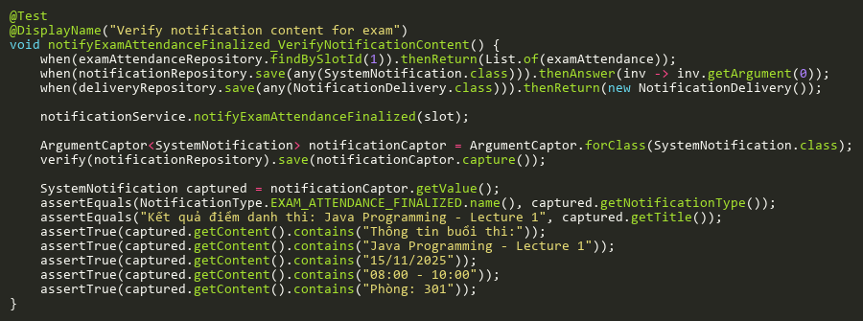
Figure: notifyExamAttendanceFinalized_VerifyNotificationContent
Reference: Sheet "NST_notifyExam", Test Case TC06

NotifyLectureAttendanceFinalizedTests
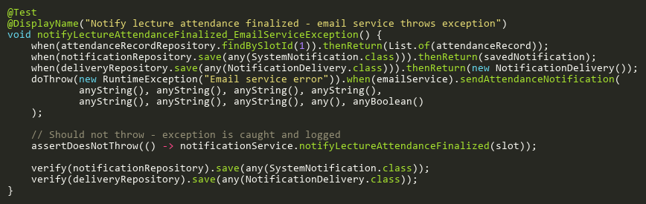
Figure: notifyLectureAttendanceFinalized_EmailServiceException
Reference: Sheet "NST_notifyLecture", Test Case TC05

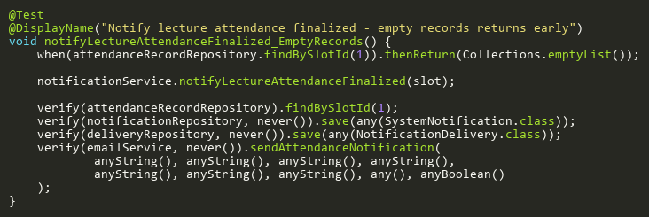
Figure: notifyLectureAttendanceFinalized_EmptyRecords
Reference: Sheet "NST_notifyLecture", Test Case TC02

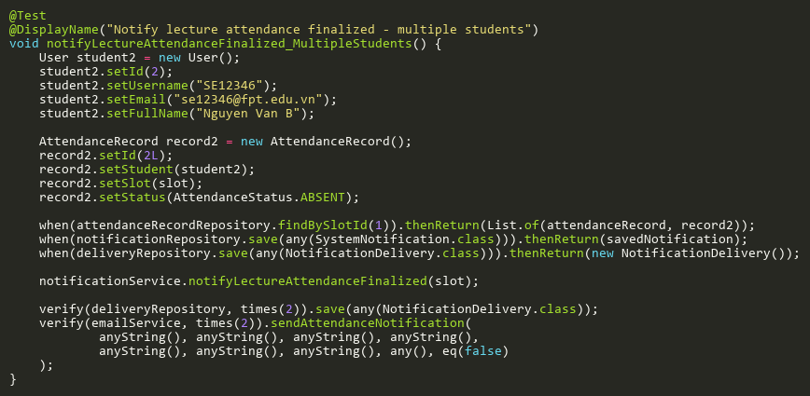
Figure: notifyLectureAttendanceFinalized_MultipleStudents
Reference: Sheet "NST_notifyLecture", Test Case TC03

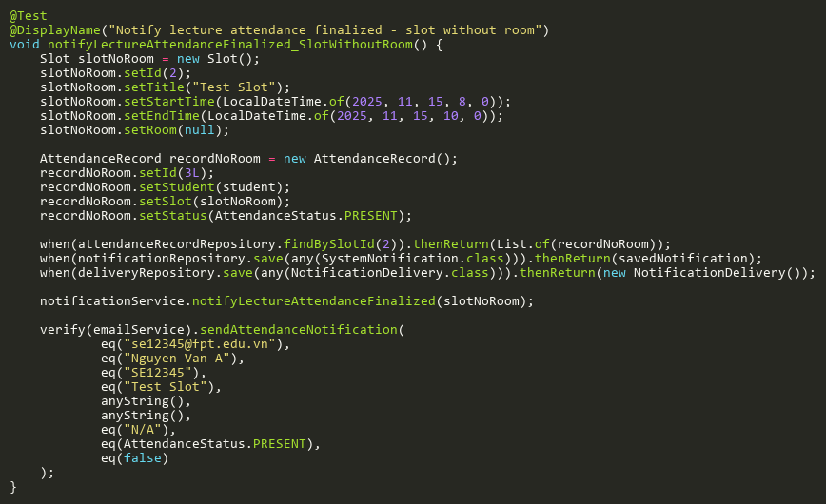
Figure: notifyLectureAttendanceFinalized_SlotWithoutRoom
Reference: Sheet "NST_notifyLecture", Test Case TC04

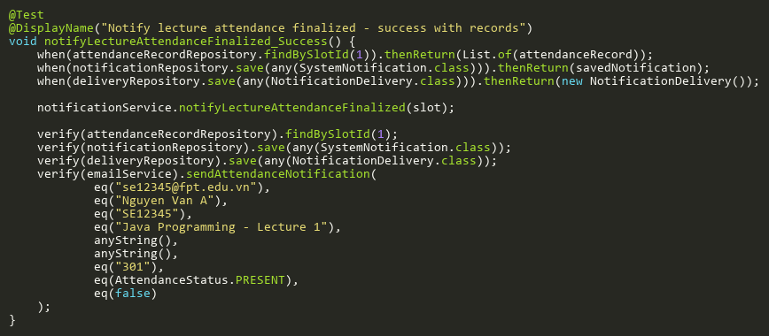
Figure: notifyLectureAttendanceFinalized_Success
Reference: Sheet "NST_notifyLecture", Test Case TC01

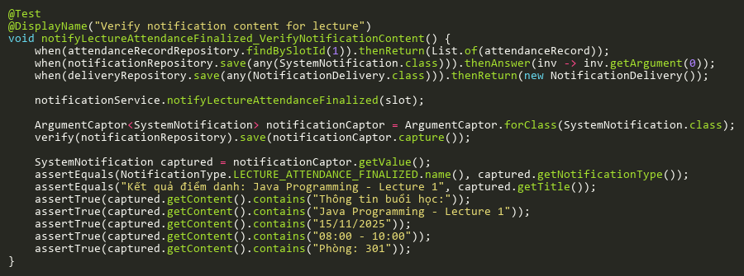
Figure: notifyLectureAttendanceFinalized_VerifyNotificationContent
Reference: Sheet "NST_notifyLecture", Test Case TC06

