PythonBackendClientTest

CheckHealthTests
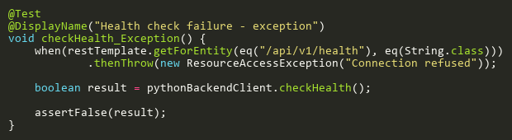
Figure: checkHealth_Exception
Reference: Sheet "PBCT_checkHealth", Test Case TC02

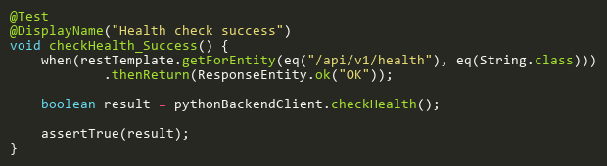
Figure: checkHealth_Success
Reference: Sheet "PBCT_checkHealth", Test Case TC01

GenerateEmbeddingPathTests
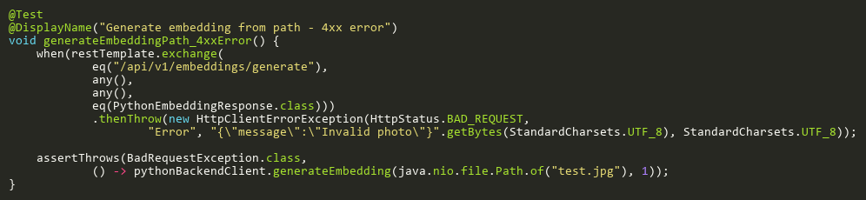
Figure: generateEmbeddingPath_4xxError
Reference: Sheet "PBCT_genEmbedPath", Test Case TC03

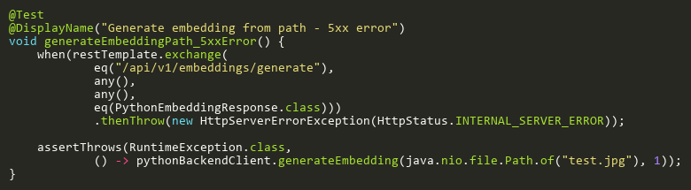
Figure: generateEmbeddingPath_5xxError
Reference: Sheet "PBCT_genEmbedPath", Test Case TC04

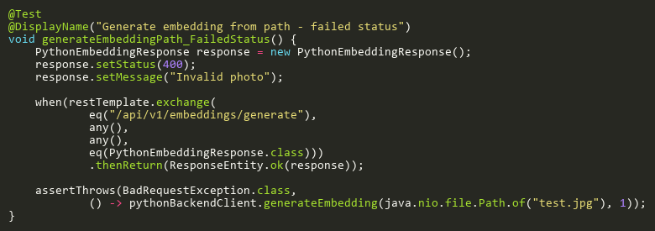
Figure: generateEmbeddingPath_FailedStatus
Reference: Sheet "PBCT_genEmbedPath", Test Case TC02

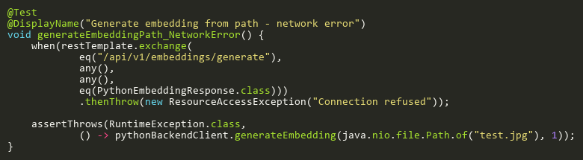
Figure: generateEmbeddingPath_NetworkError
Reference: Sheet "PBCT_genEmbedPath", Test Case TC05

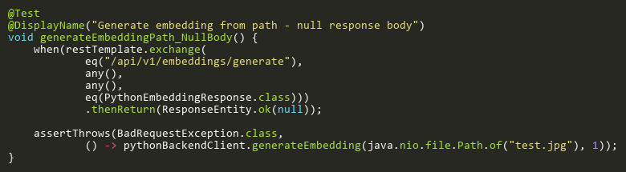
Figure: generateEmbeddingPath_NullBody
Reference: Sheet "PBCT_genEmbedPath", Test Case TC06

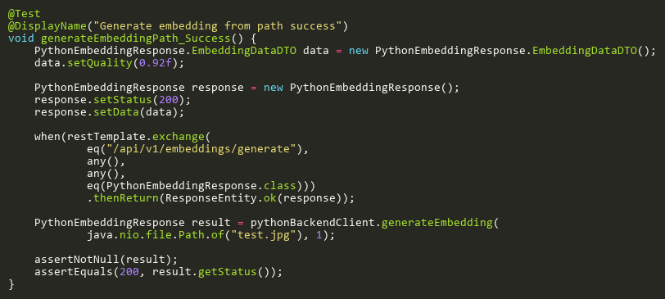
Figure: generateEmbeddingPath_Success
Reference: Sheet "PBCT_genEmbedPath", Test Case TC01

GenerateEmbeddingUrlTests
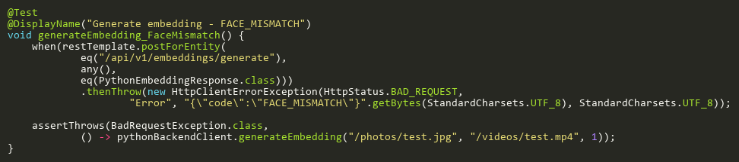
Figure: generateEmbedding_FaceMismatch
Reference: Sheet "PBCT_genEmbedURL", Test Case TC04

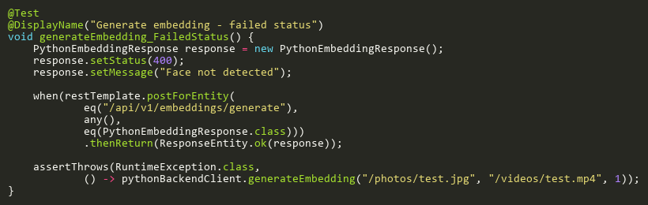
Figure: generateEmbedding_FailedStatus
Reference: Sheet "PBCT_genEmbedURL", Test Case TC02

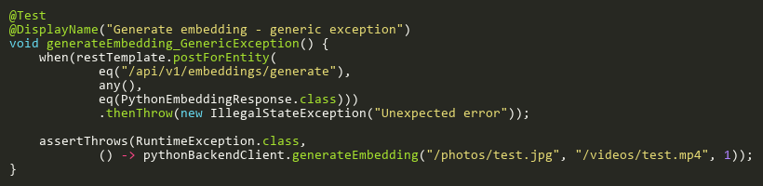
Figure: generateEmbedding_GenericException
Reference: Sheet "PBCT_genEmbedURL", Test Case TC07

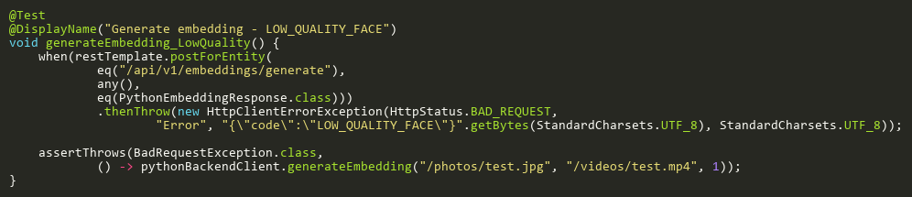
Figure: generateEmbedding_LowQuality
Reference: Sheet "PBCT_genEmbedURL", Test Case TC05

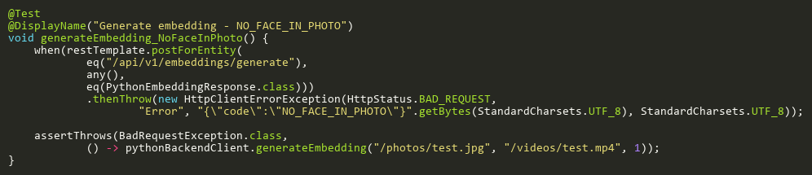
Figure: generateEmbedding_NoFaceInPhoto
Reference: Sheet "PBCT_genEmbedURL", Test Case TC03

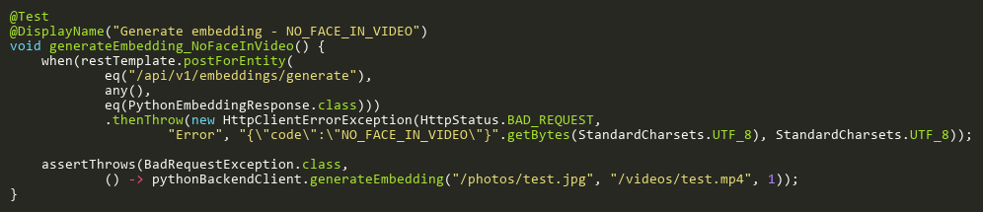
Figure: generateEmbedding_NoFaceInVideo
Reference: Sheet "PBCT_genEmbedURL", Test Case TC09

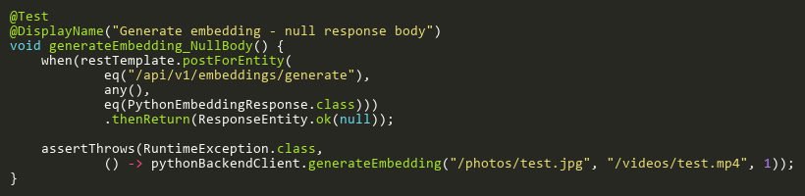
Figure: generateEmbedding_NullBody
Reference: Sheet "PBCT_genEmbedURL", Test Case TC08

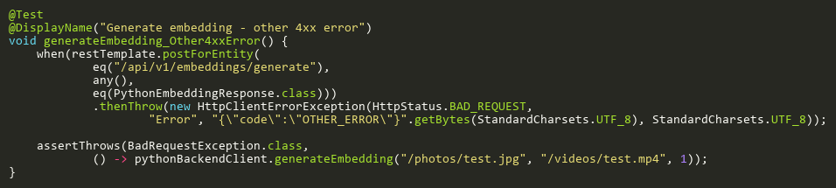
Figure: generateEmbedding_Other4xxError
Reference: Sheet "PBCT_genEmbedURL", Test Case TC06

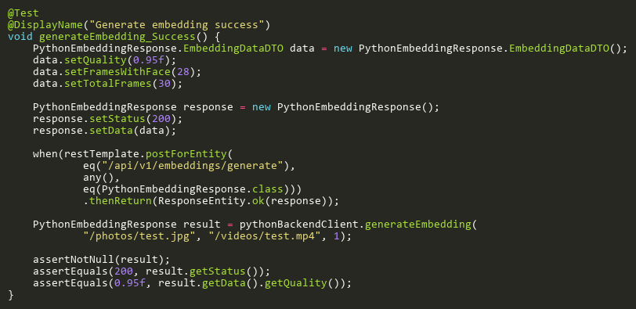
Figure: generateEmbedding_Success
Reference: Sheet "PBCT_genEmbedURL", Test Case TC01

StartRecognitionSessionTests
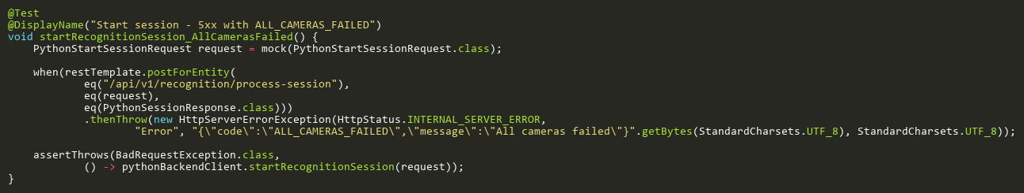
Figure: startRecognitionSession_AllCamerasFailed
Reference: Sheet "PBCT_startSession", Test Case TC07

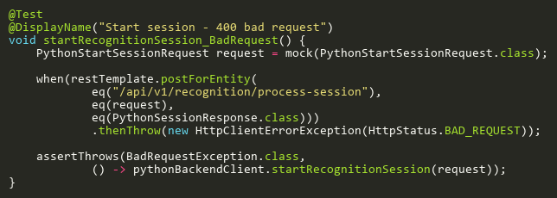
Figure: startRecognitionSession_BadRequest
Reference: Sheet "PBCT_startSession", Test Case TC04

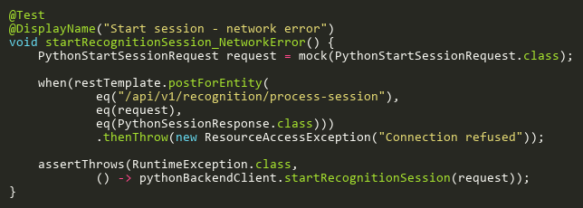
Figure: startRecognitionSession_NetworkError
Reference: Sheet "PBCT_startSession", Test Case TC08

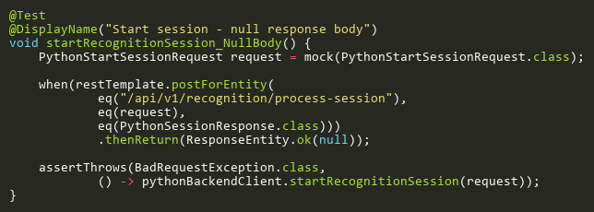
Figure: startRecognitionSession_NullBody
Reference: Sheet "PBCT_startSession", Test Case TC09

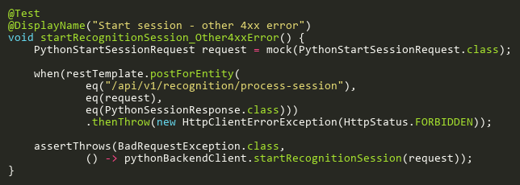
Figure: startRecognitionSession_Other4xxError
Reference: Sheet "PBCT_startSession", Test Case TC05

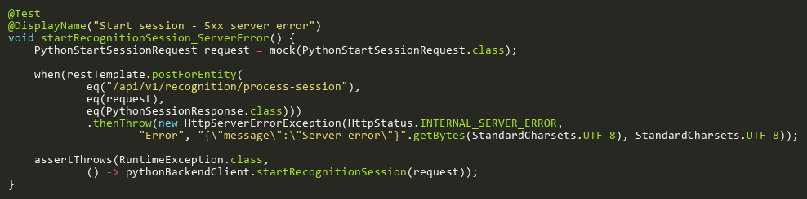
Figure: startRecognitionSession_ServerError
Reference: Sheet "PBCT_startSession", Test Case TC06

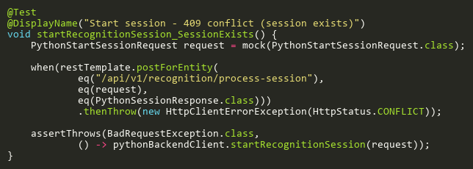
Figure: startRecognitionSession_SessionExists
Reference: Sheet "PBCT_startSession", Test Case TC03

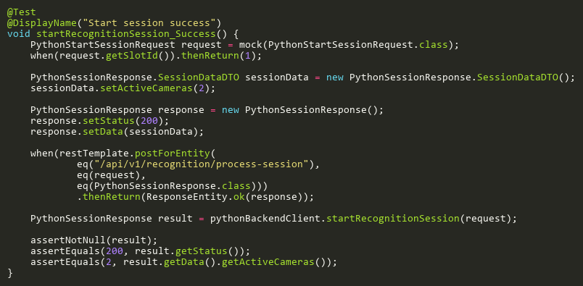
Figure: startRecognitionSession_Success
Reference: Sheet "PBCT_startSession", Test Case TC01

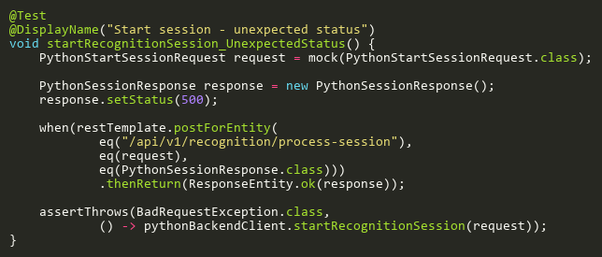
Figure: startRecognitionSession_UnexpectedStatus
Reference: Sheet "PBCT_startSession", Test Case TC02

StopRecognitionSessionTests
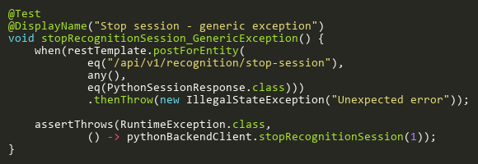
Figure: stopRecognitionSession_GenericException
Reference: Sheet "PBCT_stopSession", Test Case TC07

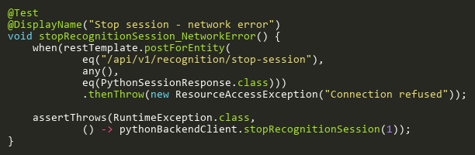
Figure: stopRecognitionSession_NetworkError
Reference: Sheet "PBCT_stopSession", Test Case TC06

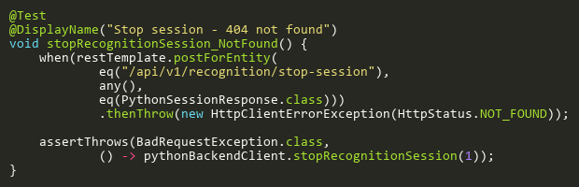
Figure: stopRecognitionSession_NotFound
Reference: Sheet "PBCT_stopSession", Test Case TC03

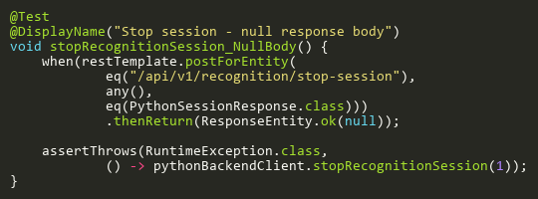
Figure: stopRecognitionSession_NullBody
Reference: Sheet "PBCT_stopSession", Test Case TC08

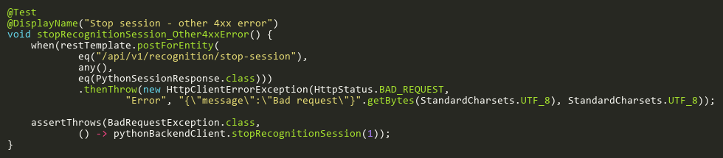
Figure: stopRecognitionSession_Other4xxError
Reference: Sheet "PBCT_stopSession", Test Case TC04

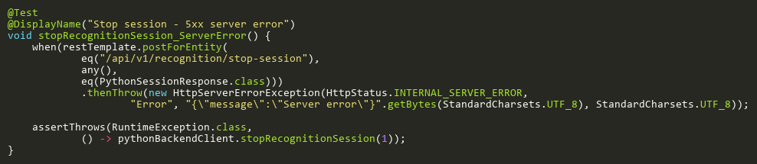
Figure: stopRecognitionSession_ServerError
Reference: Sheet "PBCT_stopSession", Test Case TC05

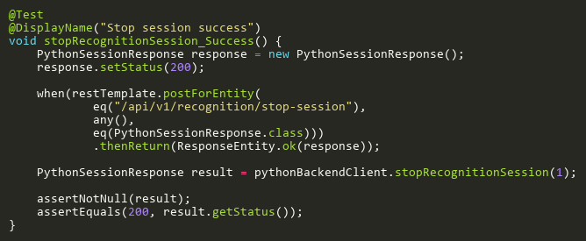
Figure: stopRecognitionSession_Success
Reference: Sheet "PBCT_stopSession", Test Case TC01

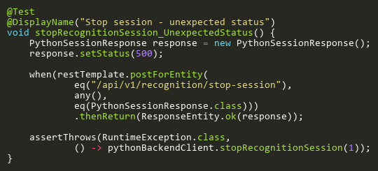
Figure: stopRecognitionSession_UnexpectedStatus
Reference: Sheet "PBCT_stopSession", Test Case TC02

TestCameraConnectionTests
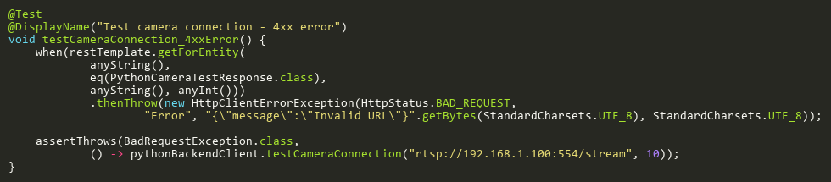
Figure: testCameraConnection_4xxError
Reference: Sheet "PBCT_testCamera", Test Case TC04

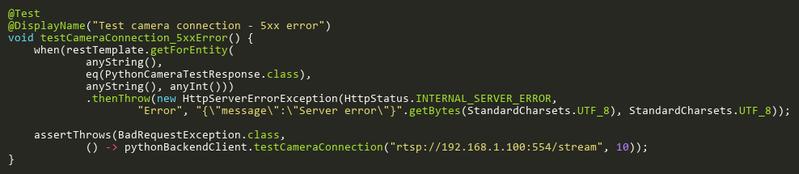
Figure: testCameraConnection_5xxError
Reference: Sheet "PBCT_testCamera", Test Case TC05

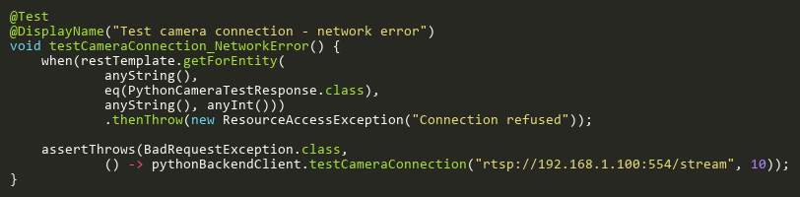
Figure: testCameraConnection_NetworkError
Reference: Sheet "PBCT_testCamera", Test Case TC06

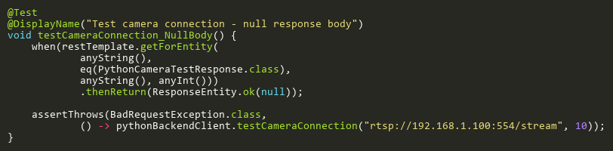
Figure: testCameraConnection_NullBody
Reference: Sheet "PBCT_testCamera", Test Case TC07

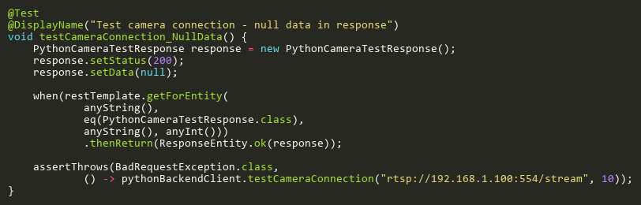
Figure: testCameraConnection_NullData
Reference: Sheet "PBCT_testCamera", Test Case TC08

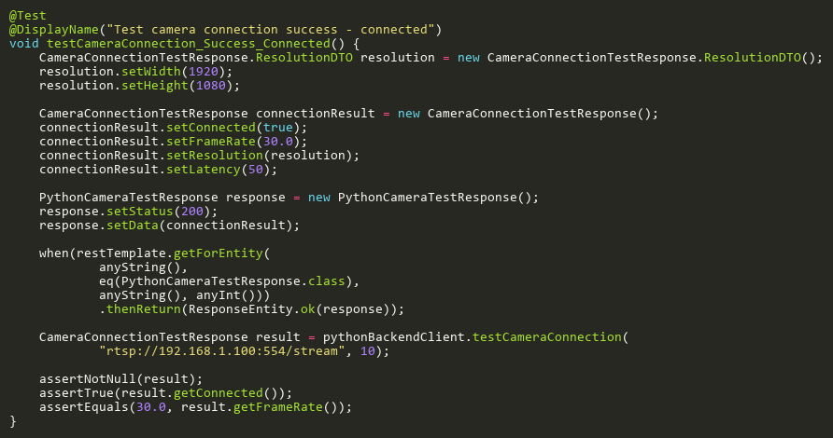
Figure: testCameraConnection_Success_Connected
Reference: Sheet "PBCT_testCamera", Test Case TC01

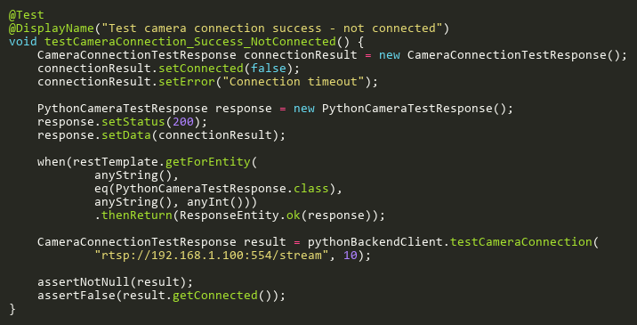
Figure: testCameraConnection_Success_NotConnected
Reference: Sheet "PBCT_testCamera", Test Case TC02

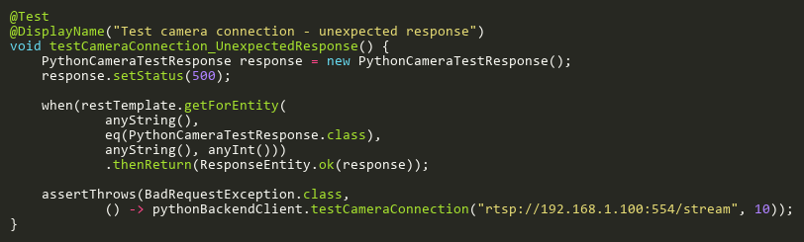
Figure: testCameraConnection_UnexpectedResponse
Reference: Sheet "PBCT_testCamera", Test Case TC03

