RoomServiceTest

CountByStaffIdTests
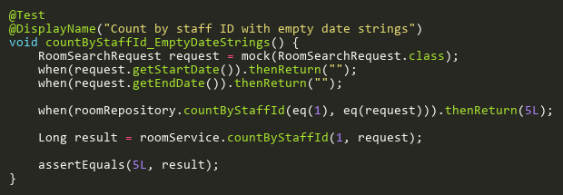
Figure: countByStaffId_EmptyDateStrings
Reference: Sheet "RMST_countByStaffId", Test Case TC05

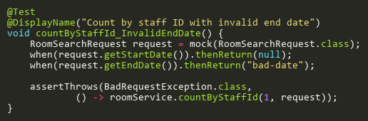
Figure: countByStaffId_InvalidEndDate
Reference: Sheet "RMST_countByStaffId", Test Case TC04

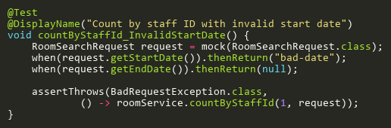
Figure: countByStaffId_InvalidStartDate
Reference: Sheet "RMST_countByStaffId", Test Case TC03

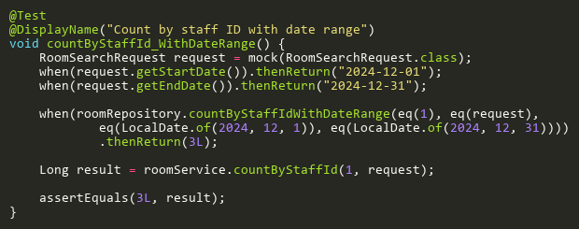
Figure: countByStaffId_WithDateRange
Reference: Sheet "RMST_countByStaffId", Test Case TC02

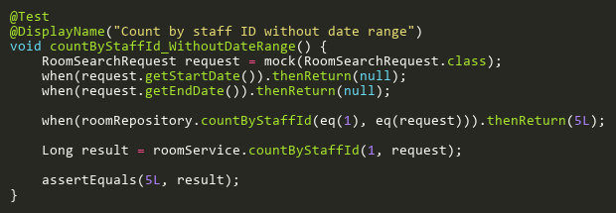
Figure: countByStaffId_WithoutDateRange
Reference: Sheet "RMST_countByStaffId", Test Case TC01

CreateTests
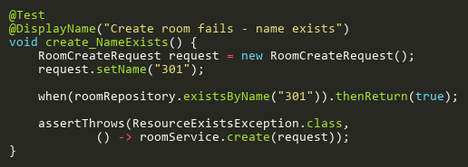
Figure: create_NameExists
Reference: Sheet "RMST_create", Test Case TC02

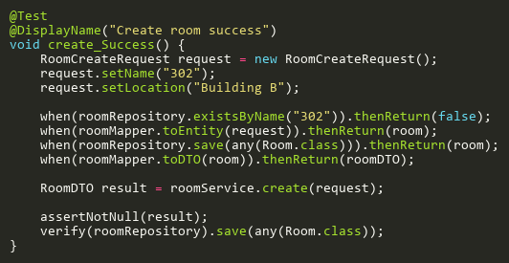
Figure: create_Success
Reference: Sheet "RMST_create", Test Case TC01

DeleteTests
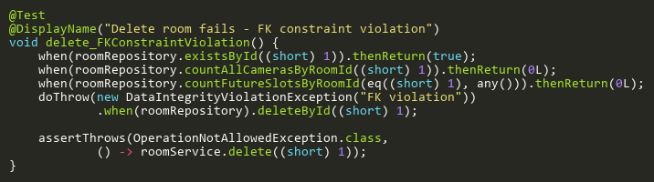
Figure: delete_FKConstraintViolation
Reference: Sheet "RMST_delete", Test Case TC05

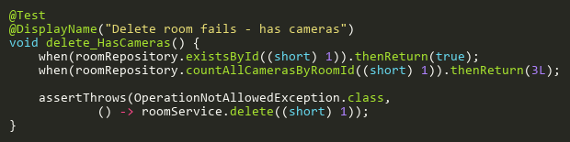
Figure: delete_HasCameras
Reference: Sheet "RMST_delete", Test Case TC03

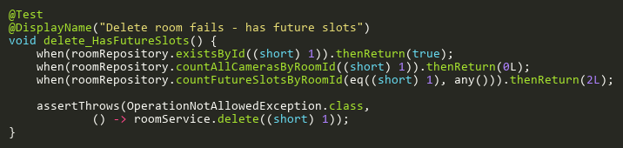
Figure: delete_HasFutureSlots
Reference: Sheet "RMST_delete", Test Case TC04

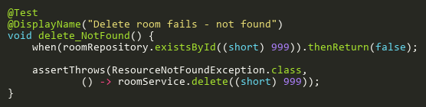
Figure: delete_NotFound
Reference: Sheet "RMST_delete", Test Case TC02

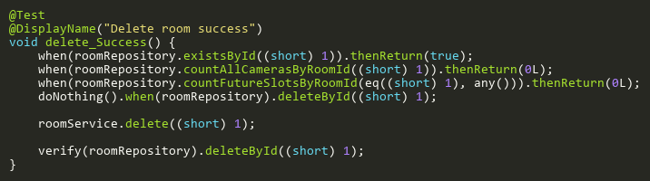
Figure: delete_Success
Reference: Sheet "RMST_delete", Test Case TC01

SearchByStaffIdTests
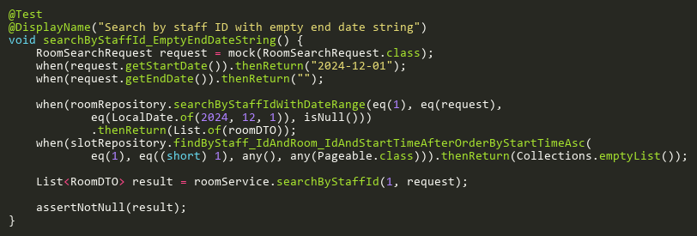
Figure: searchByStaffId_EmptyEndDateString
Reference: Sheet "RMST_searchByStaffId", Test Case TC08

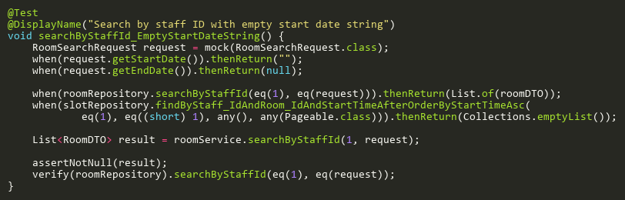
Figure: searchByStaffId_EmptyStartDateString
Reference: Sheet "RMST_searchByStaffId", Test Case TC07

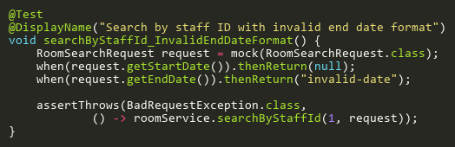
Figure: searchByStaffId_InvalidEndDateFormat
Reference: Sheet "RMST_searchByStaffId", Test Case TC05

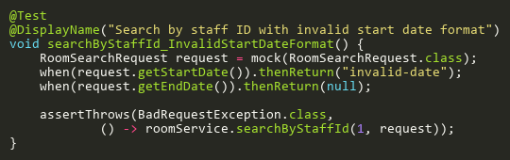
Figure: searchByStaffId_InvalidStartDateFormat
Reference: Sheet "RMST_searchByStaffId", Test Case TC04

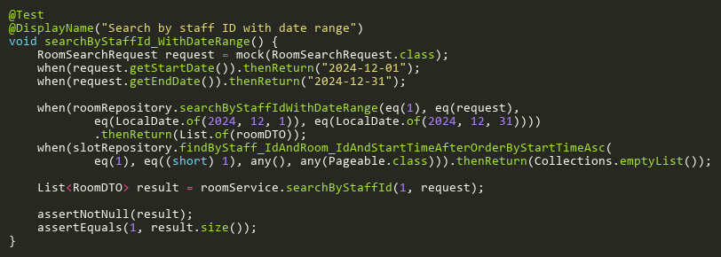
Figure: searchByStaffId_WithDateRange
Reference: Sheet "RMST_searchByStaffId", Test Case TC02

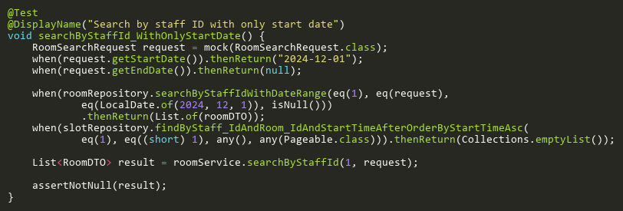
Figure: searchByStaffId_WithOnlyStartDate
Reference: Sheet "RMST_searchByStaffId", Test Case TC03

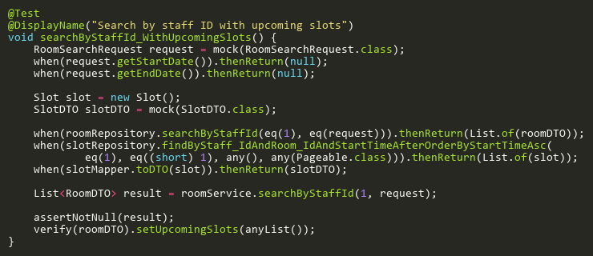
Figure: searchByStaffId_WithUpcomingSlots
Reference: Sheet "RMST_searchByStaffId", Test Case TC06

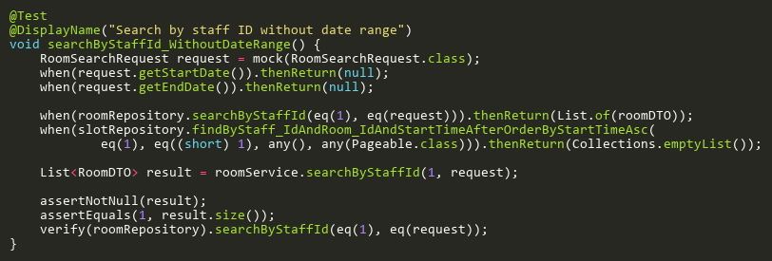
Figure: searchByStaffId_WithoutDateRange
Reference: Sheet "RMST_searchByStaffId", Test Case TC01

UpdateTests
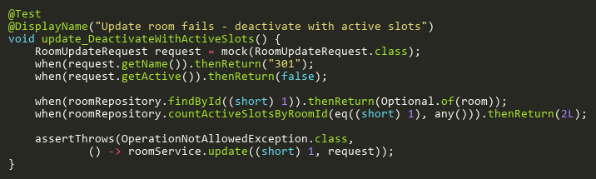
Figure: update_DeactivateWithActiveSlots
Reference: Sheet "RMST_update", Test Case TC05

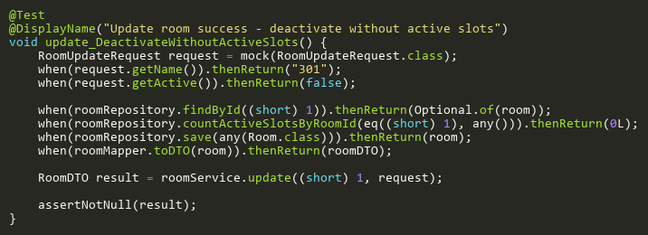
Figure: update_DeactivateWithoutActiveSlots
Reference: Sheet "RMST_update", Test Case TC06

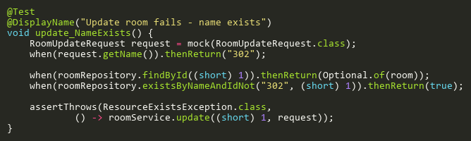
Figure: update_NameExists
Reference: Sheet "RMST_update", Test Case TC04

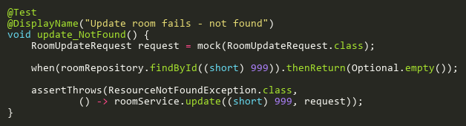
Figure: update_NotFound
Reference: Sheet "RMST_update", Test Case TC03

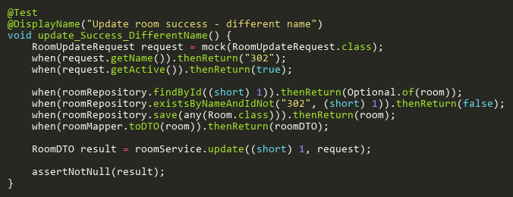
Figure: update_Success_DifferentName
Reference: Sheet "RMST_update", Test Case TC02

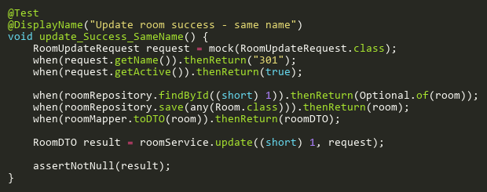
Figure: update_Success_SameName
Reference: Sheet "RMST_update", Test Case TC01

