SemesterServiceTest

CreateTests
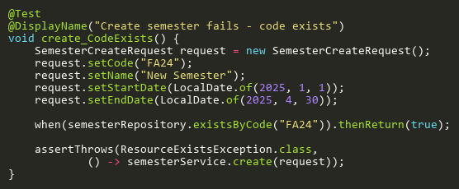
Figure: create_CodeExists
Reference: Sheet "SMST_create", Test Case TC03

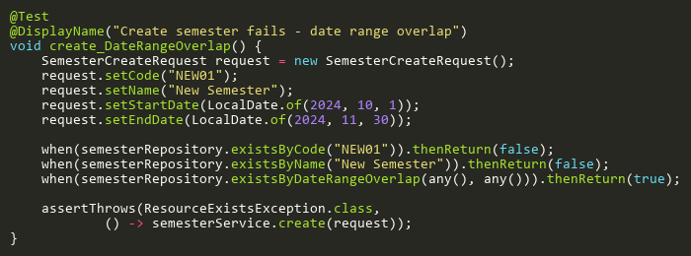
Figure: create_DateRangeOverlap
Reference: Sheet "SMST_create", Test Case TC05

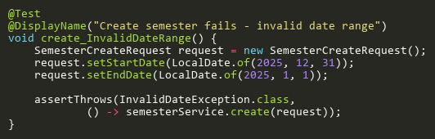
Figure: create_InvalidDateRange
Reference: Sheet "SMST_create", Test Case TC02

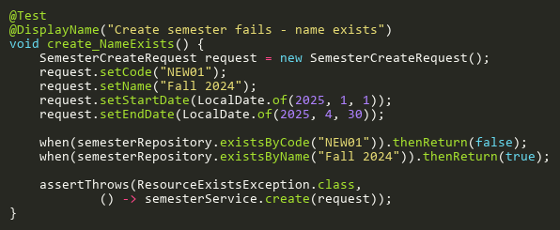
Figure: create_NameExists
Reference: Sheet "SMST_create", Test Case TC04

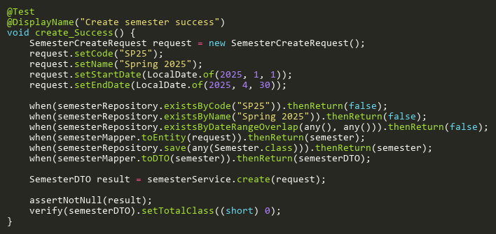
Figure: create_Success
Reference: Sheet "SMST_create", Test Case TC01

DeleteTests
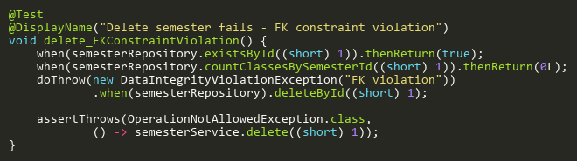
Figure: delete_FKConstraintViolation
Reference: Sheet "SMST_delete", Test Case TC04

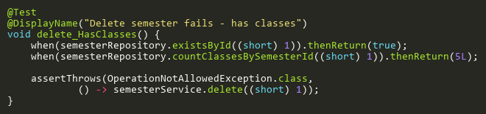
Figure: delete_HasClasses
Reference: Sheet "SMST_delete", Test Case TC03

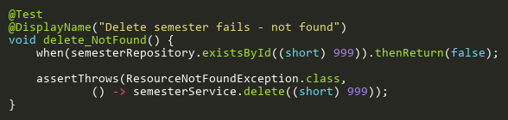
Figure: delete_NotFound
Reference: Sheet "SMST_delete", Test Case TC02

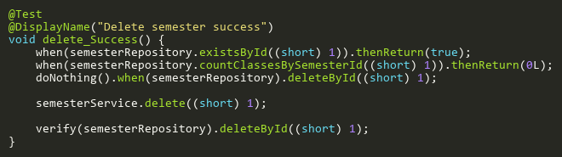
Figure: delete_Success
Reference: Sheet "SMST_delete", Test Case TC01

UpdateTests
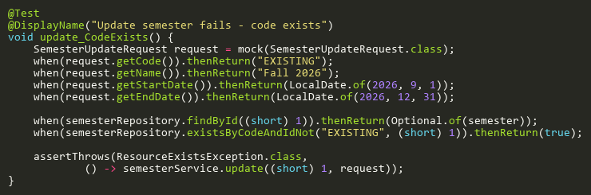
Figure: update_CodeExists
Reference: Sheet "SMST_update", Test Case TC07

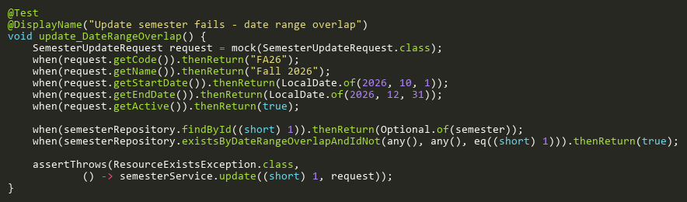
Figure: update_DateRangeOverlap
Reference: Sheet "SMST_update", Test Case TC09

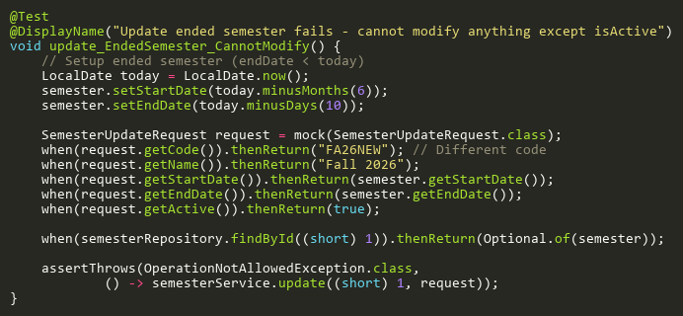
Figure: update_EndedSemester_CannotModify
Reference: Sheet "SMST_update", Test Case TC10

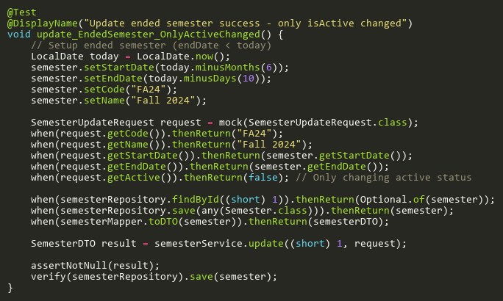
Figure: update_EndedSemester_OnlyActiveChanged
Reference: Sheet "SMST_update", Test Case TC11

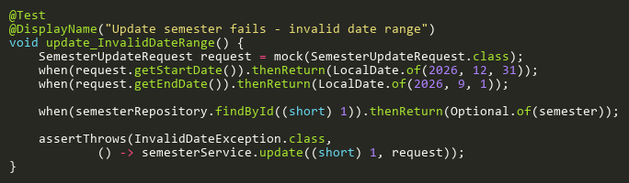
Figure: update_InvalidDateRange
Reference: Sheet "SMST_update", Test Case TC06

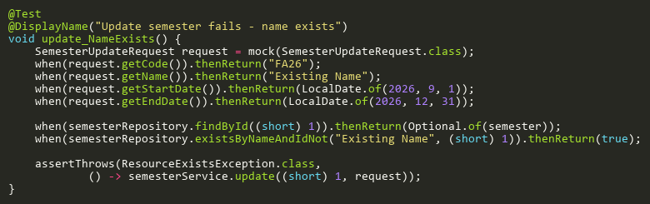
Figure: update_NameExists
Reference: Sheet "SMST_update", Test Case TC08

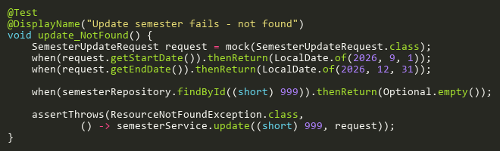
Figure: update_NotFound
Reference: Sheet "SMST_update", Test Case TC05

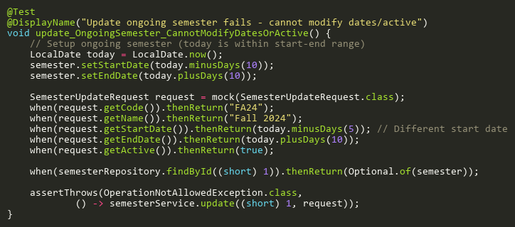
Figure: update_OngoingSemester_CannotModifyDatesOrActive
Reference: Sheet "SMST_update", Test Case TC12

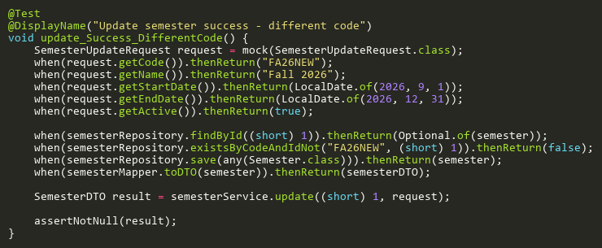
Figure: update_Success_DifferentCode
Reference: Sheet "SMST_update", Test Case TC02

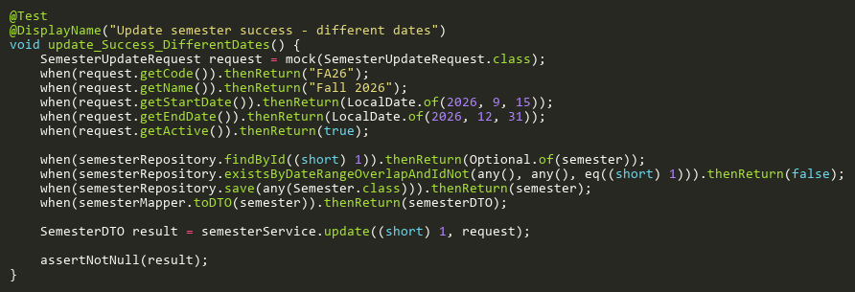
Figure: update_Success_DifferentDates
Reference: Sheet "SMST_update", Test Case TC04

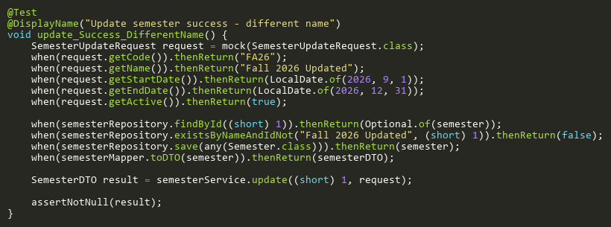
Figure: update_Success_DifferentName
Reference: Sheet "SMST_update", Test Case TC03

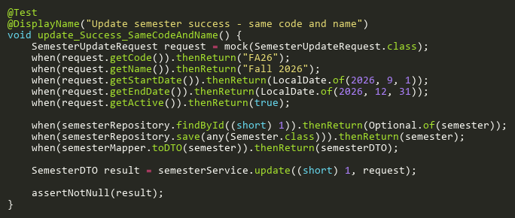
Figure: update_Success_SameCodeAndName
Reference: Sheet "SMST_update", Test Case TC01

