SlotSessionServiceTest

RescanExamSessionTests
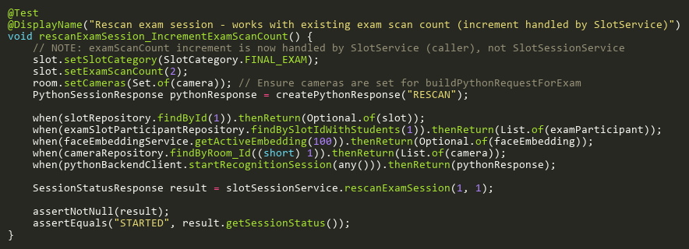
Figure: rescanExamSession_IncrementExamScanCount
Reference: Sheet "SSST_rescanExamSession", Test Case TC06

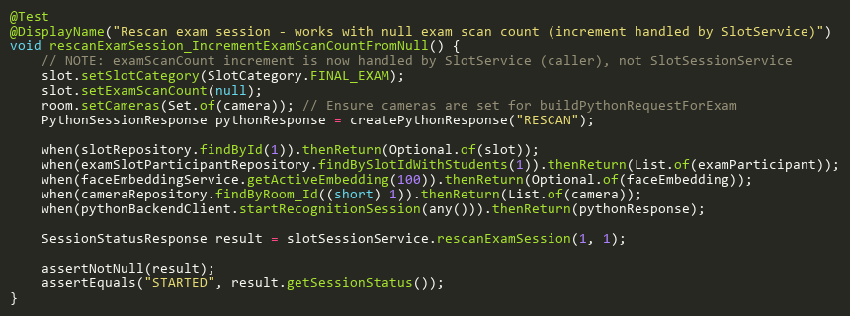
Figure: rescanExamSession_IncrementExamScanCountFromNull
Reference: Sheet "SSST_rescanExamSession", Test Case TC07

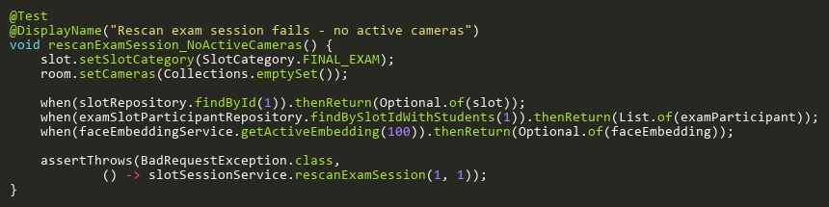
Figure: rescanExamSession_NoActiveCameras
Reference: Sheet "SSST_rescanExamSession", Test Case TC04

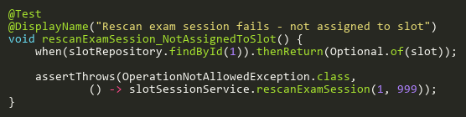
Figure: rescanExamSession_NotAssignedToSlot
Reference: Sheet "SSST_rescanExamSession", Test Case TC03

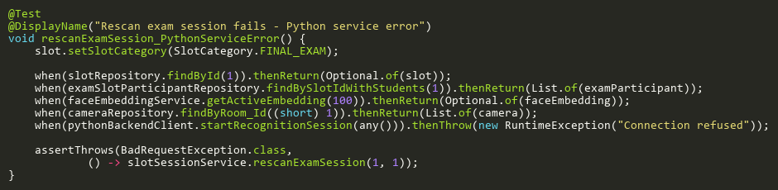
Figure: rescanExamSession_PythonServiceError
Reference: Sheet "SSST_rescanExamSession", Test Case TC05

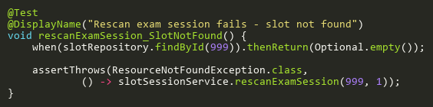
Figure: rescanExamSession_SlotNotFound
Reference: Sheet "SSST_rescanExamSession", Test Case TC02

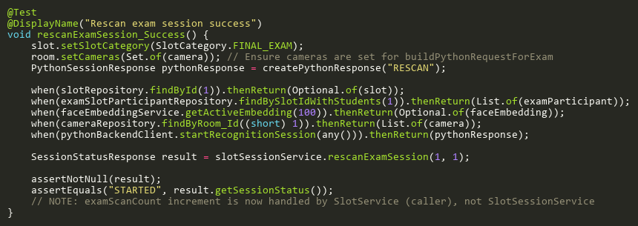
Figure: rescanExamSession_Success
Reference: Sheet "SSST_rescanExamSession", Test Case TC01

StartExamSessionTests
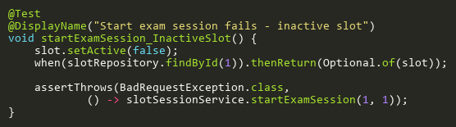
Figure: startExamSession_InactiveSlot
Reference: Sheet "SSST_startExamSession", Test Case TC04

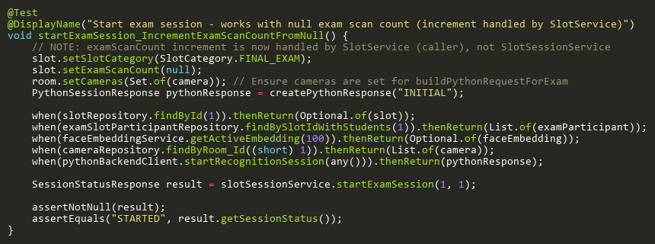
Figure: startExamSession_IncrementExamScanCountFromNull
Reference: Sheet "SSST_startExamSession", Test Case TC09

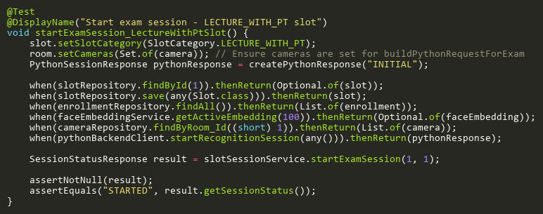
Figure: startExamSession_LectureWithPtSlot
Reference: Sheet "SSST_startExamSession", Test Case TC10

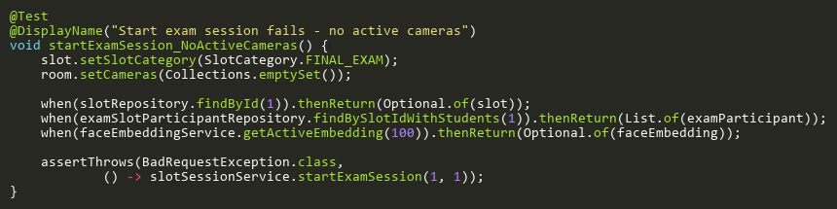
Figure: startExamSession_NoActiveCameras
Reference: Sheet "SSST_startExamSession", Test Case TC07

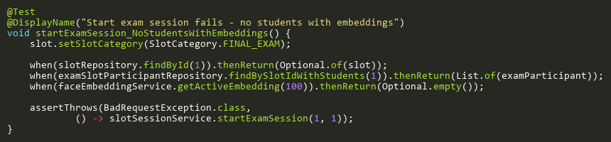
Figure: startExamSession_NoStudentsWithEmbeddings
Reference: Sheet "SSST_startExamSession", Test Case TC06

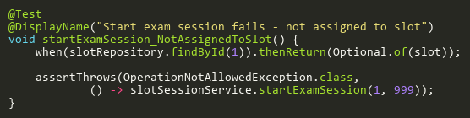
Figure: startExamSession_NotAssignedToSlot
Reference: Sheet "SSST_startExamSession", Test Case TC03

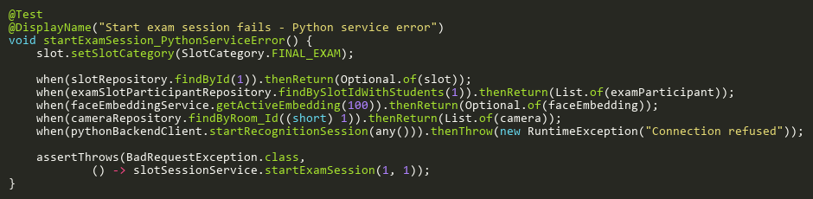
Figure: startExamSession_PythonServiceError
Reference: Sheet "SSST_startExamSession", Test Case TC08

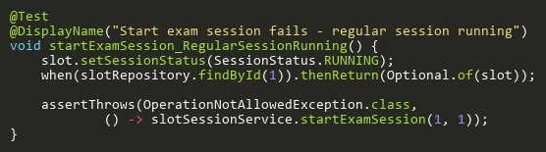
Figure: startExamSession_RegularSessionRunning
Reference: Sheet "SSST_startExamSession", Test Case TC05

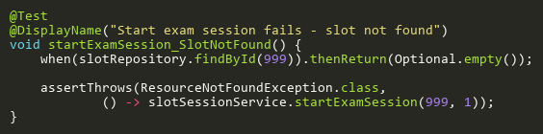
Figure: startExamSession_SlotNotFound
Reference: Sheet "SSST_startExamSession", Test Case TC02

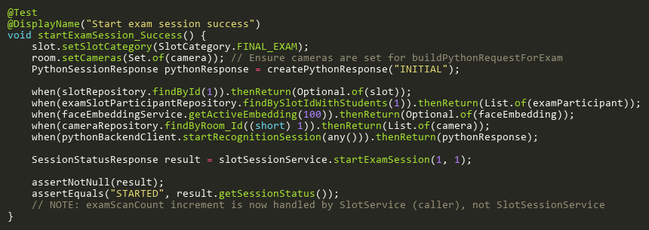
Figure: startExamSession_Success
Reference: Sheet "SSST_startExamSession", Test Case TC01

StartSessionTests
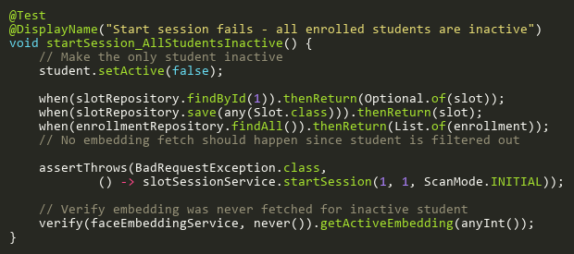
Figure: startSession_AllStudentsInactive
Reference: Sheet "SSST_startSession", Test Case TC14

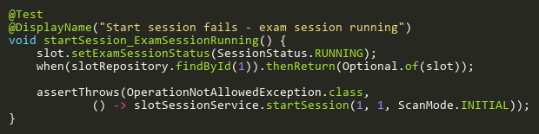
Figure: startSession_ExamSessionRunning
Reference: Sheet "SSST_startSession", Test Case TC06

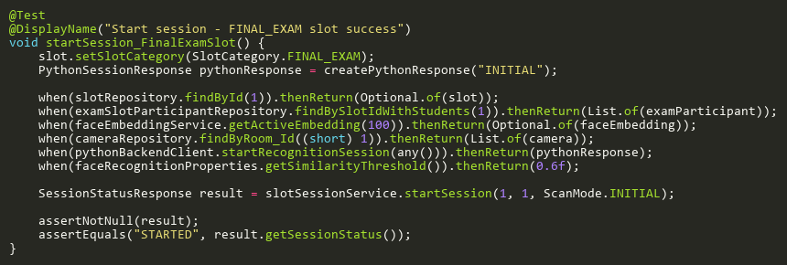
Figure: startSession_FinalExamSlot
Reference: Sheet "SSST_startSession", Test Case TC11

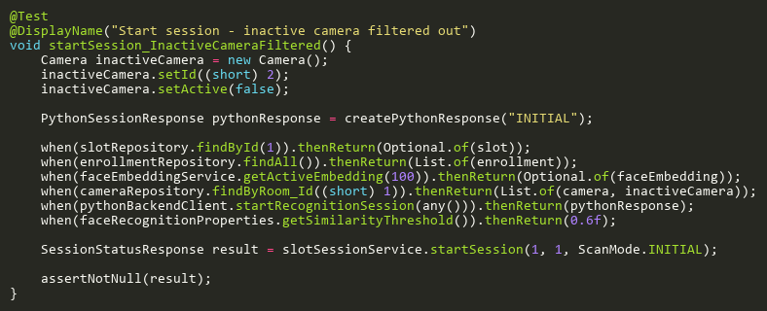
Figure: startSession_InactiveCameraFiltered
Reference: Sheet "SSST_startSession", Test Case TC12

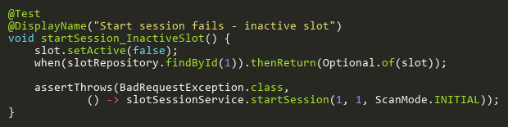
Figure: startSession_InactiveSlot
Reference: Sheet "SSST_startSession", Test Case TC05

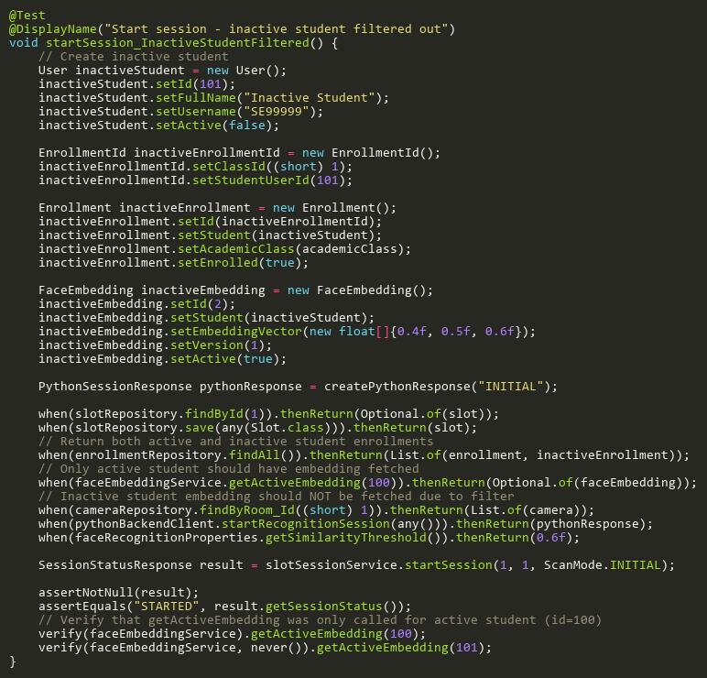
Figure: startSession_InactiveStudentFiltered
Reference: Sheet "SSST_startSession", Test Case TC13

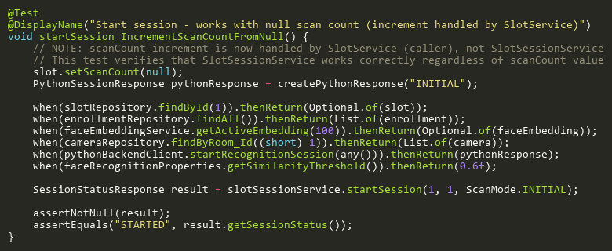
Figure: startSession_IncrementScanCountFromNull
Reference: Sheet "SSST_startSession", Test Case TC09

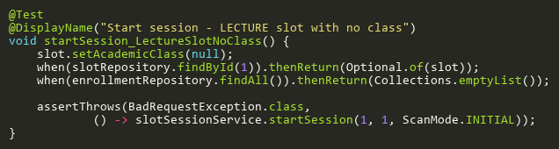
Figure: startSession_LectureSlotNoClass
Reference: Sheet "SSST_startSession", Test Case TC10

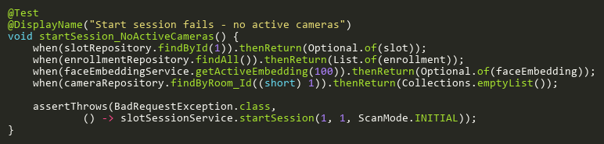
Figure: startSession_NoActiveCameras
Reference: Sheet "SSST_startSession", Test Case TC08

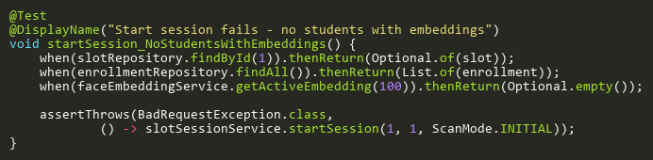
Figure: startSession_NoStudentsWithEmbeddings
Reference: Sheet "SSST_startSession", Test Case TC07

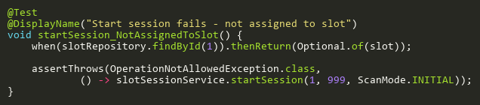
Figure: startSession_NotAssignedToSlot
Reference: Sheet "SSST_startSession", Test Case TC04

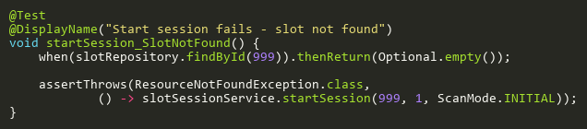
Figure: startSession_SlotNotFound
Reference: Sheet "SSST_startSession", Test Case TC03

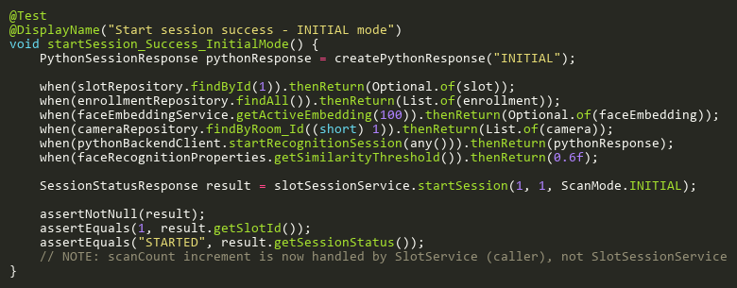
Figure: startSession_Success_InitialMode
Reference: Sheet "SSST_startSession", Test Case TC01

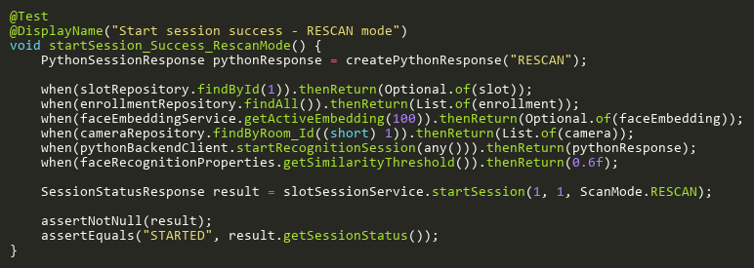
Figure: startSession_Success_RescanMode
Reference: Sheet "SSST_startSession", Test Case TC02

StopExamSessionTests
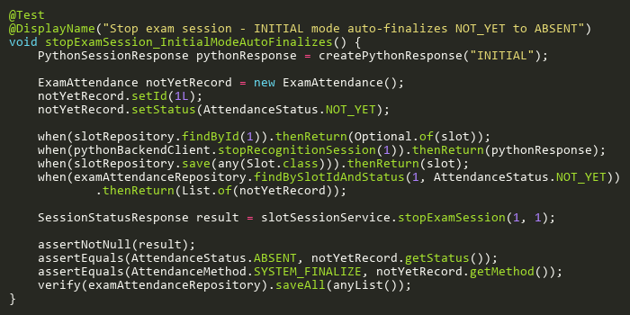
Figure: stopExamSession_InitialModeAutoFinalizes
Reference: Sheet "SSST_stopExamSession", Test Case TC06

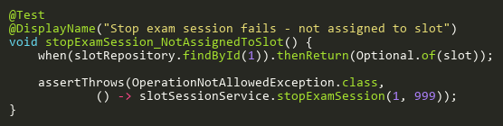
Figure: stopExamSession_NotAssignedToSlot
Reference: Sheet "SSST_stopExamSession", Test Case TC03

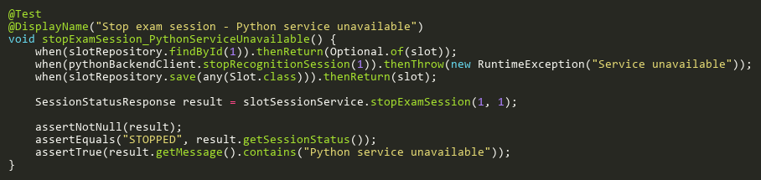
Figure: stopExamSession_PythonServiceUnavailable
Reference: Sheet "SSST_stopExamSession", Test Case TC04

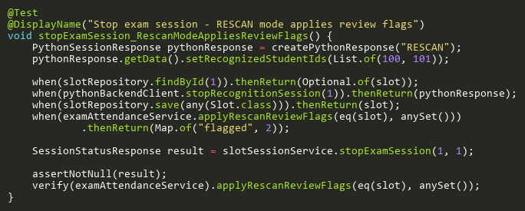
Figure: stopExamSession_RescanModeAppliesReviewFlags
Reference: Sheet "SSST_stopExamSession", Test Case TC05

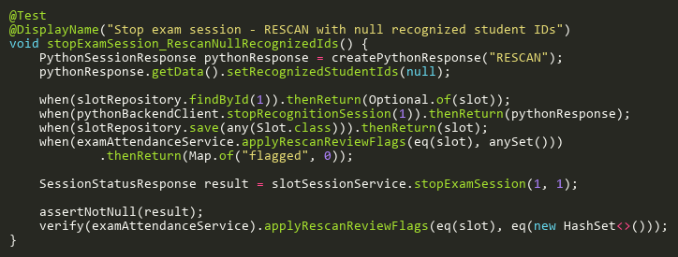
Figure: stopExamSession_RescanNullRecognizedIds
Reference: Sheet "SSST_stopExamSession", Test Case TC07

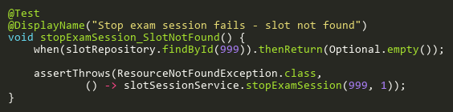
Figure: stopExamSession_SlotNotFound
Reference: Sheet "SSST_stopExamSession", Test Case TC02

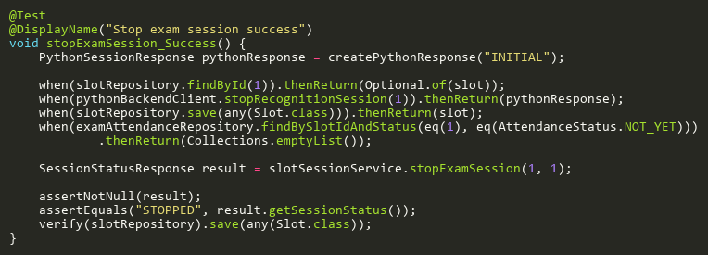
Figure: stopExamSession_Success
Reference: Sheet "SSST_stopExamSession", Test Case TC01

StopSessionTests
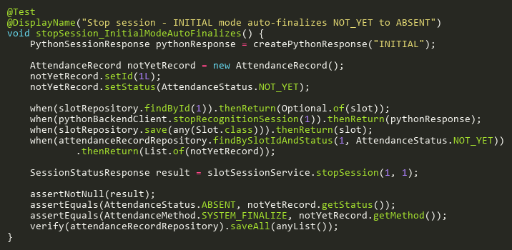
Figure: stopSession_InitialModeAutoFinalizes
Reference: Sheet "SSST_stopSession", Test Case TC06

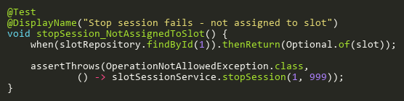
Figure: stopSession_NotAssignedToSlot
Reference: Sheet "SSST_stopSession", Test Case TC03

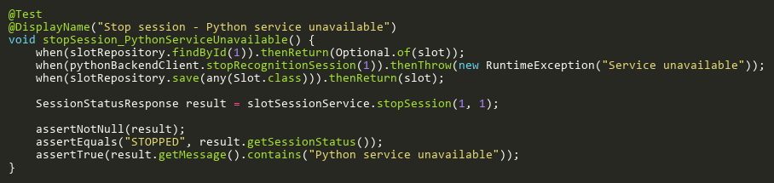
Figure: stopSession_PythonServiceUnavailable
Reference: Sheet "SSST_stopSession", Test Case TC04

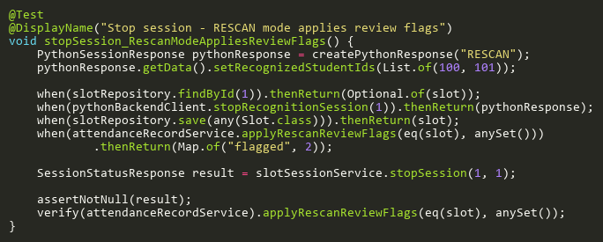
Figure: stopSession_RescanModeAppliesReviewFlags
Reference: Sheet "SSST_stopSession", Test Case TC05

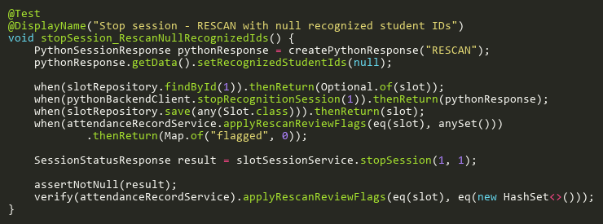
Figure: stopSession_RescanNullRecognizedIds
Reference: Sheet "SSST_stopSession", Test Case TC07

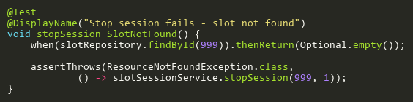
Figure: stopSession_SlotNotFound
Reference: Sheet "SSST_stopSession", Test Case TC02

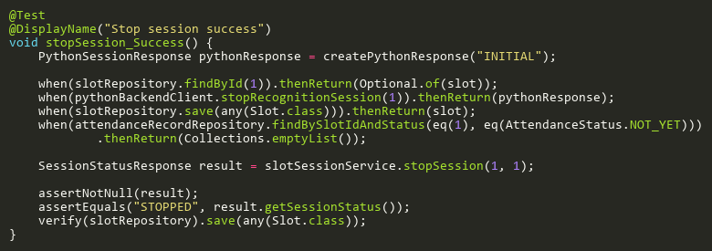
Figure: stopSession_Success
Reference: Sheet "SSST_stopSession", Test Case TC01

