StaffProfileServiceTest

CreateTests
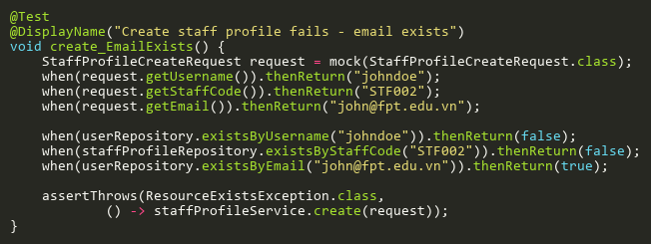
Figure: create_EmailExists
Reference: Sheet "SPST_create", Test Case TC05

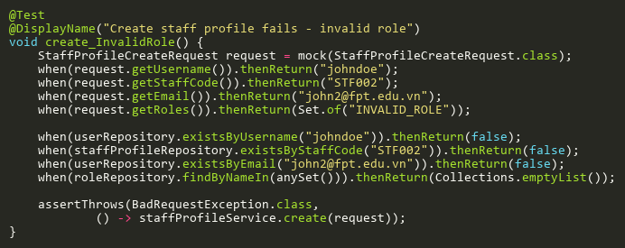
Figure: create_InvalidRole
Reference: Sheet "SPST_create", Test Case TC07

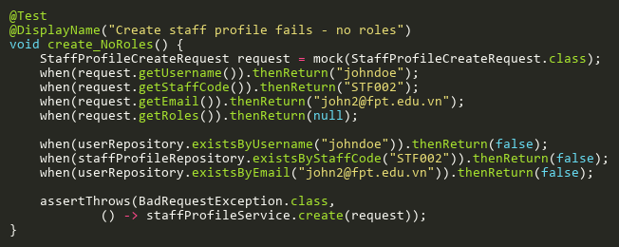
Figure: create_NoRoles
Reference: Sheet "SPST_create", Test Case TC06

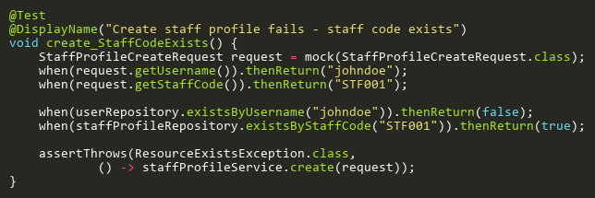
Figure: create_StaffCodeExists
Reference: Sheet "SPST_create", Test Case TC04

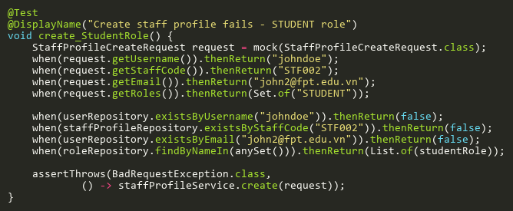
Figure: create_StudentRole
Reference: Sheet "SPST_create", Test Case TC08

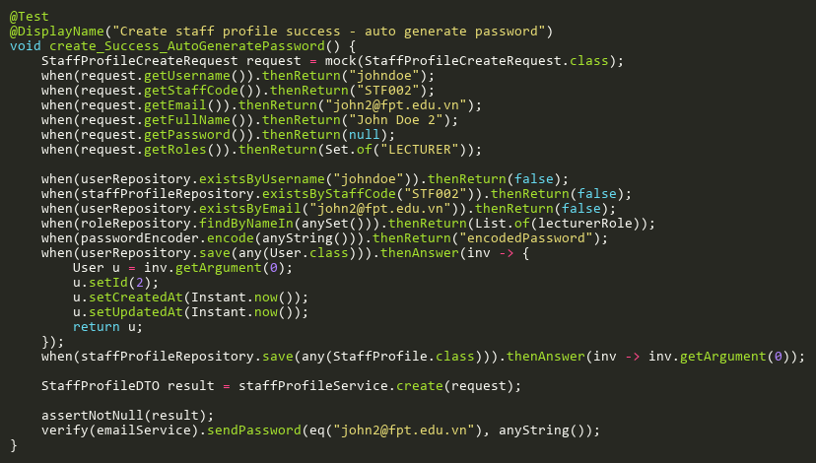
Figure: create_Success_AutoGeneratePassword
Reference: Sheet "SPST_create", Test Case TC02

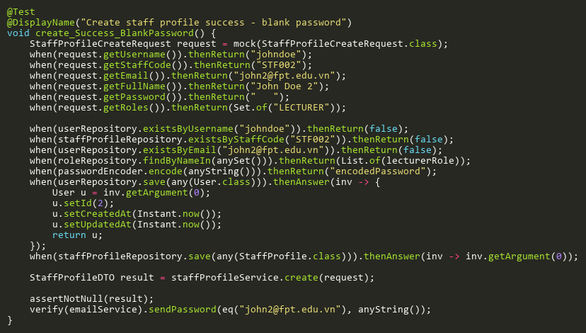
Figure: create_Success_BlankPassword
Reference: Sheet "SPST_create", Test Case TC09

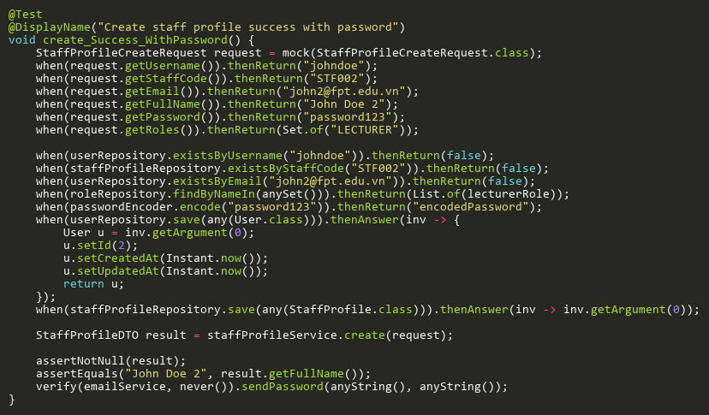
Figure: create_Success_WithPassword
Reference: Sheet "SPST_create", Test Case TC01

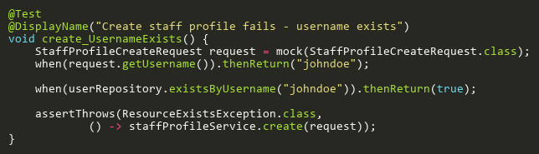
Figure: create_UsernameExists
Reference: Sheet "SPST_create", Test Case TC03

DeleteTests
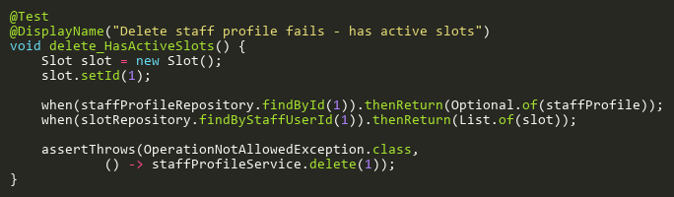
Figure: delete_HasActiveSlots
Reference: Sheet "SPST_delete", Test Case TC03

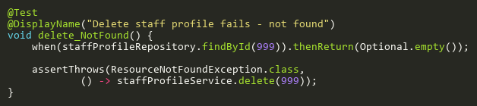
Figure: delete_NotFound
Reference: Sheet "SPST_delete", Test Case TC02

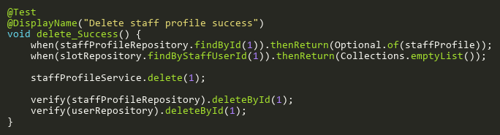
Figure: delete_Success
Reference: Sheet "SPST_delete", Test Case TC01

FindByIdTests
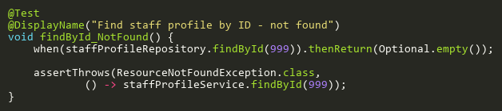
Figure: findById_NotFound
Reference: Sheet "SPST_findById", Test Case TC02

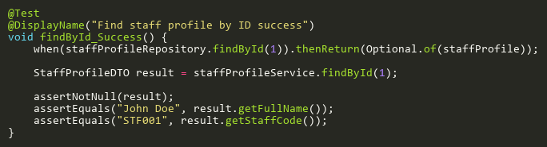
Figure: findById_Success
Reference: Sheet "SPST_findById", Test Case TC01

ImportFromCsvTests
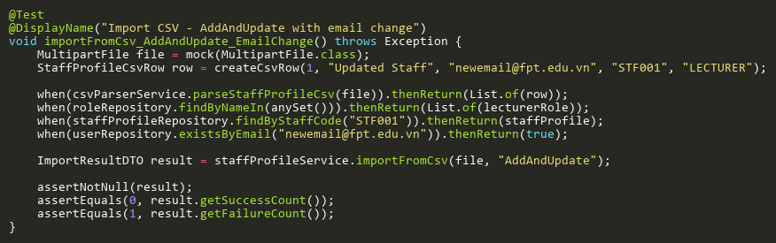
Figure: importFromCsv_AddAndUpdate_EmailChange
Reference: Sheet "SPST_importFromCsv", Test Case TC10

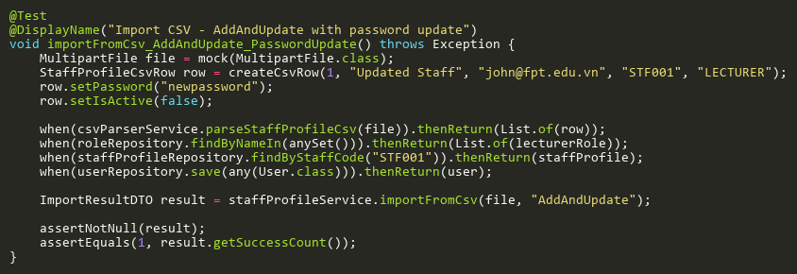
Figure: importFromCsv_AddAndUpdate_PasswordUpdate
Reference: Sheet "SPST_importFromCsv", Test Case TC12

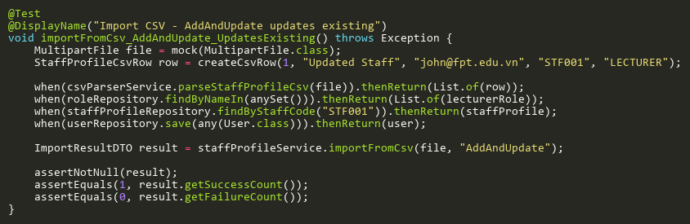
Figure: importFromCsv_AddAndUpdate_UpdatesExisting
Reference: Sheet "SPST_importFromCsv", Test Case TC05

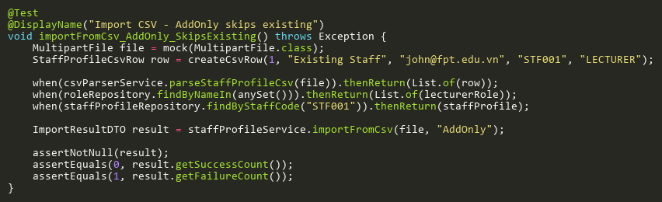
Figure: importFromCsv_AddOnly_SkipsExisting
Reference: Sheet "SPST_importFromCsv", Test Case TC04

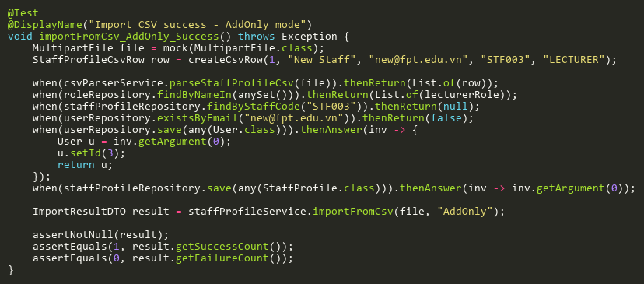
Figure: importFromCsv_AddOnly_Success
Reference: Sheet "SPST_importFromCsv", Test Case TC01

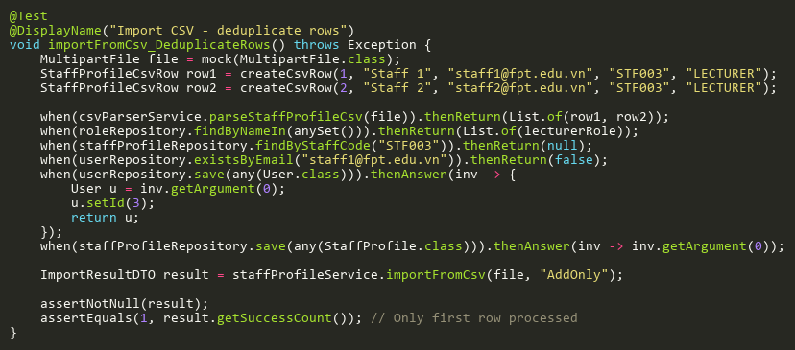
Figure: importFromCsv_DeduplicateRows
Reference: Sheet "SPST_importFromCsv", Test Case TC09

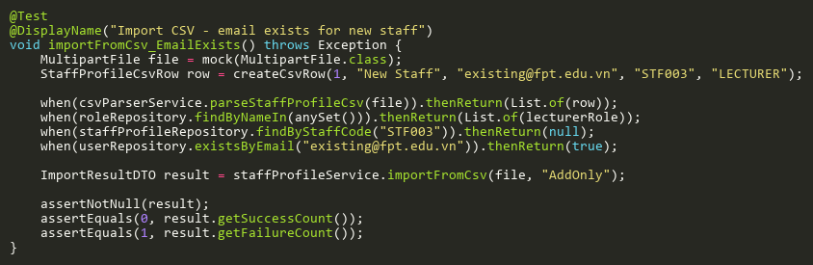
Figure: importFromCsv_EmailExists
Reference: Sheet "SPST_importFromCsv", Test Case TC06

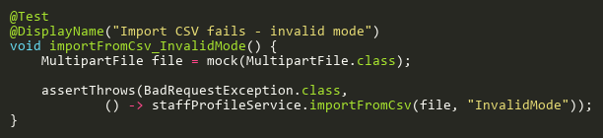
Figure: importFromCsv_InvalidMode
Reference: Sheet "SPST_importFromCsv", Test Case TC02

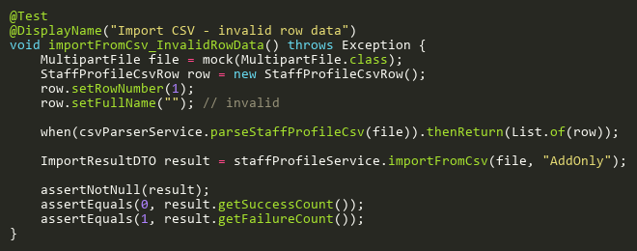
Figure: importFromCsv_InvalidRowData
Reference: Sheet "SPST_importFromCsv", Test Case TC07

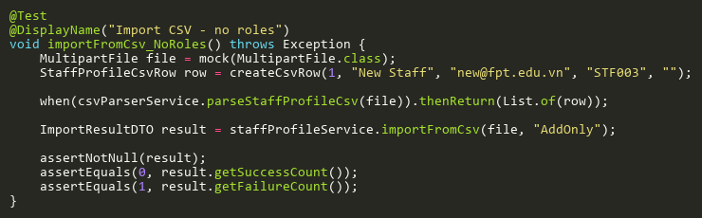
Figure: importFromCsv_NoRoles
Reference: Sheet "SPST_importFromCsv", Test Case TC08

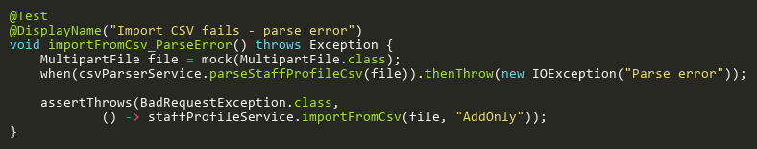
Figure: importFromCsv_ParseError
Reference: Sheet "SPST_importFromCsv", Test Case TC03

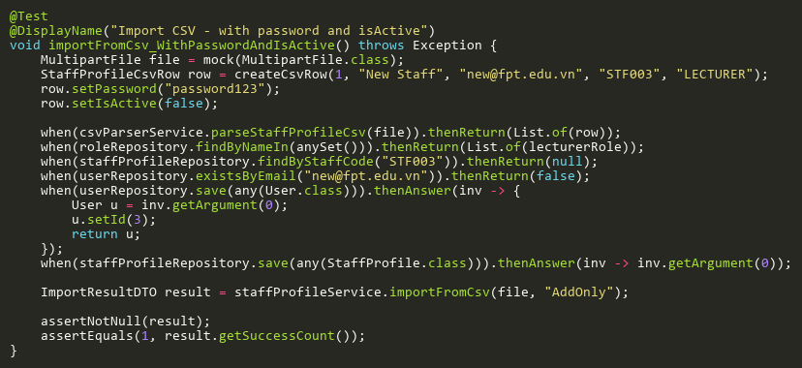
Figure: importFromCsv_WithPasswordAndIsActive
Reference: Sheet "SPST_importFromCsv", Test Case TC11

SearchTests
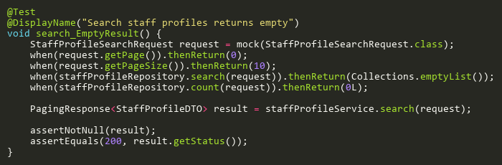
Figure: search_EmptyResult
Reference: Sheet "SPST_search", Test Case TC02

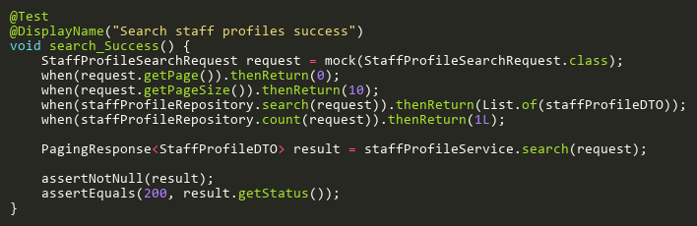
Figure: search_Success
Reference: Sheet "SPST_search", Test Case TC01

UpdateTests
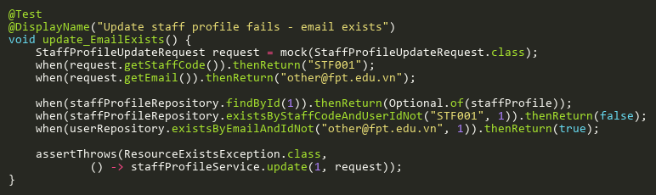
Figure: update_EmailExists
Reference: Sheet "SPST_update", Test Case TC04

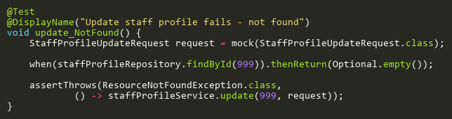
Figure: update_NotFound
Reference: Sheet "SPST_update", Test Case TC02

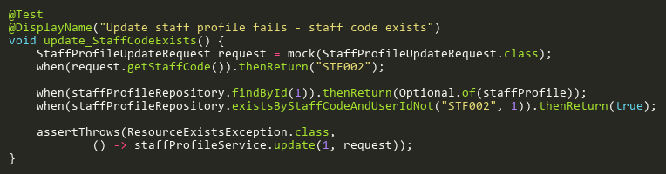
Figure: update_StaffCodeExists
Reference: Sheet "SPST_update", Test Case TC03

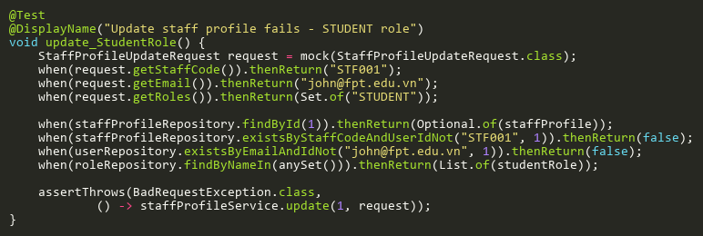
Figure: update_StudentRole
Reference: Sheet "SPST_update", Test Case TC05

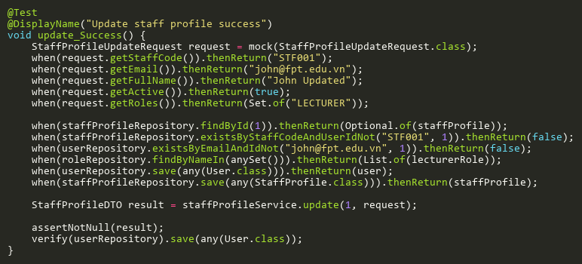
Figure: update_Success
Reference: Sheet "SPST_update", Test Case TC01

