StudentPhotoServiceTest

HasExistingPhotoTests
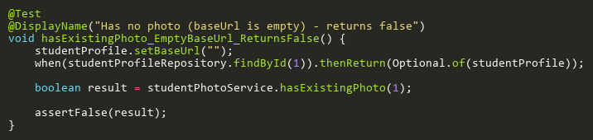
Figure: hasExistingPhoto_EmptyBaseUrl_ReturnsFalse
Reference: Sheet "SPHST_hasPhoto", Test Case TC03

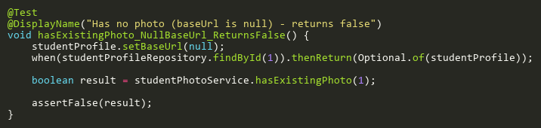
Figure: hasExistingPhoto_NullBaseUrl_ReturnsFalse
Reference: Sheet "SPHST_hasPhoto", Test Case TC02

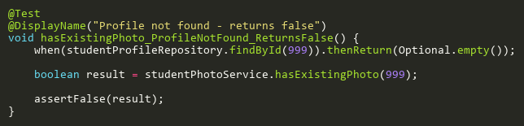
Figure: hasExistingPhoto_ProfileNotFound_ReturnsFalse
Reference: Sheet "SPHST_hasPhoto", Test Case TC04

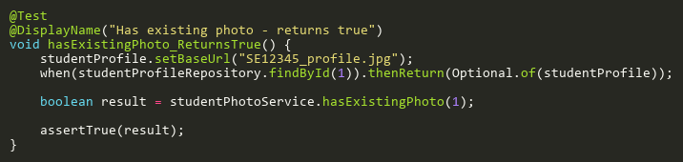
Figure: hasExistingPhoto_ReturnsTrue
Reference: Sheet "SPHST_hasPhoto", Test Case TC01

SavePhotoToUserFolderTests
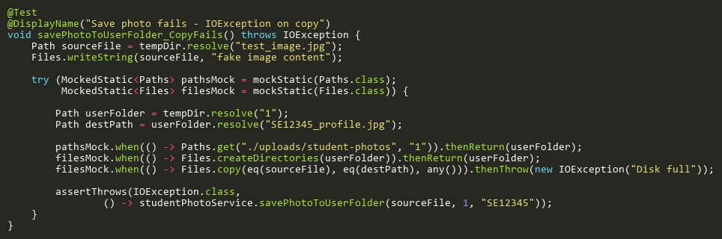
Figure: savePhotoToUserFolder_CopyFails
Reference: Sheet "SPHST_savePhoto", Test Case TC04

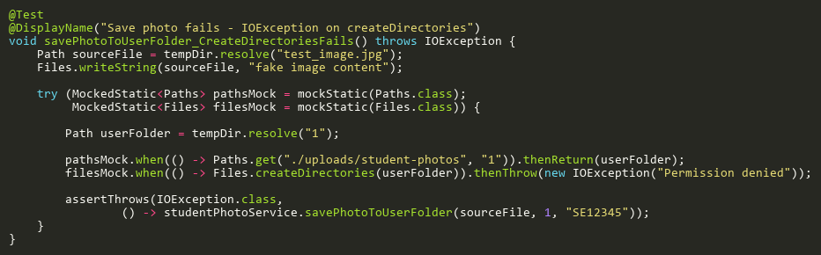
Figure: savePhotoToUserFolder_CreateDirectoriesFails
Reference: Sheet "SPHST_savePhoto", Test Case TC03

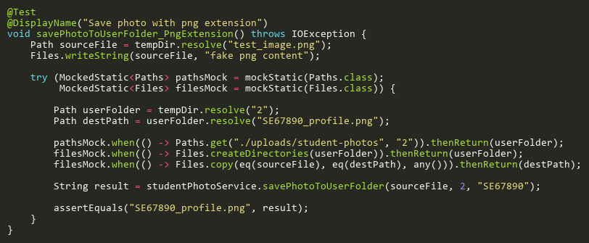
Figure: savePhotoToUserFolder_PngExtension
Reference: Sheet "SPHST_savePhoto", Test Case TC02

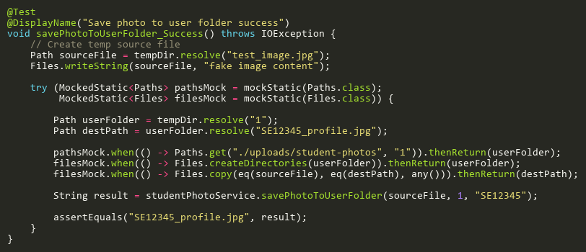
Figure: savePhotoToUserFolder_Success
Reference: Sheet "SPHST_savePhoto", Test Case TC01

UpdateStudentProfilePhotoTests
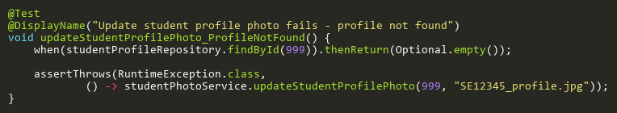
Figure: updateStudentProfilePhoto_ProfileNotFound
Reference: Sheet "SPHST_updatePhoto", Test Case TC02

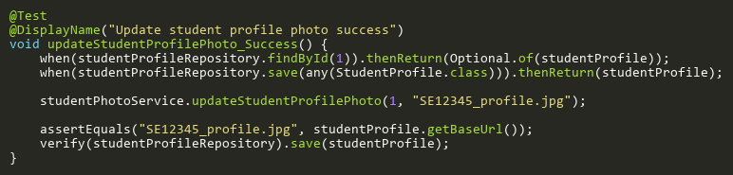
Figure: updateStudentProfilePhoto_Success
Reference: Sheet "SPHST_updatePhoto", Test Case TC01

